



**CHURCH OFFICERS**

**Rector:** The Reverend Ann Templeman – Tel: 01772 448515 and mob: 07877 659156; E: anntempleman@live.co.uk

**Associate Minister:** The Reverend Peter Templeman

**Churchwarden**

Mr Jock Davidson – Tel: 617918; E: sgtmajor@talktalk.net

**Occasional Preacher**

Mrs Margaret Kirkman – Tel: 01772 379219. Mob: 07786543581.

E: margk1946@gmail.com

**Reader in Training**

Mr Alan Johnson – Tel: 01704 822179; E: alanmarie55@gmail.com

**Churchwarden Emeritus**

Mr William G Carr. Tel: 01772 615321. E: billcarr1935@btinternet.com

**PCC Secretary**

Mrs Andrea Susnik – Tel: 615336. E: familysusnik@live.co.uk

**PCC Treasurer**

Mrs Barbara Wood – Tel: 617679. E: bw12252@sky.com

**Deanery Synod Representatives:** Mrs Jane Elphick and Mrs Jean Dewhurst

**Magazine Editor**

Mrs Erika Penrose – Tel: 613816. E: jandepenrose@btinternet.com

**Magazine Secretary**

Mrs Elsie Kirkham – Tel: 615832.

**Magazine Advert Co-ordinator**

Mrs Margaret Clark – Tel: 616990. E: mic0802@live.co.uk

**Flower Secretaries**

Mrs Lisa Redshaw – Tel 614428 and Mrs Pearl Read – Tel: 614367.

**Electoral Roll Officers**

Mrs Jean Dewhurst, Tel: 616106 and Mrs Jane Elphick, Tel: 601495.

**Verger:** Mrs Irene Pickles – Tel: 615708

**Assistant Verger:** Mr Stuart Tighe – Tel: 612963

**Weekly Giving Envelopes:** Pleas

e contact the Churchwarden.

**Parish Administrator:** Mrs Amanda Gibson – Tel: 07735 961620.

**ORGANISATIONS**

**Sunday School**

Sunday School – St Michael’s Club – now begins at 10.30 in church and happens every Sunday.

Leader: Mrs Kathleen Leigh – Tel: 612196.  Email: katleigh@live.co.uk

**Hoole Church Ladies’ Group** – meets 7.30pm, 3rd Tuesday, in School. Leader: Mrs Erika Penrose.

Tel: 613816. E: jandepenrose@btinternet.com

**St Michael’s Men’s Fellowship** – meets 7.30pm, 2nd Tuesday, in Hoole Village Memorial Hall.

Secretary: Mr Stuart Tighe – Tel: 612963.

**Friends of St Michael** – Caring for the fabric of our ancient church.

Chair: Mrs Jane Elphick, Tel: 601495.

Secretary: Mr David Turner, Tel: 01772 383344.

**Social Committee** – Contact: Mrs Sheila Taylor, Tel: 616850

**Hoole St Michael C E Primary School**

Head Teacher: Mrs Juliet Price – Tel: 613219.

**1st St. Michael’s Hoole Scout & Guide Groups – Group Scout Leader:** Mandy Clark – Tel: 01772 305452; E:gmjbclark@yahoo.co.uk.

**Church Website:** Our new church website is now live; the address is

http://www.hooleparishchurch.com. WHY NOT TAKE A LOOK!

***Please note: All adverts are at the back of the magazine.***

***Church Rotas are on pages 26& 27.***



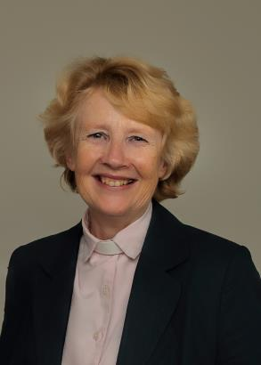**From the Rectory**

**Thy Kingdom Come**

Today the Prime Minister has resigned. Yet more political turmoil. Jesus urged his followers to pray ‘Thy Kingdom come’.

And for 11 days from Ascension Day 30th May till Pentecost 2nd June millions of Christians from every country, of all ages and races will be joining in a great wave of Prayer across the globe as together they pray to God the Father saying ‘Thy Kingdom come’

Ascension is the day when we remember Jesus’ return to heaven after his resurrection, and Pentecost is when we celebrate the outpouring of the Holy Spirit on Jesus’ disciples - often known as the ‘birthday of the Church’.

These eleven days have always been infused with expectation and anticipation — as he ascended, our Lord Jesus Christ promised the gift of the Holy Spirit to enable the disciples to be witnesses. As those first followers waited for the promise to be fulfilled by constantly devoting themselves to prayer (Acts 1:11), so the renewed call across the church is to set these days apart to pray.

And there is plenty to pray about – for love, justice and peace in the world, in our nation and then in our communities.

Moreover, in the gospels we read again and again how people would bring friends, loved ones, family members, and children to Jesus. So a particular focus of Thy Kingdom Come is to bring to God five individuals, that they might have an encounter with Jesus Christ.

At St Michael’s we are encouraging everyone to join in this wave of prayer.

There is free literature in church to help you pray and the church will be open every day for prayer with prayer ideas to help you pray.

Prayer can change your life!

Please come and join us beginning with our special Ascension Day Service of Holy Communion at 7.30pm on 30th May. Then experience the joy and exuberance of the fire of the Holy Spirit at Pentecost on 2nd June in the morning or at Lift Off church at 4.00pm as we let off red balloons over Hoole with messages of God’s Love and the fact that Jesus is alive.

Ann Templeman. May 2019.

~~~~

**ST MICHAEL AND ALL ANGELS CHURCH, HOOLE**

**SUNDAY SCHOOL – Michael’s Club for children (ages 3 to 12), every Sunday during the 10.30 service.**

**10.30am – Starts in church; children leave for their own teaching in the school after a children’s song and return after the sermon and prayers.**

**PARISH DIARY**

**THY KINGDOM COME**

**NATIONAL CALL TO PRAYER: ASCENSION DAY TO PENTECOST**

**Thursday 30th May Ascension Day**

7.30 Holy Communion

Sunday 2nd June 9.00 Holy Communion (Book of Common Prayer)

10.30 Parish Communion with Sunday School

12.00 Baptism of Rory George Thomas

4.00 Holy Communion (Old Mill Court)

Monday 3rd June 7.30 House group/Bible Study at the Rectory – John session 2

Tuesday 4th June 10.15 Holy Communion (said)

Friday 7th June 9.30 St Michael’s School Spirituality Day visit to Church

7.30 Friends’ Brass Band Concert at Walmer Bridge Village Hall

Saturday 8th June 2.00 Summer Fete at Hoole Village Hall

**PENTECOST**

Sunday 9th June 9.00 Holy Communion (Book of Common Prayer)

10.30 Morning Worship with Sunday School

12.00 Baptism of Benjamin Toby Alan Wheatley

4.00 LIFT OFF FAMILY CHURCH at Much Hoole Village Hall

Tuesday 11th June 10.15 Holy Communion (said)

7.30 House group/Bible Study at the Rectory – John session 3

**TRINITY SUNDAY**

16th June 9.00 Holy Communion (Book of Common Prayer)

10.30 Parish Communion with Sunday School

Monday 17th June 7.30 House group/Bible Study at the Rectory – John session 3

Tuesday 18th June 10.15 Holy Communion (said)

7.30 Ladies’ Group meeting at St Michael’s School

Sunday 23rd June 9.00 Holy Communion (Book of Common Prayer)

10.30 Morning Worship with Sunday School

Tuesday 25th June 10.15 Holy Communion (said)

7.30 House group/Bible Study at the Rectory – John session 4

Sunday 30th June 9.00 Holy Communion (Book of Common Prayer)

10.30 Parish Communion with Sunday School

10.30 Confirmation Service at St James’ Church, Leyland

12.00 Baptism of Joshua Thomas John Bradley

Monday 1st July 7.30 House group/Bible Study at the Rectory – John session 4

Tuesday 2nd July 10.15 Holy Communion (said)

Sunday 7th July 9.00 Holy Communion (Book of Common Prayer)

10.30 Parish Communion with Sunday School

3.00 CREAM TEA FAMILY CHURCH at St Michael’s School

Tuesday 9th July 10.15 Holy Communion (said)

7.30 House group/Bible Study at the Rectory – John session 5

Friday 12th July 7.00 Summer evening cruise on the Lancaster Canal. Starting from Barton Grange Garden Centre: Fish & Chip supper and quiz included.

**KEY FUTURE DATES**

* **LIFT OFF CHURCH**

**Sunday 9th** **June** at 4.00pm in the Village Hall

* **CREAM TEA CHURCH**

**Sunday 7th July** at 3.00pm in St Michael's School

* **HARVEST SUPPER**

**Friday 27th September** at 7.00 for 7.30 in the Village Hall

* **ST MICHAEL’S SCHOOL HARVEST FESTIVAL**
* **HARVEST FESTIVAL**

**Sunday 6th October**



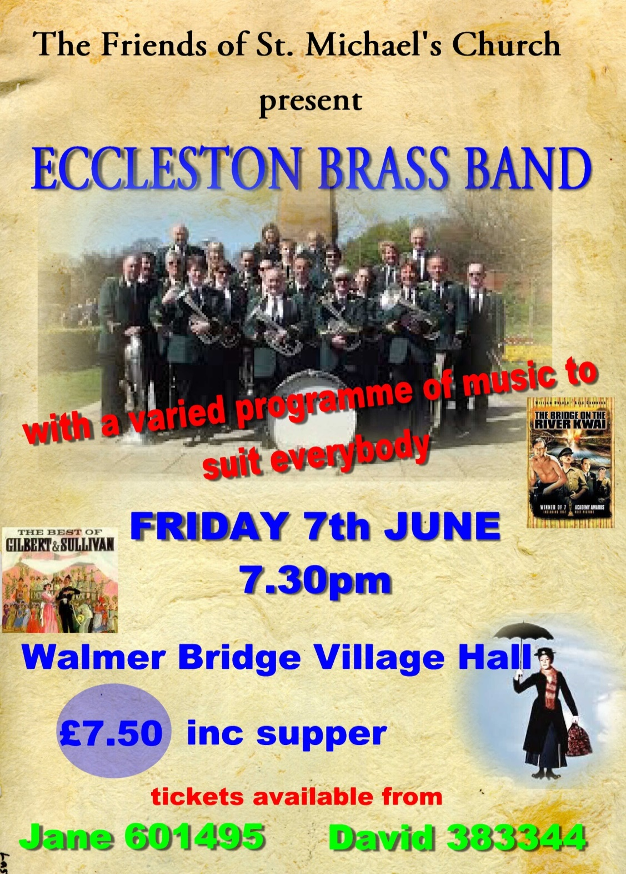

# MC900129223[1]MC900129223[1]**St Michael’s Church Ladies’ Group**

SUMMER fETE

**on Saturday 8th June at 2.00pm**

**HOOLE VILLAGE HALL,**

**LIVERPOOL ROAD, MUCH HOOLE**

***Special Attraction! The well-known local***

**TRACEY TAYLOR DANCERS**

* **Tombola**
* **Bat the RAT!**
* **Teddy Bears Picnic!**
* **Hot Dogs**
* **Plant Stall**
* **Accordion Music**
* **Home Made Cakes**
* **Big Raffle and Plant Raffle**
* **Strawberries & Ice Cream**
* 
* **Refreshments and more…**

**Admission free!**

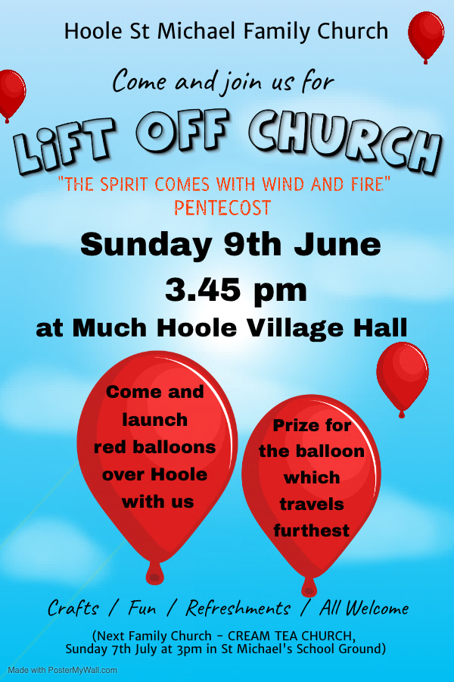

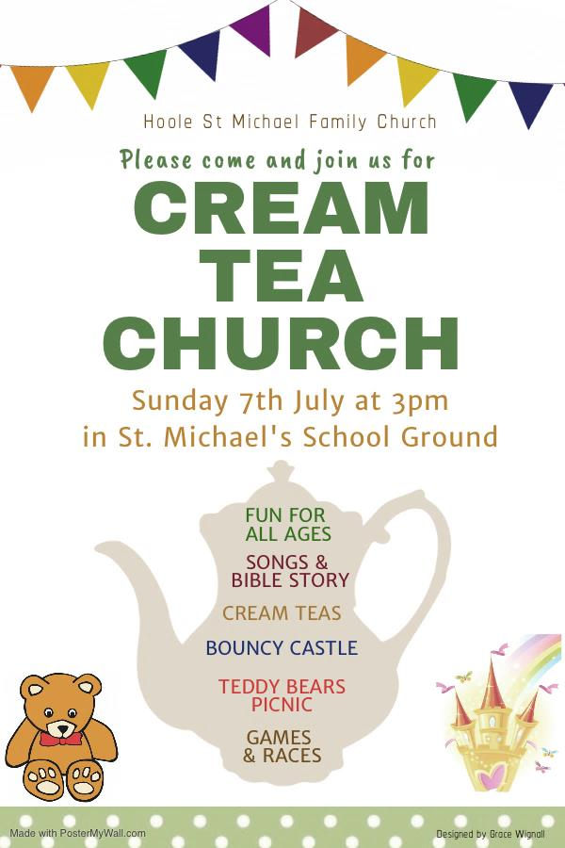**Lego Church**

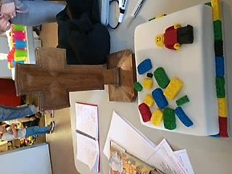 On Sunday 20th May the family church event ‘Lego Church’ took place at the Village Hall in Much Hoole. Around 40 children (74 people in all) attended the event, which followed a ‘Noah’s Ark’ theme and involved the children building Lego creations linked to the theme. Lego prizes were awarded for the best creations in each age group. Children entertained the adults by singing school favourites ‘My Lighthouse’ and the appropriately named ‘Build Up’ with the associated actions and dancing!

Singing was followed by well-earned refreshments and Lego cake, and a chance for all to network with familiar faces and newcomers alike. All children left with a small thank you gift for attending the event. ‘Lift Off Church’ - the next family church event, will take place on Sunday 9th June at the Village Hall, and will focus on Pentecost.

**Leo Crossen reports:**

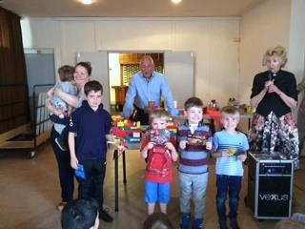 Lego Church was a chance to build creations linked to Noah’s Ark. You won prizes for the best creations. It was so much fun compared to the things you can make at home Lego lovers! There were arts and crafts too, one was to create your own mini-figure. There was Lego cake for eating, not for building! If there is another Lego Church please come along. *Leo Crossen, age 6.*

**CHURCH OPENING TIMES**  
The church is open during the day as follows:

|  |  |  |
| --- | --- | --- |
| **Day** | **Open** | **Close** |
| Monday | 9.30am | 4.30pm |
| Tuesday | 9.30am | 4.30pm |
| Wednesday | 9.30am | 4.30pm |
| Thursday | 9.30am | 4.30pm |
| Friday | Closed | |
| Saturday | 9.30am | 4.30pm |
| Sunday | 8.00am | 4.30pm |

Jock Davidson, Churchwarden

Our new church website is now live – the address is http://www.hooleparishchurch.com

Why not take a look – the more “hits” we have, the better it will be for raising our profile!

**Ladies’ Group**

We had a super trip to Barton Grange Garden Centre last month and the weather was so kind. All of us gave Sheila and Helen three cheers!

Wow, it’s the Summer Fete on **Saturday 8th June,** and we would be grateful for any donations of cakes for the cake stall, small cakes for refreshments, plants for the plant stall, and raffle and tombola prizes. Please bring anything for the raffle and tombola to church and place in the plastic box or nearby if it’s full. All will be gratefully received. Let’s hope the sun shines for us!

At our June meeting on the 18th Pam Roberts will be coming to speak about the Lancashire Witch Trials of 1612. We probably all know a little of the history surrounding these events but no doubt we’ll have learnt a lot more by the end of the evening. New members would be made most welcome. Erika

**Flower Group**

Eunice Houghton has entered the church in the 'Western Parishes in Bloom' competition. As can be seen from the photos, she and her daughter Carole were very busy with Tom and Betty Wignall preparing the border for the summer. Wooden wheelbarrows have also been planted up and placed at the church entrance with more interesting features to appear soon...  it will be judged at the beginning of July.

The brown Garden Waste Bin is now available next to the large general waste bin. Please use the brown bin for garden waste only - it is emptied fortnightly.

Julie

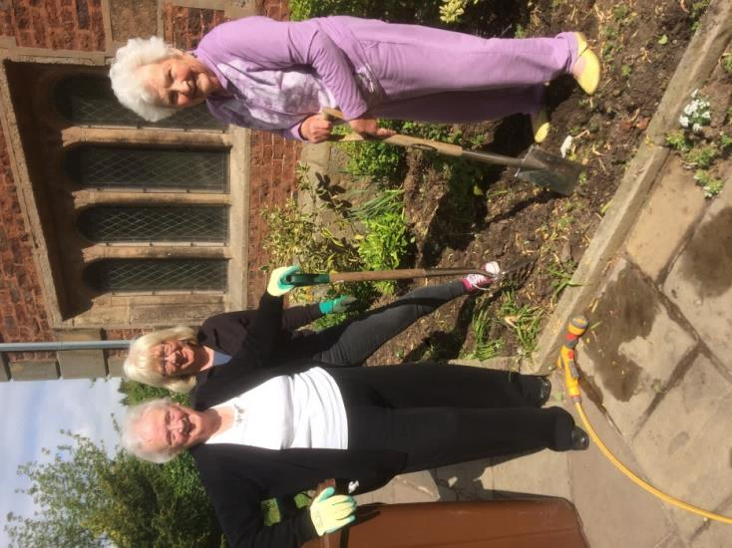

**Just before the project started…**

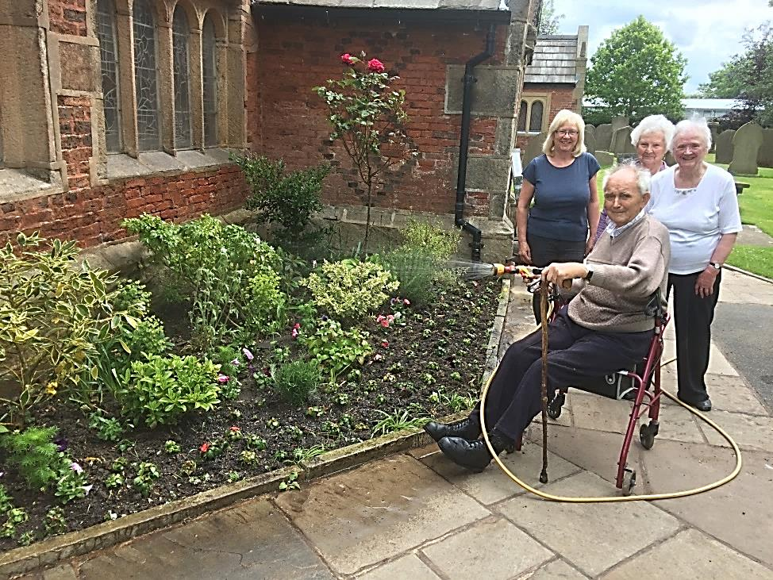

**A border full of promise…**

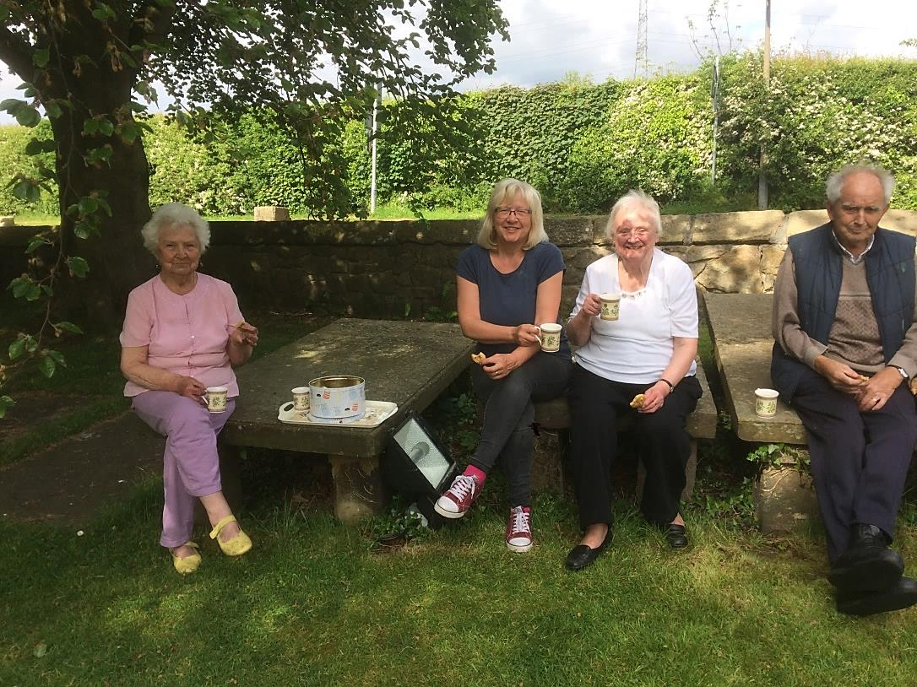**…and a well-earned cuppa to show for all the hard work!**

~~~~

**From the Parish Registers**

**Holy Baptism**

**“We welcome into the Lord’s Family”**

Ronnie Arthur Davidson was baptised on 5th May.

Billie Jane Curley was baptised on 19th May.

~~~~

**From the Register of Services**

|  |  |  |  |  |
| --- | --- | --- | --- | --- |
| Date |  | Attendance | Communicants | Amount |
| Easter: April | 21st | 213 | 160 | £542.48 |
|  | 28th | 69 | 21 | £282.50 |
| May | 5th | 60 | 59 | £298.00 |
|  | 12th | 76 | 22 | £243.55 |
|  | 19th | 64 | 60 | £209.69 |

Standing Order donations in lieu of donating via the envelope system for May: £631.50. Donations from Baptisms and Funerals: £133.72.



**TOTAL TO DATE** (23rd May 2019)

£495.35 (with gift aid £569.99)

There are possibly a few more donations yet to come in, final total available on or shortly after 31st May 2019.

Many thanks, everyone.

Barbara

~~~~

**FOMO Malawi**

Friends of Mulanje Orphans, (Malawi)

UK Charity No 1090727

**A PLEA ON BEHALF OF FOMO**

*We are repeating this article in case you missed it last month.*

As you know we (the PCC on your behalf) support FOMO as part of our regular charitable giving.  However, the Malawi people have suffered grievous flooding causing a great amount of suffering resulting in loss of life, crops, homes and basic household equipment.  You will more than likely have received an email from me with the latest FOMO newsletter attached to it – this will provide you with some background on what they have achieved and what they hope to achieve despite these setbacks.

Because of this recent natural disaster in the region, FOMO are looking to send out a container soon and a plea will go out for donations of various items of need which you may have hanging around your home and no longer really need.  Watch out for further details to follow.

In the meantime, they desperately, desperately need blankets.  Each blanket costs £3. Are you able to add an extra £3 to one of your weekly donations to church during the month of May?  If so, just mark the envelope FOMO and put it on the collection plate.

I will make sure it is passed onto Mary Woodworth who is not only a member of our choir, but one of the leading lights of the FOMO organisation (her husband Keith being the other).

Many thanks in anticipation.

Barbara Wood – Treasurer to the PCC

**HYMN OF THE MONTH**

**MAKE ME A CHANNEL OF YOUR PEACE**

**Words and music: Sebastian Temple**

**Hymn No. 437**

**Make me a channel of your peace**

**Where there is hatred, let me bring your love**

**Where there is injury, your pardon Lord**

**And where there’s doubt, true faith in you.**

This hymn, written by Sebastian Temple, is based on the words of the “Peace Prayer of St. Francis”, and was found written on the back of a holy card during the First World War. It was then published in a French devotional bulletin called La Clochette (The Little Bell) in 1912 as a prayer for peace. Mother Teresa and Archbishop Desmond Tutu made it an integral part of their daily morning prayers. It has been quoted many times, for instance Pope John Paul II used it to address the United Nations in 1995 and President Clinton repeated it in his welcoming speech, and in the first Rambo movie a priest blesses Sylvester Stallone in the words of the prayer.

I think the whole world should be thinking of peace and maybe if we all think a little about “Thy Kingdom Come” and all religions try to end this violence and follow God instead of the ways of the devil.

In a letter written to the author of “The Daily Telegraph Book of Hymns”, Sebastian Temple is quoted as saying “I tried for a whole morning but nothing came. Finally I was disgusted with myself, looked at the little statue of St. Francis on my shelf and said ‘Well, if you want to write it, YOU do it. I can’t’. I got up, went to the kitchen, made a cup of tea and drank it. When I returned to my guitar I picked it up and started playing and the song fell out of my mouth”.

St. Francis of Assisi was well known for his generosity towards man and beast. He tamed the wolf that terrorised the city of Gubbio; he was known to talk to the birds. He also said “While you are proclaiming peace with your lips, be careful to have it even more fully in your heart.” It was also the self-imposed task of St. Francis to quell all of the discord in the world and it was his request to God that He makes us a channel of His peace. St. Claire of Assisi and the Rev’d Derek Baines are among many servants and followers of the Order of St. Francis of Assisi.

**Make me a channel of your peace**

**It is in pardoning that we are pardoned.**

**In giving of ourselves that we receive**

**And in dying that we’re born to eternal life.**

This hymn is often sung at the Royal British Legion’s annual Service of Remembrance held in the Royal Albert Hall and is a straightforward request to God that should be made by everyone:

“Make me a channel of your peace.

Where there is hatred, let me bring your love”.

**Bill Carr, Church Warden Emeritus**

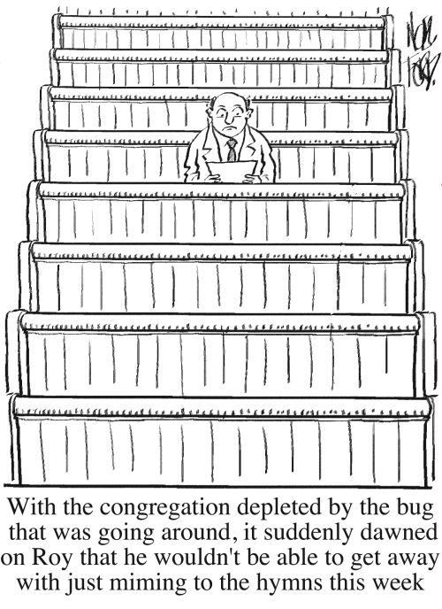

**Our Prayer Circle**

As Christians we know that one of the main things that Jesus taught us was the words of The Lord’s Prayer and very often in the Bible we are told that He went to a quiet place and prayed.  Our hymns tell us to “Take it to the Lord in prayer” and that “the voice of prayer is never silent”.  There is no doubt of the need for prayer  for our own spiritual needs as well as the knowledge of the comfort and support that it gives to both the person praying and the people being prayed for.

To that end we have set up a Prayer Circle at St Michael’s.... ‘What’s one of those then?’ you may ask.  It is simply a group of people who when called upon will pray at home separately and quietly for whatever you ask.

If you have a concern of any sort that you want us to pray for all you need to do is to ring any of the numbers and simply say what or who is in need of prayer, and whilst a minimum of explanation might be an advantage for us to focus the prayer,

you don’t even have to say who you are! The person taking

the call will pass it round the circle and you will know that we, on behalf of the church, are taking your worry to the Lord. If you would like your particular concern added into the intercessions on a Sunday morning then we can do that too.

We are happy to welcome others into the circle, just let us know and you will be added on.

Prayer is an essential part of our Christian life to keep us walking in the footsteps of our Saviour... so... the lines are open right now, we are waiting to take your call which is very important to us because it matters to you... just ring and your prayer will be increased seven-fold (at least).

Our circle consists of Ted (01772 617002), Margaret (01772 379219), Carole Bamber (01772 610670 or mobile 07989 145963), Gill Slinger (07729 121248), Barbara Wood (07745 208617) and Bill Carr (01772 615321).

*Ted, Margaret, Carole, Gill, Barbara and Bill*

**St James the Least of All**

*Parish Pump Editor: The Rev Dr Gary Bowness continues his tongue-in-cheek letters from ‘Uncle Eustace’…*

**Beware the summer strawberry tea**

The Rectory

St James the Least

My dear Nephew Darren

Never, ever feel aggrieved that your summer strawberry tea has to be held in the church hall rather than on a lawn, since there is hardly a single blade of grass to be found in your entire parish. You have no idea of the potential calamities you are avoiding.

Here, during the previous week, the organisers will be desperately asking the opinion of local farmers about the weather. In doing so, they forget that for the farming community, it is always the wrong sort of weather anyway. I once received a heartfelt plea from the staff at Heathrow Airport for our ladies to stop calling them at hourly intervals to find out if hurricanes may be imminent.

Naturally, the day will start out warm and sunny and so all the tables will be arranged on the vicarage lawn. By 10am, tablecloths will have been laid. By 10.10am, a brisk breeze will have sprung up and someone will be delegated to retrieve them all from deep within the nettle patch. By 11am, clouds will gather, and a decision will be made to transfer everything into the church hall. Once that is completed, just when it is almost too late to change, the sun will re-emerge and there will be a frantic dash to put everything back on the lawn. This ensures that by 2pm when teas start, the ladies will already be in a state of collapse.

Last year, the Dowager Duchess of Trilby graced us with her presence. As she sat with her entourage, elegantly sipping tea under a giant parasol over the table, the thing – equally elegantly – closed around her, leaving her looking like one of those unfortunate insects trapped by a carnivorous plant. To emerge from its depths looking entirely unflustered was beyond even her social skills.

Fortunately, attention was diverted from her predicament by the wife of one of our farmers. This substantial lady had been sitting in a chair with slightly too thin legs for the damp lawn. The rear two slowly sank into the grass, eventually catapulting the dear lady backwards into the lap of the local mayor. Disentangling red flannelette from mayoral chains took some time, and delicacy.

At least when I have had enough, the lawn can be cleared in minutes by drawing the raffle. The moment the last plastic shower cap and set of Christmas doilies has been awarded, there will be a dash to get home, giving my dog the opportunity to retrieve remnants of cream cakes from the flower beds.

Your loving uncle,

Eustace

**Sudoku - Medium**

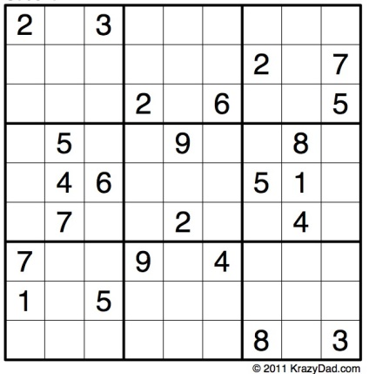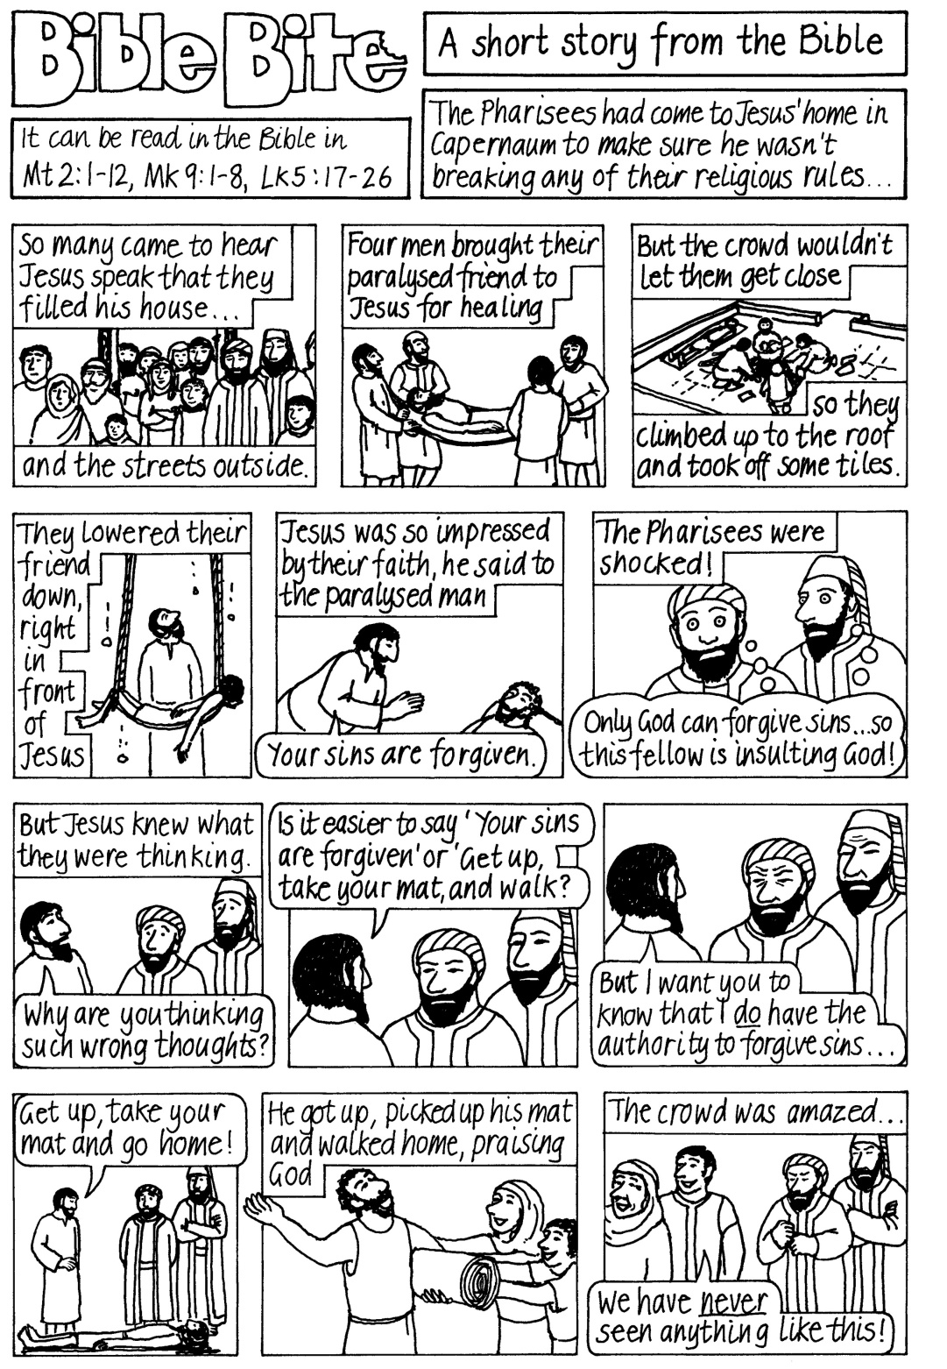

**Bible Bites Word Search**

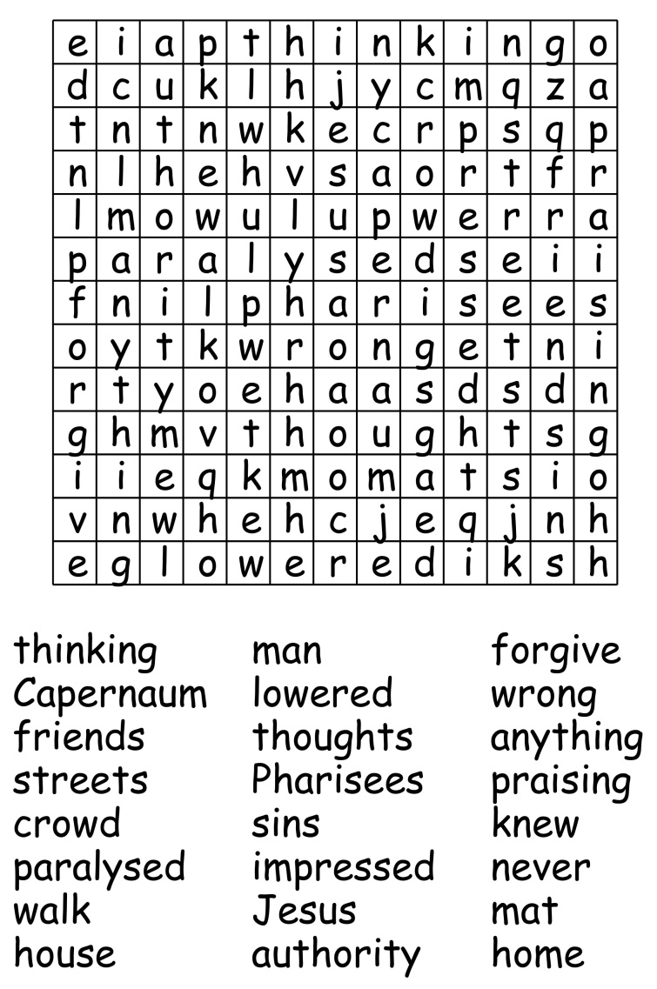



**Peace between neighbours**

Peace between neighbours near,

Peace between kindred here,

Peace between lovers dear,

In the love of the King of us all.

Peace man with man abide,

Peace man to wife allied,

Mother and bairns to guide,

And peace of the Christ above all.

Bless, O Christ, bless my face,

My face bless every face,

Christ, bless mine eye with grace,

Mine eye give a blessing to all.

*From Poems of the Western Highlanders*

~~~~

**Right Wright**

A student called ‘Wright’, so they say

Wrote ‘right’ in a wrong kind of way

His teacher, inflamed,

And loudly exclaimed

“Right Wright, write ‘right’ right, right away!”

*By Nigel Beeton*

~~~~

**A picture to colour in – Trinity Joy**



CHURCH ROTAS FOR JUNE

**Flower Arrangers**

Date Arranger(s) Sponsor(s):

June 2nd Lisa Mrs Bracewell

9th Althea & Elsie Mrs Bowker

16th Pearl & Claire Mrs J Gleave

23rd Julie Mrs Blakeley

30th Jean & Sue Mrs J Aughton

July 7th Althea & Lesley Mrs A Slater

~~~~

**Tea/Coffee Rota following our 10.30 Service**

June 2nd Erika

9th Beryl & Rona

16th Pauline & Barbara

23rd Carole & Gill

30th Beryl & Rona

July 7th Pauline & Barbara

If you’re not available on the date allocated or wish to change the date assigned to you, please find a replacement or arrange a swap.

*We’re rather short of helpers, so if you feel you could give an hour at this service every few weeks, have a word with Erika or call on 613816.*

~~~~

**Sidespersons’ Rota**

June 2nd 9.00 John Simpson

10.30 Jean Aughton and Churchwarden

9th 9.00 Mike Redshaw

10.30 Norman Skellorn, Tom Wignall and Geoff Demack

16th 9.00 Ken Bishop

10.30 Bill Carr, Scott Eckersley and Beryl Blakeley

23rd 9.00 Rob McMurray

10.30 Ted Hopkins and Robert Hawthornthwaite

30th 9.00 Jeremy Leigh

10.30 Norman Skellorn, Tom Wignall and Geoff Demack

July 7th 9.00 John Simpson

10.30 Jean Aughton and Churchwarden

**Readers’ Rota**

*If you cannot read as specified on this rota, please find a substitute and inform a churchwarden of any changes.*

June 2nd 9.00 Mike Redshaw

10.30 Margaret Kirkman and Jean Dewhurst

June 9th 9.00 Peter Templeman

10.30 Jane Elphick and Ted Hopkins

June 16th 9.00 Jock Davidson

10.30 Emma Cairns and Lillie Eaves-Holmes

June 23rd 9.00 Peter Templeman

10.30 Margaret Kirkman and Scott Eckersley

June 30th 9.00 Kathleen Leigh

10.30 Carole Bamber and Jean Dewhurst

July 7th 9.00 Mike Redshaw

10.30 Barbara Wood and Gill Slinger

Peter Templeman will contact each reader by email by the preceding Tuesday. Please will readers ensure Peter has their contact email.

