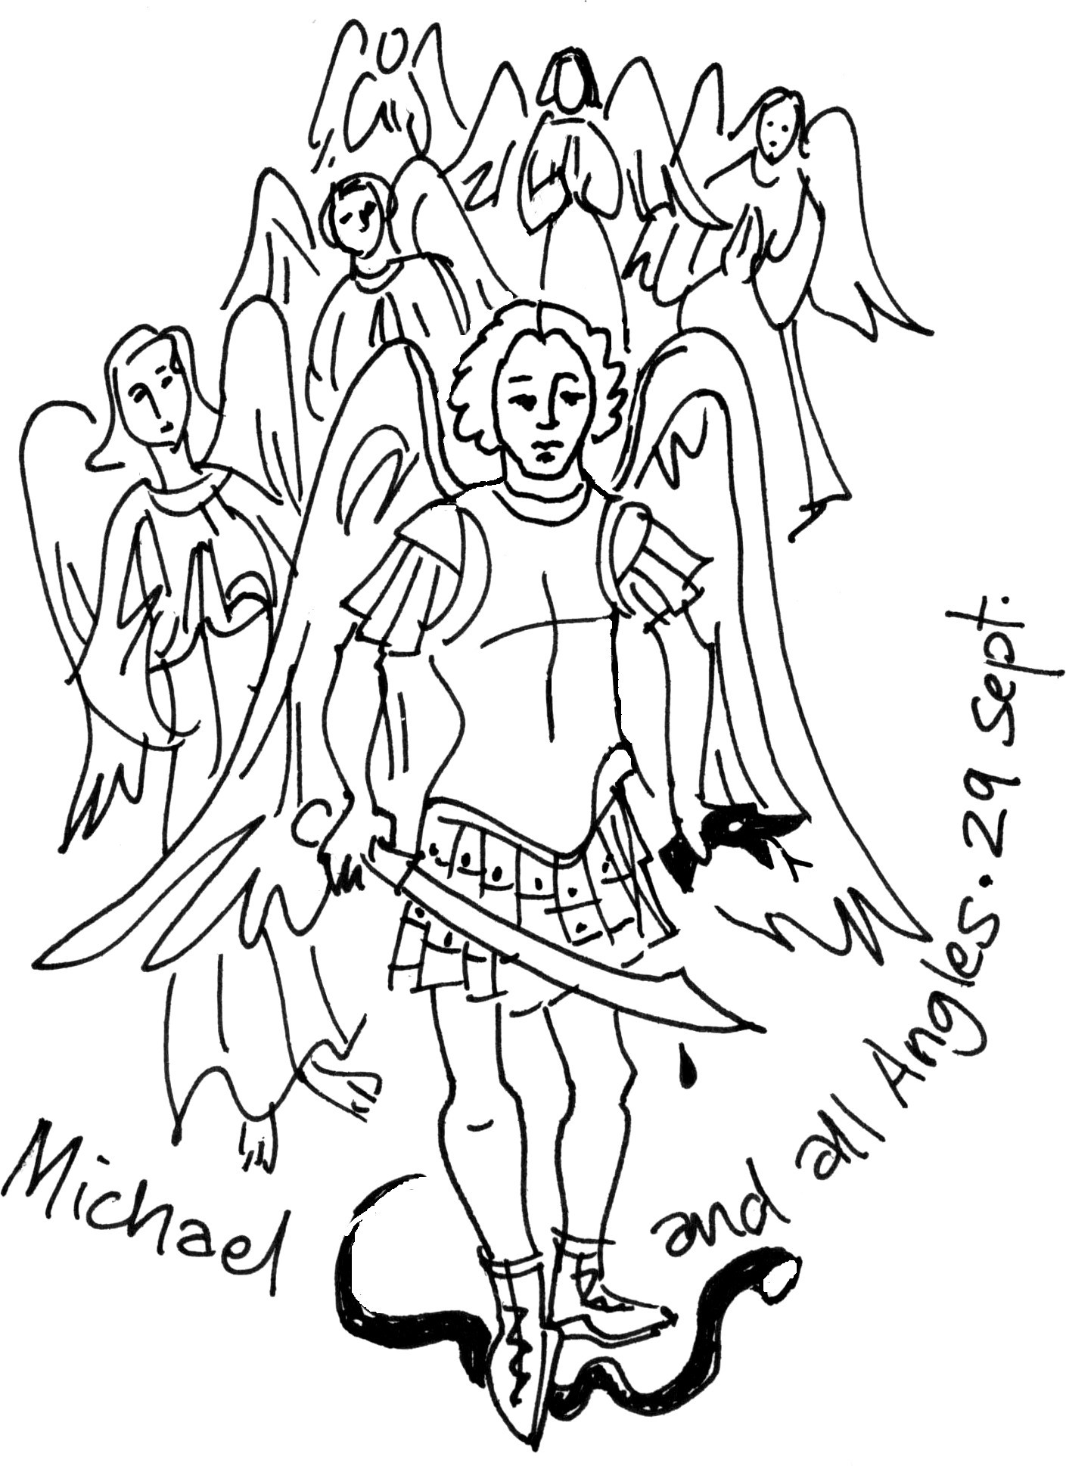

CHURCH OFFICERS
Rector: The Reverend Ann Templeman
The Rectory, 69 Liverpool Road, Much Hoole, PR4 4RB
Tel: 01772 448515 and mob: 07877 659156; E: anntempleman@live.co.uk
Associate Minister: The Reverend Peter Templeman
Churchwarden:
Mr Jock Davidson – Tel: 617918; E: sgtmajor@talktalk.net
Occasional Preacher:
Mrs Margaret Kirkman – Tel: 01772 379219. Mob: 07786543581.
E: margk1946@gmail.com
Reader in Training:
Mr Alan Johnson – Tel: 01704 822179; E: alanmarie55@gmail.com
Churchwarden Emeritus:
Mr William G Carr. Tel: 01772 615321. E: billcarr1935@btinternet.com
PCC Secretary:
Mrs Andrea Susnik – Tel: 615336. E: familysusnik@live.co.uk
PCC Treasurer:
Mrs Barbara Wood – Tel: 617679. E: bw12252@sky.com
Deanery Synod Representatives: Mrs Jane Elphick, Mrs Jean Dewhurst and Mrs Kathleen Leigh.
Parish Safeguarding Officer: Mrs Jean Dewhurst, Tel: 616106.
Magazine Editor
Mrs Erika Penrose – Tel: 613816. E: jandepenrose@btinternet.com
Magazine Secretary:
Mrs Elsie Kirkham – Tel: 615832.
Magazine Advert Co-ordinator:
Position vacant
Flower Secretaries:
Mrs Lisa Redshaw – Tel 614428 and Mrs Pearl Read – Tel: 614367.
Electoral Roll Officers:
Mrs Jean Dewhurst, Tel: 616106 and Mrs Jane Elphick, Tel: 601495.
Verger: Mrs Irene Pickles – Tel: 615708
Assistant Verger: Mr Stuart Tighe – Tel: 612963
Weekly Giving Envelopes: Please contact the Treasurer or Churchwarden.
Parish Administrator: Mrs Amanda Gibson – Tel: 07735 961620.
ORGANISATIONS
Sunday School
Sunday School – St Michael’s Club – begins at 10.30 in church and usually happens every Sunday.
Leader: Mrs Kathleen Leigh – Tel: 612196. Email: katleigh@live.co.uk
Hoole Church Ladies’ Group – meets 7.30pm, 3rd Tuesday, in School. Leader: Mrs Erika Penrose.
Tel: 613816. E: jandepenrose@btinternet.com
St Michael’s Men’s Fellowship – meets 7.30pm, 2nd Tuesday, in Hoole Village Memorial Hall.
Secretary: Mr Stuart Tighe – Tel: 612963.
Friends of St Michael – Caring for the fabric of our ancient church.
Chair: Mrs Jane Elphick, Tel: 601495.
Secretary: Mr David Turner, Tel: 01772 383344.
Social Committee – Contact: Mrs Sheila Taylor, Tel: 616850
Hoole St Michael C E Primary School
Head Teacher: Mrs Juliet Price – Tel: 613219.
1st St. Michael’s Hoole Scout & Guide Groups – Contact:
Rebecca Catterall
Church Website: http://www.hooleparishchurch.com.

Please note: All adverts are at the back of the magazine.
Church Rotas are on pages 26& 27.

Do take a look at our church website – http://www.hooleparishchurch.com

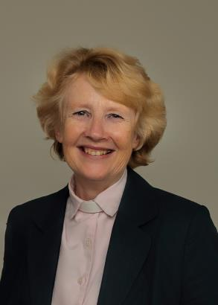
From the Rectory
‘The Fruit of the spirit is love, Joy, peace, forbearance, kindness, goodness, faithfulness, gentleness and self-control’ Gal 5 v 22, 23
Dear all
One of the many bonuses of living in Hoole is the proximity to the Lake District. Perhaps the most dramatic place is Striding Edge on Helvellyn. It’s seriously terrifying as many of you will know – this narrow craggy path is perched right on top of the mountain with sheer drops both sides. Striding Edge is also a vivid natural picture of the Christian path.
In June Bishop Jill confirmed four young people from St Michael's. She laid hands on them and said to each individually the powerful and beautiful words from the Bible "God has called you by name and made you his own" and we all prayed for the strengthening power of the Holy Spirit to come upon them to help them live out their Christian life. Being a Christian is not easy – Paul tells us to ‘walk by the Spirit’ and in his letter to the Galatians chapter 5, spells out what that means. Being a Christian is like walking on Striding Edge, it’s a challenge; it is easy to slip off either by simply going through the motions of faith e.g. going to church on Sundays purely out of habit and saying prayers without meaning them or alternatively thinking that what you do doesn’t matter at all. So Paul tells us what it looks like to walk by the Spirit and how God wants to grow in us the fruit of the Spirit.
‘The Fruit of the spirit is love, joy, peace, forbearance, kindness, goodness, faithfulness, gentleness and self-control’.
There is a fruit called the cherimoya which is found in South America. It is one fruit but it has many flavours – banana, pineapple, papaya, peach, mango and strawberry. Isn’t that brilliant? Well, as Christians we are to be like that fruit. There is one fruit of the Spirit but it has nine flavours: love, joy, peace, forbearance, patience, kindness, faithfulness, gentleness and self-control. These are qualities which do not grow quickly or easily – each requires tending and careful pruning.
Let me take just one now: peace. Peace seems to go with this time of the year: August is traditionally a holiday month; families often go away and everything back home seems much quieter – time to be still, to pray, to read, to think about faith and gear up for the renewed activity of September.
Peace is urgently needed in our society – so many people of all ages are on medication for anxiety – and Jesus promises peace: peace that the world cannot give. Jesus's peace does not take away the problems and uncertainties we face today but it does put them in perspective – the dramatically different perspective of heaven and eternity.
So whether you are a new Christian or have just been confirmed or whether you have tried to follow Jesus all your life, you have in these verses from Galatians 5 a wonderful picture of the qualities Jesus wants to grow in your life. If you want to know how you are getting on try putting your name before the verse: ‘Jemima is loving, joyful, peaceful, patient etc’. You are bound to wince – we all have a long way to go. Or try asking your nearest and dearest which flavour you should work on – they will be happy to tell you!!
Ann Templeman (Rector) August 2019
~~~~

GOING DEEPER – GROWTH GROUPS
No relationship remains static and communication is the key to ensuring relationships flourish. That is true of all our human relationships and it is equally true of our relationship with God. The Bible is the chief way he speaks to us and prayer the chief way we speak to him.
So let me encourage you to join one of our Growth groups (another name for Bible study or Housegroups) this autumn which are regarded as one of the best ways to grow in faith. We are planning four fortnightly sessions in Sept and October on Mondays and Tuesdays. We will be using a course called God’s Big Picture which gives a broad brush insight into the themes of the whole Bible beginning with the book of Genesis. It assumes no prior knowledge and is accessible for everyone. Each session (lasting about an hour with refreshments) will begin with a 10min clip given by a gifted Bible teacher and then there will be questions and discussion. There is no pressure to join in the discussion unless you wish to.
After a break we will have a short series on preparing for Christmas; we will look at some of the key Bible passages about the coming of Jesus into our world.
We hope to make one session geared to those who have little or no experience of Bible study. It would be very helpful if you could let me know if you see yourself in this category and when you are available.
Please see dates list for full dates of Growth groups.
~~~~
ST MICHAEL AND ALL ANGELS CHURCH, HOOLE
SUNDAY SCHOOL – Michael’s Club for children (ages 3 to 12), usually every Sunday during the 10.30 service.
10.30am – Starts in church; children leave for their own teaching in the school after a children’s song and return after the sermon and prayers.

Parish Diary from 11th August to 13th October
Sunday 11th August 09.00 Holy Communion (Book of Common Prayer)
10.30 Morning Worship
Tuesday 13th August 10.15 Holy Communion (said)
Sunday 18th August 09.00 Holy Communion (Book of Common Prayer)
10.30 Parish Communion
Tuesday 20th August 09.15 Holy Communion (said)
7.30 Ladies’ Group meeting in School: SEE PAGE 8
Sunday 25th August 09.00 Holy Communion (Book of Common Prayer)
10.30 Morning Worship
12.00 Baptism of Arthur John Cairns
Tuesday 27th August 10.15 Holy Communion (said)
Sunday 1st Sept 09.00 Holy Communion (Book of Common Prayer)
10.30 Parish Communion with Sunday School
SUNDAY SCHOOL STARTS UP & SUNDAY SCHOOL TEACHERS ARE COMMISSIONED
4.00 Holy Communion at Old Mill Court
Monday 2nd Sept 7.30 Growth Group at the Rectory (= Bible study/Housegroup):
GOD’S BIG PICTURE SESSION 1
Tuesday 3rd Sept 10.15 Holy Communion (said)
Sunday 8th Sept 09.00 Holy Communion (Book of Common Prayer)
10.30 Morning Worship with Sunday School
Monday 9th Sept 7.30 PCC meets at the Rectory
Tuesday 10th Sept 10.15 Holy Communion (said)
7.30 Men’s Fellowship meeting at Much Hoole Village Hall
7.30 Growth Group at the Rectory:
GOD’S BIG PICTURE SESSION 1
Saturday 14th Sept 09.00 Holy Communion (Book of Common Prayer)
10.30 Parish Communion
12.00 Wedding of Katie Tyrer and Jonathan Whittle
Sunday 15th Sept 3.45 FARM FAMILY CHURCH AT VILLAGE HALL
Monday 16th Sept 7.30 Growth Group at the Rectory:
GOD’S BIG PICTURE SESSION 2
Tuesday 17th Sept 10.15 Holy Communion (said)
7.30 Ladies’ Group meeting at Hoole Village Hall
Sunday 22nd Sept 09.00 Holy Communion (Book of Common Prayer)
10.30 Morning Worship with Sunday School
Tuesday 24th Sept 10.15 Holy Communion (said)
7.30 Growth Group at the Rectory:
GOD’S BIG PICTURE SESSION 2
Friday 27th Sept 7.00 Harvest Supper in Village Hall
Sunday 29th Sept 09.00 Holy Communion (Book of Common Prayer)
10.30 Parish Communion with Sunday School
Monday 30th Sept 7.30 Growth Group at the Rectory:
GOD’S BIG PICTURE SESSION 3
Tuesday 1st October 10.15 Holy Communion (said)
Friday 4th October St Michael’s School Harvest Festival
Sunday 6th October 09.00 Holy Communion (Book of Common Prayer)
10.30 HARVEST FESTIVAL
4.00 Holy Communion at Old Mill Court
Tuesday 8th October 10.15 Holy Communion (said)
7.30 Growth Group at the Rectory:
GOD’S BIG PICTURE SESSION 3
Sunday 13th October 09.00 Holy Communion (Book of Common Prayer)
10.30 Morning Worship
3.45 SUPERHEROES’ FAMILY CHURCH IN ST MICHAEL’S SCHOOL

KEY FUTURE DATES
- FARM FAMILY CHURCH
Sunday 15th September at 3.45pm in the Village Hall

- HARVEST SUPPER
Friday 27th September at 7.00 for 7.30pm in the Village Hall

- ST MICHAEL’S SCHOOL HARVEST FESTIVAL

- HARVEST FESTIVAL
Sunday 6th October

- SUPERHEROES FAMILY CHURCH
Sunday 13th October at 3.45pm in St Michael’s School

Intercessions: Please let the Rector or Margaret Kirkman know of anyone you would like including on our prayer list, by text or 07786 543581.

St Michael’s Harvest Supper & Quiz Night
Friday 27th September at 7.00pm at
HOOLE VILLAGE HALL

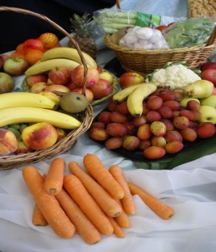

We hope that people of all ages will want to join us for our Harvest social event. The Quiz questions will be wide-ranging and include as many different interests as possible. Why not make up a table?

Tickets are £7.00 each and include delicious Hotpot and mushy peas followed by fruit pie and cream. Tea & coffee are included and the bar will be open to purchase alcohol and soft drinks.
Please book your tickets with Sheila Taylor on 616850 or at Church on Sunday morning or call the Rector on 448515 a.s.a.p., as numbers are limited.

ALL WELCOME

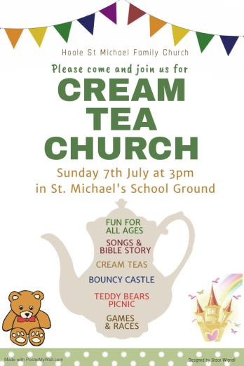
Cream Tea Church
Cream Tea church was a great success - a huge thank you to everyone who helped. It was a glorious day and the setting on the school field was perfect. Over 100 people of all ages enjoyed the various activities which included a bouncy castle, fun races, teddy bear activities, and of course Cream Teas. There was a short outdoor service with joyful family hymns like “He has the whole world in his hands” and in the aftermath of the Champions League Cup the talk had a football theme – 'Whether at home or away we aim to please the Lord!'
~~~~
Ladies’ Group
We hope all our members enjoyed the July break and your holidays, if you were able to get away.
We are looking forward to our August meeting, on Tuesday 20th August at 7.30pm, when David Tomlinson from Warburton’s Bakery is coming along to talk about “The Staff of Life”. This is an Open Evening when we hope members will bring along friends and relations who have previously not sampled what we have to offer – or indeed have come along before! This meeting will be our last at St Michael’s School and we look forward to seeing everyone.
Please note that our September meeting will move to our new venue, Hoole Village Hall – starting at the same time of 7.30pm.
Erika
CHURCH OPENING TIMES
St Michael’s Church will now be open every day. Opening times are:
Monday to Saturday inclusive: 9.30am to 4.30pm.
Sunday: 8.00am to 4.30pm.
Jock Davidson, Churchwarden

From the Parish Registers
Holy Baptism
“We welcome into the Lord’s Family”
Joshua James John Bradley was baptised on 30th June.
Jake Robert Fitzell and Max Harry Fitzell were baptised on 14th July.
Funerals
We give thanks for the life of John Harrison, aged 91 years, of Longton. Interment of ashes took place on 25th June in the churchyard.
We give thanks for the life of Robert Henry (Harry) Sutton, aged 80 years, of Little Hoole whose funeral took place on 1st July. Interment took place in the churchyard.
We give thanks for the life of Catherine Heywood, aged 89 years, of Lostock Hall. Interment of ashes took place on 4th July in the churchyard.
We give thanks for the life of Freda Webb, aged, 82 years, of Penwortham, whose funeral took place on 8th July. Interment took place in the churchyard.
We give thanks for the life of Thomas Wignall, aged 89 years, of Much Hoole, whose funeral took place on 19th July. Interment took place in the churchyard.
We give thanks for the life of Ada Butler, aged 95 years, formerly of Hutton, whose funeral took place on 31st July. Interment followed in the churchyard.
~~~~
From the Register of Services
Date |  | Attendance | Communicants | Amount
June | 23rd | 65 | 26 | £307.02
 | 30th | 73 | 63 | £229.75
July | 7th | 177 | 63 | £268.85
The attendance on July 7th includes the Cream Tea Church collection
 | 14th | 70 | 29 | £343.30
The attendance on July 14th includes the Family Church collection
 | 21st | 81 | 72 | £260.65
 | 28th | 82 | 23 | £282.25
Standing Order donations in lieu of donating via the envelope system for July: £631.50. Donations from Baptisms: £112.58. Donations from Funerals: £45.80.
PARISH JOB OPPORTUNITY
Advertisement Co-ordinator
We need a volunteer for the above. Margaret Clark, who has taken on this role for the past few years, has recently resigned after having done a sterling job.
Ideally, I don’t really want the job back again so… if you have basic Word and Excel skills you could do this.
Training will be provided and full support throughout.
Brief Job Description:
- It is a once a year activity on or around October/November of each year.
- It involves contacting all the advertisers in the magazine inviting them to renew plus follow up as necessary
- Collate the payments that come in/liaise with the treasurer for BACs payments
- Late Nov/early December, check and edit the adverts and forward them to the printer (details will be available) to be included in the January Magazine.
- Do a bit of marketing to find new advertisers if we have any blanks.
- Keep a record of all the advertisers and relevant details.

Many thanks.
Barbara Wood
Treasurer
Tel: 617679. Email: bw12252@sky.com

~~~~

WATER AID LAUNCH 2019-2020
Another Year Starts…Harvest 2019 through to Easter 2020.
For those of you who may be new readers or new church attendees this is the background:
For well over 10 years now our Church has been collecting for this charity – we save our loose change in empty jam jars (or any type of jar really – we don’t mind). Some people fill one jar, others fill multiple jars. You choose.
It is really, really easy – pick up a jar AND FILL IT with your loose change. You won’t miss it – I promise.
You will find empty jars with the Water Aid label on in various places in Church - at the end of your pew, in the porch or at the back of Church beside the font – depending on what is going on in Church that week. Or you can provide your own and pick up a Water Aid label and Gift Aid Form available in Church, probably in the box of jars in the porch.
If you are a tax payer, please complete the Water Aid Gift Aid declaration form to be found in the jar.
If you have filled in one before, please can you indicate this as it will be on record.
If you are not a tax payer, please remove the form or leave it blank.
When your jar is full, bring it into Church and hand it to our trusty churchwarden or sidesperson who will pass it to me and I will make sure it gets to the volunteer(s) who are doing the counting this year. Alternatively, you can leave your jar on the seat behind the font on a Sunday morning and it will be collected that same afternoon.
If you are at Church on Harvest Sunday – then do please consider picking up a jar there and then.
If you are not, the jars will be around for some considerable time for you to pick up at your leisure.
Many, many thanks in anticipation.
Barbara Wood (Treasurer)

Make your donation worth more with Gift Aid
so it can do more
From the Water Aid Website…
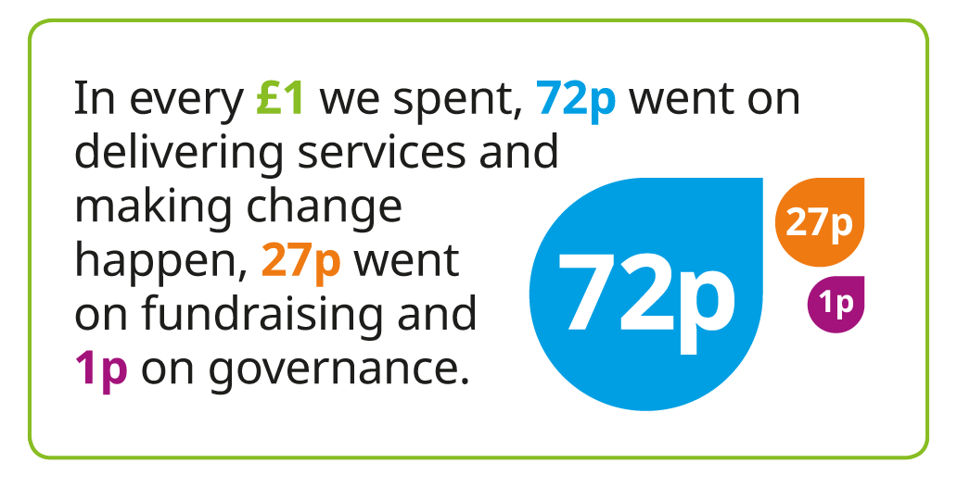

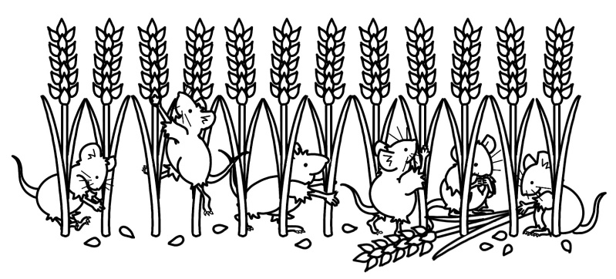

HYMN OF THE MONTH
BE STILL FOR THE PRESENCE OF THE LORD
Words and Music: David J. Evans
Hymn No. 67

This is a fairly modern hymn, written by David Evans in 1985. David’s father was in the army, so as a child he would move from place to place as his father travelled the world. But this hymn is asking us to do the opposite. It is asking us to be still and is ideal to take us into a mood of deep thought and reflection.

Be still, for the presence of the Lord, The Holy one is here.
Come, bow before Him now, with reverence and fear.
In Him no sin is found, we stand on Holy ground.
Be still, for the presence of the Lord, the Holy one, is here.

It is a hymn of three verses, each verse takes us on a different journey, the first verse invites us to stand still, stop what we are doing, take in who we are, and to ask what is really our purpose in this life of hustle and bustle, and to think about our life with God and let the pressures of life fall from us.

Be still, for the glory of the Lord is shining all around.
He burns with holy fire, with splendour He is crowned.
How awesome is the sight, our radiant King of light!
Be still for the glory of the Lord is shining all around.

This means that whilst standing still we will experience the full glory and the warmth and splendour of the Lord which is shining all around. What a wonderful feeling.

Be still, for the power of the Lord is moving in this place,
He comes to cleanse and heal, to minister His grace.
No work too hard for Him, in faith receive from Him.
Be still for the power of the Lord is moving in this place.

This makes me feel that God is with me, helping me with everything I do and with every decision I make. Sometimes I don’t listen and I get it wrong. When I sing this hymn I actually feel that God is there beside me, helping me overcome all the difficulties that life throws at me.
Bill Carr, Church Warden Emeritus

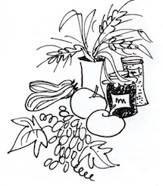
Our Prayer Circle
As Christians we know that one of the main things that Jesus taught us was the words of The Lord’s Prayer and very often in the Bible we are told that He went to a quiet place and prayed. Our hymns tell us to “Take it to the Lord in prayer” and that “the voice of prayer is never silent”. There is no doubt of the need for prayer for our own spiritual needs as well as the knowledge of the comfort and support that it gives to both the person praying and the people being prayed for.
To that end we have set up a Prayer Circle at St Michael’s.... ‘What’s one of those then?’ you may ask. It is simply a group of people who when called upon will pray at home separately and quietly for whatever you ask.
If you have a concern of any sort that you want us to pray for all you need to do is to ring any of the numbers and simply say what or who is in need of prayer, and whilst a minimum of explanation might be an advantage for us to focus the prayer, ou don’t even have to say who you are! The person taking the call will pass it round the circle and you will know that we, on behalf of the church, are taking your worry to the Lord. If you would like your particular concern added into the intercessions on a Sunday morning then we can do that too.
We are happy to welcome others into the circle, just let us know and you will be added on.
Prayer is an essential part of our Christian life to keep us walking in the footsteps of our Saviour... so... the lines are open right now, we are waiting to take your call which is very important to us because it matters to you... just ring and your prayer will be increased seven-fold (at least).
Our circle consists of Ted (01772 617002), Margaret (01772 379219), Carole Bamber (01772 610670 or mobile 07989 145963), Gill Slinger (07729 121248), Barbara Wood (07745 208617) and Bill Carr (01772 615321).
Ted, Margaret, Carole, Gill, Barbara and Bill

St James the Least of All
Parish Pump Editor: The Rev Dr Gary Bowness continues his tongue-in-cheek letters from ‘Uncle Eustace’…

On the peculiar stains and smells of old choir robes

The Rectory
St James the Least of All
My dear Nephew Darren
Your withering comments, saying that our choir robes, were ‘surplice’ to requirements did not go down well at last week’s practice. I will concede that Mr Baddeley’s robes smell somewhat kippered and are laced with burns - but you can expect little less from 40 years of enjoying a final cigarette behind a gravestone before the start of Matins.
Certainly, Mr Timmin’s surplice has a strange series of red and blue polka dots, but that is only because he uses his time in the choir stalls, when not singing, to catch up on marking his pupils’ essays. The red gash on Miss Thripp’s surplice may look as if the choirmaster has just stabbed her, but it was only a jam doughnut she ate, just before that wedding five years ago.
Our robes are steeped in history – they have seen their way through the death of Queen Victoria, the relief of Mafeking, and two World Wars.
When one morning Admiral Flagg developed an ostentatious cough, I gave him a cough sweet from the pocket of my own cassock. He later commented that it had a strange taste. Not surprising – it had been in the pocket when I was given the cassock 50 years ago from Canon Ball’s widow after he died.
In an attempt to improve the look of the surplices, Mrs Wigg offered to starch them all. Unfortunately, her enthusiasm is only surpassed by her ineptitude. She worked on the principle that if one packet of starch was good, ten would be better. When the choir arrived the following Sunday, they found twenty surplices standing round the vestry floor looking like a circle of tents at Scout camp.
Once the choir had struggled into them, they had to process up the aisle in single file, as they were all about 6 feet wide. The choir stood rigidly throughout the Service, knowing that any rapid movement risked severing a major artery.
But our style of choir dress has one advantage which yours can never equal. Within our choristers’ voluminous robes, there is ample space for peppermints, packs of cards, the Sunday newspapers and balls of wool and knitting needles. Your music group in their jeans and tee-shirts must feel utterly bereft during the sermon.
Your loving uncle,
Eustace

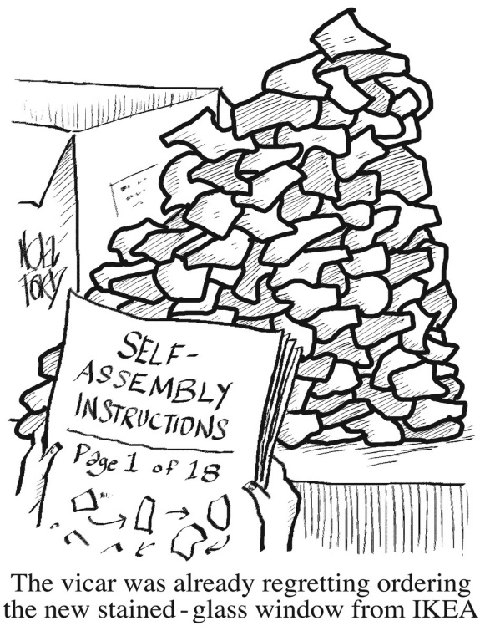
CROSSWORD
Clues
Across
1 ‘A little later someone else saw Peter and said, “You — are one of them”’ (Luke 22:58) (4)
3 Giving (1 Peter 2:5) (8)
9 They came to Jerusalem seeking an infant king (Matthew 2:7) (3,4)
10 ‘An athlete... does not receive the victor’s crown unless he competes according to the — ’ (2 Timothy 2:5) (5)
11 Pacifist, temperance advocate, open-air preacher, leading 20th- century Methodist, Donald — (5)
12 ‘Come quickly to — — , O Lord my Saviour’ (Psalm 38:22) (4,2)
14 ‘The God of Abraham, — — — , the God of our fathers, has glorified his servant Jesus’ (Acts 3:13) (5,3,5)
17 Sear by intense heat (Revelation 16:8) (6)
19 ‘It is better to take refuge in the Lord than to trust — — ’ (Psalm 118:8) (2,3)
22 Goods (Nehemiah 13:15) (5)
23 i.e. train (anag.) (7)
24 Surrounding area (Luke 24:50) (8)
25 ‘Righteousness will be his — and faithfulness the sash round his waist’ (Isaiah 11:5) (4)

Down
1 Elegant and creative (Exodus 31:4) (8)
2 ‘Listen, I tell you a mystery: We will not all — , but we will all be changed’ (1 Corinthians 15:51) (5)
4 ‘I... delight to see how orderly you are and how firm your — — — is’ (Colossians 2:5) (5,2,6)
5 Enlist (2 Samuel 24:2) (5)
6 Of the Muslim faith (7)
7 Sharp intake of breath (Job 11:20) (4)
8 Woven cloth (Ezekiel 16:13) (6)
13 Plentiful (Romans 5:17) (8)
15 CIA char (anag.) (7)
16 Paul and Silas stopped him committing suicide after an earthquake in Philippi (Acts 16:27–28) (6)
18 One of the ingredients in the making of incense for the Lord (Exodus 30:34) (5)
20 Episcopal headwear (5)
21 Inhabitant of, say, Russia, Ukraine, Poland, Slovakia or Bulgaria (4)

ANSWERS:
ACROSS: 1, Also. 3, Offering. 9, The Magi. 10, Rules. 11, Soper. 12, Help me. 14, Isaac and Jacob. 17, Scorch. 19, In man. 22, Loads. 23, Inertia. 24, Vicinity. 25, Belt.

DOWN: 1, Artistic. 2, Sleep. 4, Faith in Christ. 5, Enrol. 6, Islamic. 7, Gasp. 8, Fabric. 13, Abundant. 15, Archaic. 16, Jailer. 18, Resin. 20, Mitre. 21, Slav.

Sept 1st 9.00 Rob McMurray
10.30 Jean Aughton and Churchwarden
8th 9.00 Jeremy Leigh
10.30 Bill Carr, Scott Eckersley and Beryl Blakeley
15th 9.00 John Simpson
10.30 Ted Hopkins and Robert Hawthornthwaite
22nd 9.00 Mike Redshaw
10.30 Norman Skellorn, Geoff Demack and Eunice Houghton
29th 9.00 Ken Bishop
10.30 Bill Carr, Scott Eckersley and Beryl Blakeley
Oct 6th 9.00 Rob McMurray
10.30 Jean Aughton and Colin Brown
Readers’ Rota
If you cannot read as specified on this rota, please find a substitute and inform a churchwarden of any changes.

August 4th 9.00 Ann Templeman
10.30 Emma Cairns and Lillie Eaves-Holmes
11th 9.00 Alan Johnson
10.30 Lynn Smith and Gill Slinger
18th 9.00 Mike Redshaw
10.30 Margaret Kirkman and Jean Dewhurst
25th 9.00 Kathleen Leigh
10.30 Jane Elphick and Ted Hopkins
Sept 1st 9.00 Peter Templeman
10.30 Carole Bamber and Scott Eckersley
8th 9.00 Ann Templeman
10.30 Emma Cairns and Lillie Eaves-Holmes
Peter Templeman will contact each reader by email by the preceding Tuesday. Please will readers ensure Peter has their contact email.

