Welcome to Virtual “Sunday School” for Ascension Day – 21 May 2020
Introduction
Today is Ascension Day. Do you know what ascension means? It means to go up. Today is the day that we remember Jesus going up to heaven, 50 days after Easter.

Story
- Read Acts 1v1-11.
- Watch the video I have produced. It’s at www.hooleparishchurch.com/video
- This is a good story to see visually, so you can watch it here:
https://www.youtube.com/watch?v=UcFw8pLBSIo
Even though Jesus is no longer on earth, the Bible tells us that Jesus still hears us when we pray and his power is as big now as it was then.

Activity
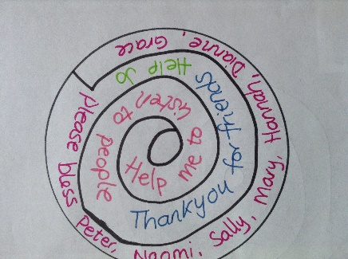
Today’s activity is also our prayer. You may need a bit of help with drawing the spiral.
- Draw round something circular and then draw a spiral inside it. Think about things you would like to pray to Jesus about – things you need help with, things you want to say thank you for, other people who need God’s help or whatever and write or draw them inside the spiral.
- Cut the spiral out and thread a piece of string through the top so that you can hold the thread and the spiral will dangle down (see picture below).
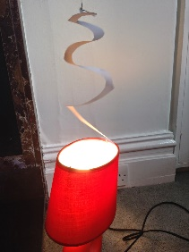
- The spiral will spin slightly as you hold it, but try holding it over a light bulb (not to close) or source of heat, the spiral will spin much more because of the rising of hot air. Even though we can't see the hot air, it is still there, rising up. The movement of the spiral 'rising' or 'ascending' reminds us that, even though we can't see him, Jesus is always with us and hears all our prayers.

Song
Today’s song reminds us that God has always, and will always be with us wherever and whoever we are: https://www.youtube.com/watch?v=qGbSK5zRTtA

Thy Kingdom Come
Following today, we begin the series Thy Kingdom Come encouraging us to pray. This year, there is a Digital Family Prayer Adventure with an app that can be used every day. There is also a podcast for each of the 9 days of Thy Kingdom Come. Why not give them a try? Go to https://www.thykingdomcome.global/resources/digital-family-prayer-adventure-map to find more details.

