PARISH DIARY
nb No Tuesday Holy Communion Services at present.
Sunday August 16th 9.00am. Holy Communion (Book of Common Prayer )
10.30am. Parish Communion with Sunday School.
Sunday August 23rd 9.00am. Holy Communion (Book of Common Prayer )
10.30am. All Age Morning Worship Sunday Sunday August 30th 9.00am. Holy Communion (Book of Common Prayer )
10.30am. Parish Communion with Sunday School.
Sunday Sept. 6th 9.00am. Holy Communion (Book of Common Prayer )
10.30am. Parish Communion with Sunday School.
Monday 7th Sept 7.30pm PCC meeting
Tuesday 8th Sept 7.30pm Bible Study/Growth Group
Sunday Sept. 13th 9.00am. Holy Communion (Book of Common Prayer )
10.30am. Morning Worship with Sunday School.
3.45pm HOGWARTS FAMILY CHURCH IN ST Michael’s church

Sunday Sept 20th 9.00am. Holy Communion (Book of Common Prayer )
10.30am. Parish Communion with Sunday School.

FUTURE DATES
Friday Sept. 25th 7.00pm Harvest Quiz Night in Hoole Village Hall
(if permitted)
Sunday Oct. 4th 10.30am Harvest Festival.
Sunday Nov 1st 4.00pm Service of Thanksgiving for loved ones.
Friday Nov. 6th VE Day Celebration Social in Walmer Bridge
Village Hall (if permitted)
Sunday Nov. 8th 10.00am Remembrance Sunday Service with
Bishop of Blackburn.
Please Note. Our church is open daily throughout the week from
9.30am to 4.30pm for visiting and private prayer.
Our Facebook page: St Michael and All Angels Church, Hoole, our website is www.hooleparishchurch.com

Rector – Revd Ann Templeman anntempleman@live.co.uk 01772 448515
The Rectory, 69 Liverpool Old Road Much Hoole PR4 4RB
Please take this sheet home with you
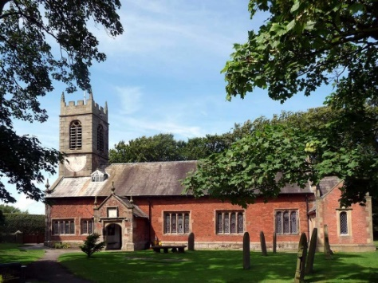
St. Michael and All Angels – Hoole

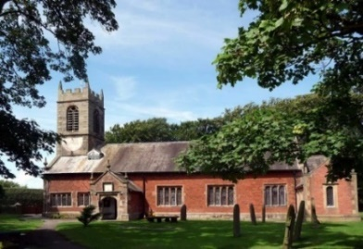

A special welcome to our church again this morning.
Please observe social distancing, but stay close to Christ.

Sunday 9th August 2020 9th Sunday after Trinity.

JESUS’ PRAISE PICNIC

‘Then Jesus declared “I am the bread of life. Whoever comes to Me
will never go hungry.”’ John 6: v 35.

PRAYER OF THE DAY: Gracious Father, revive your Church
in our day, and make her holy, strong and faithful, for your glory’s
sake in Jesus Christ our Lord. Amen.

No Sunday School today during the service
There are toys for younger children
at the back of church.

.

9.00am. Holy Communion (Book of Common Prayer) begins p237

10.30am. Morning Worship (a short said service)

Reading: John 6: v 5-15.

12.00noon. PRAISE PICNIC IN SCHOOL GROUNDS
FAVOURITE HYMNS – CHILDREN’S ACTIVITIES.
Bring your own lunch and something to sit on
FOR ALL THE CHURCH FAMILY
(see larger notice inside)

BIBLE READING: John 6: v 5-15.
When Jesus looked up and saw a great crowd coming towards him, he said to Philip, ‘Where shall we buy bread for these people to eat?’ He asked this only to test him, for he already had in mind what he was going to do.
Philip answered him, ‘It would take more than half a year’s wages to buy enough bread for each one to have a bite!’
Another of his disciples, Andrew, Simon Peter’s brother, spoke up, ‘Here is a boy with five small barley loaves and two small fish, but how far will they go among so many?’
Jesus said, ‘Make the people sit down.’ There was plenty of grass in that place, and they sat down (about five thousand men were there). Jesus then took the loaves, gave thanks, and distributed to those who were seated as much as they wanted. He did the same with the fish.
When they had all had enough to eat, he said to his disciples, ‘Gather the pieces that are left over. Let nothing be wasted.’ So they gathered them and filled twelve baskets with the pieces of the five barley loaves left over by those who had eaten.
After the people saw the sign Jesus performed, they began to say, ‘Surely this is the Prophet who is to come into the world.’ Jesus, knowing that they intended to come and make him king by force, withdrew again to a mountain by himself.

Prayer: We pray for all those suffering physically mentally or economically from the pandemic.
We pray for all who are on holiday at this time and pray for their safety. We pray for who are in special need at this time, we pray for those who are sick and include in our prayers Martin Hesketh, Althea Slater, Beryl Carr, Jane Slinger and Michael Harrison. We pray for the people of Lebanon following the recent disaster in Beirut.

Foodbank: Thanks are due to all who have contributed to the food bank during recent months. Can we urge you to continue with this much needed help. The foodbank is being used much more than before lock down
Suggested Bible readings for this week.
Mon. Aug 10th Matthew 17: v 22-end. The Temple Tax.
Tues. Aug 11th Matthew 18: v 1-5, 10 & 12-14. The Lost Sheep.
Wed. Aug 12th Matthew 18: v 15-20. A brother who sins against you.
Thur. Aug 13th Matthew 18: v 21 to 19: v 1.The Unmerciful Servant.
Fri. Aug 14th Matthew 19: v 3-12. Divorce
Sat. Aug.15th Luke 1: v 46-55. Mary’s Song.

