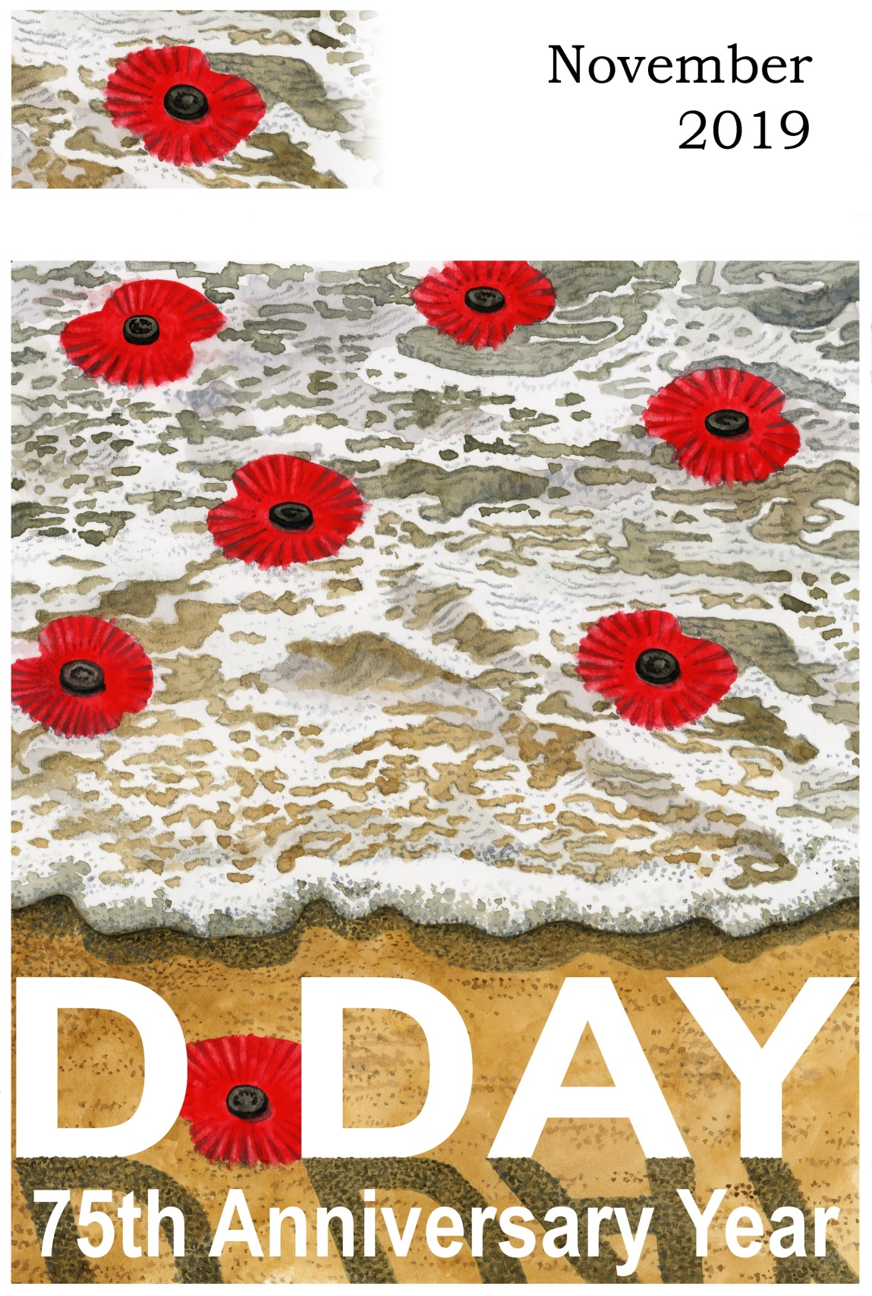
CHURCH OFFICERS
Rector: The Reverend Ann Templeman
The Rectory, 69 Liverpool Road, Much Hoole, PR4 4RB
Tel: 01772 448515 and mob: 07877 659156;
E: anntempleman@live.co.uk
Associate Minister: The Reverend Peter Templeman
Churchwarden:
Mr Jock Davidson – Tel: 617918; E: sgtmajor@talktalk.net
Occasional Preacher:
Mrs Margaret Kirkman – Tel: 01772 379219. Mob: 07786543581.
E: margk1946@gmail.com
Churchwarden Emeritus:
Mr William G Carr. Tel: 01772 615321. E: billcarr1935@btinternet.com
PCC Secretary:
Mrs Andrea Susnik – Tel: 615336. E: familysusnik@live.co.uk
PCC Treasurer:
Mrs Barbara Wood – Tel: 617679. E: bw12252@sky.com
Deanery Synod Representatives: Mrs Jane Elphick, Mrs Jean Dewhurst and Mrs Kathleen Leigh.
Parish Safeguarding Officer: Mrs Jean Dewhurst, Tel: 616106.
Magazine Editor
Mrs Erika Penrose – Tel: 613816. E: jandepenrose@btinternet.com
Magazine Secretary:
Mrs Elsie Kirkham – Tel: 615832.
Magazine Advert Co-ordinator:
Position vacant
Flower Secretaries:
Mrs Lisa Redshaw – Tel 614428 and Mrs Pearl Read – Tel: 614367.
Electoral Roll Officers:
Mrs Jean Dewhurst, Tel: 616106 and Mrs Jane Elphick, Tel: 601495.
Verger: Mrs Irene Pickles – Tel: 615708
Assistant Verger: Mr Stuart Tighe – Tel: 612963
Weekly Giving Envelopes: Please contact the Treasurer or Churchwarden.
Parish Administrator: Mrs Amanda Gibson – Tel: 07735 961620.
ORGANISATIONS
Sunday School
Sunday School – St Michael’s Club – begins at 10.30 in church and usually happens every Sunday.
Leader: Mrs Kathleen Leigh – Tel: 612196. Email: katleigh@live.co.uk
Hoole Church Ladies’ Group – meets 7.30pm, 3rd Tuesday, in School. Leader: Mrs Erika Penrose.
Tel: 613816. E: jandepenrose@btinternet.com
St Michael’s Men’s Fellowship – meets 7.30pm, 2nd Tuesday, in Hoole Village Memorial Hall.
Secretary: Mr Stuart Tighe – Tel: 612963.
Friends of St Michael – Caring for the fabric of our ancient church.
Chair: Mrs Jane Elphick, Tel: 601495.
Secretary: Mr David Turner, Tel: 01772 383344.
Social Committee – Contact: Mrs Sheila Taylor, Tel: 616850
Hoole St Michael C E Primary School
Head Teacher: Mrs Juliet Price – Tel: 613219.
1st St. Michael’s Hoole Scout & Guide Groups – Contact:
Rebecca Catterall
Church Website: http://www.hooleparishchurch.com.

CHURCH OPENING TIMES
St Michael’s Church is open every day. Opening times are:
Monday to Saturday inclusive: 9.30am to 4.30pm.
Sunday: 8.00am to 4.30pm.
Jock Davidson, Churchwarden

Do take a look at our church website – http://www.hooleparishchurch.com

Please note: All adverts are at the back of the magazine.
Church Rotas are on pages 26 & 27.

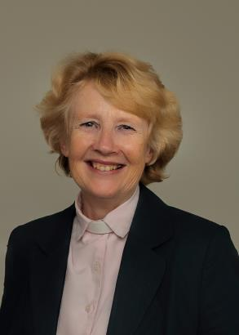
FROM THE RECTORY
A Time to Remember
Dear All
Vicar to elderly Parishioner: “Do you ever think of heaven?”
Parishioner: “All the time Rector– whenever I go into a room I say: ‘What am I here after?’!!”
Remembering and heaven go hand in hand and they do so powerfully in the month of November. November 3rd is All Saints Sunday when the church remembers ‘All Saints’ – that is All Christians (the Greek word translated ‘Saints’ simply means ‘those set apart for God’, i.e. all Christians).
All Saints Sunday is a great opportunity to remember and give thanks for the lives of our own loved ones. We are holding a special service at St Michael’s at 4.00pm when people are invited to light a candle to thank God for the lives of those who have been precious to us. There will be familiar hymns and readings and space for quiet, loving remembrance.
Personal memory loss is always difficult and troubling – corporate memory loss is immensely serious. Remembrance Sunday on 10th November gives us the chance to avoid that pitfall and enables the whole community to remember those who gave their lives that we might have the freedom we have now. We will be gathering together at St Michael’s at 10.10am on 10th November: for some it will be easy to remember as they thank God for fathers, grandfathers and friends they have lost in past wars; for the younger generation – and there will be many in church - it is vital they are helped to remember what others did for them and they learn to value their standard of living, their education, the freedoms they enjoy and the choices they can make which can so easily be taken for granted.
Ultimately the sacrifice of those we will remember on 10th November only makes sense in the context of the greatest sacrifice of all – the death of our Lord and Saviour Jesus Christ on the cross, the death that defeated the power of evil and opened the gates of heaven.
‘He died that we might live.’
Ann Templeman
November 2019
PART TIME YOUNG PEOPLE'S WORKER REQUIRED NOW
St Michael's Church, Hoole is seeking to appoint a committed Christian to support our exciting, growing ministry to children, young people and families (10hrs a week).
Our new monthly Family Church attracts over 100 people and the weekly Sunday school is drawing in many more families – we urgently need some enthusiastic, regular help and ideas.
The job description and hours of this post are flexible and can be fitted around the experience and availability of the successful candidate.
Contact the Rector Rev Ann Templeman – anntempleman@live.co.uk or 07877659156 - for job description or further information.

PREPARING FOR CHRISTMAS
Please consider joining us for 3 fortnightly sessions looking at a few Bible passages which prepare the way for the birth of Jesus Christ and will help us to prepare for the important celebration of Christmas. The sessions will be on Mondays and Tuesdays beginning on Tues 5th November. Other dates are listed below.
ST MICHAEL AND ALL ANGELS CHURCH, HOOLE
SUNDAY SCHOOL – Michael’s Club for children (ages 3 to 12), usually every Sunday during the 10.30 service.
10.30am – Starts in church; children leave for their own teaching in the school after a children’s song and return after the sermon and prayers.
Parish Diary to December
Sunday 27th Oct 09.00 Holy Communion (Book of Common Prayer)
10.30 Morning Worship with Sunday School
Tuesday 29th Oct 10.15 Holy Communion (said)
Sunday 3rd Nov 09.00 Holy Communion (Book of Common Prayer)
10.30 Parish Communion with Sunday School
4.00 SERVICE OF THANKSGIVING FOR LOVED ONES
Monday 4th Nov 7.30 PCC meets at the Rectory
Tuesday 5th Nov 10.15 Holy Communion (said)
7.30 Growth Groups restart at the Rectory:
PREPARING FOR CHRISTMAS – SESSION 1
Sunday 10th Nov 09.00 Holy Communion (Book of Common Prayer)
Note the time 10.10 REMEMBRANCE SUNDAY COMMUNITY SERVICE
4.00 Holy Communion at Old Mill Court
Monday 11th Nov 7.30 Growth Group at the Rectory:
PREPARING FOR CHRISTMAS – SESSION 1
Tuesday 12th Nov 10.15 Holy Communion (said)
7.30 Men’s Fellowship meeting at Much Hoole Village Hall
Thursday 14th Nov 12.00 Locals’ Lunch at the Village Hall
Saturday 16th Nov 10.00am-2.00pm QUIET MORNING AT WHALLEY ABBEY LED BY ARCHDEACON MARK
Sunday 17th Nov 09.00 Holy Communion (Book of Common Prayer)
10.30 Parish Communion
3.45 STAR WARS FAMILY CHURCH IN THE VILLAGE HALL
Tuesday 19th Nov 10.15 Holy Communion (said)
7.30 Ladies’ Group at Hoole Village Hall
7.30 Growth Group at the Rectory:
PREPARING FOR CHRISTMAS – SESSION 2
Sunday 24th Nov 09.00 Holy Communion (Book of Common Prayer)
10.30 Morning Worship with Sunday School
Monday 25th Nov 7.30 Growth Group at the Rectory:
PREPARING FOR CHRISTMAS – SESSION 2
Tuesday 26th Nov 10.15 Holy Communion (said)
Thursday 28th Nov 12.00 Locals’ Lunch at the Village Hall
Sunday 1st Dec 09.00 Holy Communion (Book of Common Prayer)
10.30 Parish Communion with Sunday School
4.00 Holy Communion at Old Mill Court
Tuesday 3rd Dec 10.15 Holy Communion (said)
7.30 Ladies’ Group CHRISTMAS COFFEE EVENING – OPEN EVENING – at St Michael’s School
7.30 Growth Group at the Rectory:
PREPARING FOR CHRISTMAS – SESSION 3
Sunday 8th Dec 09.00 Holy Communion (Book of Common Prayer)
10.30 Morning Worship
4.00 TOY AND CHRISTINGLE SERVICE IN CHURCH
Monday 9th Dec 7.30 Growth Group at the Rectory:
PREPARING FOR CHRISTMAS – SESSION 3
Tuesday 10th Dec 10.15 Holy Communion (said)
7.30 Men’s Fellowship meeting at Much Hoole Village
Hall
Thursday 12th Dec 12.00 Locals’ Christmas Lunch at the Village Hall
Sunday 15th Dec 09.00 Holy Communion (Book of Common Prayer)
10.30 Parish Communion with Sunday School
6.00 CAROLS BY CANDLELIGHT
Monday 16th Dec 7.30 Growth Group Christmas Social at the Rectory
Tuesday 17th Dec 10.15 Holy Communion (said)
7.30 Growth Group Christmas Social at the Rectory
Sunday 22nd Dec 09.00 Holy Communion (Book of Common Prayer)
10.30 Morning Worship
Tuesday 24th Dec 10.15 Holy Communion (said)
4.00 CHRISTMAS EVE CRIB SERVICE in Church
11.30 MIDNIGHT COMMUNION
Wednesday 25th Dec 10.30 CHRISTMAS DAY FAMILY SERVICE WITH CAROLS
AND COMMUNION
Intercessions: Please let the Rector or Margaret Kirkman know of anyone you would like including on our prayer list, by text or 07786 543581.
KEY FUTURE DATES

- STAR WARS FAMILY CHURCH IN HOOLE VILLAGE HALL
Sunday 17th November at 3.45pm

- TOY & CHRISTINGLE SERVICE IN ST MICHAEL’S CHURCH
Sunday 8th December at 4.00pm

- CAROLS BY CANDLELIGHT IN ST MICHAEL’S CHURCH
Sunday 15th December at 6.00pm

- CHRISTMAS EVE CRIB SERVICE
Tuesday 24th December at 4.00pm

- MIDNIGHT COMMUNION IN ST MICHAEL’S CHURCH
Tuesday 24th December at 11.30pm

- CHRISTMAS DAY FAMILY SERVICE WITH COMMUNION
Wednesday 25th December at 10.30am

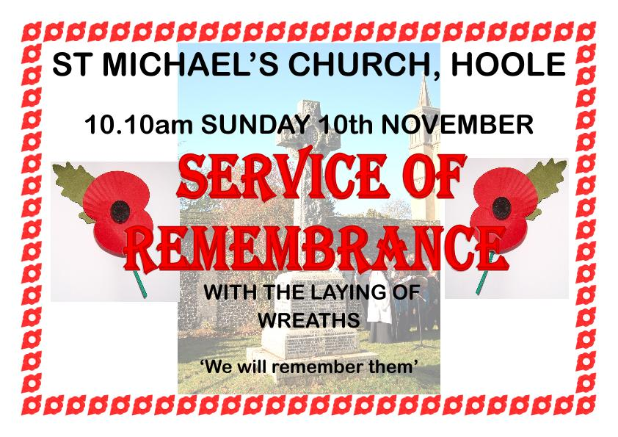
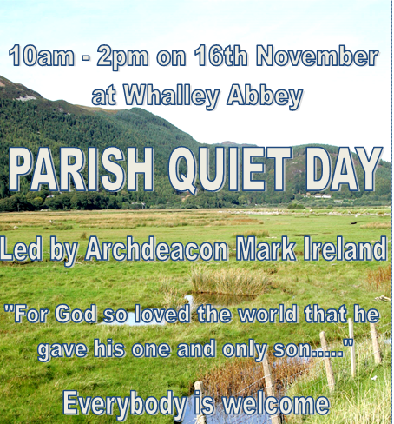
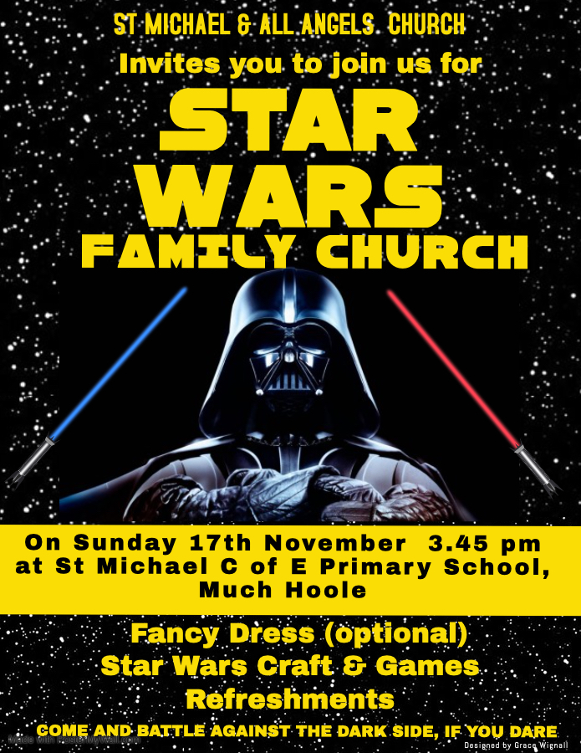
Report on Superheroes Church
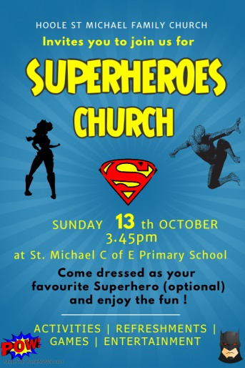
Superman, Wonder Woman, Batman and Spiderman flocked to Superheroes Church in St Michael's school in October. Everyone won medals for their costume and enjoyed a Kryptonite game and Superheroes cake. They heard that Jesus is unique – infinitely more powerful than any Superhero. He saved the world and conquered death for ever by His death on the cross and resurrection.
~~~~
Ladies’ Group
At our joint meeting with the Men’s Fellowship last month, Alan Taylor very kindly agreed to fill in at the last minute in place of the Harold Hoggarth who was unable to come due to illness. Alan’s entertaining talk was about water, with more than a touch of humour plus some interesting facts.
At our November meeting on the 19th, Brian Topping will be coming along to talk about “Tales of a Customs Officer”. This will be at the village hall at 7.30pm. All new members would be given a warm welcome and, if you’d like to find out more about our group, please phone me on 613816.
Looking ahead to our Christmas Coffee Evening on Tuesday, 3rd December, at 7.30pm at St Michael’s School (see poster), Katy Bradley, who members will recall gave us a most enjoyable evening last year, is returning with musical entertainment with her choir, “KTB Voice”. All proceeds from this event will be donated to the NW Air Ambulance. Please bring friends and relations along. Tickets at only £7.00 have been selling like hot cakes and will be available at our November meeting. There will be the usual delicious buffet, raffle, bring and buy stall, and jolly Christmas cheer!
Erika
~~~~
Men’s Fellowship
The Men’s Fellowship will be meeting at the village hall on Tuesday 12th November at 7.30pm. Their Christmas meal will be taking place on Tuesday 10th December.
~~~~
From the Parish Registers
Holy Baptism
“We welcome into the Lord’s Family”
Ethan Albie Peterson was baptised on 29th September.
Weddings
“Those whom God has joined together”
Benjamin Matthew Adam Hughes and Rosanna Celyn Tattersall, both of Much Hoole, were married on 19th October.
Interment of Ashes
“Rest eternal grant unto them”
The ashes of Teresa Mary Crompton were interred in the churchyard on 16th October.
The ashes of William Sutton were interred in the churchyard on 18th October.
~~~~
From the Register of Services
Date |  | Attendance | Communicants | Amount
September | 22nd | 73 | 22 | £283.65
 | 29th | 78 | 63 | £244.54
October  (Harvest Service) | 6th | 165 | 28 | £458.81
 | 13th | 53 | 22 | £245.35
Standing Order and Annual Donation for September (actual): £1,091.50.
Standing Order donations for October (projected): £591.50.
Standing Order donations in lieu of donating via the envelope system for November (projected): £591.50.
Donations from Baptisms: £87.16.
~~~~
YOUR 2020 GIVING TO CHURCH

Envelopes:
Please look for your 2020 giving envelopes in church in December.
The new box of envelopes will usually be near the font.
Some of you will have new numbers as the number of people giving via the regular envelope system is decreasing: therefore we have ordered fewer this year.
Please check your name first, then the number on the box.

Standing Orders:
The number of people giving by monthly SO or annual donation is increasing. However, you may recall that in the envelope scheme there were options to just “give that bit extra” at Easter, Harvest, Christmas.
Could you take that into account in your giving perhaps on those special occasions?

Thank You:
Many thanks to everyone who gives: big or small, regular or ad hoc; all is appreciated.
But like inflation, our needs keep growing with the growth of our Church.
Can you please consider giving just a teensy weensy little bit more this next year??

Consider this:
An increase of just 50p per week raises your donation by £26 per annum.
If everyone did it, that is a massive boost of £2,106!!

All enquiries are welcome whether it is about giving by envelope or standing order or anything else finance related.
Please do not hesitate to give me a call, drop me an email, pop round my house or collar me on a Sunday.

Barbara Wood - Treasurer to the PCC

CALLING ALL ADVERTISERS:
Your invitation to renew for 2020 was sent out in October.
If you have not received it, please get in touch.
If you would like to place a new advert, please get in touch.
Deadline for payment: 25th November
Deadline for editorial: 1st December
If you are a charity or community based organisation and wish to advertise in our magazine, please get in touch for our special rates.

Many thanks
Barbara Wood
Treasurer to the PCC Hoole Parish Church
01772 617679 / 07745 208617 / bw12252@sky.com

DOES THIS APPEAL TO YOU?
Mr Les Hodgson makes these candle silhouettes by hand and the proceeds go to the Royal British Legion – more details on his website. I have just ordered two, based on a recommendation by my sister and her husband who know him personally. The time of year seems appropriate. Barbara Wood
Water Aid was launched at our Harvest Service…

Well – have you?

Come to the Panto!
Friday 24th January 2020
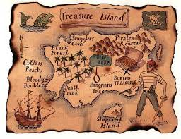
The Social Committee are organising a visit to the
Pantomime at St Andrew's Church Hall, Longton.
The Pantomime this time is ' Treasure Island' and seats have been booked for Friday 24th January, 2020 at 7.30pm.
The price of tickets is £7.00 for adults and £5.00 for children.
Please contact Sheila on 616850 to book.

From the Flower Group
Harvest is a lovely time to celebrate all our local produce. The church was decorated on the Thursday before harvest so that the children could see the church in all its glory at their harvest service on the Friday afternoon. The baskets donated to the church then, and during the Sunday service, were given to local people. Fresh local produce, generously provided by local traders Burneys and Woods, as well as freshly picked fruit from gardens, was split between the kitchens at St Catherine's Hospice and Much Hoole Primary school for their fund raiser on the Monday afternoon.
Croft bakery generously provided the wheatsheaf which is symbolically placed at the front of the church for all to see, to remind us of how farmers used to stack the wheat in sheaves at harvest time.
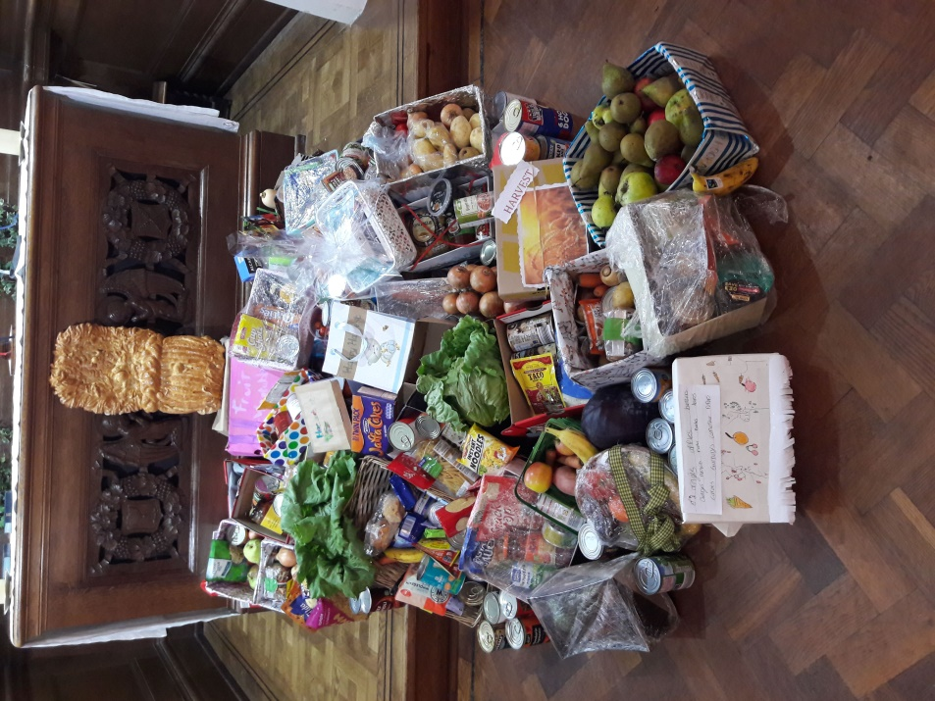
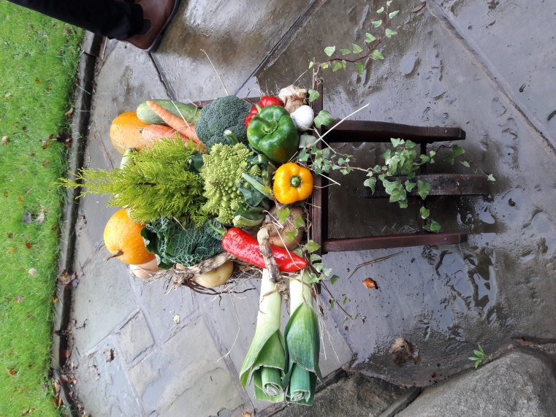
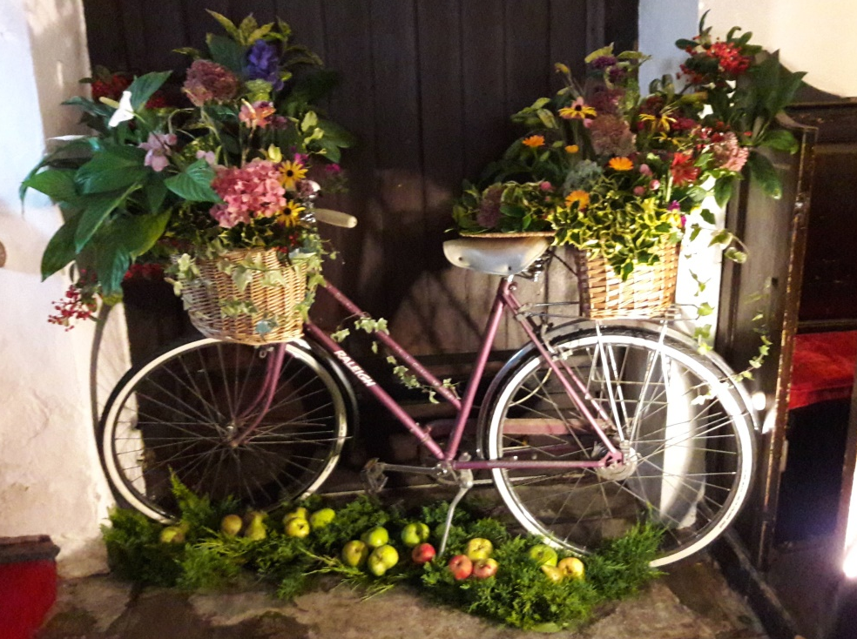
Hoole St Michael CE Primary School – October
Psalm walk with Rev Ann
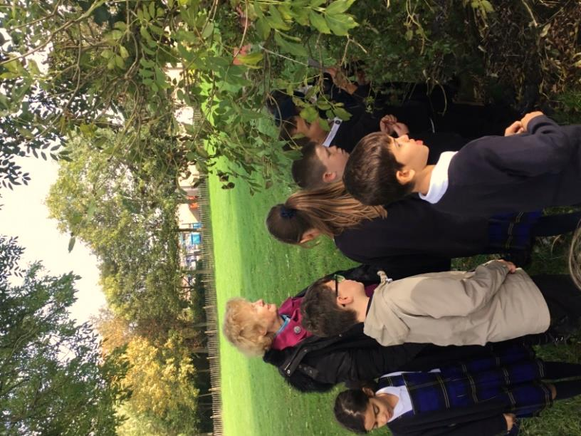
The children went outside and saw how God is all around us. Rev Ann talked about each Psalm.
Quotes from our children:
'Rev Ann described bible stories to us and explained what their message was.' Alfie
'I like the psalm about a deer.' Sophie
'We learnt about lots of psalms and had lots of fun,' Armani
'We went on a walk around school to find the psalms.' Liam
Harvest Festival
We had a lovely Harvest Festival service in church on Friday. We sold some of the fruit and vegetables and raised £26 for the Bishop's Harvest Appeal.
Free Library
We now have a library for children to help themselves to a free story book which has kindly been donated. Please feel free to visit it outside our school car park.
Juliet Price
Headteacher
Our Prayer Circle
As Christians we know that one of the main things that Jesus taught us was the words of The Lord’s Prayer and very often in the Bible we are told that He went to a quiet place and prayed. Our hymns tell us to “Take it to the Lord in prayer” and that “the voice of prayer is never silent”. There is no doubt of the need for prayer for our own spiritual needs as well as the knowledge of the comfort and support that it gives to both the person praying and the people being prayed for.
To that end we have set up a Prayer Circle at St Michael’s.... ‘What’s one of those then?’ you may ask. It is simply a group of people who when called upon will pray at home separately and quietly for whatever you ask.
If you have a concern of any sort that you want us to pray for all you need to do is to ring any of the numbers and simply say what or who is in need of prayer, and whilst a minimum of explanation might be an advantage for us to focus the prayer, ou don’t even have to say who you are! The person taking the call will pass it round the circle and you will know that we, on behalf of the church, are taking your worry to the Lord. If you would like your particular concern added into the intercessions on a Sunday morning then we can do that too.
We are happy to welcome others into the circle, just let us know and you will be added on.
Prayer is an essential part of our Christian life to keep us walking in the footsteps of our Saviour... so... the lines are open right now, we are waiting to take your call which is very important to us because it matters to you... just ring and your prayer will be increased seven-fold (at least).
Our circle consists of Ted (01772 617002), Margaret (01772 379219), Carole Bamber (01772 610670 or mobile 07989 145963), Gill Slinger (07729 121248), Barbara Wood (07745 208617) and Bill Carr (01772 615321).
Ted, Margaret, Carole, Gill, Barbara and Bill

Sudoku (Easy)

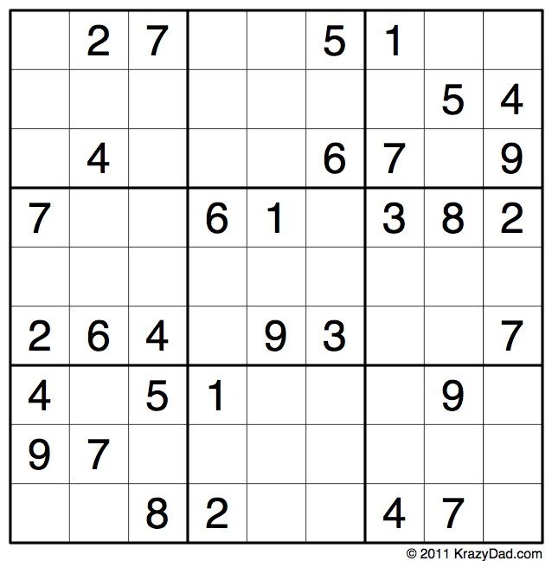

Sudoku (Medium)
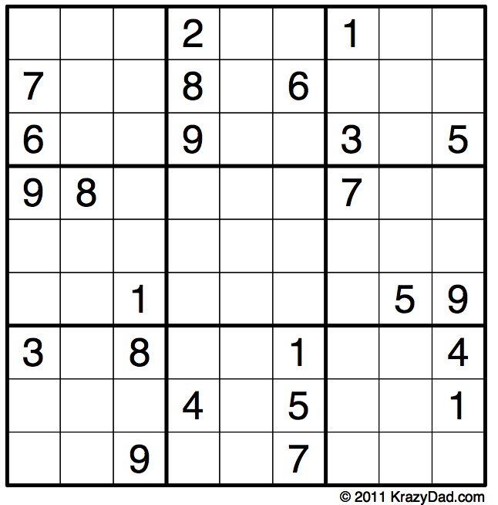
CHURCH ROTAS FOR NOVEMBER

Tea/Coffee Rota following our 10.30 Service
Nov 3rd Beryl & Rona
10th Pauline & Barbara
17th Erika
24th Carole & Gill
Dec 1st Beryl & Rona
8th Pauline & Barbara

If you wish to change the date assigned to you, please find a replacement or arrange a swap.
We’re rather short of helpers, so if you feel you could give an hour at this service every few weeks, have a word with Erika at church or call 613816, or just come along and help!

Sidespersons’ Rota
Nov 3rd 9.00 Ken Bishop
10.30 Jean Aughton, Colin Brown & Julia Brown
4.00 Ted Hopkins, Sylvia Douglas, Eunice Houghton and Geoff Demack
10th 9.00 Rob McMurray
10.30 Ted Hopkins, Robert Hawthornthwaite, Scott Eckersley and Clifford Orritt
17th 9.00 Jeremy Leigh
10.30 Norman Skellorn, Geoff Demack and Eunice Houghton
24th 9.00 John Simpson
10.30 Bill Carr, Scott Eckersley and Beryl Blakeley
Dec 1st 9.00 Mike Redshaw
10.30 Jean Aughton, Colin Brown and Julia Brown

Readers’ Rota
If you cannot read as specified on this rota, please find a substitute and inform a churchwarden of any changes.

Nov 3rd 9.00 Peter Templeman
10.30 Lynn Smith and Gill Slinger
10th 9.00 Val Simpson
10.30 Margaret Kirkman and Carole Bamber
17th 9.00 Mike Redshaw
10.30 Ted Hopkins and Carole Bamber
24th 9.00 Kathleen Leigh
10.30 Emma Cairns and Lillie Eaves-Holmes
Dec 1st 9.00 Peter Templeman
10.30 Scott Eckersley and Lynn Smith
8th 9.00 Ann Templeman
10.30 Gill Slinger and Jane Elphick
Peter Templeman will contact each reader by email by the preceding Tuesday. Please will readers ensure Peter has their contact email.

