PARISH DIARY

Tuesday 22nd Sept 7.30pm Bible Study-Just 10: Don’t Lie
Sunday Sept. 27th 9.00am. Holy Communion (Book of Common Prayer )
10.30am. Morning Worship with Sunday School.
Monday 28th Sept 7.30pm Bible Study- Just 10: Don’t Lie
Friday Oct 2nd 11.30am School Harvest Service for Y5 and Y6
Sunday Oct. 4th 9.00am Holy Communion
10.30am HARVEST FESTIVAL.

Sunday Oct 11th 9.00am. Holy Communion (Book of Common Prayer )
10.30am. Morning Worship with Sunday School.
Sunday Oct 18th 9.00am. Holy Communion (Book of Common Prayer )
10.30am. Parish Communion with Sunday School.
Sunday Oct 25th 9.00am. Holy Communion (Book of Common Prayer )
10.30am. Morning Worship with Sunday School.
12 noon APCM IN CHURCH- ANNUAL CHURCH MEETING .
If St Michael’s is your church you should be on the electoral roll; please check with Jane Elphick, Jean Dewhurst or Rev Ann if you are not sure.
3.45pm LEGO CHURCH
Sunday Nov1st 9.00am. Holy Communion (Book of Common Prayer )
(All Saints) 10.30am. Parish Communion with Sunday School.
4.00pm. SERVICE OF THANKSGIVING FOR LOVED ONES.
Sunday Nov. 8th 9.00am. Holy Communion (Book of Common Prayer )
10.00am. REMEMBRANCE SUNDAY SERVICE WITH BISHOP OF BLACKBURN.
FUTURE DATES
Friday Jan 22nd Harvest Quiz postponed from September
Please Note. Our church is open daily throughout the week from
9.30am to 4.30pm for visiting and private prayer.
Our Facebook page: St Michael and All Angels Church, Hoole, our website is www.hooleparishchurch.com

Rector – Revd Ann Templeman anntempleman@live.co.uk 01772 448515
The Rectory, 69 Liverpool Old Road Much Hoole PR4 4RB
Please take this sheet home with you

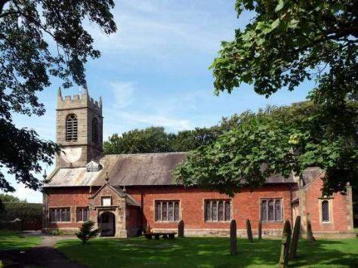
St. Michael and All Angels – Hoole

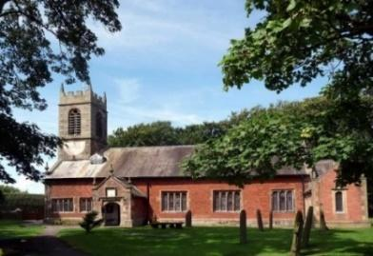

A special welcome to our church again this morning.
Please observe social distancing, but stay close to Christ.

Sunday 20th September 2020 Trinity 15

EXODUS 1 – THE PASSOVER

‘For Christ our Passover Lamb has been sacrificed.
Therefore let us keep the feast….’ I Corinthians 5: 7b & 8a.

PRAYER OF THE DAY: Lord God, defend your Church from
all false teaching and give to your people knowledge of your truth,
that we may enjoy eternal life in Jesus Christ our Lord. Amen.

Sunday School for ages 3-11during the service
There are toys for younger children at the back of church. Sunday School meets outside in the marquee during the sermon and prayers.

9.00am. Holy Communion (Book of Common Prayer) begins p237

10.30am. Parish Communion with Sunday School.
Readings: Exodus 12: v 21-23. Ex 12: v 17-20 & 1 Cor 5: v 7b & 8a.
Hymns : 695 To God be the Glory.
Children’s song – All through history.
374 Just as I am, without one plea.
408 Lord enthroned in Heavenly Splendour.

H/C Hymns: 658 There is a Redeemer. 87 Broken for me.
BIBLE READINGS: Exodus 12: v 21-23.
Then Moses summoned all the elders of Israel and said to them,
‘Go at once and select the animals for your families and slaughter the Passover lamb. Take a bunch of hyssop, dip it into the blood in the basin
and put some of the blood on the top and on both sides of the door-frame.
None of you shall go out of the door of your house until morning.
When the Lord goes through the land to strike down the Egyptians, he will see the blood on the top and sides of the door-frame and will pass over that doorway, and he will not permit the destroyer to enter your houses and strike you down.

Exodus 12: v 17-20 & 1 Corinthians 5: v 7b & 8a.
‘Celebrate the Festival of Unleavened Bread,
because it was on this very day that I brought your divisions out of Egypt. Celebrate this day as a lasting ordinance for the generations to come.
In the first month you are to eat bread made without yeast, from the evening of the fourteenth day until the evening of the twenty-first day.
For seven days no yeast is to be found in your houses. And anyone, whether foreigner or native-born, who eats anything with yeast in it must be cut off from the community of Israel. Eat nothing made with yeast. Wherever you live, you must eat unleavened bread

For Christ our Passover Lamb has been sacrificed.
Therefore let us keep the feast….

Prayer. We pray for those who are sick especially Beryl Cotton, Jane Slinger, Michael Harrison, baby Schultz, Paul Wignall, Tom Parkinson and Althea Slater
Christian Aid Walking Treasure Hunt: from 11.00am to 5.00pm on either Sat 26th or Sun 27th Sept, starting and finishing from 16 Franklands taking approx. 2- 2.5 hours. Please take information from the back of the church.
URGENTLY NEEDED:
1.Independent Examiner for church accounts ( annual task)
2. A new Church Treasurer to free Barbara up for another role. Full guidance and support available
Suggested Bible readings for this week:
Mon. Sept 21st Matthew 9: 9-13. The calling of Matthew.
Tues. Sept 22nd Luke 8: 19-21. Jesus’ Mother and Brothers.
Wed. Sept 23rd Luke 9: 1-6. Jesus sends out the twelve.
Thur. Sept 24th Luke 9: 7-9. Herod the tetrarch.
Fri. Sept 25th Luke 9: 18-22. Peter’s Confession of Christ.
Sat Sept 26th Luke 9: 43b-45. Jesus predicts his betrayal.

BIBLE STUDIES MONDAY OR TUESDAY7.30pm fortnightly
JUST 10 –Session 2 DON’T LIE/TELL THE TRUTH
Tuesday 22nd September 7.30pm Zoom or in church.
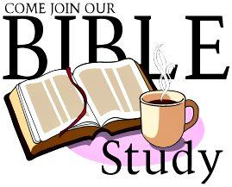
This Autumn we are looking at the 10 Commandments. Meetings will take place on Mondays and Tuesdays at 7.30pm on alternate weeks. –choose Zoom or it may be possible to meet in church with a short service of Evening prayer or Compline if there is sufficient interest. Please let Ann know by Monday evening if you would like to come to church this Tuesday 22nd September and state morning at 10.15am (possibly with Holy Communion) afternoon at 2.00pm or evening at 7.30pm
The title and some of the study material springs from a nationwide tour of talks by J John . He is a very popular and engaging speaker with lots of memorable and often amusing material to make God's timeless commands immediately relevant to our situation. Many of you will enjoy listening to some of his talks on You tube. Go to J John Just 10 from Kingsgate Week and you will find all 10 talks.
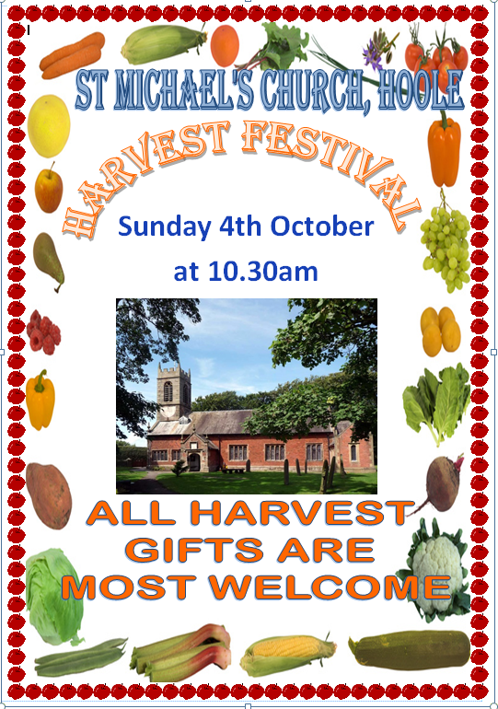
H
A
R
V
E
S
T

