PARISH DIARY

Monday 28th Sept 3.15pm Welcome Service for Reception 7.30pm Bible Study- Just 10: Don’t Lie
Friday Oct 2nd 11.30am School Harvest Service for Y5 and Y6
Sunday Oct. 4th 9.00am Holy Communion
10.30am HARVEST FESTIVAL.
Sunday Oct 11th 9.00am. Holy Communion (Book of Common Prayer )
10.30am. Morning Worship with Sunday School.
Sunday Oct 18th 9.00am. Holy Communion (Book of Common Prayer )
10.30am. Parish Communion with Sunday School.
Sunday Oct 25th 9.00am. Holy Communion (Book of Common Prayer )
10.30am. Morning Worship.
12 noon APCM IN CHURCH- ANNUAL CHURCH MEETING .
If St Michael’s is your church you should be on the electoral roll; please check with Jane Elphick, Jean Dewhurst or Rev Ann if you are not sure.
3.45pm LEGO CHURCH
Sunday Nov1st 9.00am. Holy Communion (Book of Common Prayer )
(All Saints) 10.30am. Parish Communion with Sunday School.
4.00pm. SERVICE OF THANKSGIVING FOR LOVED ONES.
Sunday Nov. 8th 9.00am. Holy Communion (Book of Common Prayer )
10.00am. REMEMBRANCE SUNDAY SERVICE WITH BISHOP OF BLACKBURN.
FUTURE DATES
Friday Jan 22nd Harvest Quiz postponed from September

Please Note. Our church is open daily throughout the week from
9.30am to 4.30pm for visiting and private prayer.
Suggested Readings this week Mon. Sept 28th Luke 9: v 46-50.
Tues. Sept 29th (St Michael and All Angels) Revelation 12: v 7-12.
Wed. Sept 30th Luke 9: 57-end. Thurs. Oct 1st Luke 10: v 1-12.
Fri. Oct 2nd Luke 10: v 13-16. Sat. Oct 3rd Luke 10: v 17-24.
Our Facebook page: St Michael and All Angels Church, Hoole, our website is www.hooleparishchurch.com

Rector – Revd Ann Templeman anntempleman@live.co.uk 01772 448515
The Rectory, 69 Liverpool Old Road Much Hoole PR4 4RB
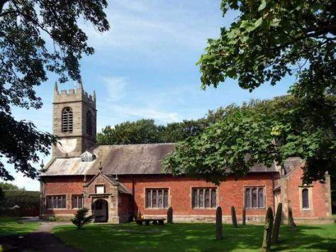
St. Michael and All Angels – Hoole

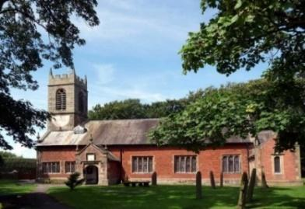

A special welcome to our church again this morning.
Please observe social distancing, but stay close to Christ.

Sunday 27th September 2020 Trinity 16

EXODUS 2 – CROSSING THE RED SEA

‘Stand firm and you will see the deliverance
the Lord will bring you this day’ Exodus 14: v 13.

PRAYER OF THE DAY: Lord of creation, whose glory is around
and within us: open our eyes to your wonders, that we may serve you
with reverence and know your peace at our lives’ end,
through Jesus Christ our Lord. Amen.

Sunday School for ages 3-11during the service
There are toys for younger children at the back of church. Sunday School meets outside in the marquee during the sermon and prayers.

9.00am. Holy Communion (Book of Common Prayer) begins p237

10.30am. Morning Worship with Sunday School.
Readings: Exodus 14: v 13-18, 21-23 & 26-28.
1 Corinthians 10: v 1-11.
Hymns : 219 – God is our strength and refuge.
Children’s song: – All through history.
Canticle 2 – O Bless the God of Israel.
281 – He who would valiant be.
252 – Guide me O thou great Redeemer.

BIBLE READINGS: Exodus 14: v 13…28. Moses answered the people, “Do not be afraid. Stand firm and you will see the deliverance the Lord will bring you today. The Egyptians you see today you will never see again. The Lord will fight for you; you need only to be still.”
Then the Lord said to Moses, “Why are you crying out to me? Tell the Israelites to move on. Raise your staff and stretch out your hand over the sea to divide the water so that the Israelites can go through the sea on dry ground. I will harden the hearts of the Egyptians so that they will go in after them. And I will gain glory through Pharaoh and all his army, through his
Chariots and horsemen. The Egyptians will know that I am the Lord when I gain glory through Pharaoh, his chariots and his horsemen.”
Then Moses stretched out his hand over the sea, and all that night the Lord drove the sea back with a strong east wind and turned it into dry land. The waters were divided, and the Israelites went through the sea on dry ground, with a wall of water on their right and on their left. The Egyptians pursued them, and all Pharaoh’s horses and chariots and horsemen followed them into the sea.
Then the Lord said to Moses, “Stretch out your hand over the sea so that the waters may flow back over the Egyptians and their chariots and horsemen.” Moses stretched out his hand over the sea, and at daybreak the sea went back to its place. The Egyptians were fleeing toward it, and the Lord swept them into the sea. The water flowed back and covered the chariots and horsemen—the entire army of Pharaoh that had followed the Israelites into the sea. Not one of them survived.

1 Corinthians 10: v 1-11. For I do not want you to be ignorant of the fact, brothers and sisters, that our ancestors were all under the cloud and that they all passed through the sea. They were all baptized into Moses in the cloud and in the sea. They all ate the same spiritual food and drank the same spiritual drink; for they drank from the spiritual rock that accompanied them, and that rock was Christ. Nevertheless, God was not pleased with most of them; their bodies were scattered in the wilderness. Now these things occurred as examples to keep us from setting our hearts on evil things as they did. Do not be idolaters, as some of them were; as it is written: “The people sat down to eat and drink and got up to indulge in revelry.” We should not commit sexual immorality, as some of them did—and in one day twenty-three thousand of them died. We should not test Christ, as some of them did—and were killed by snakes. And do not grumble, as some of them did—and were killed by the destroying angel. These things happened to them as examples and were written down as warnings for us, on whom the culmination of the ages has come.

Prayer. We pray for those who are sick especially Michael Harrison, Sarah, Beryl Cotton, Jane Slinger, baby Schultz, Paul Wignall, and Tom Parkinson.

URGENTLY NEEDED:
1. Independent Examiner for church accounts (annual task)
2. A new Church Treasurer to free Barbara up for another role. Full guidance and support available

BIBLE STUDIES MONDAY OR TUESDAY7.30pm fortnightly
JUST 10 –Session 2 DON’T LIE/TELL THE TRUTH
Monday 28th September 7.30pm Zoom or in church.
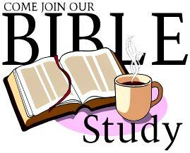
This Autumn we are looking at the 10 Commandments. Meetings will take place on Mondays and Tuesdays at 7.30pm on alternate weeks. –choose Zoom or meet in church.
The title springs from a nationwide tour of talks by J John . He is a very popular and engaging speaker with lots of memorable and often amusing material to make God's timeless commands immediately relevant to our situation. You may enjoy listening to some of his talks on You tube. Go to J John Just 10 from Kingsgate Week and you will find all 10 talks.
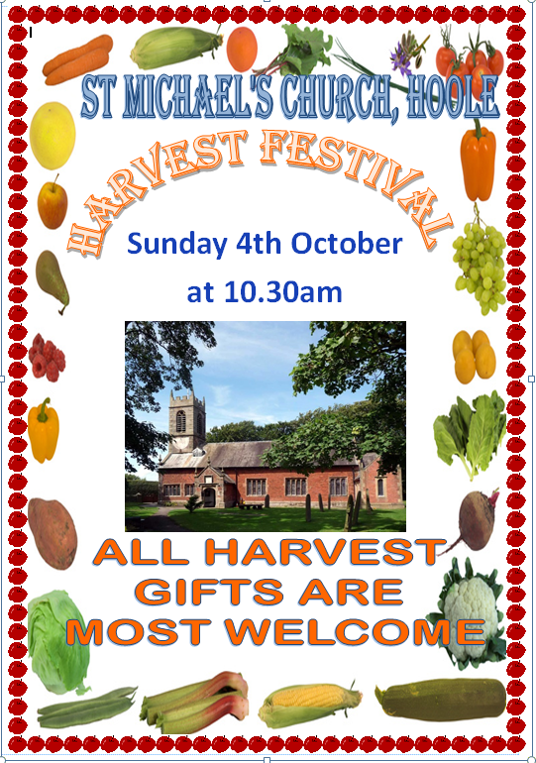
H
A
R
V
E
S
T

