**PARISH DIARY**

**Sunday Oct 18th 9.00am. Holy Communion (Book of Common Prayer )**

**10.30am. Parish Communion with Sunday School.**

**Tuesday Oct 20th 7.30pm. Bible Study/Growth Group (3): Don’t Steal**

**Sunday Oct 25th 9.00am. Holy Communion (Book of Common Prayer )**

**10.30am. Morning Worship.**

**12 noon. APCM IN CHURCH- ANNUAL CHURCH MEETING .**

**If St Michael’s is your church you should be on the electoral roll; please check with Jane Elphick, Jean Dewhurst or Rev Ann if you are not sure.**

**3.45pm. LEGO CHURCH**

**Monday Oct 26th 7.30pm. Bible Study/Growth Group (3): Don’t Steal**

**Sunday Nov1st 9.00am. Holy Communion (Book of Common Prayer )**

**(All Saints) 10.30am. Parish Communion with Sunday School.**

**4.00pm. SERVICE OF THANKSGIVING FOR LOVED ONES.**

**Monday Nov 2nd  7.30pm. Bible Study Group (4): Don’t Commit Adultery.**

**Sunday Nov. 8th 10.00am. REMEMBRANCE SUNDAY SERVICE WITH BISHOP OF BLACKBURN.**

**Monday Nov 9th 7.00pm. PCC Meeting.**

**Tuesday Nov 10th  7.30pm. Bible Study Group (4): Don’t Commit Adultery.**

**Sunday Nov1st 9.00am. Holy Communion (Book of Common Prayer )**

**(All Saints) 10.30am. Parish Communion with Sunday School.**

**3.45pm. FAMILY CHURCH LIGHT PARTY.**

**FUTURE DATES**

**Friday Jan 22nd Harvest Quiz postponed from September**

**Please Note. Our church is open daily throughout the week from**

**9.30am to 4.30pm for visiting and private prayer.**

**Suggested Readings this week**

**Mon.** Oct 12th Luke 11: v 29-32. **Tues.** Oct 13thLuke 11: v 37-41.

**Wed.** Oct 14th Luke 11: v 42-46. **Thurs.** Oct 15th Luke 11: v 47-end.

**Fri**. Oct 16th Luke 12: v 1-7. **Sat.**  Oct 17th Luke 12: v 8-12.

Our Facebook page: **St Michael and All Angels Church, Hoole**, our website is www.hooleparishchurch.com

Rector – Revd Ann Templeman anntempleman@live.co.uk 01772 448515

The Rectory, 69 Liverpool Old Road Much Hoole PR4 4RB

*Please take this sheet home with you*

**St. Michael and All Angels – Hoole**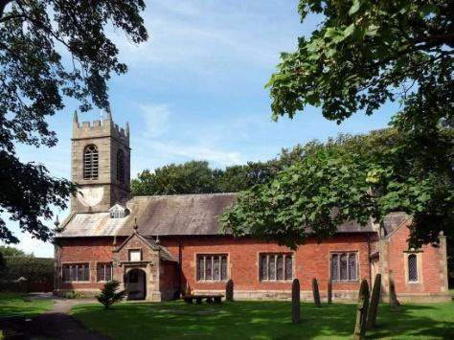

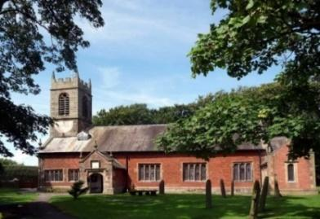

***A special welcome to our church again this morning. We welcome Rev Richard Plant once more to lead our services today while Ann and Peter are away.***

***Please observe social distancing, but stay close to Christ.***

***Sunday 11th October 2020 Trinity 18***

**GOD’S INVITATION**

**‘Many are invited, but few are chosen’** *Matthew 22 v 14.*

**PRAYER OF THE DAY: Almighty God, Grow our faith so that**

**we can move into your future, obeying your commandments that we**

**may win the crown of everlasting life, through Jesus Christ our Lord.**

**Amen.**

**Sunday School for ages 3-11during the service**

There are toys for younger children at the back of church. Sunday School meets outside in the marquee during the sermon and prayers.

**

**9.00am. Holy Communion (Book of Common Prayer) begins p237**

**10.30am. Morning Worship with Sunday School.**

**Reading: Matthew 22: v 1-14.**

**Hymns : 184 – For the beauty of the earth.**

**Children’s song – Every move I make.**

**511 – O Lord my God (How great Thou art).**

**695 – To God be the glory.**

**689 – Thy hand O God has guided.**

**BIBLE READING**: **Matthew 22: v 1-14**

Jesus spoke to them again in parables, saying: ‘The kingdom of heaven is like a king who prepared a wedding banquet for his son. He sent his servants to those who had been invited to the banquet to tell them to come, but they refused to come.

‘Then he sent some more servants and said, “Tell those who have been invited that I have prepared my dinner: my oxen and fattened cattle have been slaughtered, and everything is ready. Come to the wedding banquet.”

‘But they paid no attention and went off – one to his field, another to his business. The rest seized his servants, ill-treated them and killed them. The king was enraged. He sent his army and destroyed those murderers and burned their city.

‘Then he said to his servants, “The wedding banquet is ready, but those I invited did not deserve to come. So go to the street corners and invite to the banquet anyone you find.” So the servants went out into the streets and gathered all the people they could find, the bad as well as the good, and the wedding hall was filled with guests.

‘But when the king came in to see the guests, he noticed a man there who was not wearing wedding clothes. He asked, “How did you get in here without wedding clothes, friend?” The man was speechless.

‘Then the king told the attendants, “Tie him hand and foot, and throw him outside, into the darkness, where there will be weeping and gnashing of teeth.” ‘For many are invited, but few are chosen.’

**Prayer**. We pray for those who are sick especially Beryl Carr, Michael Harrison, Beryl Cotton, Jane Slinger, baby Schultz, Paul Wignall, Tony Brogden, Eva Coxhead and Tom Parkinson.

**URGENTLY NEEDED:**

**1. Independent Examiner for church accounts (annual task)**

**2. A new Church Treasurer to free Barbara up for another role. Full guidance and support available**

**BIBLE STUDIES MONDAY OR TUESDAY 7.30pm fortnightly**

**JUST 10 –Session 3 DON’T STEAL**

***Tuesday 20th October or Monday 26th October at 7.30pm Zoom or in church.***

**This Autumn we are looking at the 10 Commandments.**

**The title springs from a nationwide tour of talks by J John . He is a very popular and engaging speaker with lots of memorable and often amusing material to make God's timeless commands immediately relevant to our situation. You may enjoy listening to some of his talks on You tube. Go to J John Just 10 from Kingsgate Week and you will find all 10 talks.**

