**PARISH DIARY**

**Tuesday Oct 20th 7.30pm. Bible Study/Growth Group (3): Don’t Steal**

**Sunday Oct 25th 9.00am. Holy Communion (Book of Common Prayer )**

**10.30am. Morning Worship.**

**12 noon. APCM IN CHURCH- ANNUAL CHURCH MEETING .**

**If St Michael’s is your church you should be on the electoral roll; please check with Jane Elphick, Jean Dewhurst or Rev Ann if you are not sure.**

**3.45pm. LEGO CHURCH**

**Monday Oct 26th 7.30pm. Bible Study/Growth Group (3): Don’t Steal**

**Sunday Nov1st 9.00am. Holy Communion (Book of Common Prayer )**

**(All Saints) 10.30am. Parish Communion with Sunday School.**

**4.00pm. SERVICE OF THANKSGIVING FOR LOVED ONES.**

**Monday Nov 2nd  7.30pm. Bible Study Group (4): Don’t Commit Adultery.**

**Sunday Nov. 8th 10.00am. REMEMBRANCE SUNDAY SERVICE WITH BISHOP OF BLACKBURN.**

**Monday Nov 9th 7.00pm. PCC Meeting.**

**Tuesday Nov 10th  7.30pm. Bible Study Group (4): Don’t Commit Adultery.**

**Sunday Nov15th 9.00am. Holy Communion (Book of Common Prayer )**

**10.30am. Parish Communion with Sunday School.**

**3.45pm. FAMILY CHURCH LIGHT PARTY.**

**Monday Oct 26th 7.30pm. Bible Study Group (4): Don’t Commit Adultery.**

**FUTURE DATES**

**Friday Jan 22nd Harvest Quiz postponed from September**

**Please Note. Our church is open daily throughout the week from**

**9.30am to 4.30pm for visiting and private prayer.**

**Suggested Readings this week**

**Mon.** Oct 19th Luke 10: v 1-9. **Tues.** Oct 20th Luke 12: v 35-38.

**Wed.** Oct 21st Luke 12: v 39-48. **Thurs.** Oct 22nd Luke 12: v 49-53.

**Fri**. Oct 23rd Luke 12: v 54-end. **Sat.**  Oct 24th Luke 13: v 1-9.

Our Facebook page: **St Michael and All Angels Church, Hoole**, our website is www.hooleparishchurch.com

Rector – Revd Ann Templeman anntempleman@live.co.uk 01772 448515

The Rectory, 69 Liverpool Old Road Much Hoole PR4 4RB

*Please take this sheet home with you*

**St. Michael and All Angels – Hoole**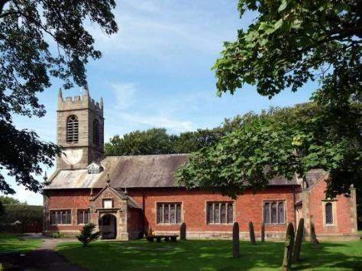

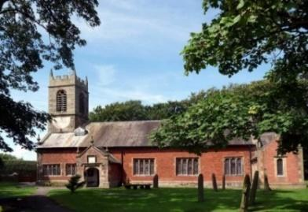

***A special welcome to our church again this morning. We welcome Rev Pat Belshaw once more to lead our services today while Ann and Peter are away.***

***Please observe social distancing, but stay close to Christ.***

***Sunday 18th October 2020 Trinity 19***

**BEING PUT TO THE TEST**

**‘Give to Caesar what is Caesar’s and to God what is God’s’**

*Matthew 22 v21.*

**PRAYER OF THE DAY: Faithful Lord, whose steadfast love**

**never ceases and whose mercies never come to an end:**

**grant us the grace to trust you and to receive the gifts of your love,**

**new every morning, in Jesus Christ our Lord. Amen.**

**Sunday School for ages 3-11during the service**

There are toys for younger children at the back of church. Sunday School meets outside in the marquee during the sermon and prayers.

**

**9.00am. Holy Communion (Book of Common Prayer) begins p237**

**10.30am. Parish Communion with Sunday School.**

**Reading: Matthew 22: v 15-22.**

**Hymns : 70 – Be thou my vision.**

**Children’s song – All through history.**

**69 – Be thou my guardian and my guide.**

**534 – O praise ye the Lord.**

**H/C Hymns: 658 – There is a Redeemer. 66 – Be still and know.**

**BIBLE READING**: **Matthew 22: v 15-22.**

Then the Pharisees went out and laid plans to trap him in his words.

They sent their disciples to him along with the Herodians. “Teacher,” they said, “we know that you are a man of integrity and that you teach the way of God in accordance with the truth. You aren’t swayed by others, because you pay no attention to who they are. Tell us then, what is your opinion? Is it right to pay the imperial tax to Caesar or not?”

But Jesus, knowing their evil intent, said, “You hypocrites, why are you trying to trap me? Show me the coin used for paying the tax.” They brought him a denarius,and he asked them, “Whose image is this? And whose inscription?” “Caesar’s,” they replied.

Then he said to them, “So give back to Caesar what is Caesar’s, and to God what is God’s.”

When they heard this, they were amazed. So they left him and went away.

**Prayer**. We pray for those who are sick, especially Michael Harrison, Beryl Cotton, Jane Slinger, baby Schultz, Paul Wignall, Bob Maxfield, Tony Brogden, Neil Heywood, Eva Coxhead and Tom Parkinson.

**THE CHURCH ANNUAL MEETING IS**

**NEXT SUNDAY 25TH OCTOBER 12 NOON IN CHURCH**

**Please try and attend this important brief meeting if you can - this is your church. Everyone on the electoral roll should receive an electronic copy of the annual report. At the meeting there will be a chance to hear something of recent events and future plans.**

**You might like to bring your own brew (can coffee be a brew too??!)**

**to refresh you after the 10.30am service**

**BIBLE STUDIES MONDAY OR TUESDAY 7.30pm fortnightly**

**JUST 10 –Session 3 DON’T STEAL**

***Tuesday 20th October or Monday 26th October at 7.30pm Zoom or in church.***

**This Autumn we are looking at the 10 Commandments.**

**The title springs from a nationwide tour of talks by J John. He is a very popular and engaging speaker with lots of memorable and often amusing material to make God's timeless commands immediately relevant to our situation. You may enjoy listening to some of his talks on You tube. Go to J John Just 10 from Kingsgate Week and you will find all 10 talks.**

**URGENTLY NEEDED:**

**1. Independent Examiner for church accounts (annual task)**

**2. A new Church Treasurer to free Barbara up for another role. Full guidance and support available**

