PARISH DIARY
Monday Oct 26th 7.30pm. Bible Study/Growth Group (3): Don’t Steal
Sunday Nov1st 9.00am. Holy Communion (Book of Common Prayer )
(All Saints) 10.30am. Parish Communion with Sunday School.
4.00pm. SERVICE OF THANKSGIVING FOR LOVED ONES.
Monday Nov 2nd 7.30pm. Bible Study Group (4): Don’t Commit Adultery.
Sunday Nov. 8th (NO 9.00am Holy Communion service today)
10.00am. REMEMBRANCE SUNDAY SERVICE WITH BISHOP OF BLACKBURN.
Monday Nov 9th 7.00pm. PCC Meeting.
Tuesday Nov 10th 7.30pm. Bible Study Group (4): Don’t Commit Adultery.
Sunday Nov 15th 9.00am. Holy Communion (Book of Common Prayer )
10.30am. Parish Communion with Sunday School.
3.45pm. FAMILY CHURCH LIGHT PARTY.
Tuesday Nov 17th 7.30pm. Bible Study/Growth Group (4): Don’t Murder.
Sunday Nov 22nd 9.00am. Holy Communion (Book of Common Prayer )
10.30am. Morning Worship with Sunday School.
Monday Nov 23rd 7.30pm. Bible Study/Growth Group (4): Don’t Murder.
Sunday Nov 29th 9.00am. Holy Communion (Book of Common Prayer )
10.30am. Parish Communion with Sunday School.

FUTURE DATES
Friday Jan 22nd Harvest Quiz postponed from September

Please Note. Our church is open daily throughout the week from
9.30am to 4.30pm for visiting and private prayer.

Suggested Readings this week
Mon. Oct 26th Luke 13: v 10-17 Tues. Oct 27th Luke 13: v 18-21.
Wed. Oct 28th John 15: v 17-end Thurs. Oct 29th Luke 13: v 31-end.
Fri. Oct 30th Luke 14: v 1-6. Sat. Oct 31st Luke 14: v 1 & 7-11.

Our Facebook page: St Michael and All Angels Church, Hoole, our website is www.hooleparishchurch.com

Rector – Revd Ann Templeman anntempleman@live.co.uk 01772 448515
The Rectory, 69 Liverpool Old Road Much Hoole PR4 4RB
Please take this sheet home with you
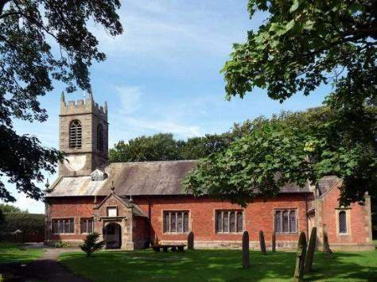
St. Michael and All Angels – Hoole

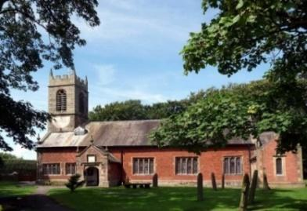

A special welcome to our church again this morning.
Please observe social distancing, but stay close to Christ.

Sunday 25th October 2020

BIBLE SUNDAY

‘Your word is a lamp to my feet and a light to my path’ Psalm 119: v 105.

PRAYER OF THE DAY: Blessed Lord, who caused all holy
Scriptures to be written for our learning: help us so to hear them,
to read, mark, learn and inwardly digest them that, through patience,
and the comfort of your holy word, we may embrace and for ever hold
fast the hope of everlasting life, which you have given us in our
Saviour Jesus Christ, who is alive and reigns with you, in the unity of
the Holy Spirit, one God, now and for ever. Amen.

No Sunday School today during the service
There are toys for younger children at the
back of church. Lego Church at 3.45pm

9.00am. Holy Communion (Book of Common Prayer) begins p237

10.30am. Morning Worship. Reading: Luke 4: v 14-24.
Hymns : 67 – Be still for the presence of the Lord.
Supplement 11: You’re the word of God the Father.
Canticle 2: Benedictus.
420: Lord, thy word abideth.
465: Name of all majesty.
12.00noon. Annual Church Meeting (in church)
3.45pm. Lego Church (in Church)

BIBLE READING: Luke 4: v 14-24.
‘Your word is a lamp to my feet and a light to my path’
Jesus returned to Galilee in the power of the Spirit, and news about him spread through the whole countryside. He was teaching in their synagogues, and everyone praised him. He went to Nazareth, where he had been brought up, and on the Sabbath day he went into the synagogue, as was his custom. He stood up to read, and the scroll of the prophet Isaiah was handed to him. Unrolling it, he found the place where it is written:

“The Spirit of the Lord is on me, because he has anointed me to
proclaim good news to the poor. He has sent me to proclaim
freedom for the prisoners and recovery of sight for the blind, to
set the oppressed free, to proclaim the year of the Lord’s favour.”

Then he rolled up the scroll, gave it back to the attendant and sat down. The eyes of everyone in the synagogue were fastened on him. He began by saying to them, “Today this scripture is fulfilled in your hearing.”
All spoke well of him and were amazed at the gracious words that came from his lips. “Isn’t this Joseph’s son?” they asked.
Jesus said to them, “Surely you will quote this proverb to me: ‘Physician, heal yourself!’ And you will tell me, ‘Do here in your hometown what we have heard that you did in Capernaum.’”
“Truly I tell you,” he continued, “no prophet is accepted in his hometown.

‘Your word is a lamp to my feet and a light to my path’
THE BIBLE SPEAKS TO ST MICHAEL’S TODAY
1. Matthew 11 v 28 – Come to Me all you who are weary and burdened, and I will give you rest.
2. John 3 v 16 – God so loved the world that He gave His one and only Son, that whoever believes in Him shall not perish but have eternal life.
3. Matthew 6 v 34:Therefore do not worry about tomorrow, for tomorrow will worry about itself.
4.Luke1v49 The Mighty One has done great things for me: holy is His Name
5. Hebrews 10 v 24-25 – Let us consider how we may spur one another on towards love and good deeds. Let us not give up meeting together, as some are in the habit of doing, but let us encourage one another
Prayer. We pray for those who are sick and in need, especially Finley Morris, Michael Harrison, baby Schultz, Paul Wignall, Bob Maxfield, Tony Brogden, Neil Heywood, Eva Coxhead, Tom Parkinson and Alan Fleetwood
THE CHURCH ANNUAL MEETING IS TODAY 12noon. Please stay
URGENTLY NEEDED: A new Church Treasurer to free Barbara up for another role. NEXT BIBLE STUDY; DON’T STEAL
Monday 26th– Zoom or in Church with brief Service of Compline
This Autumn we are looking at the 10 Commandments on You tube. Go to J John Just 10 Kingsgate Week, Don’t steal is session3