PARISH DIARY
Monday Dec 7th 7.30pm. Bible Study Group (6): Honour your Father and
Mother. By Zoom or in Church with Compline
Friday Dec 11th 6.30pm. Youth Alpha Group
Sunday Dec 13th 9.00am. Holy Communion (Book of Common Prayer )
10.30am. Morning Worship with Sunday School
and Youth Alpha Group.
Commissioning of Sidespeople Team
Tues Dec 15th 7.30pm. CHRISTMAS SOCIAL with CAROLS AND CHRISTMAS QUIZ BY ZOOM
Sunday Dec 20th 9.00am. Holy Communion (Book of Common Prayer )
10.30am. Parish Communion with Sunday School.
6.00pm. CAROLS BY CANDLELIGHT.
Monday Dec 21st 2.30pm. Interment of Ashes (Barbara McManmon).
CHRISTMAS EVE 4.00pm. CRIB SERVICE
11.30pm. MIDNIGHT COMMUNION.
CHRISTMAS DAY 10.30am. FAMILY SERVICE with
CAROLS AND COMMUNION.
Sunday Dec 27th 10.30am. Morning Worship with Sunday School.

Sunday Jan 3rd 9.00am. Holy Communion (Book of Common Prayer )
10.30am. Parish Communion with Sunday School.

Sunday Jan 10th 9.00am. Holy Communion (Book of Common Prayer )
10.30am. Morning Worship with Sunday School
FUTURE DATES
Friday Jan 22nd Parish Quiz (if permitted)

Please Note. Our church is open daily throughout the week from
9.30am to 4.30pm for visiting and private prayer.

Suggested Readings this week
Mon. Dec 7th Luke 5: v 17-26. Tues. Dec 8th Matthew 18: v 12-14.
Wed. Dec 9th Matthew 11: 28-end. Thurs. Dec 10th Matthew 11: v 11-15.
Fri. Dec 11th Matthew 11: v 16-19. Sat. Dec 12th Matthew 17: v 10-13.

Our Facebook page: St Michael and All Angels Church, Hoole, our website is www.hooleparishchurch.com

Rector – Revd Ann Templeman anntempleman@live.co.uk 01772 448515
The Rectory, 69 Liverpool Old Road Much Hoole PR4 4RB
Please take this sheet home with you
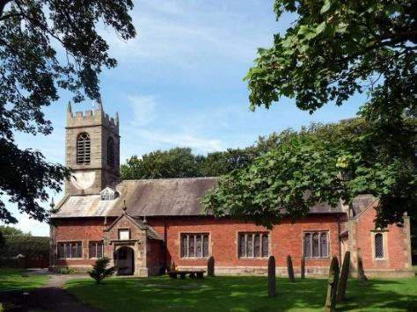
St. Michael and All Angels – Hoole

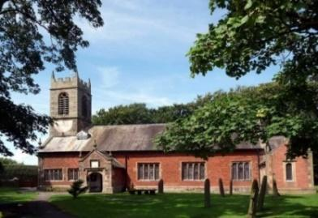

A special welcome back to our church again this morning.
Please observe social distancing, but stay close to Christ.

Sunday 6th December 2020 Advent 2.

THE CALL OF GOD

A voice of one calling in the desert Isaiah 40: v3.
“ Prepare the way for the Lord”

PRAYER OF THE DAY: Almighty God,
purify our hearts and minds, that when your Son Jesus Christ comes
again as Judge and Saviour we may be ready to receive him,
who is our Lord and our God. Amen.

No Sunday School today, Toy and Christingle service at 3.45pm. There are toys for younger children at the back of church.

9.00am. Holy Communion (Book of Common Prayer) begins p237

10.30am. Parish Communion.
Readings: Isaiah 40: v 1-11. Mark 1: v 1 - 3.
Hymns : 259 – Hail to the Lord’s anointed.
144 – Dear Lord and Father of mankind.
658 – There is a Redeemer.
405 – Lo He comes with clouds descending.
H/C Hymn: Supplement 2 – How deep the Father’s love.

3.45pm. Toy and Christingle Service

BIBLE READINGS: Isaiah 40: v 1-11.
Comfort, comfort my people, says your God. Speak tenderly to Jerusalem,
and proclaim to her that her hard service has been completed, that her sin has been paid for, that she has received from the Lord’s hand double for all her sins. A voice of one calling:
‘In the wilderness prepare the way for the Lord; make straight in the
desert a highway for our God. Every valley shall be raised up,
every mountain and hill made low; the rough ground shall become level,
the rugged places a plain. And the glory of the Lord will be revealed,
and all people will see it together. For the mouth of the Lord has
spoken.’ A voice says, ‘Cry out.’ And I said, ‘What shall I cry?’

‘All people are like grass, and all their faithfulness is like the flowers of the field. The grass withers and the flowers fall, because the breath of the Lord blows on them. Surely the people are grass. The grass withers and the flowers fall, but the word of our God endures for ever.’ You who bring good news to Zion, go up on a high mountain. You who bring good news to Jerusalem, lift up your voice with a shout, lift it up, do not be afraid; say to the towns of Judah, ‘Here is your God!’ See, the Sovereign Lord comes with power, and he rules with a mighty arm. See, his reward is with him,
and his recompense accompanies him. He tends his flock like a shepherd:
he gathers the lambs in his arms and carries them close to his heart; he gently leads those that have young.
Mark 1: v 1-3. The beginning of the good news about Jesus
the Messiah, the Son of God, as it is written in Isaiah the prophet:
‘I will send my messenger ahead of you, who will prepare your way’ –
‘a voice of one calling in the wilderness, “Prepare the way for the Lord,
make straight paths for him.”
Prayer. We pray for those who are sick and in need, especially Michael Pulvermacher, Bob Maxfield, Baby Erica Ivy, Rita Davidson
Ian Wilkinson, Beryl Carr, Tom and Susan Parkinson.

BIBLE STUDIES / GROWTH GROUP Monday 7th December at 7.30pm
JUST 10 – Session 6 Honour your Father and Mother
Zoom or in church with a brief Service of Compline.

Things to Collect: The weekly giving envelopes for 2021 are now available by the font. Please collect yours and also if possible pass on any others.
CHRISTMAS SOCIAL BY ZOOM
Tuesday 15th December 7.30 – c 8.30pm
Everyone is invited to St Michael’s Christmas social.
Carols, Christmas Quiz, Drama
Bring your own celebration drink and mincepie.
Zoom link will be sent to all on electoral roll
CONFIRMATION 7th March 2021 at 10.30am
Bishop Jill Duff is coming to St Michael’s to confirm a number of adults and young people. Preparation classes are about to start for both groups. Please let me know if you would like to join. The adult sessions will also be helpful to anyone simply wishing to explore Christian basics

