PARISH DIARY
Tues Dec 15th 7.30pm. CHRISTMAS SOCIAL with CAROLS AND CHRISTMAS QUIZ BY ZOOM
Sunday Dec 20th 9.00am. Holy Communion (Book of Common Prayer )
10.30am. Parish Communion with Sunday School.
6.00pm. CAROLS BY CANDLELIGHT.
Monday Dec 21st 2.30pm. Interment of Ashes (Barbara McManmon).
CHRISTMAS EVE 4.00pm. CRIB SERVICE
11.30pm. MIDNIGHT COMMUNION.
CHRISTMAS DAY 10.30am. FAMILY SERVICE with
CAROLS AND COMMUNION.
Sunday Dec 27th 10.30am. Morning Worship.

Sunday Jan 3rd 9.00am. Holy Communion (Book of Common Prayer )
10.30am. Parish Communion with Sunday School.

Sunday Jan 10th 9.00am. Holy Communion (Book of Common Prayer )
10.30am. Morning Worship with Sunday School
Monday 11th Jan 7.30pm Bible Study in church and by Zoom;
‘Keep the Sabbath – Take a Break’
Sunday Jan 17th 9.00am. Holy Communion (Book of Common Prayer )
10.30am. Parish Communion with Sunday School.
3.45pm. FAMILY CHURCH LIGHT PARTY.
Monday Jan 18th 7.30pm. PCC Meeting.
Tuesday 11th January 7.30pm Bible Study in church and by Zoom;
‘Keep the Sabbath – Take a Break’
Sunday Jan 24th 9.00am. Holy Communion (Book of Common Prayer )
10.30am. Morning Worship with Sunday School

KEY FUTURE DATES
Sunday March 9th 10.03am. Confirmation Service with Bishop Jill Duff..
Suggested Readings this week
Mon. Dec 14th Matthew 21: v 23-27. Tues. Dec 15th Matthew 21: v 28-32.
Wed. Dec 16th Luke 7: 18b-23. Thurs. Dec 17th Matthew 1: v 1-17.
Fri. Dec 18th Matthew 1: v 18-24. Sat. Dec 19th Luke 1: v 5-25.

Our Facebook page: St Michael and All Angels Church, Hoole, our website is www.hooleparishchurch.com

Rector – Revd Ann Templeman anntempleman@live.co.uk 01772 448515
The Rectory, 69 Liverpool Old Road Much Hoole PR4 4RB
Please take this sheet home with you
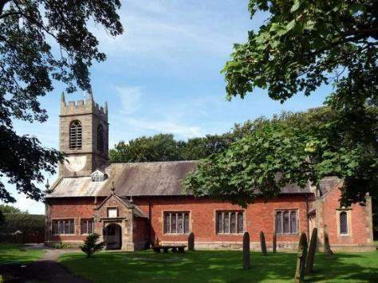
St. Michael and All Angels – Hoole

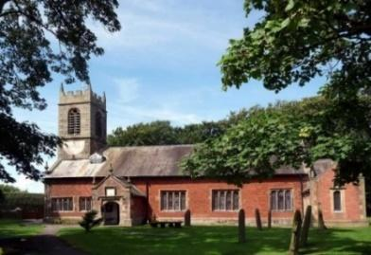

A special welcome to our church again this morning.
Please observe social distancing, but stay close to Christ.

Sunday 13th December 2020 Advent 3.

THE END OF DEATH

“The Lord Almighty will swallow up death for ever.” Isaiah 25: v 8.

PRAYER OF THE DAY: God for whom we watch and wait,
you sent John the Baptist to prepare the way of your Son:
give us courage to speak the truth, to hunger for justice, and to suffer
for the cause of right, with Jesus Christ our Lord. Amen.

Sunday School for ages 3-11during the service
There are toys for younger children at the back of church. Sunday School meets outside in the marquee during the sermon and prayers.

9.00am. Holy Communion (Book of Common Prayer) begins p237

10.30am. Morning Worship with Sunday School
and Youth Alpha Group.
Commissioning of Sidespeople Team.
Readings: Isaiah 25: v 6-9 and 26: v 1-6.

Hymns : 419 – Lord the light of your love (Shine Jesus shine).
370 – Joy to the world.
Supplement 9– The Lord’s my shepherd.
108 – Colours of day.
372 – Judge eternal, throned in splendour.
BIBLE READING: Isaiah 25: v 6-9 and 26: 1-6.
On this mountain the Lord Almighty will prepare a feast of rich food for all peoples, a banquet of aged wine – the best of meats and the finest
of wines. On this mountain he will destroy the shroud that enfolds all peoples, the sheet that covers all nations; he will swallow up death for ever.
The Sovereign Lord will wipe away the tears from all faces; he will remove his people’s disgrace from all the earth. The Lord has spoken.
In that day they will say, ‘Surely this is our God; we trusted in him, and he saved us. This is the Lord, we trusted in him; let us rejoice and be glad in his salvation.’

We have a strong city; God makes salvation its walls and ramparts.
Open the gates that the righteous nation may enter, the nation that keeps faith. You will keep in perfect peace those whose minds are steadfast,
because they trust in you. Trust in the Lord forever, for the Lord, the Lord himself, is the Rock eternal. He humbles those who dwell on high,
he lays the lofty city low; he levels it to the ground and casts it down to the dust. Feet trample it down—the feet of the oppressed, the footsteps of the poor.

Prayer. We pray for those who are sick and in need, especially Michael Pulvermacher, Bob Maxfield, Laura Baller, Baby Erica Ivy, Rita Davidson
Ian Wilkinson, Beryl Carr, and Tom Parkinson.

The Weekly Giving Envelopes for 2021 are now available by the font.
Please collect yours and also if possible pass on any others to friends or
neighbours..

CONFIRMATION 7th March 2021 at 10.30am
Bishop Jill Duff is coming to St Michael’s to confirm a number of adults and young people. Preparation classes are about to start for both groups. Please let me know if you would like to join.
The adult sessions will also be helpful to anyone simply wishing to explore Christian basics

CHRISTMAS SOCIAL BY ZOOM
Tuesday 15th December 7.30 – c 8.30pm
Everyone is invited to St Michael’s Christmas social.
Carols, Christmas Quiz etc by Zoom
Bring your own celebration drink and mincepie.
Zoom link will be sent to all on electoral roll

