PARISH DIARY
Monday Dec 21st 2.30pm. Interment of Ashes (Barbara McManmon).
CHRISTMAS EVE 4.00pm. CRIB SERVICE
11.30pm. MIDNIGHT COMMUNION.
CHRISTMAS DAY 10.30am. FAMILY SERVICE with
CAROLS AND COMMUNION.
Sunday Dec 27th 10.30am. Morning Worship.

Sunday Jan 3rd 9.00am. Holy Communion (Book of Common Prayer )
10.30am. Parish Communion with Sunday School.

Sunday Jan 10th 9.00am. Holy Communion (Book of Common Prayer )
10.30am. Morning Worship with Sunday School
Monday 11th Jan 7.30pm. Bible Study in church and by Zoom;
‘Keep the Sabbath – Take a Break’
Sunday Jan 17th 9.00am. Holy Communion (Book of Common Prayer )
10.30am. Parish Communion with Sunday School.
3.45pm. FAMILY CHURCH LIGHT PARTY.
Monday Jan 18th 7.30pm. PCC Meeting.
Tuesday 19th Jan 7.30pm Bible Study in church and by Zoom;
‘Keep the Sabbath – Take a Break’
Sunday Jan 24th 9.00am Holy Communion (Book of Common Prayer )
10.30am Morning Worship with Sunday School
Sunday Jan 31st 9.00am. Holy Communion (Book of Common Prayer )
10.30am All Age Worship
Sunday Feb 7th 9.00am Holy Communion (Book of Common Prayer )
10.30am Parish Communion with Sunday School.

KEY FUTURE DATES
Sunday March 7th 10.30am Confirmation Service with Bishop Jill Duff.

Suggested Readings this week.
Mon. Dec 21st Luke 1: v 39-45. Tues. Dec 22nd Luke 1: v 46-56.
Wed. Dec 23rd Luke 1: v 57-66. Thurs. Dec 24th Luke 1: v 67-79.
Fri. Dec 25th Christmas Day – The birth of Christ: Luke 2: v 1-20.
Sat. Dec 26th Boxing Day – St Stephen (Martyr): Acts 7: v 51-end.

Our Facebook page: St Michael and All Angels Church, Hoole, our website is www.hooleparishchurch.com

Rector – Revd Ann Templeman anntempleman@live.co.uk 01772 448515
The Rectory, 69 Liverpool Old Road Much Hoole PR4 4RB
Please take this sheet home with you
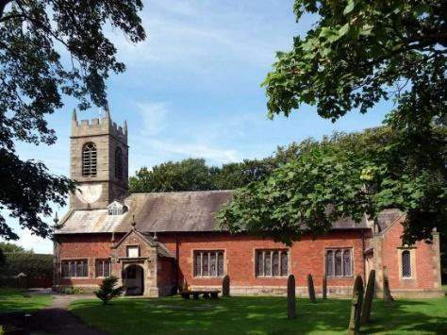
St. Michael and All Angels – Hoole

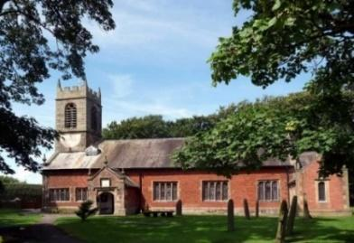

A special welcome to our church again this morning.
Please observe social distancing, but stay close to Christ.

Sunday 20th December 2020 Advent 4.

MARY’S RESPONSE TO GOD’S INITIATIVE

“I am the Lord’s Servant” Mary replied,
“May your word to me be fulfilled.” Luke 1: v 38.

PRAYER OF THE DAY: Eternal God, as Mary waited for the birth
of your Son, so we wait for his coming in glory; bring us through the
birth pangs of this present age to see, with her, our great salvation
in Jesus Christ our Lord. Amen.

Sunday School for ages 3-11during the service
There are toys for younger children at the back of church. Sunday School will meet during the sermon and prayers.

9.00am. Holy Communion (Book of Common Prayer) begins p237

10.30am. Morning Worship with Sunday School
Readings: Luke 1: v 1-4; Luke 1: v 26-38:
Philippians 2: v 10 & 11.

Hymns : 631 – Tell out my soul.
Children’s Song.
486 – Of the Father’s love begotten.
332 – I the Lord of sea and sky.
H/C Hymn: 588 – See amid the winter’s snow.
BIBLE READINGS: Luke 1: v 1-4: Many have undertaken to draw up an account of the things that have been fulfilled among us, just as they were handed down to us by those who from the first were eye witnesses and servants of the word. With this in mind, since I myself have carefully investigated everything from the beginning, I too decided to write an orderly account for you, most excellent Theophilus, so that you may know the certainty of the things you have been taught.

Luke 1: v 26-38: In the sixth month of Elizabeth’s pregnancy, God sent the angel Gabriel to Nazareth, a town in Galilee, to a virgin pledged to be married to a man named Joseph, a descendant of David. The virgin’s name was Mary. The angel went to her and said, ‘Greetings, you who are highly favoured! The Lord is with you.’
Mary was greatly troubled at his words and wondered what kind of greeting this might be. But the angel said to her, ‘Do not be afraid, Mary, you have found favour with God. You will conceive and give birth to a son, and you are to call him Jesus. He will be great and will be called the Son of the Most High. The Lord God will give him the throne of his father David, and he will reign over Jacob’s descendants for ever; his kingdom will never end.’ ‘How will this be,’ Mary asked the angel, ‘since I am a virgin?’
The angel answered, ‘The Holy Spirit will come on you, and the power of the Most High will overshadow you. So the holy one to be born will be called the Son of God. Even Elizabeth your relative is going to have a child in her old age, and she who was said to be unable to conceive is in her sixth month. For no word from God will ever fail.’
‘I am the Lord’s servant,’ Mary answered. ‘May your word to me be fulfilled.’ Then the angel left her.

Philippians 2: v 10 & 11. God exalted him thus, that at the name of Jesus every knee should bow, in heaven and on earth and under the earth, and every tongue acknowledge that Jesus Christ is Lord, to the glory of God the Father.

Prayer. We pray for those who are sick and in need, especially Michael Pulvermacher, Baby Erica Ivy, Ian Wilkinson and Beryl Carr. We give thanks for the life of Barbara McManmon whose ashes are to be interred tomorrow and pray for her family and friends

The Weekly Giving Envelopes for 2021 are now available by the font.
Please collect yours and also if possible pass on any others to friends. or
CONFIRMATION 7th March 2021 at 10.30am
Bishop Jill Duff is coming to St Michael’s to confirm a number of adults and young people. Preparation classes are about to start for both groups. Please let me know if you would like to join.
The adult sessions will also be helpful to anyone simply wishing to explore Christian basics
