PARISH DIARY

Monday 11th Jan 7.30pm. Bible Study by Zoom;
‘Keep the Sabbath – Take a Break’
Sunday Jan 17th 9.00am. Holy Communion (BCP )
10.30am. Parish Communion.
Monday Jan 18th 7.30pm. PCC Meeting by Zoom.
Tuesday 19th Jan 7.30pm Bible Study by Zoom;
‘Keep the Sabbath – Take a Break’
Sunday Jan 24th 9.00am Holy Communion (BCP)
10.30am Morning Worship
Sunday Jan 31st 9.00am. Holy Communion (BCP)
10.30am All Age Worship
Sunday Feb 7th 9.00am Holy Communion (BCP )
10.30am Parish Communion
Sunday Feb 14th 9.00am. Holy Communion (BCP)
10.30am. Morning Worship

KEY FUTURE DATES
Sunday March 7th 10.30am Confirmation Service with Bishop Jill Duff.
Suggested Readings this week.
Mon. Jan 11th Mark 1: v 14-20. The Calling of the First Disciples.
Tues. Jan 12th Mark 1: v 21-28. Jesus Drives Out an Evil Spirit.
Wed. Jan 13th Mark 1: v 29-39. Jesus Heals Many and Prays Solitarily.
Thurs. Jan 14th Mark 1: v 40-end. A man with leprosy
Fri. Jan 15th Mark 2: v 1-12. Jesus Heals a Paralytic.
Sat. Jan 16th Mark 2: v 13-17. The Calling of Levi.
The recording of today’s 10.30am service will be on our website this afternoon

Our Facebook page: St Michael and All Angels Church, Hoole, our website is www.hooleparishchurch.com
Rector – Revd Ann Templeman anntempleman@live.co.uk 01772 448515
The Rectory, 69 Liverpool Old Road Much Hoole PR4 4RB
Please take this sheet home with you

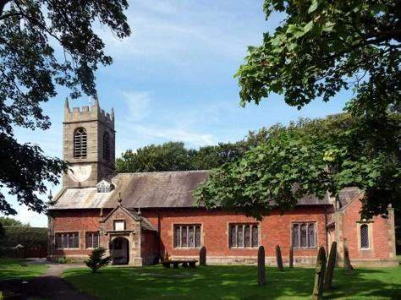
St. Michael and All Angels – Hoole

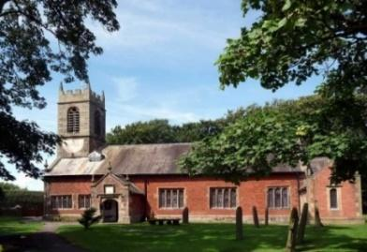

A special welcome to our church again this morning.
Please observe social distancing, but stay close to Christ.

Sunday 10th January 2021

NEW BEGINNINGS / THE BAPTISM OF JESUS

“Therefore go and make disciples of all nations, baptising them in the name of the Father and of the Son and of the Holy Spirit.” Matthew 28 v 19.

PRAYER OF THE DAY: Eternal Father, who at the baptism of Jesus
revealed him to be your Son, anointing him with the Holy Spirit:
grant to us, who are born again by water and the Spirit, that we may
be faithful to our calling as your adopted children; through Jesus
Christ your Son our Lord, who is alive and reigns with you,
in the unity of the Holy Spirit, one God, now and for ever. Amen.

The children will be staying in the service today and contributing to it.
There are toys for younger children at the back

9.00am. Holy Communion (Book of Common Prayer) begins p237

10.30am. Morning Worship

Readings: Mark 1: v 4-11 Matthew 28: v 19.

Hymns : 409 – Lord for the years.
Inside sheet – O Christ the same.
195 – From heaven you came (The Servant King).
BIBLE READINGS: Mark 1: v 4-11: John the Baptist appeared in the wilderness, preaching a baptism of repentance for the forgiveness of sins. The whole Judean countryside and all the people of Jerusalem went out to him. Confessing their sins, they were baptised by him in the River Jordan. John wore clothing made of camel’s hair, with a leather belt round his waist, and he ate locusts and wild honey. And this was his message: ‘After me comes the one more powerful than I, the straps of whose sandals I am not worthy to stoop down and untie. I baptise you with water, but he will baptise you with the Holy Spirit.’
At that time Jesus came from Nazareth in Galilee and was baptised by John in the Jordan. Just as Jesus was coming up out of the water, he saw heaven being torn open and the Spirit descending on him like a dove. And a voice came from heaven: ‘You are my Son, whom I love; with you I am well pleased.’

Matthew 28: v 19. Therefore go and make disciples of all nations, baptising them in the name of the Father and of the Son and of the Holy Spirit.

Hymn: O Christ the same through all our story's pages,
Our loves and hopes, our failures and our fears;
Eternal Lord, the King of all the ages,
Unchanging still, amid the passing years:
O living Word, the source of all creation,
Who spread the skies, and set the stars ablaze,
O Christ the same, who wrought man's whole salvation,
We bring our thanks for all our yesterdays.
O Christ the same, the friend of sinners, sharing
Our inmost thoughts, the secrets none can hide,
Still as of old upon your body bearing
The marks of love, in triumph glorified:
O Son of Man, who stooped for us from heaven,
O Prince of life, in all your saving power,
O Christ the same, to whom our hearts are given,
We bring our thanks for this the present hour.
O Christ the same, secure within whose keeping
Our lives and loves, our days and years remain,
Our work and rest, our waking and our sleeping,
Our calm and storm, our pleasure and our pain:
O Lord of love, for all our joys and sorrows,
For all our hopes, when earth shall fade and flee,
O Christ the same, for all our brief tomorrows,
We bring our thanks for all that is to be.
Prayer. We pray for our school at this time – the children, their parents and staff. We pray too for those who are sick, especially Michael Pulvermacher, Baby Erica Ivy, Beryl Carr and Tom Parkinson and for all those recently ereaved.

The Weekly Giving Envelopes There are still some envelopes for this year
to be collected by the font. Please collect yours and also if possible pass on
any others to friends or neighbours.

Please also take a pew sheet to any friends who are unable to attend church at present.

BIBLE STUDIES. These begin again this week on Zoom continuing our series on the 10 commandments. Why not make this part of your new beginning in 2021.
On Mon 11th and Tues 19th Jan at 7.30pm we will be looking at the 4th Commandment ‘Keep the Sabbath’ or ‘Take a Break’.
The Zoom link will be sent round and will be on the website in the pew sheet. Try listening to J.John on Youtube on Just 10 session 7 Kingsgate Community centre

CONFIRMATION 7th March 2021 at 10.30am
Bishop Jill Duff is coming to St Michael’s to confirm a number of adults and young people. Preparation classes are about to start for both groups. Please let me know if you would like to join.
ST MICHAEL’S NEW YEAR ZOOM SOCIAL
Come and join us on Friday 15th January 7.30PM
QUIZ AND MUSIC FROM COLIN AND CAROLE

Zoom link on website on pew sheet

