PARISH DIARY
Please see website & pew sheets for weekly update on services

Monday Jan 18th 7.30pm. PCC Meeting by Zoom.
Tuesday 19th Jan 7.30pm Bible Study by Zoom;
‘Keep the Sabbath – Take a Break’
Sunday Jan 24th 9.00am Holy Communion (said)
10.30am Morning Worship (?Zoom)
Monday Jan 25th 7.30pm Bible Study by Zoom
Sunday Jan 31st 9.00am. Holy Communion (said)
10.30am Morning Worship
Tuesday Feb 2nd 7.30pm Bible Study by Zoom
Sunday Feb 7th 9.00am Holy Communion (said )
10.30am Morning Worship (?Zoom)
Sunday Feb 14th 9.00am. Holy Communion (said)
10.30am. Morning Worship (?Zoom )
We will aim to have recordings of all virtual services on the website by Sunday lunch time.

The Zoom link for our Zoom services for those who wish to join will be on the front page of the website.

KEY FUTURE DATES
Sunday March 7th 10.30am Confirmation Service with Bishop Jill Suggested Readings this week.
Mon. Jan 18th Mark 2: v 18-22. Jesus Questioned about Fasting.
Tues. Jan 19th Mark 2: v 23-end. Lord of the Sabbath.
Wed. Jan 20th Mark 3: v 1-6. Jesus in the Synagogue on the Sabbath.
Thurs. Jan 21st Mark 3: v 7-12. Crowds Follow Jesus.
Fri. Jan 22nd Mark 3: v 13-19. The Appointing of the Twelve Apostles.
Sat. Jan 23rd Mark 2: v 20-end. Jesus and Beelzebub.
Our Facebook page: St Michael and All Angels Church, Hoole, our website is www.hooleparishchurch.com
Rector – Revd Ann Templeman anntempleman@live.co.uk 01772 448515
The Rectory, 69 Liverpool Old Road Much Hoole PR4 4RB
Please take this sheet home with you
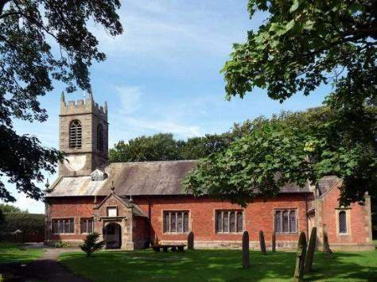
St. Michael and All Angels – Hoole

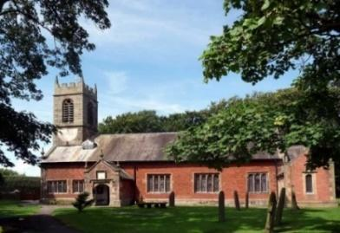

A special welcome to our church again this morning.
Please observe social distancing, but stay close to Christ.

Sunday 17th January 2021 Epiphany 2

Jesus turns water into wine – Jesus’ transforming power.

100% PROOF

“You have saved the best until now.” John 2: v 10.

PRAYER OF THE DAY: Almighty God,
in Christ you make all things new: transform the poverty of our
nature by the riches of your grace, and in the renewal of our lives
make known your heavenly glory; through Jesus Christ your Son our
Lord, who is alive and reigns with you, in the unity of the Holy Spirit,
one God, now and for ever. Amen.

There will be a ‘break out group’ opportunity for young people during the sermon
within the Zoom Service today.

9.00am. Holy Communion (Book of Common Prayer) begins p237

10.30am. Morning Worship (Zoom Service)

Reading: John 2: v 1-11.

Hymns : 54 – At the Name of Jesus.
727 – What a friend we have in Jesus.
428 – Love Divine.
BIBLE READINGS: John 2: v 1-11: On the third day a wedding took place at Cana in Galilee. Jesus’ mother was there, and Jesus and his disciples had also been invited to the wedding. When the wine was gone, Jesus’ mother said to him, “They have no more wine.” “Woman, why do you involve me?” Jesus replied. “My hour has not yet come.” His mother said to the servants, “Do whatever he tells you.”
Nearby stood six stone water jars, the kind used by the Jews for ceremonial washing, each holding from twenty to thirty gallons. Jesus said to the servants, “Fill the jars with water”; so they filled them to the brim.
Then he told them, “Now draw some out and take it to the master of the banquet.”
They did so, and the master of the banquet tasted the water that had been turned into wine. He did not realize where it had come from, though the servants who had drawn the water knew. Then he called the bridegroom aside and said, “Everyone brings out the choice wine first and then the cheaper wine after the guests have had too much to drink; but you have saved the best till now.” What Jesus did here in Cana of Galilee was the first of the signs through which he revealed his glory; and his disciples believed in him.
Thanks so much to Colin and Carole for a really great New Year Social and Quiz on Friday night.
Do you know who is the fastest milkman in the West??!
Look out for the next Social

Prayer. We pray for the schools in our parish at this time – the children, their parents and staff. We pray for our Confirmation Group, preparing for Confirmation in March 7th. We pray too for those who are sick, especially Michael Pulvermacher, Eva Coxhead, Baby Erica Ivy, Beryl Carr and Tom Parkinson. We give thanks for the lives of Eric Tattersall and Lesley Staziker and pray for their families and friends.

The Weekly Giving Envelopes There are still some envelopes for this year to be collected by the font. Please collect yours and also if possible pass on any others to friends or neighbours.

Please also take a pew sheet to any friends who are unable to attend church at present.

BIBLE STUDIES. These continue this week on Zoom in our series on the 10 commandments. Why not make this part of your new beginning in 2021.
On Tues 19th Jan at 7.30pm we will be looking at the 4th Commandment ‘Keep the Sabbath’ or ‘Take a Break’.
The Zoom link will be sent round and will be on the website in the pew sheet. Try listening to J.John on You tube on Just 10 session 7 Kingsgate Community centre

CONFIRMATION 7th March 2021 at 10.30am
Bishop Jill Duff is coming to St Michael’s to confirm a number of adults and young people. Preparation classes are about to start for both groups. Please let me know if you would like to join.

