Parish Dates February 2021 onwards
Monday 8th February 7.30pm Bible Study by Zoom
Friday 12th February 7.30pm Zoom VALENTINE QUIZ & SOCIAL
Sunday 14th February 09.00am Holy Communion in Church
10.30am Morning Worship via Zoom
3.45pm FAMILY CHURCH LIGHT PARTY VIA ZOOM -book your place & receive your glowsticks lizboland@yahoo.co.uk
Wednesday 17th February ASH WEDNESDAY
6.00pm Holy Communion in Church
Sunday 21st February 09.00am Holy Communion in Church
10.30am Morning Worship via Zoom
Tuesday 23rd February 7.30pm Zoom Bible Study
Thursday 25th February 7.30pm Short time of Prayer via Zoom
Sunday 28th February 09.00am Holy Communion in Church
10.30am Morning Worship via Zoom
Tuesday 2nd March 7.30pm Zoom Bible Study
Thursday 4th March 7.30pm Short time of Prayer via Zoom
Sunday 7th March 09.00am Holy Communion in Church
10.30am CONFIRMATION SERVICE in Church with Bishop Jill Duff
Sunday 14th March MOTHERING SUNDAY
09.00am Holy Communion in Church
10.30am Holy Communion in Church -First Communion for Confirmation candidates
We will aim to have recordings of all virtual services on the website hooleparishchurch.com by Sunday lunch time.

The Zoom link for our Zoom services for those who wish to join will be on the front page of the website.
Our Facebook page: St Michael and All Angels Church, Hoole, our website is www.hooleparishchurch.com
Rector – Revd Ann Templeman anntempleman@live.co.uk 01772 448515
The Rectory, 69 Liverpool Old Road Much Hoole PR4 4RB

Please take this sheet home with you
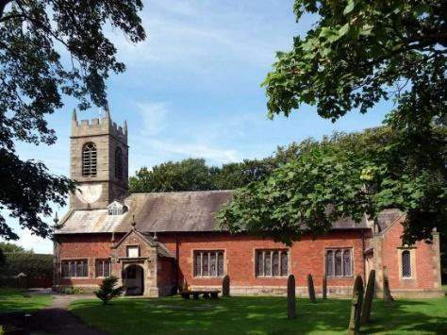
St. Michael and All Angels – Hoole

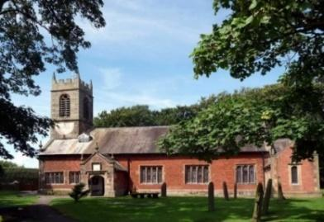

A special welcome to our church again this morning.
Please observe social distancing, but stay close to Christ.

Sunday 7th February 2021 2 before Lent

WALK IN THE LIGHT

Walk in the light - - - If we confess our sins, He is faithful and just and will forgive us our sins and purify us from all unrighteousness. 1 John 1: v 7, 9.

PRAYER OF THE DAY: Almighty God, give us reverence for all
creation and respect for every person, that we may mirror your
likeness in Jesus Christ our Lord. Amen.

There will be a ‘break out group’ opportunity for young people during the sermon
within the Zoom Service today.

9.00am. Holy Communion (Book of Common Prayer) begins p237

10.30am. Morning Worship (Zoom Service)

Reading: 1 John 1: v 1-10.

Hymns : 666 – Walk in the light.
Supp. 11 – You’re the Word of God the Father.
419 – Shine Jesus shine.

BIBLE READING: 1 John 1: v 1-10.That which was from the beginning, which we have heard, which we have seen with our eyes, which we have looked at and our hands have touched – this we proclaim concerning the Word of life. The life appeared; we have seen it and testify to it, and we proclaim to you the eternal life, which was with the Father and has appeared to us. We proclaim to you what we have seen and heard, so that you also may have fellowship with us. And our fellowship is with the Father and with his Son, Jesus Christ. We write this to make our joy complete.

This is the message we have heard from him and declare to you: God is light; in him there is no darkness at all. If we claim to have fellowship with him and yet walk in the darkness, we lie and do not live out the truth. But if we walk in the light, as he is in the light, we have fellowship with one another, and the blood of Jesus, his Son, purifies us from all sin.

If we claim to be without sin, we deceive ourselves and the truth is not in us. If we confess our sins, he is faithful and just and will forgive us our sins and purify us from all unrighteousness. If we claim we have not sinned, we make him out to be a liar and his word is not in us.

Prayer. We pray for our Confirmation Group, preparing for Confirmation on March 7th. We pray too for those who are sick, especially Michael Pulvermacher, Eva Coxhead, Baby Erica Ivy, Beryl Carr and Beryl Cotton. We give thanks for the life of James Coulton and pray for his family and friends.

BIBLE STUDIES/GROWTH GROUPS

Our next Zoom study is on Monday Feb 8th beginning at 7.30pm when we will be looking at the 2nd Commandment – KNOW GOD
Try listening to J.John on Youtube on Just 10 session 9 Kingsgate
The Zoom link has not changed and is on the website.

LENT For all Christians Lent is a time to take stock and spend more time with God. Our Bishops are providing a special booklet of daily Bible readings and prayer entitled Read, Mark and learn which will take us through the whole of Mark’s Gospel. These are completely free and will be at the back of the church for you to help yourself. Just sign your name to say you have taken one.
Lent begins for us with a live service of Holy Communion in Church at 6.00pm on Ash Wednesday Feb 17th
We will then use the Tuesday reading each week as the basis for our Zoom Bible study which will be weekly on Tuesdays throughout Lent at 7. 30pm starting on February 23rd Zoom link on website). There will also be a short time of prayer each week on Zoom on Thursdays at 7.30pm starting Feb 24th
Suggested Bible Readings this week.

Mon. Feb 8th Mark 6: v 45-end. Jesus Walks on the Water.
Tues. Feb 9th Mark 7: v 1-13. Clean and Unclean.
Wed. Feb 10th Mark 7: v 14-23. Clean and Unclean (continued).
Thurs. Feb 11th Mark 7: v 24-30. The Faith of a Syro-Phoenician woman.
Fri. Feb 12th Mark 7: v 31-end. The Healing of a Deaf and mute Man.
Sat. Feb 13th Mark 8: v 1-10. Jesus Feeds the Four Thousand

