Parish Dates From June 2022
Tuesday 28th June 10.15am Morning Prayer.
7.30pm House Group/Bible Study at The Rectory
Friday 1st July 2.00pm Wedding Jonathan Crankshaw & Lucinda Wing
Saturday 2nd July 2.00 – 4.00pm Ladies Group Summer Fete
Village Hall.

Sunday 3rd July 9.00am Holy Communion
10.30am Parish Communion with Sunday School
12.00 Baptism of Tilly and Stanley Sanderson
Monday 4th July 7.30pm House Group/Bible Study at The Rectory
Tuesday 5th July 10.15am Holy Communion .
Thursday 7th July 4.30pm Chat & Chocolate in Church.

Sunday 10th July 9.00am Holy Communion
10.30am CONFIRMATION SERVICE
WITH BISHOP TONY PORTER.
Tuesday 12th July 10.15am Holy Communion/Morning Prayer in church
7.30pm House Group/Bible Study at the Rectory

Sunday 17th July 9:00am Holy Communion
10:30am Parish Communion
3.45pm FOREST CHURCH on school field
Tuesday 19th July 10.15am Holy Communion/Morning Prayer in church.

Sunday 24th July 9:00am Holy Communion
10:30am Morning Worship with Sunday School.
Tuesday 26th July 10.15am Holy Communion/Morning Prayer in church.
Saturday 30th July 1.30pm Marriage Blessing of Emma Duxbury and
Howard Aspinall.
Sunday 31st July 9.00am Holy Communion
10.30am Parish Communion

Suggested Bible readings this week.
Monday 27th June. Matt. 8: v 18-22. Tuesday 28th June. Matt. 8: v 23-27.
Wed. 29th June. Matt. 16: v 13-19. Thursday 30th June. Matt. 9: v 1-8.
Friday 1st July. Matt. 9: v 9-13. Saturday 2nd July. Matt. 9: v 14-17.

Website : www.hooleparishchurch.com
Facebook page: St Michael and All Angels Church, Hoole,
Rector – Revd Ann Templeman anntempleman@live.co.uk 01772 448515
The Rectory, 69 Liverpool Old Road Much Hoole PR4 4RB
Please take this sheet home with you
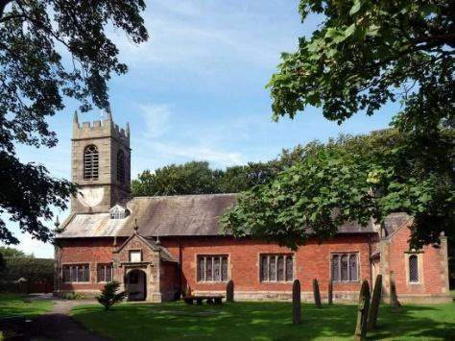
St. Michael and All Angels – Hoole

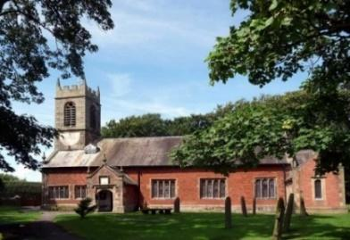

Welcome to our church again this morning, with a special welcome to Revd Richard Plant who is leading our worship today. Please stay for a chat and a cup of tea or coffee after the 10.30 service, a great way to meet people

Sunday 26th June 2022 (Trinity 2)

THE HOLY SPIRIT COMES WITH POWER

“In the last days God says I will pour out my Spirit on all people”.
Acts 2: v 17.

PRAYER OF THE DAY: Holy Spirit, sent by the Father, ignite in us
your holy fire; strengthen your children with the gift of faith, revive
your Church with the breath of love, and renew the face of the earth,
through Jesus Christ our Lord. Amen.

Sunday School today during the service
There are toys and colouring sheets
for younger children at the back of church.

9.00am. Holy Communion (Book of Common Prayer) begins p237

10.30am. Morning Worship with Sunday School

Reading: Acts 2: v 1-21.

Hymns: 676 – This is the day.
Screen – All through history.
84 – Breathe on me breath of God.
615 – Spirit of the living God. (during prayers)
114 – Come down O Love divine.
672 – Thine be the glory.
READING: Acts 2: v 1-21.
When the day of Pentecost came, they were all together in one place. Suddenly a sound like the blowing of a violent wind came from heaven and filled the whole house where they were sitting. They saw what seemed to be tongues of fire that separated and came to rest on each of them. All of them were filled with the Holy Spirit and began to speak in other tongues as the Spirit enabled them.
Now there were staying in Jerusalem God-fearing Jews from every nation under heaven. When they heard this sound, a crowd came together in bewilderment, because each one heard their own language being spoken. Utterly amazed, they asked: ‘Aren’t all these who are speaking Galileans? Then how is it that each of us hears them in our native language? Parthians, Medes and Elamites; residents of Mesopotamia, Judea and Cappadocia, Pontus and Asia, Phrygia and Pamphylia, Egypt and the parts of Libya near Cyrene; visitors from Rome (both Jews and converts to Judaism); Cretans and Arabs – we hear them declaring the wonders of God in our own tongues!’ Amazed and perplexed, they asked one another, ‘What does this mean?’ Some, however, made fun of them and said, ‘They have had too much wine.’
Then Peter stood up with the Eleven, raised his voice and addressed the crowd: ‘Fellow Jews and all of you who live in Jerusalem, let me explain this to you; listen carefully to what I say. These people are not drunk, as you suppose. It’s only nine in the morning! No, this is what was spoken by the prophet Joel:
‘“In the last days, God says, I will pour out my Spirit on all people.
Your sons and daughters will prophesy, your young men will see visions,
your old men will dream dreams.
Even on my servants, both men and women, I will pour out my Spirit in
those days, and they will prophesy.
I will show wonders in the heavens above and signs on the earth below,
blood and fire and billows of smoke.
The sun will be turned to darkness and the moon to blood before the coming
of the great and glorious day of the Lord.
And everyone who calls on the name of the Lord will be saved.”

BIBLE STUDY/ HOUSEGROUPS at the Rectory at 7.30pm
Tuesday 28th June and Monday 4th July:- 1 John 5: v 1-12.Tuesday 12th July:- 1 John 5: v 13-end.
Prayer: We pray for those preparing for Baptism Confirmation and Marriage. We pray for those who are sick, especially Erica Ivy, Rose Brown, Beryl Cottam, Tom Parkinson, Steve Coughlan, Neil Dexter, and Antonietta Broadhurst, Josephine Hodge, Isobel Wooldridge, Patricia Edwardson, Bill and Beryl Carr. We give thanks for the life of Patricia Mortimer and pray for her family and friends.

Hoole Church Ladies Group: Summer outing to Lytham Hall Tuesday 16th August at 1.00pm. This is an open event – all are welcome. Guided tour of the hall followed by afternoon tea. £20. Lifts can be arranged. Contact Honey on 613816 or Sheila on 616850.
The Ladies’ Group Summer Fete is on 2nd July from 2.00pm to 4.00pm at the Village Hall. Donations of raffle and tombola prizes please in the plastic box at the back of the church.

HEARTFELT THANKS TO EVERYONE WHO CONTRIBUTED TO OUR PLATINUM JUBILEE CELEBRATIONS.
OUR FAITHFUL QUEEN
a beautiful book commemorating 70 years of Faithful Service. £5 at back of church for OUR PLATINUM LODGE

PETER’S CRICKET BOOK
THE MAN IN THE MIDDLE – LINKING CRICKET & THE GOSPEL
£5 AT BACK OF CHURCH IN AID OF OUR PLATINUM LODGE

