**Parish Dates From May 2023**

**Sunday 21st May 9.00am Holy Communion**

**10.30am SERVICE OF CONFIRMATION + Philip**

**Monday 22nd May 2.00pm Funeral of Steve Newman**

**7.30PM PCC in the Lodge**

**Tuesday 23rd May 10.15am Holy Communion in the Lodge.**

**7.30pm Bible Study in the Lodge: What Happens when we Die.**

**Wednesday 24th May 9.30am–11.30am ST MICHAEL’S LITTLE ANGELS**

**Sunday 28th May 9.00am Holy Communion**

**PENTECOST 10.30am PARISH COMMUNION with Sunday School.**

**(1st Communion of Confirmation Candidates)**

**Tuesday 30th May 10.15am Holy Communion in the Lodge.**

**Wednesday 31st May 7.30pm in the Lodge. WHAT DO CHRISTIANS**

**BELIEVE ABOUT SAME SEX RELATIONSHIPS?**

**Thursday 1st June 4.30pm Chat and Chocolate in the Lodge.**

**Sunday 4th June 9.00am Holy Communion**

**10.30am Parish Communion with Sunday School**

**Monday 5th June 7.30pm in the Lodge. WHAT DO CHRISTIANS**

**BELIEVE ABOUT SAME SEX RELATIONSHIPS?**

**Tuesday 6th June 10.15am Holy Communion in the Lodge.**

**Wednesday 7th June 9.30am–11.30am ST MICHAEL’S LITTLE ANGELS**

**Thursday 8th June 4.30pm Bible and Biscuits in the Lodge.**

**Sunday 11th June 9.00am Holy Communion**

**10.30am Morning Worship**

**3.45PM HOLIDAY CHURCH IN THE VILLAGE HALL**

**Tuesday 13th June 10.15am Morning Prayer in the Lodge.**

**Wednesday 14th June 9.30am–11.30am ST MICHAEL’S LITTLE ANGELS**

**7.30pm Bible Study in the Lodge.**

**Thursday 15th June 4.30pm Chat and Chocolate in the Lodge.**

**Sunday 18th June 9.00am Holy Communion**

**10.30am ALL AGE SERVICE**

**Suggested Bible Readings this week please see**

**THY KINGDOM COME NOVENA BOOKLET AT BACK OF CHURCH. READINGS ARE BASED ON JOHN’S 1ST LETTER**

**www.hooleparishchurch.com**Facebook: **St Michael &All Angels Church, Hoole**,

Rector Ann Templeman anntempleman@live.co.uk 01772 448515 or 07877659156

***PLEASE TAKE THIS SHEET HOME WITH YOU.***

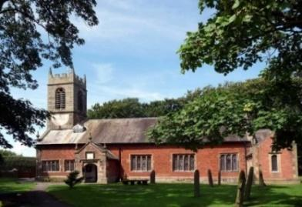

Welcome to our Church today.

***Sunday after Ascension Day - 21st May 2023***

***Alleluia, Christ is Risen - - - He is Risen indeed, Alleluia.***

**THY KINGDOM COME.**

**PRAYER FOR THY KINGDOM COME Almighty God, your ascended Son has sent us into the world to preach the good news of your kingdom: inspire us with your Spirit and fill our hearts with the fire of your love, that all who hear your Word may be drawn to you, through Jesus Christ our Lord. Amen.**

**PRAYER OF THE DAY Risen, ascended Lord, as we rejoice at your triumph, fill your Church on earth with power and compassion, that all who are estranged by sin may find forgiveness and know your peace, to the glory of God the Father. Amen**

**9.00am: Holy Communion (Book of Common Prayer) begins p237.**

**10.30am: Service of Confirmation with Bishop Philip (separate sheet)**

**Prayer:**  We pray for all those to be confirmed today - Ruby, Matthew and Austin We pray for those who are sick especially Erika Ivy, Sam Burns, Daniel Connor, Jean Smallwood, Shirley Rainsbury, Bill and Beryl Carr. We give thanks for the life of Steve Newman and pray for Hilary and his family and friends.

**THY KINGDOM COME**

**Please help yourself to the beautiful free daily prayer books Novena at the back of the church as we pray with Christians all over the world from now till Pentecost next Sunday; THY KINGDOM COME**

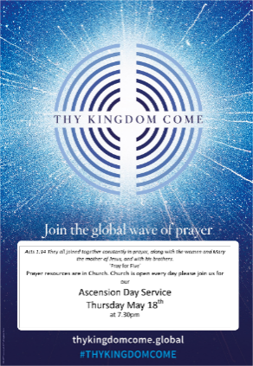**Reading. John 17: v 1-11.**After Jesus said this, he looked towards heaven and prayed: ‘Father, the hour has come. Glorify your Son, that your Son may glorify you. For you granted him authority over all people that he might give eternal life to all those you have given him. Now this is eternal life: that they know you, the only true God, and Jesus Christ, whom you have sent. I have brought you glory on earth by finishing the work you gave me to do. And now, Father, glorify me in your presence with the glory I had with you before the world began.

‘I have revealed you to those whom you gave me out of the world. They were yours; you gave them to me and they have obeyed your word. Now they know that everything you have given me comes from you. For I gave them the words you gave me and they accepted them. They knew with certainty that I came from you, and they believed that you sent me. I pray for them. I am not praying for the world, but for those you have given me, for they are yours. All I have is yours, and all you have is mine. And glory has come to me through them. I will remain in the world no longer, but they are still in the world, and I am coming to you. Holy Father, protect them by the power of[b] your name, the name you gave me, so that they may be one as we are one.

**WHAT HAPPENS WHEN WE DIE? The second session has been moved from Mon 15th May to Tues 23rd May 7.30 in the Lodge**

**WHAT IS THE CHRISTIAN TEACHING ON SAME SEX RELATIONSHIPS?**

**Wednesday 31st May repeated Monday 5th June 7.30pm in the Lodge**



