**Parish Dates From March 2022**

**Tuesday 12th April 10.15am Holy Communion.**

**7.30pm Men’s Fellowship Village Hall; How Ormskirk treated evacuees from Liverpool..**

**MAUNDY THURS 14th April 7.00pm PASSOVER MEAL St Michael’s School. Friday 15th April 11.00am FAMILY CHURCH**

**GOOD FRIDAY 12.00- 1.30pm Christian Aid lunch in Village Hall.**

**£5.00 for Afghanistan, Syria and Ukraine.**

**2.00pm AN HOUR AND A HALF AT THE CROSS**

**IN CHURCH incorporating THE TRIAL by St Michael’s Players.**

**Sunday 17th April 09.00am Holy Communion**

**EASTER DAY 10.30am PARISH COMMUNION**

**WITH EASTER EGG HUNT FOR CHILDREN.**

**Monday 18th April 12.00noon Interment of ashes – Brian Gregory.**

**Tuesday 19th April 10.15am Holy Communion**

**7.30pm Ladies’ Group in the Village Hall -**

**Jubilee Sailing Trust**

**Sunday 24th April 09.00am Holy Communion**

**10.30am Family Worship with Sunday School.**

**Tuesday 26th April 10.15am Prayer time in church.**

**Sunday 24th April 09.00am Holy Communion**

**10.30am Parish Communion with Sunday School.**

**4.00pm Holy Communion (Old Mill Court)**

**PARISH WALK – Friday April 22nd COME AND JOIN US**!

Start at Dolphin, Marsh Lane. Meet at Dolphin Car Park 4.20pm for 4.30pm start. Walk around the Marsh Area will take 1hr 15 mins approx. Ending up at the Dolphin Pub for Fish & Chips tea. Vegetarian and Coeliac menu available. Length of walk 3 to 4 miles approx. Please give your names to Colin Wilson, Sheila Taylor or Rev Ann. Hope you can join

us.

**Website :** **www.hooleparishchurch.com**

Facebook page: **St Michael and All Angels Church, Hoole**,

Rector – Revd Ann Templeman anntempleman@live.co.uk 01772 448515

The Rectory, 69 Liverpool Old Road Much Hoole PR4 4RB

*Please take this sheet home with you*

**St. Michael and All Angels – Hoole**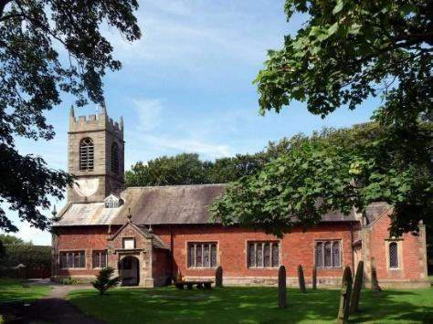

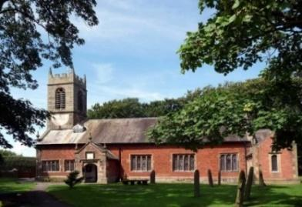

***Welcome to our church again this morning. Please stay for a chat and a cup of tea or coffee after the 10.30 service, a great way to meet people***

***PALM SUNDAY with DISTRIBUTION OF PALM CROSSES***

***Sunday 10th April 2022***

**JESUS COMES TO JERUSALEM AS KING**

**“Do not be afraid, your king is coming seated on a donkey”** *John 12: v 15.*

**PRAYER OF THE DAY: Almighty and everlasting God, who in your**

**tender love towards the human race sent your Son our Saviour Jesus**

**Christ to take upon him our flesh and to suffer death upon the cross:**

**grant that we may follow the example of his patience and humility,**

**and also be made partakers of his resurrection; through Jesus Christ**

**your Son our Lord.**  **Amen.**



**DONKEY RIDES today during the service**

**9.00am. Holy Communion (Book of Common Prayer) p237**

**10.10am. Meet at the school to process to church for –**

**10.30am. Family Worship with Donkey rides.**

**Hymns: 14 – All glory, laud and honour.**

**Screen/video – I reach up high.**

**Suppl. 8 – King of Kings, Majesty.**

**905 – We have a King who rides a donkey.**

**195 – From heaven you came *(The Servant King)***

**READING: John 12: v 12-19.** The next day the great crowd that had come for the festival heard that Jesus was on his way to Jerusalem. They took palm branches and went out to meet him, shouting,

‘Hosanna!’ ‘Blessed is he who comes in the name of the Lord!’

‘Blessed is the king of Israel!’

Jesus found a young donkey and sat upon it, as it is written:

‘Do not be afraid, Daughters of Zion; see, your king is coming,  
     seated on a donkey’s colt.’

At first his disciples did not understand all this. Only after Jesus was glorified did they realise that these things had been written about him and that these things had been done to him.

Now the crowd that was with him when he called Lazarus from the tomb and raised him from the dead continued to spread the word. Many people, because they had heard that he had performed this sign, went out to meet him.  So the Pharisees said to one another, ‘See, this is getting us nowhere. Look how the whole world has gone after him!’

**Prayer:** We pray for those who are sick, especially Erica Ivy, Beryl Cottam, Tom Parkinson, Ann Bradshaw, Steve Coughlan, Neil Dexter, Antonietta Broadhurst and Roy Sanderson. We give thanks for the lives of Alan Orritt, Cath Marshall and Tom Bannister and pray for their families and friends.

SPACE FOR PRAYER

Prayer is our conversation with God; He wants us to come to him with all our worries and our thanks, here in the church we have put aside a space. (under the gallery at the front). Please feel free to sit in private prayer, give us your requests and know that God through Jesus is listening.

**A Prayer for Ukraine**

**God of peace and justice, we pray for the people of Ukraine today.  
We pray for peace and the laying down of weapons.  
We pray for all those who fear for tomorrow,  
that your Spirit of comfort would draw near to them.  
We pray for those with power over war or peace,  
for wisdom, discernment and compassion to guide their decisions. Above all, we pray for all your precious children, at risk and in fear, that you would hold and protect them.  
We pray in the name of Jesus, the Prince of Peace. Amen**

