Parish Dates April 2021 onwards
Sunday April 18th 09.00am Holy Communion in Church
10.30am Parish Communion in Church

Sunday April 25th 09.00am Holy Communion in Church
10.30am Morning Worship in Church
Monday April 26th 7.30pm Bible Study by Zoom
Tuesday April 27th 11.00am funeral of Joan Gleave
7.30pm Bible Study in Church with Compline

Sunday May 2nd 09.00am Holy Communion in Church
10.30am Parish Communion in Church

Sunday May 9th 09.00am Holy Communion in Church
10.30am Morning Worship in Church
Monday May 10th 7.30pm Bible Study by Zoom
Tuesday May 11th 7.30pm Bible Study in Church with Compline

Sunday May 16th 10.00am Parish Communion
One service only this week followed by at
11.00am ANNUAL CHURCH MEETING.
Monday May 17th 7.30pm PCC Meeting.

Key Future Dates
16-18th July OUTREACH WEEKEND
Friday July 16th 7.00pm Parish Social with Quiz and Entertainment
in the New Village Hall.
Sunday July 18th 2.00pm – 4.00pm Event for children and families
with Bishop Philip.
All the above services are ‘Live’ in church
We will aim to have recordings of all 10.30 services on the website www.hooleparishchurch.com by Sunday lunch time.

The Zoom link for all church Zoom activities is on the front page of the website.
Our Facebook page: St Michael and All Angels Church, Hoole, our website is www.hooleparishchurch.com
Rector – Revd Ann Templeman anntempleman@live.co.uk 01772 448515
The Rectory, 69 Liverpool Old Road Much Hoole PR4 4RB
Please take this sheet home with you
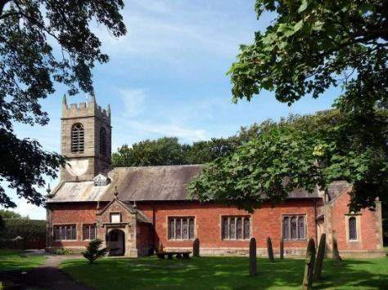
St. Michael and All Angels – Hoole

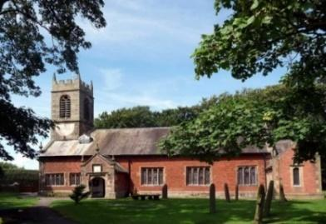

Welcome to our church again this morning. A special welcome to those who may not have been in church for some time. Please observe social distancing, but stay close to Christ.

Sunday 11th April 2021 Easter 2.

Alleluia, Christ is Risen - - - He is Risen indeed, Alleluia.

HOW JESUS’ RESURRECTION AFFECTED HIS FOLLOWERS

“With great power the apostles continued to testify to the resurrection of the Lord Jesus, and much grace was given them all.” Acts 4: v 33.

PRAYER OF THE DAY: Risen Christ, for whom no door is locked,
no entrance barred: open the doors of our hearts, that we may seek
the good of others and walk the joyful road of sacrifice and peace,
to the praise of God the Father. Amen.

Sunday School today during the service
There are toys for younger children
at the back of church.

9.00am. Holy Communion (Book of Common Prayer) begins p237

Reading: Acts 4: v 32-37.

10.30am. Morning Worship with Sunday School.
Reading: Acts 4: v 31-37.
Hymns : 695 – To God be the glory.
Supp. 7 – See what a morning.
667 – (tune 2) The strife is o’er.
716 – We have a Gospel to proclaim.

BIBLE READING: Acts 4: v 31-37.

After they prayed, the place where they were meeting was shaken. And they were all filled with the Holy Spirit and spoke the word of God boldly All the believers were one in heart and mind. No one claimed that any of their possessions was their own, but they shared everything they had. With great power the apostles continued to testify to the resurrection of the Lord Jesus. And God’s grace was so powerfully at work in them all that there was no needy person among them. For from time to time those who owned land or houses sold them, brought the money from the sales and put it at the apostles’ feet, and it was distributed to anyone who had need.
Joseph, a Levite from Cyprus, whom the apostles called Barnabas (which means ‘son of encouragement’), sold a field he owned and brought the money and put it at the apostles’ feet.

Prayer. We pray for those who are sick, especially Baby Erica Ivy, Joanne, Eva Coxhead, Patricia Mortimer and Beryl Carr. We give thanks for the lives of Jack Staziker, Michael Pulvermacher and Joan Gleave and we pray for their families and friends.

This week’s Bible readings are:-
Mon. April 12th Acts 4: v 23-31 - - - John 3: v 1-8.
Tues. April 13th Acts 4: v 12-end - - - John 3: v 7-15.
Wed. April 14th Acts 5: v 17-26 - - - John 3: v 16-21.
Thurs. April 15th Acts 5: v 27-33 - - - John 3: v 31-end.
Fri. April 16th Acts 5: v 34-42 - - - John 6: v 1-15.
Sat. April 17th Acts 6: v 1-7 - - - John 6: v 16-21.

Please note: THE ANNUAL CHURCH MEETING (APCM) date has been changed from 25th April to 16th May 2021. The meeting will take place in church at 11.00am.
THERE WILL ONLY BE ONE SERVICE ON 16TH MAY AT 10.00AM. THE HOPE IS THAT MEMBERS OF BOTH CONGREGATIONS WILL WANT TO ATTEND CHURCH AT 10am AND JOIN TOGETHER IN THE ANNUAL CHURCH MEETING at 11.00am.
Year End Reports & Accounts 2020 are available to view on our website www.hooleparishchurch.com
A limited number of hard copies will be available in Church.
CHRISTIAN AID ARE ASKING FOR TOOLS FOR AFRICA – PLEASE SEE LITERATURE AT BACK OF CHURCH
FORTNIGHTLY BIBLE STUDIES RESUME
Mon 26th April 7.30pm by Zoom
and Tuesday 27th April 7.30pm in Church with Compline

a final session on the 1st commandment – Live by priorities – ‘You shall have no other gods before me’

