Parish Dates April 2021 onwards
Sunday April 25th 09.00am Holy Communion in Church
10.30am Morning Worship in Church
3.45pm Toy Story Church at Church
Monday April 26th 7.30pm Bible Study by Zoom
Tuesday April 27th 11.00am Funeral of Joan Gleave
7.30pm Bible Study in Church with Compline

Sunday May 2nd 09.00am Holy Communion in Church
10.30am Parish Communion in Church

Sunday May 9th 09.00am Holy Communion in Church
10.30am Morning Worship in Church
Monday May 10th 7.30pm Bible Study by Zoom
Tuesday May 11th 7.30pm Bible Study in Church with Compline

Sunday May 16th 10.00am Parish Communion
One service only this week followed by at
11.00am ANNUAL CHURCH MEETING.
Monday May 17th 7.30pm PCC Meeting.

Saturday May 22nd 2.30pm Wedding of Sarah and Craig
Sunday May 23rd 09.00am Holy Communion in Church
10.30am Morning Worship in Church
Key Future Dates
16-18th July OUTREACH WEEKEND
Friday July 16th 7.00pm Parish Social with Quiz and Entertainment
in the New Village Hall.
Sunday July 18th 2.00pm – 4.00pm Event for children and families
with Bishop Philip.
All the above services are ‘Live’ in church
We will aim to have recordings of all 10.30 services on the website www.hooleparishchurch.com by Sunday lunch time.
The Zoom link for all church Zoom activities is on the front of website.
Our Facebook page: St Michael and All Angels Church, Hoole, our website is www.hooleparishchurch.com
Rector – Revd Ann Templeman anntempleman@live.co.uk 01772 448515
The Rectory, 69 Liverpool Old Road Much Hoole PR4 4RB
Please take this sheet home with you
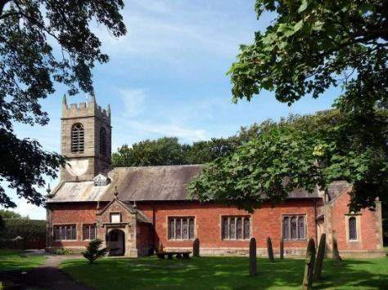
St. Michael and All Angels – Hoole

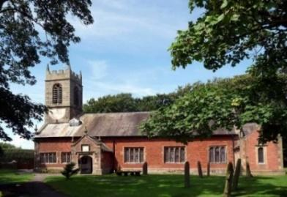

Welcome to our church again this morning. A special welcome to Revd Richard Plant who is leading our worship today while Ann and Peter are on holiday.

Sunday 18th April 2021 Easter 3.

Alleluia, Christ is Risen - - - He is Risen indeed, Alleluia.

IN THE POWER OF CHRIST

“Repent therefore and turn to God so that your sins
may be wiped out.” Acts 3: v 19.

PRAYER OF THE DAY: Risen Christ, you filled your disciples with
boldness and fresh hope: strengthen us to proclaim your risen life and
fill us with your peace, to the glory of God the Father. Amen.

Sunday School today during the service
There are toys for younger children
at the back of church.

9.00am. Holy Communion (Book of Common Prayer) begins p237

10.30am. Parish Communion with Sunday School.
Reading: Acts 3: v 11-19.
Hymns : 54 – (v 1,5 & 6) At the Name of Jesus.
Video/Screen – Nothing too Big Big Big.
297 – (v 1,4,5 & 6) How sweet the name of Jesus sounds.
Supp 1 – In Christ alone.
H/C Hymns: 212 – God forgave my sin. 84: Breathe on me breath of God.
BIBLE READING: Acts 3: v 11-19. While the man held on to Peter and John, all the people were astonished and came running to them in the place called Solomon’s Colonnade. When Peter saw this, he said to them:
“Fellow Israelites, why does this surprise you? Why do you stare at us as if by our own power or godliness we had made this man walk? The God of Abraham, Isaac and Jacob, the God of our fathers, has glorified his servant Jesus. You handed him over to be killed, and you disowned him before Pilate, though he had decided to let him go. You disowned the Holy and Righteous One and asked that a murderer be released to you. You killed the author of life, but God raised him from the dead. We are witnesses of this. By faith in the name of Jesus, this man whom you see and know was made strong. It is Jesus’ name and the faith that comes through him that has completely healed him, as you can all see.
“Now, fellow Israelites, I know that you acted in ignorance, as did your leaders. But this is how God fulfilled what he had foretold through all the prophets, saying that his Messiah would suffer. Repent, then, and turn to God, so that your sins may be wiped out, that times of refreshing may come from the Lord,

Prayer. We pray for those who are sick, especially Baby Erica Ivy, Joanne, Eva Coxhead, Patricia Mortimer and Beryl Carr. We give thanks for the lives of Jack Staziker, Michael Pulvermacher and Joan Gleave and we pray for their families and friends.
- - - - - - - - - - - - - - - - - -
Please note: THE ANNUAL CHURCH MEETING (APCM) date has been changed from 25th April to 16th May 2021. The meeting will take place in church at 11.00am.
THERE WILL ONLY BE ONE SERVICE ON 16TH MAY AT 10.00AM. THE HOPE IS THAT MEMBERS OF BOTH CONGREGATIONS WILL WANT TO ATTEND CHURCH AT 10am AND JOIN TOGETHER IN THE ANNUAL CHURCH MEETING at 11.00am.

Year End Reports & Accounts 2020 are available to view on our website
www.hooleparishchurch.com
A limited number of hard copies will be available in Church.
- - - - - - - - - - - - - - - - - - - -
CHRISTIAN AID ARE ASKING FOR TOOLS FOR AFRICA – PLEASE SEE LITERATURE AT BACK OF CHURCH
FORTNIGHTLY BIBLE STUDIES RESUME
Mon 26th April 7.30pm by Zoom
and Tuesday 27th April 7.30pm in Church with Compline
a final session on the 1st commandment – Live by priorities – ‘You shall have no other gods before me’
This week’s Bible readings are:-
Mon. April 19th Acts 6: v 8-15 - - - John 6: v 22-29.
Tues. April 20th Acts 7: v 51-8: v1a - - - John 6: v 30-35.
Wed. April 21st Acts 8: v 1b-8 - - - John 6: v 35-40.
Thurs. April 22nd Acts 8: v 26-end - - - John 6: v 44-51.
Fri. April 23rd Rev 12: v 7-12 - - - John 15: v 18-21.
Sat. April 24th Acts 9: v 31-42 - - - John 6: v 60-69.

