Parish Dates From April 2022
Tuesday 26th April 10.15am Morning Prayer
Sunday 1st May 09.00am Holy Communion
(Services taken by 10.30AM PARISH COMMUNION Sunday School
Bishop Tony Porter) 4.00pm Holy Communion (Old Mill Court)
Tuesday 3rd May 10.15am Morning Prayer.

Sunday 8th May 10.00am PARISH COMMUNION WITH SUNDAY
SCHOOL
11.00 ANNUAL CHURCH MEETING IN
SCHOOL WITH JACOB’S JOIN LUNCH
Monday 9th May 7.30pm PCC meeting in the Village Hall.
Tuesday 10th May 10.15am Holy Communion.
7.30pm Bible Study at the Rectory
7.30pm Men’s Fellowship AGM in the Village Hall

Sunday 15th May 09.00am Holy Communion
10.30am Parish Communion.
3.45pm ROYAL CHURCH in the Village Hall.
Monday 16th May 7.30pm Bible Study at the Rectory
Tuesday 17th May 10.15am Prayer time in church.
7.30pm Ladies Group meet in the Village Hall

Sunday 22nd May 09.00am Holy Communion
10.30am Morning Worship with Sunday School.
Tuesday 24th May 10.15am Holy Communion.
Thursday 26th May 9.00am School Service in Church
ASCENSION DAY 7.30pm HOLY COMMUNION

Sunday 29th May 09.00am Holy Communion
10.30am Parish Communion with Sunday School.
Sunday 5th June QUEEN’S PLATINUM JUBILEE
PENTECOST (see poster inside)

Suggested Bible readings this week.
Monday 25th April Mark 13: v 5-13. Tuesday 26th April John 15: v 18-21.
Wednesday 27th April John 3: v 16-21. Thursday 28th April John 3: v 31-end.
Friday 29th April John 6: v 1-15. Saturday 30th April John 6: v 16-21.

Website : www.hooleparishchurch.com
Facebook page: St Michael and All Angels Church, Hoole,
Rector – Revd Ann Templeman anntempleman@live.co.uk 01772 448515
The Rectory, 69 Liverpool Old Road Much Hoole PR4 4RB
Please take this sheet home with you
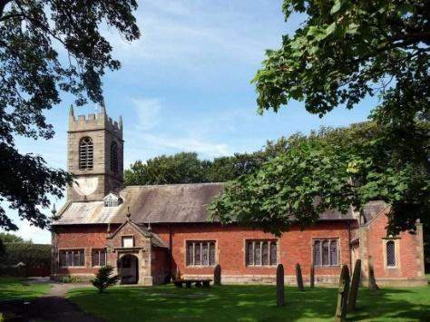
St. Michael and All Angels – Hoole

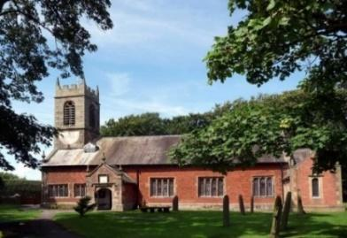

Welcome to our church again this morning. Please stay for a chat and a cup of tea or coffee after the 10.30 service, a great way to meet people

Sunday 24th April 2022 (Easter 2)

Alleluia, Christ is Risen - - - He is Risen indeed, Alleluia.

BELIEVING IS SEEING
Jesus said “Blessed are those who have not seen and yet have believed”
John 20: v 29.

PRAYER OF THE DAY: Risen Christ, for whom no door is locked,
no entrance barred: open the doors of our hearts, that we may seek
the good of others and walk the joyful road of sacrifice and peace,
to the praise of God the Father. Amen.

Sunday School today during the service
There are toys and colouring sheets
for younger children at the back of church.

9.00am. Holy Communion (Book of Common Prayer) begins p237

10.30am. Morning Worship with Sunday School.
Reading: John 20: v 19-31.

Hymns: 450 – Morning has broken.
Screen – My Lighthouse.
Gloria
676 – This is the day.
637 – The day of resurrection.

Prior to the service the choir will sing:
8 – Alleluia, Alleluia, give thanks to the risen Lord.
READING: John 12: v 1-11. On the evening of that first day of the week, when the disciples were together, with the doors locked for fear of the Jewish leaders, Jesus came and stood among them and said, ‘Peace be with you!’ After he said this, he showed them his hands and side. The disciples were overjoyed when they saw the Lord.
Again Jesus said, ‘Peace be with you! As the Father has sent me, I am sending you.’ And with that he breathed on them and said, ‘Receive the Holy Spirit. If you forgive anyone’s sins, their sins are forgiven; if you do not forgive them, they are not forgiven.’
Now Thomas (also known as Didymus), one of the Twelve, was not with the disciples when Jesus came. So the other disciples told him, ‘We have seen the Lord!’ But he said to them, ‘Unless I see the nail marks in his hands and put my finger where the nails were, and put my hand into his side, I will not believe.’
A week later his disciples were in the house again, and Thomas was with them. Though the doors were locked, Jesus came and stood among them and said, ‘Peace be with you!’ Then he said to Thomas, ‘Put your finger here; see my hands. Reach out your hand and put it into my side. Stop doubting and believe.’ Thomas said to him, ‘My Lord and my God!’
Then Jesus told him, ‘Because you have seen me, you have believed; blessed are those who have not seen and yet have believed.’
Jesus performed many other signs in the presence of his disciples, which are not recorded in this book. But these are written that you may believe that Jesus is the Christ, the Son of God, and that by believing you may have life in his name.

Prayer: We pray for those who are sick, especially Erica Ivy, Beryl Cottam, Tom Parkinson, Steve Coughlan, Neil Dexter, Antonietta Broadhurst, Stuart Tighe and Roy Sanderson. We give thanks for the life of Brian Gregory and pray for his family and friends.
OUR FAITHFUL QUEEN
a beautiful book commemorating 70 years
of Faithful Service. £5 at back of church

SPACE FOR PRAYER
Prayer is our conversation with God; He wants us to come to him with all our worries and our thanks, here in the church we have put aside a space. (under the gallery at the front). Please feel free to sit in private prayer, give us your requests and know that God through Jesus is listening.

A Prayer for Ukraine
God of peace and justice, we pray for the people of Ukraine today.
We pray for peace and the laying down of weapons.
We pray for all those who fear for tomorrow,
that your Spirit of comfort would draw near to them.
We pray for those with power over war or peace,
for wisdom, discernment and compassion to guide their decisions. Above all, we pray for all your precious children, at risk and in fear, that you would hold and protect them.
We pray in the name of Jesus, the Prince of Peace. Amen

ANNUAL CHURCH MEETING SUNDAY MAY 8th.
There will only be one morning service in Church on May 8th at 10.00am. 11.00am Annual Church Meeting in School followed by a Jacob’s Join Lunch. Please sign the list at the back of the church with your contribution.
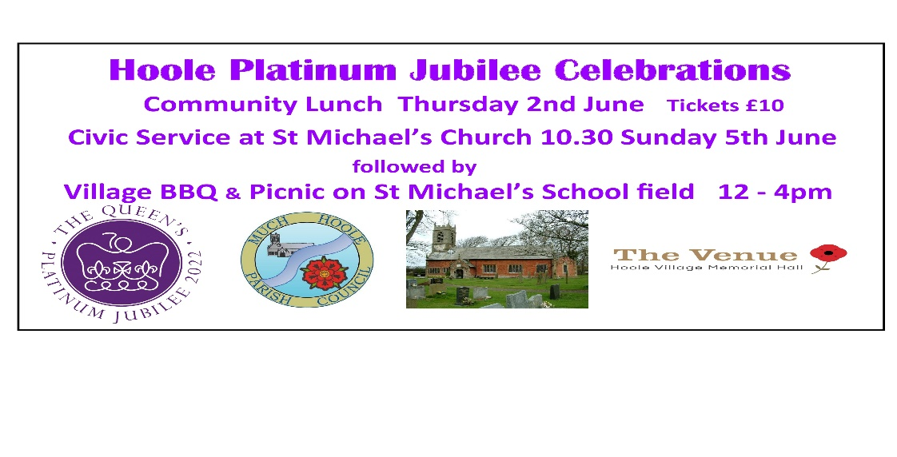The Community Lunch begins the Queen’s Platinum Jubilee Celebrations on Thursday June 2nd and is a ticket only event @ £10.00 available from Stan, or ring 01772 615708 or 07747 607552.

