Parish Dates April 2021 onwards
Monday April 26th 7.30pm Bible Study by Zoom
Tuesday April 27th 11.00am Funeral of Joan Gleave
7.30pm Bible Study in Church with Compline

Sunday May 2nd 09.00am Holy Communion in Church
10.30am Parish Communion in Church

Sunday May 9th 09.00am Holy Communion in Church
10.30am Morning Worship in Church
Monday May 10th 7.30pm Bible Study by Zoom
Tuesday May 11th 7.30pm Bible Study in Church with Compline

Sunday May 16th 10.00am Parish Communion
One service only this week followed by at
11.00am ANNUAL CHURCH MEETING.
Monday May 17th 7.30pm PCC Meeting.
Saturday May 22nd 2.30pm Wedding of Sarah and Craig

Sunday May 23rd 09.00am Holy Communion in Church
10.30am Morning Worship in Church

Sunday May 30th 09.00am Holy Communion in Church
10.30am Parish Communion in Church

Key Future Dates
16-18th July OUTREACH WEEKEND
Friday July 16th 7.00pm Parish Social with Quiz and Entertainment
in the New Village Hall.
Sunday July 18th 2.00pm – 4.00pm Event for children and families
with Bishop Philip.
All the above services are ‘Live’ in church
We will aim to have recordings of all 10.30 services on the website www.hooleparishchurch.com by Sunday lunch time.
The Zoom link for all church Zoom activities is on the front of website.
Our Facebook page: St Michael and All Angels Church, Hoole, our website is www.hooleparishchurch.com
Rector – Revd Ann Templeman anntempleman@live.co.uk 01772 448515
The Rectory, 69 Liverpool Old Road Much Hoole PR4 4RB
Please take this sheet home with you
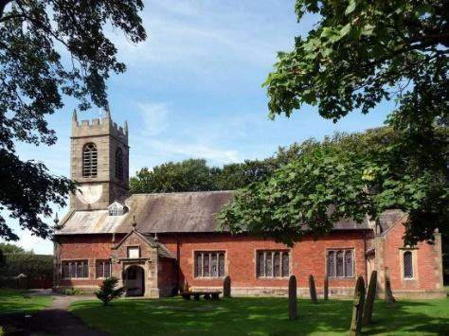
St. Michael and All Angels – Hoole

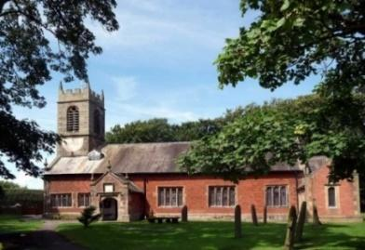

Welcome to our church again this morning. We are pleased to welcome back friends, who have not felt able to attend during the last twelve months.

Sunday 25th April 2021 Easter 4.

Alleluia, Christ is Risen - - - He is Risen indeed, Alleluia.

THE SAVING POWER AND LOVE OF THE LORD JESUS.

“Salvation is found in no-one else, for there is no other name under
heaven given to mankind by which we must be saved.” Acts 4: v 12.

PRAYER OF THE DAY: Merciful Father, you gave your Son Jesus
Christ to be the good shepherd, and in his love for us to lay down his
life and rise again: keep us always under his protection, and give us
grace to follow in his steps; through Jesus Christ our Lord. Amen.

No Sunday School today during the service
TOY STORY CHURCH at 3.45pm.
(See the poster inside.)
at the back of church.

9.00am. Holy Communion (Book of Common Prayer) begins p237

10.30am. Morning Worship.
Readings: Acts 4: v 5-12. John 10: v 11-18.
Hymns : 465 – Name of all Majesty.
Supp. 9 – The Lord’s my Shepherd.
Supp. 3 – Before the throne of God above.
337 – I will sing the wondrous story.

3.45pm. TOY STORY CHURCH at Church.
BIBLE READINGS: Acts 4: v 5-12. The next day the rulers, the elders and the teachers of the law met in Jerusalem. Annas the high priest was there, and so were Caiaphas, John, Alexander and others of the high priest’s family. They had Peter and John brought before them and began to question them: “By what power or what name did you do this?”
Then Peter, filled with the Holy Spirit, said to them: “Rulers and elders of the people! If we are being called to account today for an act of kindness shown to a man who was lame and are being asked how he was healed, then know this, you and all the people of Israel: It is by the name of Jesus Christ of Nazareth, whom you crucified but whom God raised from the dead, that this man stands before you healed. Jesus is
“‘the stone you builders rejected, which has become the cornerstone.’
Salvation is found in no one else, for there is no other name under heaven given to mankind by which we must be saved.”

John 10: v 11-18. ‘I am the good shepherd. The good shepherd lays down his life for the sheep. The hired hand is not the shepherd and does not own the sheep. So when he sees the wolf coming, he abandons the sheep and runs away. Then the wolf attacks the flock and scatters it. The man runs away because he is a hired hand and cares nothing for the sheep.
‘I am the good shepherd; I know my sheep and my sheep know me – just as the Father knows me and I know the Father – and I lay down my life for the sheep. I have other sheep that are not of this sheepfold. I must bring them also. They too will listen to my voice, and there shall be one flock and one shepherd. The reason my Father loves me is that I lay down my life – only to take it up again. No one takes it from me, but I lay it down of my own accord. I have authority to lay it down and authority to take it up again. This command I received from my Father.’

Prayer. We pray for those who are sick, especially Baby Erica Ivy, Joanne, Eva Coxhead, Patricia Mortimer, Beryl Carr and Michael Harrison. We give thanks for the lives of Michael Pulvermacher and Joan Gleave and we pray for their families and friends.

FORTNIGHTLY BIBLE STUDIES RESUME
Mon 26th April 7.30pm by Zoom
and Tuesday 27th April 7.30pm in Church with Compline
a final session on the 1st commandment – Live by priorities – ‘You shall have no other gods before me’
Please note: THE ANNUAL CHURCH MEETING (APCM) date has been changed from 25th April to 16th May 2021. The meeting will take place in church at 11.00am.

THERE WILL ONLY BE ONE SERVICE ON 16TH MAY AT 10.00AM. THE HOPE IS THAT MEMBERS OF BOTH CONGREGATIONS WILL WANT TO ATTEND CHURCH AT 10am AND JOIN TOGETHER IN THE ANNUAL CHURCH MEETING at 11.00am.

Year End Reports & Accounts 2020 are available to view on our website
www.hooleparishchurch.com
A limited number of hard copies will be available in Church.
This week’s Bible readings are:-
Mon. April 26th Acts 15: v 35-end - - - Mark 13: v 5-13.
Tues. April 27th Acts 11: v 19-26 - - - John 10: v 22-30.
Wed. April 28th Acts 12: v 24 to 13: v5 - - - John 12: v 44-end.
Thurs. April 29th Acts 13: v 13-25 - - - John 13: v 16-20.
Fri. April 30th Acts 13: v 26-33 - - - John 14: v 1-6.
Sat. May 1st Isaiah 30: v 15-21 - - - John 14: v 1-14.

