Parish Dates From March 2023

HOLY WEEK
Tuesday 4th April 10.15am Holy Communion in the Lodge.
Thursday 6th April 7.00pm PASSOVER MEAL
MAUNDY THURSDAY in ST MICHAEL’S SCHOOL
Friday 7th April 11:00am AN HOUR AT THE CROSS IN CHURCH
GOOD FRIDAY 11:00AM A CHILDREN’S HOUR AT THE CROSS IN THE LODGE
12.00noon Hunger Lunch in the Lodge in aid of FOMO.
Sunday 9th April 9.00am Holy Communion
EASTER SUNDAY 10.30AM PARISH COMMUNION WITH EASTER EGG HUNT IN THE CHURCHYARD.
Tuesday 11th April 10.15am Morning Worship in the Lodge.
7.30pm Men’s Fellowship in the Village Hall.
Spitfires and Hurricanes (John Hutchinson)
Sunday 16th April 9.00am Holy Communion
10.30am Morning Worship with Sunday School
Tuesday 18th April 10.15am Holy Communion in the Lodge.
7.30pm Ladies’ Group in the Village Hall.
Thursday 20th April 4.30pm Bible and Biscuits in the Lodge.
Sunday 23rd April 9.00am Holy Communion
10.30am Morning Worship with Sunday School
Tuesday 25th April 10.15am Holy Communion in the Lodge.
Wednesday 26th April 7.30pm Bible Study in the Lodge
Thursday 27th April 4.30pm Chat and Chocolate in the Lodge.
Friday 28th April 7.00pm CHARITY DINNER in the Village Hall.
Sunday 30th April 9.00am Holy Communion
10.30am HOLY COMMUNION with Sunday school.
Monday May 1st 7.30pm Bible Study in the Lodge
Tuesday 2nd May 10.15am Holy Communion in the Lodge.
Thursday 4th May 4.30pm Bible and Biscuits in the Lodge.
Sunday 7th May 10.30am CIVIC SERVICE with Sunday School.
CORONATION 12.00noon COMMUNITY CELEBRATIONS
WEEKEND on St Michael’s School Field.
Monday 8th May 10.00am-4.00pm Local History Festival in Village Hall.
www.hooleparishchurch.com
Facebook page: St Michael and All Angels Church, Hoole,
Rector Ann Templeman anntempleman@live.co.uk 01772 448515 or 07877659156
PLEASE TAKE THIS SHEET HOME WITH YOU.
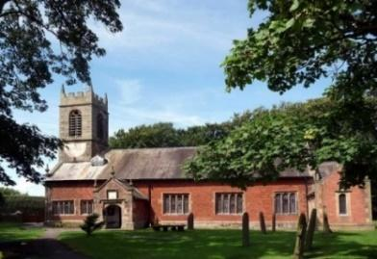
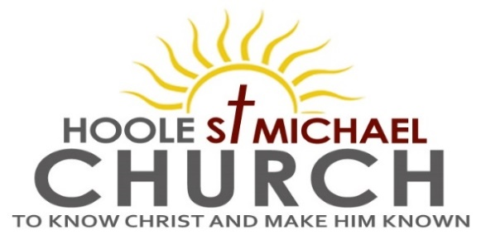

Welcome to our Church today.
Please stay for refreshments in the Lodge after the service.
Sunday 2nd April 2023

PALM SUNDAY – JESUS THE SERVANT KING.

Blessed is the King who comes in the name of the Lord. Luke 19: v 38.

PRAYER OF THE DAY True and humble King, hailed by the crowd
as Messiah: grant us the faith to know you and love you, that we may
be found beside you on the way of the cross, which is the path of glory.
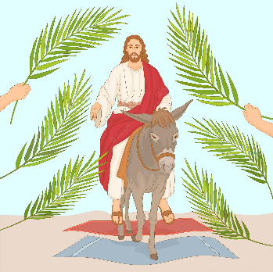
Donkey rides in the car park and activities for children in the Lodge during the service

9.00am. Holy Communion (Book of Common Prayer) begins p237

10.10am. Assemble at School to process to Church with donkey.

10.30am. Palm Sunday Service with Sunday School.
Reading: Luke 19: v 28-40.
Hymns: 14 – All glory laud and honour.
264 (Junior Praise) – We have a King who rides a donkey.
201 – Give me joy in my heart (Sing hosanna)
195 – From heaven you came (The Servant King).
H/C Hymns: Screen – 448 – Meekness and majesty.
Suppl. 8 – King of Kings.
620 – Such Love.

Reading: Luke 19: v 28-40. After Jesus had said this, he went on ahead, going up to Jerusalem. As he approached Bethphage and Bethany at the hill called the Mount of Olives, he sent two of his disciples, saying to them, ‘Go to the village ahead of you, and as you enter it, you will find a colt tied there, which no one has ever ridden. Untie it and bring it here. If anyone asks you, “Why are you untying it?” say, “The Lord needs it.”’
Those who were sent ahead went and found it just as he had told them. As they were untying the colt, its owners asked them, ‘Why are you untying the colt?’ They replied, ‘The Lord needs it.’
They brought it to Jesus, threw their cloaks on the colt and put Jesus on it. As he went along, people spread their cloaks on the road. When he came near the place where the road goes down the Mount of Olives, the whole crowd of disciples began joyfully to praise God in loud voices for all the miracles they had seen:
‘Blessed is the king who comes in the name of the Lord!’
‘Peace in heaven and glory in the highest!’
Some of the Pharisees in the crowd said to Jesus, ‘Teacher, rebuke your disciples!’ ‘I tell you, ’he replied, ‘If they keep quiet, the stones will cry out.’
Prayer: We pray for all the Outreach events planned for the King’s Coronation. We pray for those who are sick amongst whom are Erica Ivy, Sam Burns, Christine Barker, Daniel Connor, Shirley Rainsbury, Bill and Beryl Carr. We give thanks for the life of Mona Lewis and pray for her family and friends.
PASSOVER MEAL
Maundy Thursday, 6th April at 7.00pm
St Michael’s Primary School.
Suitable for the whole family
This is a lovely way to enjoy a meal together and discover more about the background of our Communion service.
Please give your name to one of the churchwardens or sign the list at the back of the church
There is no charge but we invite donations of around £7 per adult
(£2 children) Please see Hilary Newman to help with salad or potatoes

Suggested Bible Readings this week
Monday 3rd April Luke 21: v 1-28. Tuesday 4th April Luke 21: v 29 to 22: v 6.
Wed. 5th April Luke 22: v 7-34. Thursday 6th March Luke 22: v 35-62.
Friday 7th April Luke 22: v 63 to 23: v 25. Saturday 8th April Luke 23: v 26-56.

CORONATION CHARITY DINNER FRIDAY 28TH APRIL at the VENUE, MUCH HOOLE VILLAGE HALL 7.00PM
Please hand in your booking form asap

CORONATION WEEKEND MAY 6TH/7TH
Sunday May 7th 10.30am
CIVIC SERVICE in St Michael’s Church
COMMUNITY CELEBRATIONS ON ST MICHAEL’S SCHOOL FIELD REFRESHMENTS, STALLS and FOOTBALL MATCH
Monday May 8th
LOCAL HISTORY FESTIVAL 10.00AM – 4.00PM IN THE VENUE

