**Parish Dates From May 2023**

**Tuesday 2nd May 10.15am Holy Communion in the Lodge.**

**7.30pm Bible Study in the Lodge**

**Wednesday 3rd May 9.30am–11.30am ST MICHAEL’S LITTLE ANGELS**

**BABY/TODDLER GROUP IN THE LODGE.**

**Thursday 4th May 4.30pm Bible and Biscuits in the Lodge.**

**Friday 5th May School Coronation Big Lunch (see below)**

**Sunday 7th May *Note No 9.00am Service today\***

**CORONATION 10.30am CIVIC SERVICE with Sunday School.**

**WEEKEND 12.00noon COMMUNITY CELEBRATIONS**

**on St Michael’s School Field.**

**Monday 8th May 10.00am-4.00pm Local History Festival in Village Hall.**

**Tuesday 9th May 10.15am Holy Communion in the Lodge.**

**7.30pm Men’s Fellowship AGM in the Village Hall.**

**Wednesday 10th May 9.30am–11.30am ST MICHAEL’S LITTLE ANGELS**

**7.30pm Bible Study in the Lodge.**

**Thursday 11th May 4.30pm Chat and Chocolate in the Lodge.**

**Sunday 14th May 9.00am Holy Communion**

**10.30am Morning Worship with Sunday School**

**12.00noon ANNUAL CHURCH MEETING followed by**

**JACOB’S JOIN MEAL IN SCHOOL.**

**Monday 15th May 7.30pm Bible Study in the Lodge.**

**Tuesday 16th May 10.15am Holy Communion in the Lodge.**

**12.00noon Ladies Group Lunch and Shopping afternoon (Sheila 616850)**

**Wednesday 17th May 9.30am–11.30am ST MICHAEL’S LITTLE ANGELS**

**Thursday 18th May 4.30pm Bible and Biscuits in the Lodge.**

**ASCENSION DAY 9.00am School Ascension Day service**

**7.30pm Holy Communion**

**Sunday 21st May 9.00am Holy Communion**

**10.30am SERVICE OF CONFIRMATION+ Philip**

**Tuesday 23rd May 10.15am Holy Communion in the Lodge.**

**SCHOOL CORONATION BIG LUNCH FRIDAY 5TH MAY**

The school have invited us to join them for lunch between 12 and 1.00pm in school with singing & games. Bbring your own picnic. Let Liz know today if you can come.

**www.hooleparishchurch.com**

Facebook page: **St Michael and All Angels Church, Hoole**,

Rector Ann Templeman anntempleman@live.co.uk 01772 448515 or 07877659156

***PLEASE TAKE THIS SHEET HOME WITH YOU.***

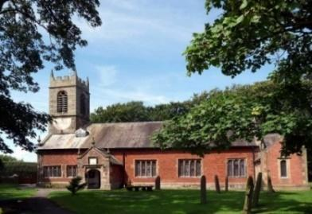

Welcome to our Church today.

Please stay for refreshments in the Lodge after the 10.30am service.

***Sunday 30th April 2023 (Easter 4)***

***Alleluia, Christ is Risen - - - He is Risen indeed, Alleluia.***

**THE LORD’S PRAYER.**

***Your Kingdom come, Your will be done, on earth as it is in Heaven***

*Matthew 6: v10.*

**PRAYER OF THE DAY** **Risen Christ, faithful shepherd of your**

**Father’s sheep: teach us to hear your voice and to follow your**

**command, that all your people may be gathered into one flock,**

**to the glory of God the Father. Amen.**



**Sunday School today during the service.**

There are toys and colouring sheets for younger children

at the back of church.

**9.00am. Holy Communion (Book of Common Prayer) begins p237**

**10.30am. Parish Communion with Sunday School.**

**Reading: Matthew 6: v 5-15.**

**Hymns: 489 – O God beyond all praising.**

**Screen – My Lighthouse.**

**727 – What a Friend we have in Jesus.**

**Suppl. 2 – How deep the Father’s love for us.**

**H/C Hymns: Screen – Not I but Christ through me.**

**620 – Such love.**

**12.00noon: Baptism of Roman Bowers.**

**4.00pm: Holy Communion (Old Mill Court)**

**Reading: Matthew 6: v 5-15.** When you pray, do not be like the hypocrites, for they love to pray standing in the synagogues and on the street corners to be seen by others. Truly I tell you, they have received their reward in full. But when you pray, go into your room, close the door and pray to your Father, who is unseen. Then your Father, who sees what is done in secret, will reward you. And when you pray, do not keep on babbling like pagans, for they think they will be heard because of their many words. Do not be like them, for your Father knows what you need before you ask him.

‘This, then, is how you should pray:

‘“Our Father in heaven, hallowed be your name,  
your kingdom come, your will be done, on earth as it is in heaven.  
 Give us today our daily bread.  
 And forgive us our debts, as we also have forgiven our debtors.  
 And lead us not into temptation, but deliver us from the evil one.”

For if you forgive other people when they sin against you, your heavenly Father will also forgive you. But if you do not forgive others their sins, your Father will not forgive your sins.

**Prayer:**  We pray for all the Outreach events planned for the King’s Coronation, and for our new Toddler and Baby Group starting this week. We pray for those who are sick especially Erica Ivy, Sam Burns, Daniel Connor, JeanSmallwood, Shirley Rainsbury, Bill and Beryl Carr. We give thanks for the life of Christine Barker, and pray for her family and friends.

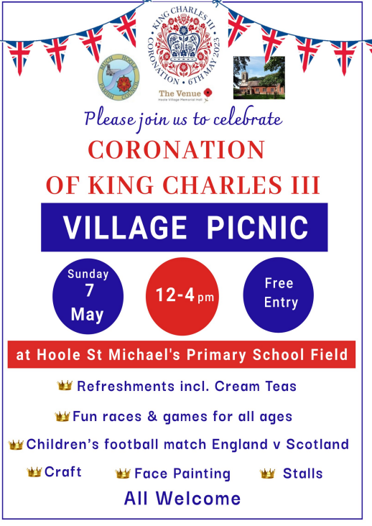

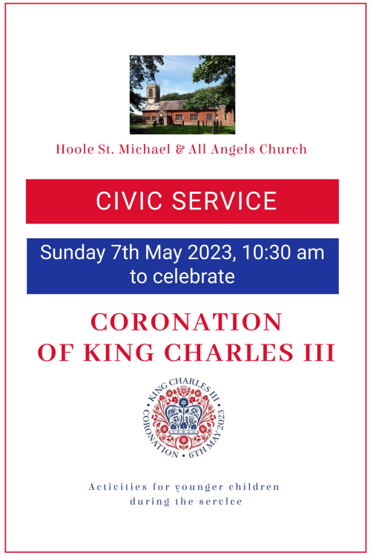

**WHAT HAPPENS WHEN WE DIE?** The Bible's answers to your questions

If you missed last week’s session please join us on Tues 2nd May at 7.30pm in the Lodge to look together at 1 Corinthians 15 v

There will then be 2 more sessions on this key subject and

Chapter on Wed May 10th and again on Mon May 15th

Please let me know any other questions you would like to ask.



**Suggested Bible Readings this week**

Monday 24th April John 15: v 18-21. Tuesday 25th April Mark 13: v 5-13.

Wed. 26th April John 6: v 35-40. Thursday 27th April John 6: v 44-51.

Friday 28th April John 6: v 52-59. Saturday 29th April John 6: v 60-69.

**CORONATION  WEEKEND MAY 6TH/7TH**

**Sunday May 7th 10.30am**

**CIVIC SERVICE in St Michael’s Church**

**COMMUNITY CELEBRATIONS ON ST MICHAEL’S  SCHOOL FIELD WITH BBQ, and FOOTBALL MATCH**

**Monday May 8th**

**LOCAL HISTORY FESTIVAL 10-4.00PM IN THE VENUE**

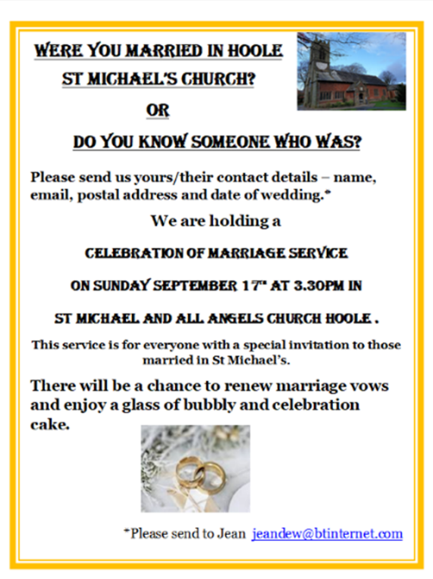

**Suggested Bible Readings this week**

Monday 1st May John 14: v 1-14. Tuesday 2nd May John 10: v 22-30.

Wed. 3rd May John 12: v 44-end. Thursday 4th May John 13: v 16-20.

Friday 5th May John 14: v 1-6. Saturday 6th May John 14: v 7-14.