Parish Dates From March 2022
Monday 4th April 7.30pm Housegroup at the Rectory
Tuesday 5th April 10.15am Prayer time in Church.
Thursday 7th April 1.45pm Funeral of Cath Marshall.

Sunday 10th April 09.00am Holy Communion
PALM SUNDAY 10.30am Family Worship with Donkey rides.
(Assemble in the School playground at 10.10am to process to church)
Tuesday 12th April 10.15am Morning Prayer.
7.30pm Men’s Fellowship meet in the Village Hall
MAUNDY THURS 14th April 7.00pm PASSOVER MEAL St Michael’s School. Friday 15th April 11.00am FAMILY CHURCH
GOOD FRIDAY 12.00- 1.30pm Christian Aid lunch in Village Hall.
2.00pm AN HOUR AND A HALF AT THE CROSS
IN CHURCH incorporating THE TRIAL by St Michael’s Players.

Sunday 17th April 09.00am Holy Communion
EASTER DAY 10.30am PARISH COMMUNION
WITH EASTER EGG HUNT FOR CHILDREN.
Monday 18th April 12.00noon Interment of ashes – Brian Gregory.
Tuesday 19th April 10.15am Morning Prayer.
7.30pm Ladies’ Group meet in the Village Hall

Sunday 24th April 09.00am Holy Communion
10.30am Family Worship with Sunday School.

A Prayer for Ukraine
God of peace and justice, we pray for the people of Ukraine today.
We pray for peace and the laying down of weapons.
We pray for all those who fear for tomorrow,
that your Spirit of comfort would draw near to them.
We pray for those with power over war or peace,
for wisdom, discernment and compassion to guide their decisions. Above all, we pray for all your precious children, at risk and in fear, that you would hold and protect them.
We pray in the name of Jesus, the Prince of Peace. Amen

Website : www.hooleparishchurch.com
Facebook page: St Michael and All Angels Church, Hoole,
Rector – Revd Ann Templeman anntempleman@live.co.uk 01772 448515
The Rectory, 69 Liverpool Old Road Much Hoole PR4 4RB
Please take this sheet home with you
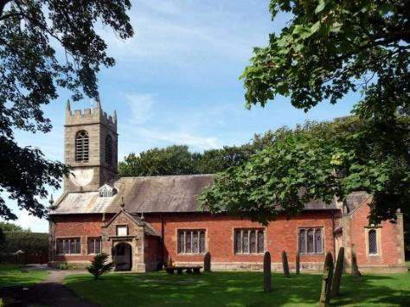
St. Michael and All Angels – Hoole

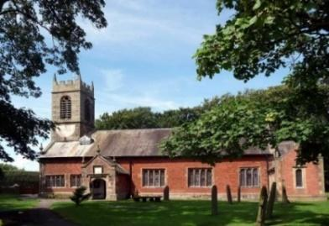

Welcome to our church again this morning. Please stay for a chat and a cup of tea or coffee after the 10.30 service, a great way to meet people

Sunday 3rd April 2022 (Lent 5)

PASSION SUNDAY
Jesus said “It was intended that she should save this perfume
for the day of my burial” John 12: v 7.

PRAYER OF THE DAY: Gracious Father, you gave up your Son
out of love for the world: lead us to ponder the mysteries of his
passion, that we may know eternal peace through the shedding of
our Saviour’s blood, Jesus Christ our Lord. Amen.

Sunday School today during the service
There are toys and colouring sheets
for younger children at the back of church.

9.00am. Holy Communion (Book of Common Prayer) begins p237
10.30am. Parish Communion with Sunday School.
Readings: 2 Corinthians 2: v 14-17. John 12: v 1-11.

Hymns: 463 – My Song is Love Unknown (omit v 2 & 3).
Screen – God Can Do Anything.
535 – O sacred head, surrounded.
Suppl. 4 – O to see the dawn (The power of the cross).
531 – Onward Christian soldiers (Trad. words-back of book)

H/C Hymns: 87 – Broken for me.
658 – There is a Redeemer.

4.00pm: Holy Communion (Old Mill Court).
READING: 2 Corinthians 2: v 14-17. Thanks be to God, who always leads us as captives in Christ’s triumphal procession and uses us to spread the aroma of the knowledge of him everywhere. For we are to God the pleasing aroma of Christ among those who are being saved and those who are perishing. To the one we are an aroma that brings death; to the other, an aroma that brings life. And who is equal to such a task? Unlike so many, we do not peddle the word of God for profit. On the contrary, in Christ we speak before God with sincerity, as those sent from God.

John 12: v 1-11. Six days before the Passover, Jesus came to Bethany, where Lazarus lived, whom Jesus had raised from the dead. Here a dinner was given in Jesus’ honour. Martha served, while Lazarus was among those reclining at the table with him. Then Mary took about half a litre of pure nard, an expensive perfume; she poured it on Jesus’ feet and wiped his feet with her hair. And the house was filled with the fragrance of the perfume.
But one of his disciples, Judas Iscariot, who was later to betray him, objected, ‘Why wasn’t this perfume sold and the money given to the poor?
It was worth a year’s wages.’ He did not say this because he cared about the poor but because he was a thief; as keeper of the money bag, he used to help himself to what was put into it.
‘Leave her alone,’ Jesus replied. ‘It was intended that she should save this perfume for the day of my burial. You will always have the poor among you, but you will not always have me.’
Meanwhile a large crowd of Jews found out that Jesus was there and came, not only because of him but also to see Lazarus, whom he had raised from the dead. So the chief priests made plans to kill Lazarus as well, for on account of him many of the Jews were going over to Jesus and believing in him.
Prayer: We pray for Arthur Wilson who was baptised last week and for all those preparing for confirmation. We pray for those who are sick, especially Erica Ivy, Tom Parkinson, Ann Bradshaw, Steve Coughlan and Roy Sanderson. We give thanks for the lives of Alan Orritt, and Cath Marshall and pray for their families and friends.

LENT BIBLE STUDY 7.30PM THE RECTORY
Monday 4 April - John 13 v 1 – 20 - Jesus washes the disciples’ feet

