**PARISH DATES**

**Monday 5th August 2.30pm Holy Communion Service at Ribble Court.**

**Tuesday 6th August 10.15am Holy Communion in the Lodge**

**Sunday 11th August 9.00am Holy Communion**

**10.30am Morning Worship & Prayer for Healing**

**Tuesday 13th August 10.15am Holy Communion in the Lodge**

**Saturday 17th August 1.30pm THE CELEBRATION OF THE MARRIAGE**

**OF CAROL SALISBURY & HUGH DENT**

**Sunday 18th August 9.00am Holy Communion**

**10.30am Parish Communion.**

**Tuesday 20th August 10.15am Morning Prayer in the Lodge**

**Sunday 25th August 9.00am Holy Communion**

**10.30am Morning Worship**

**Tuesday 27th August 10.15am Morning Prayer in the Lodge**

**Sunday 1st Sept. 9.00am Holy Communion**

**10.30am Parish Communion with Sunday School.**

**4.00pm Holy Communion (Old Mill Court)**

**Tuesday 3rd Sept. 10.15am Morning Prayer in the Lodge**

**Sunday 8th Sept. 9.00am Holy Communion**

**10.30am Morning Worship with Sunday School.**

**FUTURE IMPORTANT PARISH DATES 2024**

**Monday 9th Sept. 7.30pm-9.30pm Alpha Course starts in the Village Hall**

**Monday 23rd Sept. 7.00-8.30pm Alpha Course continues in the Lodge.**

**Friday 27th Sept. 7.00pm Harvest Social with Ann & Peter’s Farewell**

**in the Village Hall**

**Sunday 29th Sept. 10.30am Harvest Thanksgiving – Ann & Peter’s Farewell**

**Service.**

**PRAY FOR OUR CHURCH**

**Please come and join us for Prayer for the future of our church on Tuesdays**

**in the Lodge at 10.15 during our service of Holy Communion**

**Suggested Bible readings for this week:**

Monday 5th Aug. Matt. 14: v 13-21. Tuesday 6th Aug. Luke 9: v 28-36.

Wednesday 7th Aug. Matt. 15: v 21-28. Thursday 8th Aug. Matt. 16: v 13-23.

Friday 9th Aug. Matt. 16: v 24-28. Saturday 10th Aug. Matt. 17: v 14-20.

[**www.hooleparishchurch.com**](http://www.hooleparishchurch.com)Facebook : **St Michael and All Angels Church, Hoole**,

Rector Ann Templeman anntempleman@live.co.uk 01772 448515 or 07877659156

***PLEASE TAKE THIS SHEET HOME WITH YOU.***

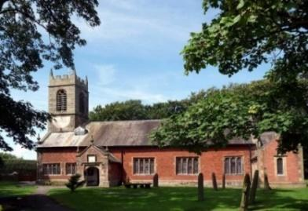

Welcome to our Church today.

Please stay for refreshments in the Lodge which follow the 10.30am service.

***Sunday 4th August 2024***

**GOD’S GLORY IS REVEALED**

***The Heavens declare the glory of God. His laws are sweet as honey.***

***O Lord my Rock and my Redeemer. (from Psalm 19)***

**PRAYER OF THE DAY Lord of heaven and earth, as Jesus taught**

**his disciples to be persistent in prayer, give us patience and courage**

**never to lose hope, but always to bring our prayers before you;**

**through Jesus Christ our Lord. Amen.**



**No Sunday School today during the service.**

Toys/colouring sheets for younger children at the back of church.

**9.00am. Holy Communion (Book of Common Prayer p237)**

**10.30am. Parish Communion.**

**Reading: Psalm 19.**

**Hymns: 511 – O Lord my God (How great Thou art).**

**67 – Be still, for the presence of the Lord.**

**Suppl. 11 – You’re the Word of God the Father.**

**461 – My Jesus, my Saviour.**

**H/C Hymns: 17 – All Heaven declares.**

**45 – As the deer pants for the water.**

**4.00pm. Holy Communion (Old Mill Court).**

**Monday 5th August.**

**2.30pm. Holy Communion (Ribble Court)**

**Reading: The Glory of God. Psalm 19**

The heavens declare the glory of God;  the skies proclaim the work of his hands.  
 Day after day they pour forth speech; night after night they reveal knowledge.  
They have no speech, they use no words; no sound is heard from them.  
 Yet their voice goes out into all the earth, their words to the ends of the world.  
In the heavens God has pitched a tent for the sun.  
   It is like a bridegroom coming out of his chamber, like a champion rejoicing to run his course.  
It rises at one end of the heavens and makes its circuit to the other;  
nothing is deprived of its warmth.

The law of the Lord is perfect, refreshing the soul.  
The statutes of the Lord are trustworthy, making wise the simple.  
The precepts of the Lord are right, giving joy to the heart.  
The commands of the Lord are radiant, giving light to the eyes.  
The fear of the Lord is pure, enduring for ever.  
The decrees of the Lord are firm, and all of them are righteous.

They are more precious than gold, than much pure gold;  
they are sweeter than honey, than honey from the honeycomb.  
By them your servant is warned; in keeping them there is great reward.  
But who can discern their own errors? Forgive my hidden faults.  
Keep your servant also from wilful sins; may they not rule over me.  
Then I will be blameless, innocent of great transgression.

May these words of my mouth and this meditation of my heart  
be pleasing in your sight,  
    Lord, my Rock and my Redeemer.

**Prayer:** We pray for a successful response to our Giving in Grace campaign and the appointment of a new Rector. We continue to pray for all those currently affected by the conflicts and natural disasters in the troubled areas of the world. We pray for all those affected by the recent events in Southport, praying especially for the families of the three young girls who lost their lives. We give thanks for the emergency services and volunteers who responded so positively to the situation.

We pray for the sick, especially Beryl Carr, Jim Ashcroft, Jean Smallwood, Sue Meadows, Debbie Meagh, Michelle, Judith Stopford and Elaine Read, and for Liz Boland recovering from a recent operation. We give thanks for the lives of Patricia Edwardson, Ann Johnson and Harry Pugh and pray for their families and friends.

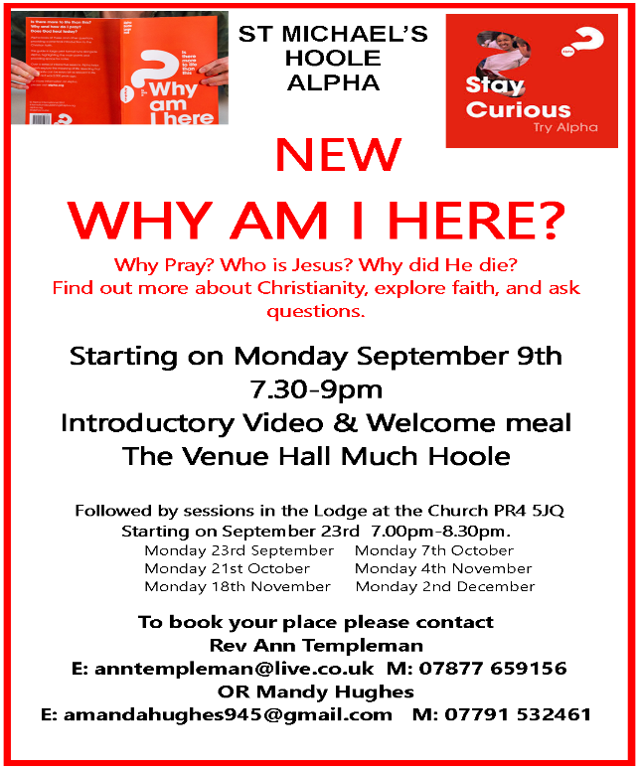



**REVD. HARRY PUGH**

The death was announced one week ago of our former Rector Harry Pugh. Following retirement, he returned to Lancashire and has been assisting at the church of St Stephen on the Cliffs, Holmfield Road, Blackpool, FY2 9RG, where his funeral will take place on **Friday August 16th at 12.00noon**. Cremation will follow. His ashes will be interred here at St Michaels at a date yet to be decided.