PARISH DATES
Tuesday 22nd August 10.15am Morning Worship in the Lodge.
Sunday 27th August 9.00am Holy Communion
10.30am Parish Communion*
Tuesday 29th August 10.15am Holy Communion in the Lodge.
Wed. 30th August 11.00am Funeral of Gerry McCormick
at West Lancashire Crematorium.
Friday 1st Sept. 1.00pm Funeral of Edith Chadwick in Church
Sunday 3rd Sept. 9.00am Holy Communion
10.30am Parish Communion with Sunday School
(First Sunday School following the Summer break)
4.00pm Holy Communion (Old Mill Court)
Monday 4th Sept. 7.30pm Next Steps in the Bible 1 in the Lodge
Tuesday 5th Sept. 10.15am Holy Communion in the Lodge.
Sunday 10th Sept. 9.00am Holy Communion
10.30am Morning Worship.
3.45pm HOGWARTS FAMILY CHURCH IN CHURCH.
Tuesday 12th Sept. 10.15am Morning Worship in the Lodge.
7.30pm Men’s Group Meeting in the Village Hall
Sunday 17th Sept. 9.00am Holy Communion
10.30am Parish Communion with Sunday School
3.30pm CELEBRATION OF MARRIAGE
WITH BISHOP JILL DUFF
Monday 18th Sept. 7.30pm Next Steps in the Bible 2 in the Lodge
Tuesday 19th Sept. 10.15am Holy Communion in the Lodge.

* No official Sunday School during August, but there will be informal children’s
activities in the lodge during Sermon and Prayers.

FUTURE DATES FOR YOUR DIARY:
SEPTEMBER 10th 3.45pm - Hogwarts Church
SEPTEMBER 17TH 3.30pm – Celebration of Marriage Service Bishop Jill Duff
SEPTEMBER 29th 7.00pm - Harvest Social and Quiz – Village Hall
OCTOBER 1st 10.30am- Harvest Thanksgiving Service
NOVEMBER 5th 6.00pm - Service of Thanksgiving for Loved Ones
NOVEMBER 11th 10.00 - 2.00 – Parish Quiet Day at Whalley Abbey with Archdeacon Mark

www.hooleparishchurch.com Facebook : St Michael and All Angels Church, Hoole,
Rector Ann Templeman anntempleman@live.co.uk 01772 448515 or 07877659156
PLEASE TAKE THIS SHEET HOME WITH YOU.
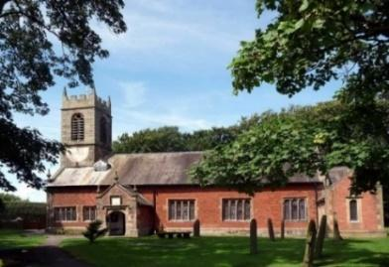
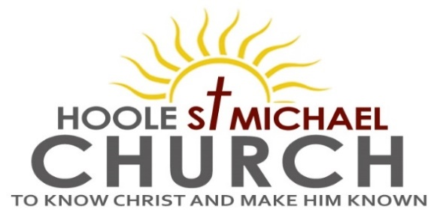

Welcome to our Church today, with a special welcome to Pat Belshaw
who is leading our worship at 9.00am and Katie Bradley our organist at 10.30am. Please stay for refreshments in the Lodge which follow the 10.30am service

Sunday 20th August 2023

“THERE’S A WIDENESS IN GOD’S MERCY”

“Lord, Son of David, have mercy on me”. (Matthew 15: v 22).

PRAYER OF THE DAY God of glory, the end of our searching,
help us to lay aside all that prevents us from seeking your kingdom,
and to give all that we have to gain the pearl beyond all price,
through our Saviour Jesus Christ. Amen.

No Sunday School today during the service.
There will be activity time in the lodge and there are toys and colouring sheets for younger children at the back of church.

9.00am. Holy Communion (Book of Common Prayer) begins p237

10.30am. Morning Worship.
Reading: Matthew 15: v 21-28.
Hymns: 16 – All hail the power of Jesus’ name.
Children’s Hymn – God loves me . . .
314 – Immortal invisible, God only wise.
448 – Meekness and majesty.
221 – God is working his purpose out.
766 – You shall go out with joy.

Reading: Matthew 14: v 22-33.
Leaving that place, Jesus withdrew to the region of Tyre and Sidon.
A Canaanite woman from that vicinity came to him, crying out, ‘Lord, Son of David, have mercy on me! My daughter is demon-possessed and suffering terribly.’ Jesus did not answer a word. So his disciples came to him and urged him, ‘Send her away, for she keeps crying out after us.’
He answered, ‘I was sent only to the lost sheep of Israel.’
The woman came and knelt before him. ‘Lord, help me!’ she said.
He replied, ‘It is not right to take the children’s bread and toss it to the dogs.’
‘Yes it is, Lord,’ she said. ‘Even the dogs eat the crumbs that fall from their master’s table.’
Then Jesus said to her, ‘Woman, you have great faith! Your request is granted.’ And her daughter was healed at that moment.

Prayer: We pray for Ann, Peter and all those away on holiday at this time, we especially pray for our children’s minister Liz, now home but still recovering from her recent emergency operation. We give thanks for those leading the beach mission in Lincolnshire. We pray for those who are sick especially Erica Ivy, Daniel Conner, Jean Smallwood, Jon Slinger, Elaine Cowburn, Kathleen Smalley, Nick and Marilyn Winter, Andy Shaw, Bill and Beryl Carr. We give thanks life of Gerry McCormick and pray for his granddaughter Abby and the family. We give thanks also for the lives of Irene Banister and Edith Chadwick and pray for their families and friends.

Message from Liz:
Thank you all for the cards, prayers and messages you've sent while I've been ill. I was desperately sad to miss Beach Mission, and was very unwell for a few days, but am now very much on the mend. I hope to be back working from home in the next few days and then we're going on a much needed holiday, and I will hopefully be back properly in September.

Hoole St. Michael’s Men’s Group: will hold the first meeting of the new season on Tuesday September 12th at 7.30pm in the Village Hall. At the AGM in May we took the decision to use the name ‘Group’ rather than ‘Fellowship’ in our title as it had been pointed out that some people thought the name fellowship implied an exclusive rather than inclusive group. So in line with the Ladies we are now a ‘Group’ and very much open to all. Our first meeting will be a talk on Water Treatment by one of our own members, Alan Taylor, please come along, you will be most welcome.

BIBLE FOR BEGINNERS
CONTINUES fortnightly in SEPTEMBER
from MONDAY SEPT 4TH 7.30pm in the LODGE
We will be looking at the story of Jesus Christ in the New Testament and also as illustrated in the Biblically based
film series the CHOSEN

Suggested Bible Readings for this week:
Monday 21st Aug. Matt. 19: v 16-22. Tuesday 22nd Aug. Matt. 19: v 23-end.
Wed. 23rd Aug. Matt. 20: v 1-16. Thursday 24th Aug. Luke 22: v 24-30.
Friday 25th Aug. Matt. 22: v 34-40. Saturday 26th Aug. Matt. 23: v 1-12.

