PARISH DATES
Tuesday 29th August 10.15am Holy Communion in the Lodge.
Wed. 30th August 11.00am Funeral of Gerry McCormick
at West Lancashire Crematorium.
Friday 1st Sept. 1.00pm Funeral of Edith Chadwick in Church
Sunday 3rd Sept. 9.00am Holy Communion
10.30am Parish Communion with Sunday School
(First Sunday School following the Summer break)
4.00pm Holy Communion (Old Mill Court)
Monday 4th Sept. 7.30pm Next Steps in the Bible 1 in the Lodge
Tuesday 5th Sept. 10.15am Holy Communion in the Lodge.
Sunday 10th Sept. 9.00am Holy Communion
10.30am Morning Worship.
3.45pm HOGWARTS FAMILY CHURCH IN CHURCH.
Tuesday 12th Sept. 10.15am Morning Worship in the Lodge.
7.30pm Men’s Group Meeting in the Village Hall
Sunday 17th Sept. 9.00am Holy Communion
10.30am Parish Communion with Sunday School
3.30pm CELEBRATION OF MARRIAGE
WITH BISHOP JILL DUFF
Monday 18th Sept. 7.30pm Next Steps in the Bible 2 in the Lodge
Tuesday 19th Sept. 10.15am Holy Communion in the Lodge.
7.30pm Ladies Group Meeting in the Village Hall
Sunday 24th Sept. 9.00am Holy Communion
10.30am Morning Worship with Sunday School.
Tuesday 26th Sept. 10.15am Morning Worship in the Lodge.
Friday 29th Sept. 7.00pm Harvest Social and Quiz in the Village Hall

FUTURE DATES FOR YOUR DIARY:
SEPTEMBER 10th 3.45pm - Hogwarts Church
SEPTEMBER 17TH 3.30pm – Celebration of Marriage Service Bishop Jill Duff
SEPTEMBER 29th 7.00pm - Harvest Social and Quiz – Village Hall
OCTOBER 1st 10.30am- Harvest Thanksgiving Service
NOVEMBER 5th 6.00pm - Service of Thanksgiving for Loved Ones
NOVEMBER 11th 10.00 - 2.00 – Parish Quiet Day at Whalley Abbey with Archdeacon Mark

www.hooleparishchurch.com Facebook : St Michael and All Angels Church, Hoole,
Rector Ann Templeman anntempleman@live.co.uk 01772 448515 or 07877659156
PLEASE TAKE THIS SHEET HOME WITH YOU.
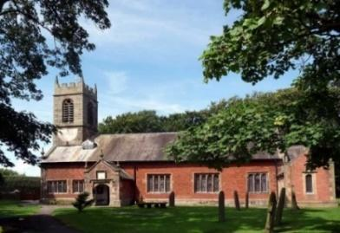
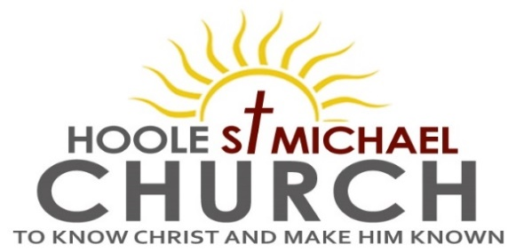

Welcome to our Church today, with congratulations to Ann and Peter
on the occasion of their Golden Wedding Anniversary.
Please stay for refreshments in the Lodge which follow the 10.30am service.

Sunday 27th August 2023

“WHO DO YOU SAY THAT I AM”

“But what about you?” he asked. “Who do you say I am?” Simon Peter answered, “You are the Christ, the Son of the living God”. (Matt. 16: v 15&16).

PRAYER OF THE DAY Almighty and everlasting God, you are
always more ready to hear than we to pray and to give more than
either we desire or deserve: pour down upon us the abundance of your
mercy, forgiving us those things of which our conscience is afraid and
giving us those good things which we are not worthy to ask but
through the merits and mediation of Jesus Christ your Son our Lord,
who is alive and reigns with you, in the unity of the Holy Spirit,
one God, now and for ever. Amen.

No Sunday School today during the service.
There will be activity time in the lodge and there are toys and colouring sheets for younger children at the back of church.

9.00am. Holy Communion (Book of Common Prayer) begins p237

10.30am. Parish Communion.
Readings: Matthew 16: v 13-17. Romans 12: v 1 & 2.
Hymns: 54 – At the name of Jesus (4 verses only).
45 – As the deer pants for the water.
Suppl. 3 – Before the throne of God above.
332 – I the Lord of sea and sky.
H/C Hymns: Screen – How deep the Father’s love.
374 – Just as I am.
Reading 1: Matthew 16: v 13-17.
When Jesus came to the region of Caesarea Philippi, he asked his disciples, ‘Who do people say the Son of Man is?’
They replied, ‘Some say John the Baptist; others say Elijah; and still others, Jeremiah or one of the prophets.’
‘But what about you?’ he asked. ‘Who do you say I am?’
Simon Peter answered, ‘You are the Christ, the Son of the living God.’
Jesus replied, ‘Blessed are you, Simon son of Jonah, for this was not revealed to you by flesh and blood, but by my Father in heaven.

Reading 2: Romans 12: v 1 & 2.
Therefore, I urge you, brothers and sisters, in view of God’s mercy, to offer your bodies as a living sacrifice, holy and pleasing to God – this is your true and proper worship. Do not conform to the pattern of this world, but be transformed by the renewing of your mind. Then you will be able to test and approve what God’s will is – his good, pleasing and perfect will.

Prayer: We pray for Ann, Peter on the occasion of their Golden Wedding Anniversary. We pray for those who are sick especially our children’s minister Liz, as she recovers from her operation, Erica Ivy, Daniel Conner, Jean Smallwood, Jon Slinger, Elaine Cowburn, Kathleen Smalley, Nick and Marilyn Winter, Andy Shaw, Bill and Beryl Carr. We give thanks life of Gerry McCormick and pray for his granddaughter Abby and the family. We give thanks also for the lives of Irene Banister and Edith Chadwick and pray for their families and friends.

Sunday School: As our Sunday School re-starts next week following the Summer break, so too we hope to welcome back to church, Liz our Children’s minister, still on recovery from her operation, but anxious to be back. We ask that she be given patience till her recovery is complete.

Hoole St. Michael’s Men’s Group: will hold the first meeting of the new season on Tuesday September 12th at 7.30pm in the Village Hall. At the AGM in May we took the decision to use the name ‘Group’ rather than ‘Fellowship’ in our title as it had been pointed out that some people thought the name fellowship implied an exclusive rather than inclusive group. So in line with the Ladies we are now a ‘Group’ and very much open to all. Our first meeting will be a talk on Water Treatment by one of our own members, Alan Taylor, please come along, you will be most welcome.
BIBLE FOR BEGINNERS
CONTINUES fortnightly in SEPTEMBER
from MONDAY SEPT 4TH 7.30pm in the LODGE
We will be looking at the story of Jesus Christ in the New Testament and also as illustrated in the Biblically based
film series the CHOSEN
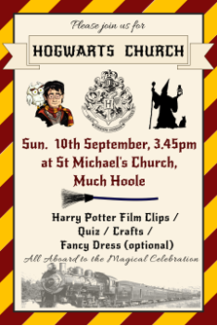
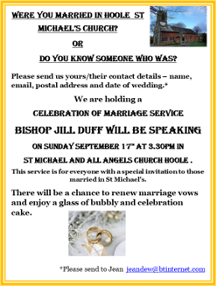

Suggested Bible Readings for this week:
Monday 28th Aug. Matt. 23: v 13-22. Tuesday 29th Aug. Matt. 23: v 23-26.
Wed. 30th Aug. Matt. 23: v 27-32. Thursday 31st Aug. Matt. 24: v 42-end.
Friday 1st Sept. Matt. 25: v 1-13. Saturday 2nd Sept. Matt. 25: v 14-30.

