Parish Dates From August 2022

Tuesday 16th August 10.15am Morning Prayer in church.
1.00pm Ladies Group trip to Lytham Hall.
Sunday 21st August 9.00am Holy Communion
10.30am All Age Worship
Tuesday 23rd August 10.15am Morning Prayer in church.
Sunday 28th August 9.00am Holy Communion
10.30am Parish Communion*
Tuesday 30th August 10.15am Holy Communion in church.
Sunday 4th Sept. 9.00am Holy Communion
10.30am Parish Communion with Bishop Tony
SUNDAY SCHOOL RE-STARTS TODAY.
4.00pm Holy Communion (Old Mill Court)
Tuesday 6th Sept. 10.15am Holy Communion/Morning Prayer in church.
Sunday 11th Sept. 9.00am Holy Communion
10.30am Parish Communion with Sunday School.
Monday 12th Sept. 7.30pm PCC meets in the Lodge.
Tuesday 13th Sept. 10.15am Holy Communion.
7.30pm Bible Study in the Lodge.
* No Sunday School as such, but some children’s activities during the service.
SOME IMPORTANT DATES FOR YOUR DIARY;
1.Sunday 18th September 10.30am: Opening of the Lodge
Celebration service, Opening by Archdeacon Mark.
Refreshments BBQ and children’s activities
2.Fri 30th Sept 7pm Harvest Supper & Quiz Village Hall
3.Sun 2nd Oct 10.30am Harvest Festival & Gift Day

Suggested Bible readings this week.
Monday 15th Aug. Luke. 1: v 46-55. Tuesday 16th Aug. Matt. 19: v 23-end.
Wed. 17th Aug. Matt. 20: v 1-16. Thursday 18th Aug. Matt. 22: v 1-14.
Friday 19th Aug. Matt. 22: v 34-40. Saturday 20th Aug. Matt. 23: v 1-12.
Website : www.hooleparishchurch.com
Facebook page: St Michael and All Angels Church, Hoole,
Rector – Revd Ann Templeman anntempleman@live.co.uk 01772 448515

SOPlease take this sheet home with you
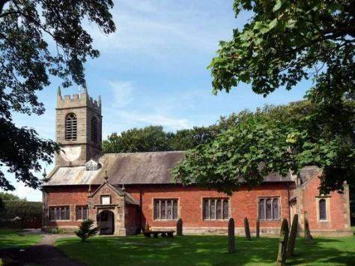
St. Michael and All Angels – Hoole

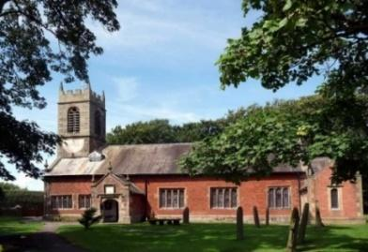

Welcome to our church this morning. With a special welcome to Revd. Pat Belshaw, who is leading our worship today. Please stay for a chat and a cup of tea or coffee after the 10.30 service- a great way to meet people

Sunday 14th August 2022 Trinity 9

LIGHT UP THE FIRE

‘I have come to bring fire to the earth,
and how I wish it was already kindled’. Luke 12: v 49.

PRAYER OF THE DAY: Gracious Father, revive your Church in
our day, and make her holy, strong and faithful, for your glory’s sake
in Jesus Christ our Lord. Amen.

No Sunday School today during the service
There are toys and colouring sheets
for younger children at the back of church.

9.00am. Holy Communion (Book of Common Prayer) begins p237

10.30am. Morning Worship.

Reading: Luke 12: v 49-56.

Hymns: 108 – Colours of day.
590 – Seek ye first.
617 – Stand up, stand up for Jesus.
(Traditional words – inside rear cover of hymn book)
626 – Take up thy cross, the Saviour said.
70 – Be thou my vision.
Reading. Luke 12: v 49-56. “I have come to bring fire on the earth, and how I wish it were already kindled! But I have a baptism to undergo, and what constraint I am under until it is completed! Do you think I came to bring peace on earth? No, I tell you, but division. From now on there will be five in one family divided against each other, three against two and two against three. They will be divided, father against son and son against father, mother against daughter and daughter against mother, mother-in-law against daughter-in-law and daughter-in-law against mother-in-law.”
He said to the crowd: “When you see a cloud rising in the west, immediately you say, ‘It’s going to rain,’ and it does. And when the south wind blows, you say, ‘It’s going to be hot,’ and it is. Hypocrites! You know how to interpret the appearance of the earth and the sky. How is it that you don’t know how to interpret this present time?

Prayer: We pray for Ann and Peter on their well-deserved holiday. We pray for those who are sick, especially Erica Ivy, Mona Lewis, Isobel Wooldridge, Patricia Edmondson, Beryl Cotton, Jim Ashcroft, Tom Parkinson, Rose Brown, Steve Coughlan, Josephine Hodge, Joan Sumner, Bill & Beryl Carr. We give thanks for the life of Thomas Sanderson and pray for his family and friends. We give thanks for the resources to build our Lodge and ask for wisdom in its equipping and use for service to God and the community

YOUR CHANCE TO DONATE SPECIFIC ITEMS FOR THE LODGE

Several people have said that they would like to donate to the Platinum Jubilee
Lodge Appeal, but would prefer to make donations towards a specific item,
rather than donating into a general fund. If you feel able to donate you don’t
have to buy the item – we will do that – just let us know what you wish to buy
and arrange to transfer the appropriate amount of money.

A donation of £10 could buy any of the following: dustpan and brush,
doormat, cleaning products, washing up caddy, toilet roll holder, toilet brush.
A donation of £20 could buy any of these items: small folding tables, mop and
bucket, coat hooks, waste bins, wall clock.
A £30 donation could be used to buy a mirror for the toilet area, a baby
change unit, or window blinds.
If you are able to spare £50, this would buy us a computer desk or a bracket to
mount the (already donated) TV. £150 would buy the fridge or children’s work table we need. Finally, we will need to buy some new chairs, which are likely to
st £25 for the children and £45 for adult chairs.
If you prefer, a general donation can be made, some of which will be used to
assist teaching for our children and young people’s work, and adult discussion
groups, including DVD’s, books, craft materials, stationery etc.
If you feel able to make a donation, thank you so much.
There are three ways to donate: place your gift in the collection on our Harvest gift day on 2nd October, clearly marked; or hand it before then in an envelope to the
churchwardens clearly marked with your wishes; or transfer the amount to:
PCC Hoole Parish Church A/c no: 84453034 sort code: 40-37-25 using the
reference “lodge FandF” – advising the wardens of any purchasing preference.

