**Parish Dates August 2021 onwards**

Tuesday August 17th 10.15am – 10.45am. Prayer time in Church.

Saturday August 21st 2.00pm Marriage of Liam Greenwood and Amy Woollam.

**Sunday August 22nd 09.00am Holy Communion**

**10.30am Morning Worship**

**3.00pm Fundraising event for Fomo and the Lodge**

(full details inside sheet)

Tuesday August 24th 10.15am – 10.45am. Prayer time in Church.

Thursday August 26th from 11.30am Locals’ Lunch in New Village Hall

**Sunday August 29th 09.00am Holy Communion in Church**

**10.30am ALL AGE SERVICE Parish Communion**

Tuesday August 31st 10.15am – 10.45am. Prayer time in Church.

**Sunday Sept 5th 09.00am Holy Communion**

**10.30am Parish Communion**

**SUNDAY SCHOOL BEGINS AGAIN**

Monday Sept 6th 7.30pm PCC meeting at the Rectory

Tuesday Sept 7th 10.15am – 10.45am. Prayer time in Church

7.30pm Bible Study in Rectory (venue tbc)

Thursday Sept 9th from 11.30am Locals’ Lunch in New Village Hall

**Sunday Sept 12th 9.00am Holy Communion**

**10.30am Morning Worship**

**3.45pm Minecraft Church in School.**

Monday Sept 13th 7.30pm Bible Study at the Rectory

Tuesday Sept 14th 10.15am – 10.45am Prayer time in Church.

**Saturday Sept 18th 3-5.00pm Clay Pigeon shooting party see flier for more details / contact Colin Wilson on 616978**

**Key Future Dates SAVE THE DATE Harvest Festival and Social**

**Friday Oct 1st 7.00pm Harvest Social with Quiz , Meal**

**and Entertainment in the New Village Hall.**

**Sunday Oct 3rd 10.30am HARVEST FESTIVAL**

**Nb There will be no audio recordings of 10.30 services on 8th ,15th 22nd August. More technical help needed!**

**Website:** **www.hooleparishchurch.com****.**

Facebook page: **St Michael and All Angels Church, Hoole**,

Rector – Revd Ann Templeman anntempleman@live.co.uk 01772 448515

The Rectory, 69 Liverpool Old Road Much Hoole PR4 4RB

*Please take this sheet home with you*

**St. Michael and All Angels – Hoole**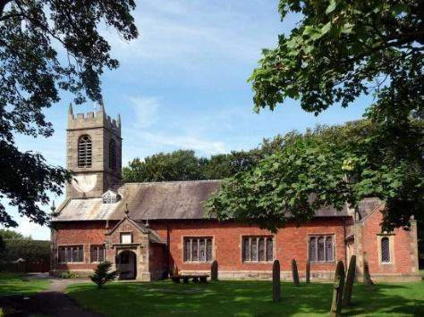

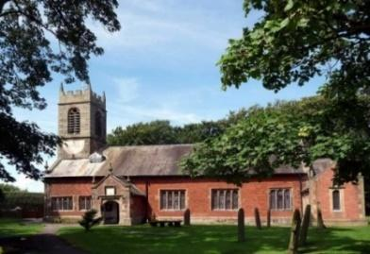

***Welcome to our church again this morning. We continue to welcome new friends and welcome back others and a special welcome to Revd Richard Plant as he leads our worship today as Ann and Peter are on holiday.***

***Sunday 15th August 2021 The Blessed Virgin Mary (Trinity 11)***

**TO GOD BE THE GLORY**

**“The Mighty One has done great things for me – Holy is his name*.”***

*Luke 1: v 49.*

**PRAYER OF THE DAY: God of glory, the end of our searching,**

**help us to lay aside all that prevents us from seeking your kingdom,**

**and to give all that we have to gain the pearl beyond all price,**

**through our Saviour Jesus Christ. Amen.**

**No Sunday School as such today during the service but the children will be taken out by Mandy Hughes for a Bible story and activity.**

There are also toys and colouring sheets

for younger children at the back of church.

**

**9.00am. Holy Communion (Book of Common Prayer) begins p237**

**10.30am. Parish Communion.**

**Reading: Luke 1: v 46-55.**

**Hymns: 552– O worship the Lord in the beauty of holiness.**

**631 – Tell out my soul.**

**Supp 5 – Bless the Lord O my soul.**

**695 – To God be the glory.**

**H/C Hymns: 285 – Holy, holy is the Lord. 201 – Give me joy in my heart.**

**BIBLE READING: Luke 1: v 46-55.**  Mary said: ‘My soul glorifies the Lord  and my spirit rejoices in God my Saviour,

for he has been mindful of the humble state of his servant.  
 From now on all generations will call me blessed, for the Mighty One has done great things for me –  holy is his name.  
His mercy extends to those who fear him, from generation to generation.  
He has performed mighty deeds with his arm; he has scattered those who are proud in their inmost thoughts.  
He has brought down rulers from their thrones but has lifted up the humble. He has filled the hungry with good things but has sent the rich away empty.  
He has helped his servant Israel, remembering to be merciful to Abraham and his descendants for ever, just as he promised our ancestors.’

**Prayer.** We give thanks for the planning permission for our much needed Lodge in the churchyard and pray that we will be able to find the money for this exciting new venture which is essential for the growth of our church. We give thanks for the new Village Hall and ask for God’s blessing on the new season of activities starting there. We pray for all who are on holiday at this time thinking especially of Ann and Peter on their well-earned holiday and for those leading our worship in their absence, and for Liz as she leads the special two weeks summer Beach Mission in Lincolnshire

We pray for those who are sick, especially Baby Erica Ivy, Patricia Mortimer, Bill and Beryl Carr, Alan Fleetwood, Nicola Middleton, Anthony Brogden and Josephine Hodge. We ask for God’s blessing on Liam and Amy as they prepare for their wedding next Saturday.

**FUNDRAISING EVENT** to be held in the garden at the home of Peter and Jean Smallwood at **3.00pm on Sunday August 22nd.** There will be **v**arious stalls, food and a raffle and all funds raised will be shared between ‘FOMO’ and the Church ‘Lodge’ fund.

**BIBLE STUDIES AND PRAYER TIMES**

**Join us for Prayer time 10.15am -10.45am in church**

**each Tuesday morning throughout August.**

**Bible Studies will resume in September Mondays and Tuesdays.**

**REFRESHMENTS AFTER 10.30 SERVICE Volunteers needed for rota. Please let Barbara Wood know if you can help.**  bw12252@hotmail.com

