**Parish Dates August 2021 onwards**

Tuesday August 24th 10.15am – 10.45am. Prayer time in Church.

Thursday August 26th from 11.30am Locals’ Lunch in New Village Hall

**Sunday August 29th 09.00am Holy Communion in Church**

**10.30am ALL AGE SERVICE Parish Communion**

Tuesday August 31st 10.15am – 10.45am. Prayer time in Church.

**Sunday Sept 5th 09.00am Holy Communion**

**10.30am Parish Communion**

**SUNDAY SCHOOL BEGINS AGAIN**

Monday Sept 6th 7.30pm PCC meeting at the Rectory

Tuesday Sept 7th 10.15am – 10.45am. Prayer time in Church

7.30pm Bible Study in Rectory (venue tbc)

Thursday Sept 9th from 11.30am Locals’ Lunch in New Village Hall

Friday Sept 10th 9.00am Beginning of term service

for whole school and parents.

**Sunday Sept 12th 9.00am Holy Communion**

**10.30am Morning Worship**

**3.45pm Minecraft Church in School.**

Monday Sept 13th 7.30pm Bible Study at the Rectory

Tuesday Sept 14th 9.00am Service for new starters and parents.

10.15am – 10.45am Prayer time in Church.

**Saturday Sept 18th 3.00-5.00pm Clay Pigeon Shooting Party: see inside.**

**Sunday Sept 19th 09.00am Holy Communion**

**10.30am Parish Communion with Sunday School and**

**baptism of Miran Jensen (Grandchild of Mandy Hughes)**

**12.00noon Baptism of Nancy Gladwinfield.**

**Key Future Dates SAVE THE DATE Harvest Festival and Social**

**Friday Oct 1st 7.00pm Harvest Social with Quiz , Meal**

**and Entertainment in the New Village Hall.**

**Sunday Oct 3rd 10.30am HARVEST FESTIVAL**

**Nb There will be no audio recordings of 10.30 services on 8th ,15th 22nd August. More technical help needed!**

**Website:** **www.hooleparishchurch.com****.**

Facebook page: **St Michael and All Angels Church, Hoole**,

Rector – Revd Ann Templeman anntempleman@live.co.uk 01772 448515

The Rectory, 69 Liverpool Old Road Much Hoole PR4 4RB

*Please take this sheet home with you*

**St. Michael and All Angels – Hoole**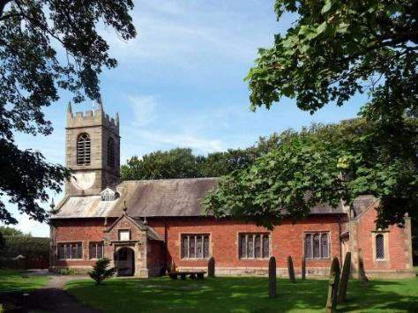

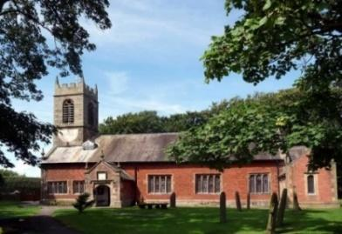

***Welcome to our church again this morning. We continue to welcome new friends and welcome back others and a special welcome to Revd Richard Plant as he leads our worship today as Ann and Peter are on holiday.***

***Sunday 22nd August 2021 Trinity 12***

**THE TEACHING OF THE SABBATH**

**“The people were delighted with all the wonderful things**

**Jesus was doing.*”*** *Luke 13: v 17.*

**PRAYER OF THE DAY: God of constant mercy,**

**who sent your Son to save us: remind us of your goodness,**

**increase your grace within us, that our thankfulness may grow,**

**through Jesus Christ our Lord. Amen.**

**No Sunday School as such today during the service but the children will be taken out for a Bible story and activity.**

There are also toys and colouring sheets

for younger children at the back of church.

**

**9.00am. Holy Communion (Book of Common Prayer) begins p237**

**10.30am. Morning Worship.**

**Reading: Luke 13: v 10-19.**

**Hymns: 625 – Take my life, and let it be.**

**305 – I danced in the morning.**

**212 – God forgave my sin.**

**67 – Be still, for the presence of the Lord.**

**332 – I, the Lord of sea and sky.**

**3.00pm. Fund raising event at the home of Jean Smallwood** (see inside**)**

**BIBLE READING: Luke 13: v 10-19.**  On a Sabbath Jesus was teaching in one of the synagogues, and a woman was there who had been crippled by a spirit for eighteen years. She was bent over and could not straighten up at all. When Jesus saw her, he called her forward and said to her, ‘Woman, you are set free from your infirmity.’ Then he put his hands on her, and immediately she straightened up and praised God.

Indignant because Jesus had healed on the Sabbath, the synagogue leader said to the people, ‘There are six days for work. So come and be healed on those days, not on the Sabbath.’

The Lord answered him, ‘You hypocrites! Doesn’t each of you on the Sabbath untie your ox or donkey from the stall and lead it out to give it water? Then should not this woman, a daughter of Abraham, whom Satan has kept bound for eighteen long years, be set free on the Sabbath day from what bound her?’

When he said this, all his opponents were humiliated, but the people were delighted with all the wonderful things he was doing.

Then Jesus asked. What is the kingdom of God like? What shall I compare it to? It is like a mustard seed, which a man took and planted in his garden. It grew and became a tree, and the birds of the air perched in its branches.

**Prayer.** We give thanks for the planning permission for our much needed Lodge in the churchyard and pray that we will be able to find the money for this exciting new venture which is essential for the growth of our church. We pray for all who are on holiday at this time thinking especially of Ann and Peter on their well-earned holiday and for those leading our worship in their absence. We pray for those who are sick, especially Baby Erica Ivy, Patricia Mortimer, Bill and Beryl Carr, Alan Fleetwood, Nicola Middleton, Anthony Brogden and Josephine Hodge. We ask for God’s blessing on Liam and Amy who were married here yesterday. We give thanks for the life of Kenneth Thomas and pray for his family and friends.

**FUNDRAISING EVENT** to be held in the garden at the home of Peter and Jean Smallwood at **3.00pm Today.** There will be **v**arious stalls, food and a raffle and all funds raised will be shared between ‘FOMO’ and the Church ‘Lodge’ fund.

**CLAY SHOOTING PARTY** to take place at 3.00pm on Saturday Sept 18th at the ‘Dolphin Clay Target Centre’, Marsh Lane Longton. Price per person is £35.00 which includes cartridges, Clays, Gun Hire, Instruction and safety wear. For further information contact Colin Wilson at southview1953@tiscali.co.uk or on 616978.

**BIBLE STUDIES AND PRAYER TIMES**

**Join us for Prayer time 10.15am -10.45am in church**

**each Tuesday morning throughout August.**

**Bible Studies will resume in September Mondays and Tuesdays.**

