Parish Dates From August 2022

Tuesday 30th August 10.15am Holy Communion in church.
Sunday 4th Sept. 9.00am Holy Communion
10.30am Parish Communion with Bishop Tony
SUNDAY SCHOOL RE-STARTS TODAY.
4.00pm Holy Communion (Old Mill Court)
Tuesday 6th Sept. 10.15am Morning Prayer in church.
Thursday 8th Sept. 4.30pm Chat & Chocolate
Sunday 11th Sept. 9.00am Holy Communion
10.30am Parish Communion with Sunday School.
Monday 12th Sept. 7.30pm PCC meets in the Lodge/Village Hall.
Tuesday 13th Sept. 9.00am School service in Church
10.15am Holy Communion.
7.30pm Bible Study in the Lodge.
Thursday 15th Sept. 4.30pm Bible & Biscuits in the Lodge
7.30pm Men’s Fellowship in the Village Hall
Sunday 18th Sept. Note – NO 9.00am Service today
10.30am GRAND OPENING OF
PLATINUM JUBILEE LODGE AND CELEBRATION SERVICE
WITH ARCHDEACON MARK. BBQ – CHILDREN’S ACTIVITIES.
Tuesday 20th Sept. 10.15am Holy Communion in church.
7.30pm Ladies Group meet in the Village Hall
Thursday 22nd Sept. 4.30pm Chat & Chocolate in the Lodge
Sunday 25th Sept. 9.00am Holy Communion
10.30am Parish Communion with Sunday School.
Monday 26th Sept. 7.30pm Bible Study in the Lodge.
Tuesday 27th Sept. 10.15am Holy Communion.
SOME IMPORTANT DATES FOR YOUR DIARY;
Fri 30th Sept 7pm Harvest Supper & Quiz Village Hall
Sun 2nd Oct 10.30am Harvest Festival & Gift Day

Suggested Bible readings this week.
Monday 29th Aug. Luke 4: v 16-30. Tuesday 30th Aug. Luke 4: v 31-37.
Wed. 31st Aug. Luke. 4: v 38-end. Thursday 1st Sept. Luke 5: v 1-11.
Friday 2nd Sept. Luke 5: v 33-end. Saturday 3rd Sept. Luke 6: v 1-5.
Website : www.hooleparishchurch.com
Facebook page: St Michael and All Angels Church, Hoole,
Rector – Revd Ann Templeman anntempleman@live.co.uk 07877659156 01772 448515

SOPlease take this sheet home with you
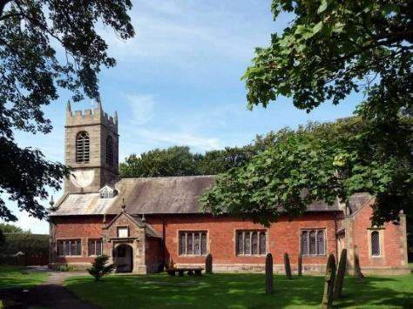
St. Michael and All Angels –Hoole

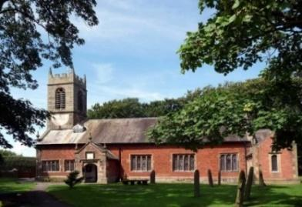

Welcome to our church this morning. Please stay for a chat and a cup of tea or coffee after the 10.30 service- a great way to meet people

Sunday 28th August 2022
“FOLLOW ME”

“For everyone who exalts himself will be humbled, and he who
humbles himself will be exalted”. Luke 14: v 11.

PRAYER OF THE DAY: God of glory, the end of our searching,
help us to lay aside all that prevents us from seeking your kingdom,
and to give all that we have to gain the pearl beyond all price,
through our Saviour Jesus Christ. Amen.

No Sunday School today during the service
Sunday School re-commences next week
There are toys and colouring sheets
for younger children at the back of church.

9.00am. Holy Communion (Book of Common Prayer) begins p237

10.30am. Parish Communion.

Readings: Luke 9: v 57-62. Luke 14: v 1 & 7-14.

Hymns: 551 – O worship the King.
437 – Make me a channel of your peace/
(Screen – You are shaped for serving God)
408 – Lord, enthroned in heavenly splendour.
503 – O Jesus, I have promised.

H/C Hymns. 463 – My song is love unknown. 29 Amazing Grace
Reading 1: Luke 9: v 57-62. As they were walking along the road, a man said to him, “I will follow you wherever you go.”
Jesus replied, “Foxes have dens and birds have nests, but the Son of Man has no place to lay his head.” He said to another man, “Follow me.”
But he replied, “Lord, first let me go and bury my father.”
Jesus said to him, “Let the dead bury their own dead, but you go and proclaim the kingdom of God.”
Still another said, “I will follow you, Lord; but first let me go back and say goodbye to my family.”
Jesus replied, “No one who puts a hand to the plough and looks back is fit for service in the kingdom of God.”

Reading 2: Luke 14: v 1 & 7-14. One Sabbath, when Jesus went to eat in the house of a prominent Pharisee, he was being carefully watched.
When he noticed how the guests picked the places of honour at the table, he told them this parable: ‘When someone invites you to a wedding feast, do not take the place of honour, for a person more distinguished than you may have been invited. If so, the host who invited both of you will come and say to you, “Give this person your seat.” Then, humiliated, you will have to take the least important place. But when you are invited, take the lowest place, so that when your host comes, he will say to you, “Friend, move up to a better place.” Then you will be honoured in the presence of all the other guests. For all those who exalt themselves will be humbled, and those who humble themselves will be exalted.’
Then Jesus said to his host, ‘When you give a luncheon or dinner, do not invite your friends, your brothers or sisters, your relatives, or your rich neighbours; if you do, they may invite you back and so you will be repaid. But when you give a banquet, invite the poor, the crippled, the lame, the blind, and you will be blessed. Although they cannot repay you, you will
be repaid at the resurrection of the righteous.’

Prayer: We pray for our schools and children as a new term is about to start, and for the Alpha course starting in October,. Also for the resources to build our Lodge and ask for wisdom in its equipping and use for service to God and the community. We pray for those who are sick, especially Erica Ivy, Mona Lewis, Isobel Wooldridge, Patricia Edmondson, Beryl Cotton, Jim Ashcroft, Tom Parkinson, Jim Belshaw, Steve Coughlan, Josephine Hodge, Bill & Beryl Carr. We give thanks for the life of Joan Sumner and Anne Scott and pray for their families and friends.
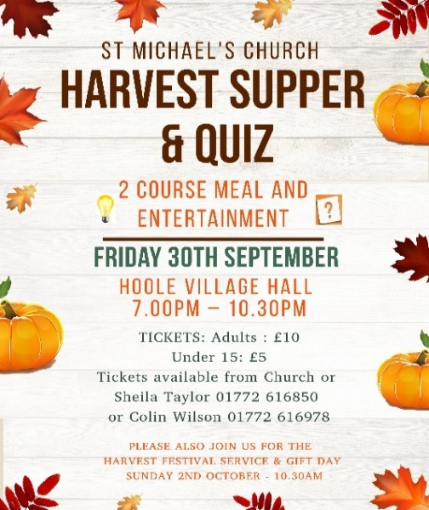

YOUR CHANCE TO DONATE SPECIFIC ITEMS FOR THE LODGE

Several people have said that they would like to donate to the Platinum Jubilee
Lodge Appeal, but would prefer to make donations towards a specific item,
rather than donating into a general fund. If you feel able to donate you don’t
have to buy the item – we will do that – just let us know what you wish to buy
and arrange to transfer the appropriate amount of money.

A donation of £10 could buy any of the following: dustpan and brush,
doormat, cleaning products, washing up caddy, toilet roll holder, toilet brush.
A donation of £20 could buy any of these items: small folding tables, mop and
bucket, coat hooks, waste bins, wall clock.
A £30 donation could be used to buy a mirror for the toilet area, a baby
change unit, or window blinds.
If you are able to spare £50, this would buy us a computer desk or a bracket to
mount the (already donated) TV. £150 would buy the fridge or children’s work table we need. Finally, we will need to buy some new chairs, which are likely to
st £25 for the children and £45 for adult chairs.
If you prefer, a general donation can be made, some of which will be used to
assist teaching for our children and young people’s work, and adult discussion
groups, including DVD’s, books, craft materials, stationery etc.
If you feel able to make a donation, thank you so much.
There are three ways to donate: place your gift in the collection on our Harvest gift day on 2nd October, clearly marked; or hand it before then in an envelope to the
churchwardens clearly marked with your wishes; or transfer the amount to:
PCC Hoole Parish Church A/c no: 84453034 sort code: 40-37-25 using the
reference “lodge FandF” – advising the wardens of any purchasing preference.

