**Parish Dates August 2021 onwards**

Tuesday August 31st 10.15am – 10.45am. Prayer time in Church.

**Sunday Sept 5th 09.00am Holy Communion**

**10.30am Parish Communion**

**SUNDAY SCHOOL BEGINS AGAIN**

Monday Sept 6th 7.30pm PCC meeting at the Rectory

Tuesday Sept 7th 10.15am – 10.45am. Prayer time in Church

7.30pm Bible Study in Rectory (venue tbc)

Thursday Sept 9th from 11.30am Locals’ Lunch in New Village Hall

Friday Sept 10th 9.00am Beginning of term service whole school & parents.

**Sunday Sept 12th 9.00am Holy Communion**

**10.30am Morning Worship**

**3.45pm Minecraft Church in School.**

Monday Sept 13th 3.30pm Bereavement group tea

7.30pm Bible Study at the Rectory

Tuesday Sept 14th 9.00am Service for new starters and parents.

10.15am – 10.45am Prayer time in Church.

**Saturday Sept 18th 3.00-5.00pm Clay Pigeon Shooting Party: see inside.**

**Sunday Sept 19th 09.00am Holy Communion**

**10.30am Parish Communion with Sunday School and**

**baptism of Miran Jensen (Grandchild of Mandy Hughes)**

**12.00noon Baptism of Nancy Gladwinfield.**

Tuesday Sept 21st 10.15am – 10.45am Prayer time in Church.

7.30pm Bible Study at the Rectory

**Sunday Sept 26th h 9.00am Holy Communion**

**10.30am Morning Worship**

**12.00noon Baptism of Elijah-John Fiddler**

**Key Future Dates SAVE THE DATE Harvest Festival and Social**

**Friday Oct 1st 7.00pm Harvest Social with Quiz , Meal**

**and Entertainment in the New Village Hall.**

**Sunday Oct 3rd 10.30am HARVEST FESTIVAL**

**Audio recording of the service re-commences today.**

**Website:** **www.hooleparishchurch.com****.**

Facebook page: **St Michael and All Angels Church, Hoole**,

Rector – Revd Ann Templeman anntempleman@live.co.uk 01772 448515

The Rectory, 69 Liverpool Old Road Much Hoole PR4 4RB

*Please take this sheet home with you*

**St. Michael and All Angels – Hoole**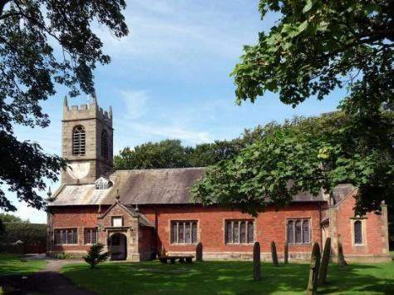

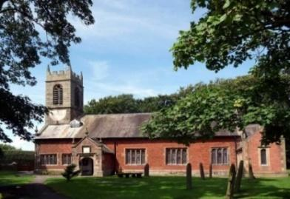

***Welcome to our church again this morning. We continue to welcome new friends and welcome back others and a special welcome to Revd Pat Belshaw as she leads our worship today as Ann and Peter are on holiday.***

***Sunday 29th August 2021 Trinity 13***

**THE ARMOUR OF GOD**

**“Be strong in the Lord and in his mighty power”***Ephesians 6: v 10*

**PRAYER OF THE DAY: Almighty God, you search us and know us:**

**may we rely on you in strength and rest on you in weakness, now and**

**in all our days; through Jesus Christ our Lord. Amen.**

**No Sunday School today as today it is an**

**‘All Age Service’.**

There are also toys and colouring sheets

for younger children at the back of church.

**

**9.00am. Holy Communion (Book of Common Prayer) begins p237**

**10.30am. Parish Communion (All Age Worship).**

**Reading: Ephesians 6: v 10-18.**

**Hymns: Supp. 5 – Bless the Lord O my soul.**

**Video – God Suit (Cheeky Pandas).**

**70 – Be thou my vision.**

**249 – Great is thy faithfulness.**

**H/C Hymns: Supp. 9 – The Lord’s my shepherd.**

**738 – When I survey the wondrous cross.**

**BIBLE READING: Ephesians 6: v 10-18.** Finally, be strong in the Lord and in his mighty power. Put on the full armour of God, so that you can take your stand against the devil’s schemes. For our struggle is not against flesh and blood, but against the rulers, against the authorities, against the powers of this dark world and against the spiritual forces of evil in the heavenly realms. Therefore put on the full armour of God, so that when the day of evil comes, you may be able to stand your ground, and after you have done everything, to stand. Stand firm then, with the belt of truth buckled round your waist, with the breastplate of righteousness in place, and with your feet fitted with the readiness that comes from the gospel of peace. In addition to all this, take up the shield of faith, with which you can extinguish all the flaming arrows of the evil one. Take the helmet of salvation and the sword of the Spirit, which is the word of God.

And pray in the Spirit on all occasions with all kinds of prayers and requests. With this in mind, be alert and always keep on praying for all the Lord’s people.

**Prayer.** We give thanks for the planning permission for our much needed Lodge in the churchyard and pray that we will be able to find the money for this exciting new venture which is essential for the growth of our church. We pray for all who are on holiday at this time thinking especially of Ann and Peter on their well-earned holiday and for those leading our worship in their absence. We pray for those who are sick, especially Baby Erica Ivy, Patricia Mortimer, Bill and Beryl Carr, Alan Fleetwood, Nicola Middleton, Anthony Brogden and Josephine Hodge. We give thanks for the life of Kenneth Thomas and pray for his family and friends.

**TEA ROTA** We are still in need of volunteers to join the tea rota after the 10.30am service. Could you be that person? We are trying to get enough people so that it will be a 5 week rota, I need 2 more people in order to do that. Please have a chat with me in church if you may be interested or my contact details are below. Thanks Gill Slinger. Phone.  07729121284, email. gillian.slinger@ btinternet.com

**CLAY SHOOTING PARTY** to take place at 3.00pm on Saturday Sept 18th at the ‘Dolphin Clay Target Centre’, Marsh Lane Longton. Price per person is £35.00 which includes cartridges, Clays, Gun Hire, Instruction and safety wear. For further information contact Colin Wilson at southview1953@tiscali.co.uk or on 616978.

**BIBLE STUDIES AND PRAYER TIMES**

**Join us for Prayer time 10.15am -10.45am in church**

**each Tuesday morning throughout August.**

**Bible Studies will resume in September Mondays and Tuesdays.**



