**Parish Dates August 2021 onwards**

Tuesday August 10th 10.15am – 10.45am. Prayer time in Church.

Thursday August 12th from 11.30am Locals’ Lunch in New Village Hall

**Sunday August 15th 09.00am Holy Communion in Church**

**10.30am Parish Communion in Church**

Tuesday August 17th 10.15am – 10.45am. Prayer time in Church.

Saturday August 21st 2.00pm Marriage of Liam Greenwood and Amy Woollam.

**Sunday August 22nd 09.00am Holy Communion**

**10.30am Morning Worship**

Tuesday August 24th 10.15am – 10.45am. Prayer time in Church.

Thursday August 26th from 11.30am Locals’ Lunch in New Village Hall

**Sunday August 29th 09.00am Holy Communion in Church**

**10.30am ALL AGE SERVICE Parish Communion**

Tuesday August 31st 10.15am – 10.45am. Prayer time in Church.

**Sunday Sept 5th 09.00am Holy Communion**

**10.30am Parish Communion**

**SUNDAY SCHOOL BEGINS AGAIN**

Monday Sept 6th 7.30pm PCC meeting at the Rectory

Tuesday Sept 7th 10.15am – 10.45am. Prayer time in Church

7.30pm Bible Study in Rectory (venue tbc)

**Sunday Sept 12th 9.00am Holy Communion**

**10.30am Morning Worship**

**3.45pm Minecraft Church in School.**

**Saturday Sept 18th 3-5.00pm Clay Pigeon shooting party see flier for more details / contact Colin Wilson on 616978**

**Key Future Dates SAVE THE DATE Harvest Festival and Social**

**Friday Oct 1st 7.00pm Harvest Social with Quiz , Meal**

**and Entertainment in the New Village Hall.**

**Sunday Oct 3rd 10.30am HARVEST FESTIVAL**

**Nb There will be no audio recordings of 10.30 services on 8th ,15th 22nd August. More technical help needed!**

**Website:** **www.hooleparishchurch.com****.**

Facebook page: **St Michael and All Angels Church, Hoole**,

Rector – Revd Ann Templeman anntempleman@live.co.uk 01772 448515

The Rectory, 69 Liverpool Old Road Much Hoole PR4 4RB

*Please take this sheet home with you*

**St. Michael and All Angels – Hoole**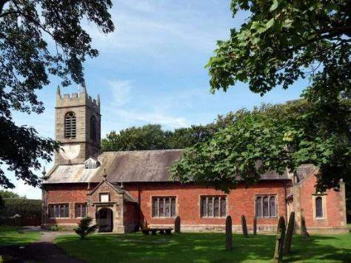

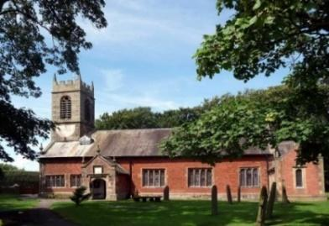

***Welcome to our church again this morning. We continue to welcome new friends and welcome back others.***

***Sunday 8th August 2021 Trinity 10***

**GOD’S INVITATION TO THE THIRSTY**

**“Whoever drinks the water I give him will never thirst*.”*** *John 4: v 14.*

**PRAYER OF THE DAY: Lord of heaven and earth, as Jesus**

**taught his disciples to be persistent in prayer, give us patience and**

**courage never to lose hope, but always to bring our prayers before**

**you; through Jesus Christ our Lord. Amen.**

**No Sunday School as such today during the service but Kayleigh will be taking children out for a Bible story and activity.**

There are also toys and colouring sheets

for younger children at the back of church.

**

**9.00am. Holy Communion (Book of Common Prayer) begins p237**

**10.30am. Morning Worship.**

**Reading: Isaiah 55.**

**Hymns: 450 – Morning has broken.**

**590 – Seek ye first the kingdom of God.**

**45 – As the deer pants for the water.**

**212 – God forgave my sin.**

**205 – Glorious things of thee are spoken (omit v 3)**

**766 – You shall go out with joy.**

**BIBLE READING: Isaiah 55.**  Come, all you who are thirsty,

 come to the waters; and you who have no money, come, buy and eat!  
Come, buy wine and milk without money and without cost. Why spend money on what is not bread, and your labour on what does not satisfy? Listen, listen to me, and eat what is good, and you will delight in the richest of fare. Give ear and come to me; listen, that you may live.

I will make an everlasting covenant with you, my faithful love promised to David. See, I have made him a witness to the peoples, a ruler and commander of the peoples. Surely you will summon nations you know not,  
and nations you do not know will come running to you, because of the Lord your God, the Holy One of Israel, for he has endowed you with splendour.’

Seek the Lord while he may be found; call on him while he is near.  
Let the wicked forsake their ways and the unrighteous their thoughts.  
Let them turn to the Lord, and he will have mercy on them, and to our God, for he will freely pardon. For my thoughts are not your thoughts, neither are your ways my ways,’ declares the Lord.

‘As the heavens are higher than the earth, so are my ways higher than your ways and my thoughts than your thoughts. As the rain and the snow  
come down from heaven, and do not return to it without watering the earth  
and making it bud and flourish, so that it yields seed for the sower and bread for the eater, so is my word that goes out from my mouth: it will not return to me empty, but will accomplish what I desire and achieve the purpose for which I sent it.

You will go out in joy and be led forth in peace; the mountains and hills  
will burst into song before you, and all the trees of the field will clap their hands. Instead of the thorn-bush will grow the juniper, and instead of briers the myrtle will grow. This will be for the Lord’s renown for an everlasting sign, that will endure for ever.’

**Prayer.** We give thanks for the planning permission for our much needed Lodge in the churchyard and pray that we will be able to find the money for this exciting new venture which is essential for the growth of our church. We give thanks for the new Village Hall and ask for God’s blessing on the new season of activities about to start there. We pray for all who are on holiday at this time thinking especially of Ann and Peter as they prepare to go away and of Liz as she leads the special two weeks summer Beach Mission in Lincolnshire

We pray for those who are sick, especially Baby Erica Ivy, Patricia Mortimer, Bill and Beryl Carr, Alan Fleetwood, Nicola Middleton, Anthony Brogden and Josephine Hodge. We give thanks for the life of Victor Ernest Marsh and pray for his family and friends.

**REFRESHMENTS AFTER 10.30 SERVICE Volunteers needed for rota. Please let Barbara Wood know if you can help.**  bw12252@hotmail.com

**BIBLE STUDIES AND PRAYER TIMES**

**Join us for Prayer time 10.15am -10.45am in church**

**each Tuesday morning throughout August.**

**Bible Studies will resume in September Mondays and Tuesdays.**

