Parish Dates From December 2022

TONIGHT

If you can’t make the Carol service in person, it will be live streamed. To view this, go to St Michael and All Angels Church, Hoole | Facebook
Tues 13th Dec 10.15am Holy Communion in the Lodge 7.00pm Men’s Fellowship Meal in the Village Hall
Wed14th Dec.7.00pm Christmas Social in the Lodge with Carols & Jacob’s Join
Thursday 15th Dec. 4.30pm Bible & Biscuits in the Lodge
Friday 16th Dec. 9.00am St Michael’s School Christmas Service.
1.30pm Funeral of Muriel Bamber

Sunday 18th Dec. 9.00am Holy Communion
10.30am Parish Communion.
12.30pm Sunday School Christmas Party in the Lodge.
2.30pm Chat & Chocolate Christmas Party in Lodge.
Tuesday 20th Dec 10.15am Holy Communion in the Lodge
CHRISTMAS EVE 4.00pm CRIB SERVICE
11.15pm MIDNIGHT COMMUNION.
CHRISTMAS DAY 10.30am FAMILY SERVICE Carols and Communion.
Sunday 1st Jan 2023 10.30am Parish Communion.
Tuesday 3rd Jan. 10.15am Morning Prayer in the Lodge.
Thursday 5th Jan. 4.30pm Chat and Chocolate in the Lodge.
Sunday 8th Jan 9.00am Holy Communion
10.30am Morning Worship with Sunday School
www.hooleparishchurch.com
Facebook page: St Michael and All Angels Church, Hoole,
Rector – Revd Ann Templeman anntempleman@live.co.uk
01772 448515 or 07877659156
SOPlease take this sheet home with you
St. Michael and All Angels –Hoole
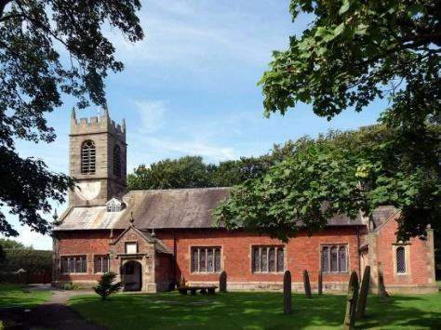

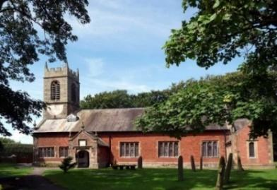

Welcome to our church this morning. Please stay for a chat and a cup of tea or coffee in the Lodge after the 10.30 service.

Sunday 11th December 2022
JOHN PREPARES THE WAY FOR JESUS CHRIST

When John heard in prison what Christ was doing, he sent his disciples to ask him “Are you the one who was to come, or should we expect someone else?”
Matthew 11 v 2-3.

PRAYER OF THE DAY: God for whom we watch and wait, you sent
John the Baptist to prepare the way of your Son: give us courage to
speak the truth, to hunger for justice, and to suffer for the cause of
right, with Jesus Christ our Lord. Amen.
Sunday School today during the service
There are toys and colouring sheets
for younger children at the back of church

9.00am. Holy Communion (Book of Common Prayer) begins p237

10.30am. Morning Worship with Sunday School.
Reading: Matthew 11: v 2-11.
Hymns: Suppl. 5 – Bless the Lord O my soul.
Screen – Great big God.
Both Canticles as set.
Suppl. 10 – Here is Love, vast as the ocean.
419 – Lord the light of your love (Shine Jesus shine).

6.00pm: CAROLS BY CANDLELIGHT
Reading: Matthew 11: v 2-11 When John, who was in prison, heard about the deeds of the Messiah, he sent his disciples to ask him, “Are you the one who is to come, or should we expect someone else?”
Jesus replied, “Go back and report to John what you hear and see: The blind receive sight, the lame walk, those who have leprosy are cleansed, the deaf hear, the dead are raised, and the good news is proclaimed to the poor. Blessed is anyone who does not stumble on account of me.”
As John’s disciples were leaving, Jesus began to speak to the crowd about John: “What did you go out into the wilderness to see? A reed swayed by the wind? If not, what did you go out to see? A man dressed in fine clothes? No, those who wear fine clothes are in kings’ palaces. Then what did you go out to see? A prophet? Yes, I tell you, and more than a prophet. This is the one about whom it is written:
“‘I will send my messenger ahead of you,
who will prepare your way before you.’
Truly I tell you, among those born of women there has not risen anyone greater than John the Baptist; yet whoever is least in the kingdom of heaven is greater than he.

Prayer: We pray for our Carol Service later today and all other Celebrations of Christmas to take place. We pray for the sick especially Liz Boland, Erika Ivy, Sam Burns, Christine Barker, Mona Lewis, Antonietta Broadhurst, Isaac Rostron, Margaret Thornborrow, Andy Shaw, Carole Bamber, Beryl and Bill Carr. We give thanks for the life of Muriel Bamber, whose funeral will take place on Friday and pray for her family and friends.
WATCHING IN HOPE – Copies of this Advent booklet published by the Diocese are still available in Church, please take one.
There are daily Bible readings with reflections through Advent.
Please borrow a Bible if necessary.
Suggested Bible readings from the booklet this week..

Monday 12th Dec. Micah. 7 v 8-13. Tuesday 13th Dec. Micah 7: v 14-20.
Wed. 14th Dec. Jeremiah 26: v 1-8 & 16-19. Thursday 15th Dec. Malachi 1: v 1-5.
Friday 16th Dec. Malachi 1: v 6-9. Saturday 17th Dec Malachi 1: v 10-14.

Note – The Weekly Giving envelopes for 2023 are now in church by the font. Please collect yours and assist by passing on others if possible.
Christmas Social in the Lodge with Carols and Jacob’s Join. Wednesday Dec 14th at 7.00pm. All are welcome; please let Colin Wilson or churchwarden or Ann know if you can come. Contributions of readings, drama etc as well as food very welcome. Colin: southview1953@tiscali.co.uk tel 01772616978
The Food Bank is urgently in need of supplies. Please help if you can.

