Parish Dates December 2021 onwards
Tuesday 14th December 10.15am - 10.45am Mornng Prayer in Church.
2.15pm School Carol Service in Church
7.30pm Housegroup Christmas Social at the
Rectory for everyone with Carols, Christmas readings and refreshments.
7.30pm Men’s Fellowship Christmas meal.
Thursday 16th December 4:30pm Chat & Chocolate
Friday 17th December 9.00am Hubbersty Assembly in Church
Sunday 19th December 09.00am Holy Communion
10.30am Parish Communion & Sunday School
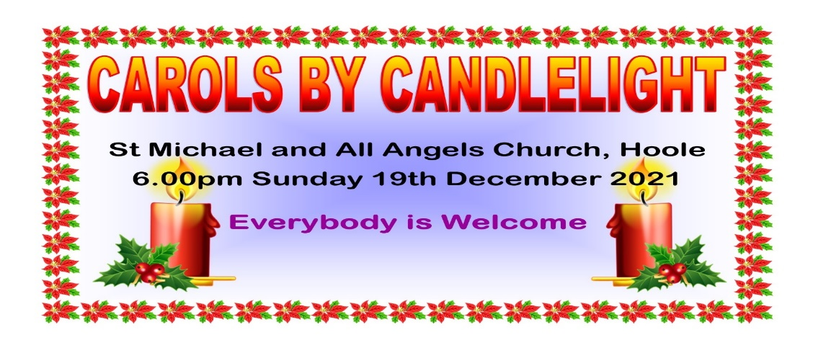
6.00pm CAROLS BY CANDLELIGHT

Tuesday 21st December 10.15am Holy Communion in Church.
CHRISTMAS EVE 4.00pm CRIB SERVICE
11.30pm MIDNIGHT COMMUNION
CHRISTMAS DAY 10.30am FAMILY SERVICE WITH CAROLS AND COMMUNION
Sunday 26th December 10.30am Parish Communion

SAVE THE DATE
Friday 21st January 7.00pm -10.30pm New Year Parish Social: Music from 60s and 90s in the Village Hall.
Website : www.hooleparishchurch.com
Facebook page: St Michael and All Angels Church, Hoole,
Rector – Revd Ann Templeman anntempleman@live.co.uk 01772 448515The Rectory, 69 Liverpool Old Road Much Hoole PR4 4RB
Please take this sheet home with you
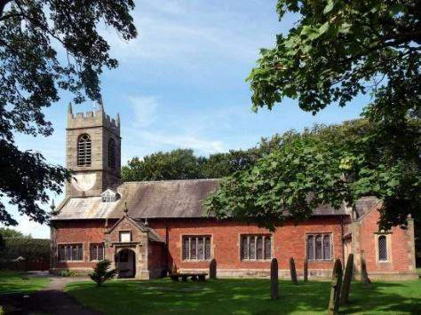
St. Michael and All Angels – Hoole

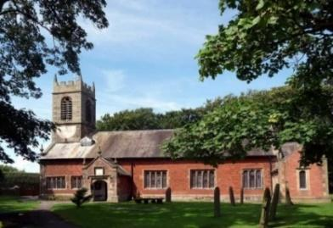

Welcome to our church again this morning. Please stay for a chat and a
cup of tea or coffee after the 10.30 service, a great way to meet people

Sunday 12th December 2021 Advent 3

FRIENDSHIP – DAVID AND JONATHAN.

‘There are friends who pretend to be friends, but there is a Friend who sticks closer than a brother.’

PRAYER OF THE DAY: God for whom we watch and wait, you
sent John the Baptist to prepare the way of your Son: give us courage
to speak the truth, to hunger for justice, and to suffer for the cause of
right, with Jesus Christ our Lord. Amen.

Sunday School today during the service
There are toys and colouring sheets
for younger children at the back of church.

9.00am. Holy Communion (Book of Common Prayer) begins p237
10.30am. Morning Worship with Sunday School

Readings: 1 Samuel 14: I Samuel 18.

Hymns: 259 – Hail to the Lord’s Anointed.
Screen/video – Joy to the world.
297 – How sweet the Name of Jesus sounds.
727 – What a Friend we have in Jesus.
Screen – From the squalor of a borrowed stable.

BIBLE READING: 1 Samuel 14. One day Jonathan son of Saul said to his young armour-bearer, ‘Come, let’s go over to the Philistine outpost on the other side.’ But he did not tell his father. Jonathan said to his young armour-bearer, ‘Come, let’s go over to the outpost of those uncircumcised men. Perhaps the Lord will act on our behalf. Nothing can hinder the Lord from saving, whether by many or by few.’ ‘Do all that you have in mind,’ his armour-bearer said. ‘Go ahead; I am with you heart and soul.’
So Jonathan said to his armour-bearer, ‘Climb up after me; the Lord has given them into the hand of Israel.’ Jonathan climbed up, using his hands and feet, with his armour-bearer right behind him. The Philistines fell before Jonathan, and his armour-bearer followed and killed behind him. In that first attack Jonathan and his armour-bearer killed some twenty men in an area of about half an acre.

I Samuel 18 & 20. Jonathan made a covenant with David because he loved him as himself. Jonathan took off the robe he was wearing and gave it to David, along with his tunic, and even his sword, his bow and his belt.
Then Jonathan said to David, ‘I swear by the Lord, the God of Israel, that I will surely sound out my father by this time the day after tomorrow! If he is favourably disposed towards you, will I not send you word and let you know? But if my father intends to harm you, may the Lord deal with me, be it ever so severely, if I do not let you know and send you away in peace. May the Lord be with you as he has been with my father. But show me unfailing kindness like the Lord’s kindness as long as I live, so that I may not be killed, and do not ever cut off your kindness from my family – not even when the Lord has cut off every one of David’s enemies from the face of the earth.’
So Jonathan made a covenant with the house of David, saying, ‘May the Lord call David’s enemies to account.’ And Jonathan made David reaffirm his oath out of love for him, because he loved him as he loved himself. Jonathan said to David, ‘Go in peace, for we have sworn friendship with each other in the name of the Lord, saying, “The Lord is witness between you and me, and between your descendants and my descendants for ever.”’ Then David left, and Jonathan went back to the town.

John 15. Jesus said “You are my friends if you do what I command you. I no longer call you servants, instead I have called you friends.

Prayer: We pray for all who are homeless or disadvantaged at this time of the year. We pray for those who are sick, especially Baby Erica Ivy, Patricia Mortimer, Rose Wood, Tom Parkinson, Karen Kenyon, Rose Brown, Steve Coughlan and James Turbefield. We give thanks for the life of Mary Ainscough, and pray for her family and friends.

HOUSEGROUP CHRISTMAS SOCIAL

TUESDAY 14TH DECEMBER 7.30pm AT THE RECTORY
Carols, Christmas readings and refreshments. All welcome.
Bring your own Christmas reading or poem if you wish.
Prayer time continues each Tuesday morning in Church at 10.15am .
