Parish Dates December 2021 onwards
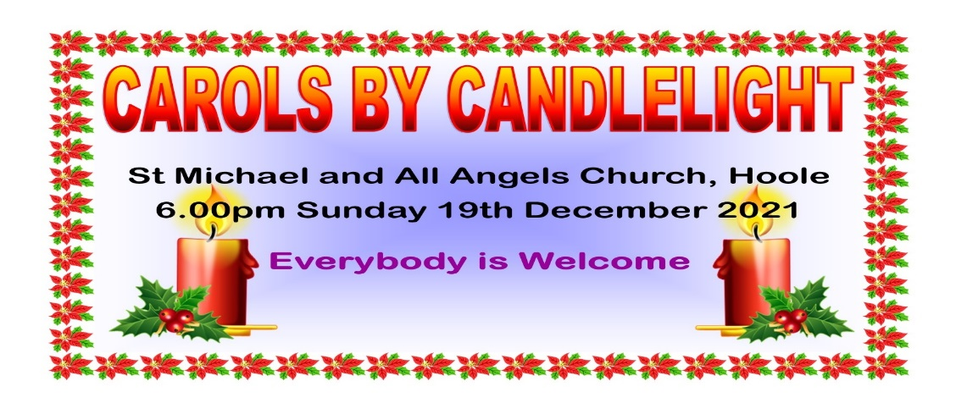
Today - Sunday 19th December 6.00pm CAROLS BY CANDLELIGHT

MULLED WINE AND MINCEPIES WILL BE SERVED AFTER
CAROLS BY CANDLELIGHT TONIGHT

Tuesday 21st December 10.15am Holy Communion in Church.

CHRISTMAS EVE 4.00pm CRIB SERVICE
Children are invited to come dressed as shepherds or angels
11.30pm MIDNIGHT COMMUNION
CHRISTMAS DAY 10.30am FAMILY SERVICE WITH CAROLS AND COMMUNION
CHILDREN ARE INVITED TO BRING ONE OF THEIR PRESENTS TO THE SERVICE
Sunday 26th December 10.30am Parish Communion
Monday January 17th 7.30pm PCC at the Village Hall

SAVE THE DATE
Friday 21st January 7.00pm -10.30pm New Year Parish Social:
Music from 60s to 90s in the Village Hall.
Website : www.hooleparishchurch.com
Facebook page: St Michael and All Angels Church, Hoole,
Rector – Revd Ann Templeman anntempleman@live.co.uk 01772 448515The Rectory, 69 Liverpool Old Road Much Hoole PR4 4RB
Please take this sheet home with you
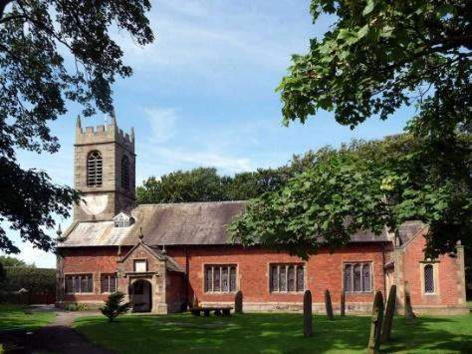
St. Michael and All Angels – Hoole

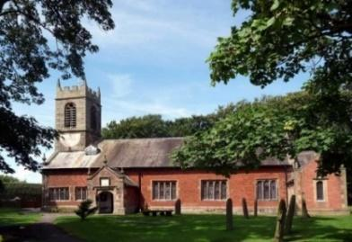

Welcome to our church again this morning. Please stay for a chat and a
cup of tea or coffee after the 10.30 service, a great way to meet people

Sunday 19th December 2021 Advent 4

GOD’S GRACE AND KINDNESS

‘So Mephibosheth ate at David’s table like one of the King’s sons.’
2 Samuel 9: v 11.

PRAYER OF THE DAY: Eternal God, as Mary waited for the birth
of your Son, so we wait for his coming in glory; bring us through the
birth pangs of this present age to see, with her, our great salvation
in Jesus Christ our Lord. Amen.

Sunday School today during the service
There are toys and colouring sheets
for younger children at the back of church.

9.00am. Holy Communion (Book of Common Prayer) begins p237
10.30am. Parish Communion with Sunday School

Reading: 2 Samuel 9: v 1-13.

Hymns: Carol sheet 18 – Angels from the realms of glory.
Screen/video – T’was on a starry night.
Carol sheet 8 – See amid the winter’s snow.
486 – Of the Father’s love begotten.

H/C Hymns: 649 – The King of love.

6.00pm. Carols by Candlelight. (see back page)

BIBLE READING: 2 Samuel 9: v 1-13. David asked, ‘Is there anyone still left of the house of Saul to whom I can show kindness for Jonathan’s sake?’ Now there was a servant of Saul’s household named Ziba. They summoned him to appear before David, and the king said to him, ‘Are you Ziba?’ ‘At your service,’ he replied. The king asked, ‘Is there no one still alive from the house of Saul to whom I can show God’s kindness?’ Ziba answered the king, ‘There is still a son of Jonathan; he is lame in both feet.’
‘Where is he?’ the king asked. Ziba answered, ‘He is at the house of Makir son of Ammiel in Lo Debar.’ So King David had him brought from Lo Debar, from the house of Makir son of Ammiel.
When Mephibosheth son of Jonathan, the son of Saul, came to David, he bowed down to pay him honour. David said, ‘Mephibosheth!’ ‘At your service,’ he replied. ‘Don’t be afraid,’ David said to him, ‘for I will surely show you kindness for the sake of your father Jonathan. I will restore to you all the land that belonged to your grandfather Saul, and you will always eat at my table.’ Mephibosheth bowed down and said, ‘What is your servant, that you should notice a dead dog like me?’
Then the king summoned Ziba, Saul’s steward, and said to him, ‘I have given your master’s grandson everything that belonged to Saul and his family. You and your sons and your servants are to farm the land for him and bring in the crops, so that your master’s grandson may be provided for. And Mephibosheth, grandson of your master, will always eat at my table.’ (Now Ziba had fifteen sons and twenty servants.) Then Ziba said to the king, ‘Your servant will do whatever my lord the king commands his servant to do.’ So Mephibosheth ate at David’s^{[a]} table like one of the king’s sons.
Mephibosheth had a young son named Mika, and all the members of Ziba’s household were servants of Mephibosheth. And Mephibosheth lived in Jerusalem, because he always ate at the king’s table; he was lame in both feet.

Prayer: We pray for all who are homeless or disadvantaged at this time of the year. We pray for those who are sick, especially Baby Erica Ivy, Patricia Mortimer, Rose Wood, Tom Parkinson, Karen Kenyon, Rose Brown, Peter Parker, Steve Coughlan and James Turbefield.

WEEKLY GIVING ENVELOPES 2022: Please collect yours as soon as possible ready to start using them in January. As usual there will be a tax status slip in the box which needs returning for the Attention of the Treasurer. If you wish to start taking envelopes or change to Standing Order just ask in Church.

HOUSEGROUPS AND MIDWEEK PRAYERTIME

Housegroups at the Rectory continue in the New Year on
Tuesday January 18th
Prayer time continues each Tuesday morning in Church at 10.15am .
This week December 21st will be a service of Holy Communion.
