**Parish Dates From December 2022**

**Monday 5th Dec. 6.15pm PCC meets in Lodge**

**7.30pm Preparing for Christmas 2:- Bible Study in Lodge**

**Tuesday 6th Dec. 10.15am Holy Communion in the Lodge**

**7.30pm Ladies Group Christmas Coffee Evening**

**In the Village Hall.**

**Thursday 8th Dec. 4.30pm Chat & Chocolate in the Lodge.**

**Sunday 11th Dec. 9.00am Holy Communion**

**10.30am Morning Worship with Sunday School.**



**Tuesday 13th Dec 10.15am Holy Communion in the Lodge**

**7.30pm Men’s Fellowship Meal in the Village Hall**

**Wednesday 14th Dec. 7.00pm Christmas Social in the Lodge**

**with Carols and Jacob’s Join**

**Thursday 15th Dec. 4.30pm Bible & Biscuits in the Lodge**

**Friday 16th Dec. 9.00am St Michael’s School Christmas Service.**

**Sunday 18th Dec. 9.00am Holy Communion**

**10.30am Parish Communion.**

**12.30pm Sunday School Christmas Party in the Lodge.**

**2.30pm Chat & Chocolate Christmas Party in Lodge.**

**Tuesday 20th Dec 10.15am Holy Communion in the Lodge**

**CHRISTMAS EVE 4.00pm CRIB SERVICE**

**11.15pm MIDNIGHT COMMUNION.**

**CHRISTMAS DAY 10.30am FAMILY SERVICE Carols and Communion.**

**www.hooleparishchurch.com**

Facebook page: **St Michael and All Angels Church, Hoole**,

Rector – Revd Ann Templeman anntempleman@live.co.uk

01772 448515 or 07877659156

**SO***Please take this sheet home with you*

**St. Michael and All Angels –Hoole**

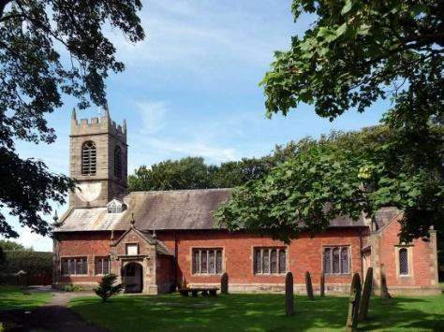

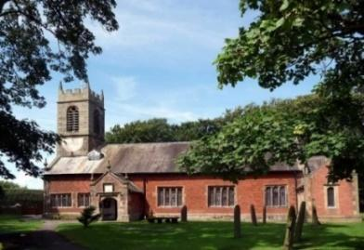

***Welcome to our church this morning. Please stay for a chat and a cup of tea or coffee in the Lodge after the 10.30 service.***

***Sunday 4th December 2022***

**GOD’S GREAT GIFT**

**For God so loved the world that He gave His one & only Son, that whoever believes in him should not perish, but have everlasting life.** *Jn John 3v16*

**PRAYER OF THE DAY: Almighty God, purify our hearts and minds,**

**that when your Son Jesus Christ comes again as judge and saviour**

**we may be ready to receive him, who is our Lord and our God. Amen.**

**No Sunday School today during the service**

As it is the toy and Christingle this afternoon. Toys and colouring sheets at the back of church

**

**9.00am. Holy Communion (Book of Common Prayer) begins p237**

**10.30am. Parish Communion with Sunday School.**

**Reading: Hebrews 1: v 1-9.**

**Hymns: 489 – O God beyond all praising.**

**574 – Purify my heart.**

**Suppl. 10 – Here is Love vast as the ocean.**

**405 – Lo, He comes with clouds descending.**

**H/C Hymns: Screen – Power of the cross. 620 – Such Love.**

**(738 – When I survey the wondrous cross.)**

**12.00noon: Interment of the ashes of Patricia Mortimer.**

**3.45pm: TOY AND CHRISTINGLE SERVICE.**

**Reading: Hebrews 1: v 1-9.** In the past God spoke to our ancestors through the prophets at many times and in various ways, but in these last days he has spoken to us by his Son, whom he appointed heir of all things, and through whom also he made the universe. The Son is the radiance of God’s glory and the exact representation of his being, sustaining all things by his powerful word. After he had provided purification for sins, he sat down at the right hand of the Majesty in heaven. So he became as much superior to the angels as the name he has inherited is superior to theirs.

For to which of the angels did God ever say, ‘You are my Son; today

I have become your Father’? Or again, ‘I will be his Father,     and he will be my Son’? And again, when God brings his firstborn into the world, he says,

‘Let all God’s angels worship him.’ In speaking of the angels he says, ‘He makes his angels spirits, and his servants flames of fire.’

But about the Son he says, ‘Your throne, O God, will last for ever and ever;  a sceptre of justice will be the sceptre of your kingdom. You have loved righteousness and hated wickedness;     therefore God, your God, has

set you above your companions  by anointing you with the oil of joy.’

**Prayer:** We pray for the Toy and Christingle service to take place this afternoon. We give thanks for the life of Patricia Mortimer whose ashes are to be interred today and pray for her family and friends. We pray for the sick especially Liz Boland, Erika Ivy, Sam Burns, Christine Barker, Mona Lewis, Scott Eckersley, Antonietta Broadhurst, Isaac Rostron, Margaret Thornborrow, Andy Shaw, Beryl and Bill Carr.

**WATCHING IN HOPE – Please collect a copy of this Advent booklet published by the Diocese**

**There are daily Bible readings with reflections through Advent.**

**Please borrow a Bible if necessary.**

**Suggested Bible readings from the booklet this week..**

Monday 5th Dec. Micah. 4 v 9-13. Tuesday 6th Dec. Micah 5: v 1-6.

Wednesday 7th Dec. Micah 5: v 7-15. Thursday 8th Dec. Micah 6: v 1-5.

Friday 9th Dec. Micah 6: v 6-8. Saturday 10th Dec. Micah 6: v 9-16.

**Note – The Weekly Giving envelopes for 2023 are now in church by the font. Please collect yours and assist by passing on others if possible.**

**Note – The Food Bank is urgently in need of supplies, Please help if you can.**

**Bible Study: Preparing for Christmas 2 Mon 5th Dec Micah 5 7.30pm in the Lodge**

