Prayer: We pray for those who are sick, especially Baby Erica Ivy, Patricia Mortimer, Rose Wood, Tom Parkinson, Josephine Hodge, Karen Kenyon,.Rose Brown and Steve Coughlan. We give thanks for the life of Bryan Marcus and pray for his family and friends

WEEKLY GIVING ENVELOPES 2022: Please collect yours as soon as possible ready to start using them in January. As usual there will be a tax status slip in the box which needs returning for the Attention of the Treasurer. If you wish to start taking envelopes or change to Standing Order just ask in Church.

Parish Dates December 2021 onwards
Monday 6th December 7.30pm Bible Study at the Rectory
Tuesday 7th December 7.30pm Ladies Group in Village hall
Thursday Dec 9th from 11.30am Christmas Locals’ Lunch in Village Hall.
Sunday 12th December 09.00am Holy Communion
10.30am Morning Worship with Sunday School
Tuesday 14th December 2.15pm School Carol Service in Church
7.30pm Housegroup Christmas Social at the
Rectory for everyone with Carols, Christmas readings and refreshments.
7.30pm Men’s Fellowship Christmas meal.
Thursday 16th December 4:30pm Chat & Chocolate
Friday 17th December 9.15am Hubbersty Assembly in Church
Sunday 19th December 09.00am Holy Communion
10.30am Parish Communion & Sunday School
6.00pm CAROLS BY CANDLELIGHT
CHRISTMAS EVE 4.00pm CRIB SERVICE
11.30pm MIDNIGHT COMMUNION
CHRISTMAS DAY 10.30am FAMILY SERVICE WITH CAROLS AND COMMUNION
Sunday 26th December 10.30am Parish Communion

SAVE THE DATE
Friday 21st January 7.00pm -10.30pm New Year Parish Social: Music from60s/ 70s and 90s in the Village Hall.
Website : www.hooleparishchurch.com
Facebook page: St Michael and All Angels Church, Hoole,
Rector – Revd Ann Templeman anntempleman@live.co.uk 01772 448515The Rectory, 69 Liverpool Old Road Much Hoole PR4 4RB
Please take this sheet home with you
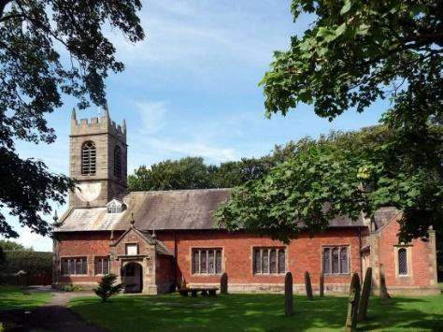
St. Michael and All Angels – Hoole

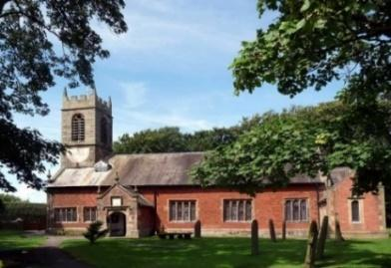

Welcome to our church again this morning. Please stay for a chat and a
cup of tea or coffee after the 10.30 service, a great way to meet people

Sunday 5th December 2021 Advent 2

DAVID, A MAN AFTER GOD’S OWN HEART

‘People look at the outward appearance, but God looks at the heart.’
1 Samuel 16; v 7.
PRAYER OF THE DAY: Almighty God, give us grace that we may cast away the works of darkness, and put upon us the armour of light, now in the time of this mortal life, in which your Son Jesus Christ came to visit us in great humility; that in the last day, when he shall come again in his glorious Majesty, to judge both the living and the dead, we may rise to the life immortal; through him who lives and reigns with you and the Holy Spirit,
now and ever. Amen.

No Sunday School today during the service
There are toys and colouring sheets
for younger children at the back of church.

9.00am. Holy Communion (Book of Common Prayer) begins p237
10.30am. Parish Communion.

Readings: 1 Samuel 16 v 23, 17 v 4, 8-11, 32-37, 45-47
Hymns: 480 – O come, O come, Emmanuel
582 – Restore, O Lord.
Supp. 9 – The Lord’s my Shepherd.
281 – He who would valiant be.
H/C Hymns Sheets (new) 1: There is a higher throne. 2: God of Glory.

3.45pm. Toy and Christingle Service.

BIBLE READING: 1 Samuel 16 -17
Whenever the spirit from God came upon Saul, David would take his harp and play it. Then relief would come to Saul, and he would feel better.
A champion named Goliath, who was from Gath, came out of the Philistine camp. He was over nine feet tall.
Goliath stood and shouted to the ranks of Israel, ‘Am I not a Philistine, and are you not the servants of Saul? Choose a man and let him come down to me. If he is able to fight and kill me, we will become your subjects; but if I overcome him and kill him, you will become our subjects and serve us.’ Then the Philistine said, ‘This day I defy the armies of Israel! Give me a man and let us fight each other.’ On hearing the Philistine’s words, Saul and all the Israelites were dismayed and terrified.
David said to Saul, ‘Let no one lose heart on account of this Philistine; your servant will go and fight him.’ Saul replied, ‘You are not able to go out against this Philistine and fight him; you are only a young man, and he has been a warrior from his youth.’ But David said to Saul, ‘Your servant has been keeping his father’s sheep. When a lion or a bear came and carried off a sheep from the flock, I went after it, struck it and rescued the sheep from its mouth. When it turned on me, I seized it by its hair, struck it and killed it. Your servant has killed both the lion and the bear; this uncircumcised Philistine will be like one of them, because he has defied the armies of the living God. The Lord who rescued me from the paw of the lion and the paw of the bear will rescue me from the hand of this Philistine.’
Saul said to David, ‘Go, and the Lord be with you.’
David said to the Philistine, ‘You come against me with sword and spear and javelin, but I come against you in the name of the Lord Almighty, the God of the armies of Israel, whom you have defied. This day the Lord will deliver you into my hands, and I’ll strike you down and cut off your head. This very day I will give the carcasses of the Philistine army to the birds and the wild animals, and the whole world will know that there is a God in Israel. All those gathered here will know that it is not by sword or spear that the Lord saves; for the battle is the Lord’s, and he will give all of you into our hands.’

Colossians 2.15
Having disarmed the powers and authorities, He made a public spectacle of them triumphing over them by the cross.

AFTER GOD’S OWN HEART

Please take the Diocesan ADVENT BOOKLET AFTER GOD'S OWN HEART.
It is free and contains daily readings and prayers for each day of Advent. The daily Advent readings are based around the life of David - Jesus was from the House of David and born in Bethlehem David's birth place.

ADVENT BIBLE STUDIES/HOUSEGROUPS
We are going to take one of the weekly readings in the booklet as the subject of our Bible studies

MONDAY 6th Dec 1 Samuel 30 v 1-29 – ‘My Grace is sufficient for you.’

TUESDAY 14TH DECEMBER 7.30pm HOUSEGROUP CHRISTMAS SOCIAL AT THE RECTORY Carols, Christmas readings and refreshments. All welcome.
Prayer time continues each Tuesday morning in Church at 10.15am
PTO for prayer this week.

