Parish Dates From February 2023

Tuesday 14th Feb. 10.15am Morning Prayer in the Lodge.
7.30pm Men’s Fellowship in the Village Hall.
‘My Life of Work’ – Colin Wilson
Wednesday 15th Feb NO ALPHA THIS WEEK.
Saturday 18th Feb 7.30pm Karaoke and Quiz Night (see inside)
Sunday 19th Feb 9.00am Holy Communion
10.30am Holy Communion.
3.45pm. PANCAKE CHURCH IN VILLAGE HALL
Tuesday 21st Feb. 10.15am Morning Prayer in the Lodge.
7.30pm Ladies Group in the Village Hall.
Wednesday 22nd Feb. 9.00am ASH WEDNESDAY SCHOOL SERVICE.
7.30pm. ASH WEDNESDAY HOLY COMMUNION.
Thursday 23rd Feb 4.30pm Chat & Chocolate in the Lodge
Sunday 26th Feb 9.00am Holy Communion
10.30am Morning Worship with Sunday School
Tuesday 28th Feb. 10.15am Holy Communion in the Lodge.
Wednesday 1st March 7.15pm ALPHA in the Lodge
HOW CAN I RESIST EVIL?
Thursday 2nd March 4.30pm Bible and Biscuits in the Lodge.
Sunday 5th March 9.00am Holy Communion
10.30am Parish Communion with Sunday School
4.00pm Holy Communion (Old Mill Court)
Tuesday 7th March 10.15am Holy Communion in the Lodge.
Wednesday 8th March 7.15pm ALPHA in the Lodge
DOES GOD HEAL TODAY?
Thursday 9th March 4.30pm Chat & Chocolate in the Lodge
Sunday 12th March 9.00am Holy Communion
10.30am Morning Worship
3.45pm. GRANDPARENTS CHURCH IN VILLAGE HALL
Tuesday 14th March 10.15am Holy Communion in the Lodge.

Suggested Bible Readings This Week.
Monday 13th Feb. Mark 8 v 11-13. Tuesday 14th Feb. Mark 8: v 14-21.
Wednesday 15th Feb. Mark 8: v 22-26. Thursday 16th Feb. Mark 8 v 27-33.
Friday 17th Feb. Mark 8: v 34 to 9: v1. Saturday 18th Feb. Mark 9: v 2-13.
www.hooleparishchurch.com
Facebook page: St Michael and All Angels Church, Hoole,
Rector Ann Templeman anntempleman@live.co.uk 01772 448515 or 07877659156
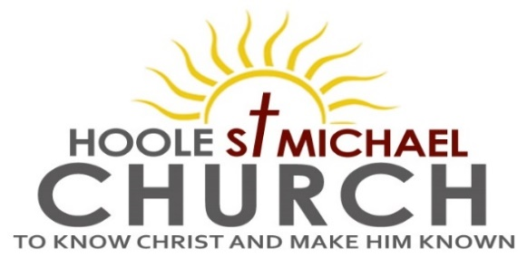
Welcome to our Church today.
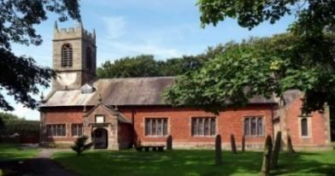
Please stay for refreshments in the Lodge after the service.
Sunday 12th February 2023

CHRISTIAN TEACHING ON MARRIAGE.

God created mankind in his own image -male and female he created them
A man will leave his father and mother and they will become one flesh

PRAYER OF THE DAY Almighty God, give us reverence for all
Creation and respect for every person, that we may mirror your
Likeness in Jesus Christ our Lord. Amen.
Sunday School today during the service. There are toys and
colouring sheets for younger children at the back of church

9.00am. Holy Communion (Book of Common Prayer) begins p237

10.30am. Morning Worship with Sunday School
Reading: Genesis 2: v 18-24.
Hymns: 428 – Love divine, all loves excelling.
Screen – Our God is a great big God.
437 – Make me a channel of your peace.
Suppl. 3 – Before the throne of God above.
636 – The Church’s one foundation.

Reading: Genesis 2: v 18-24. The Lord God said, ‘It is not good for the man to be alone. I will make a helper suitable for him.’
Now the Lord God had formed out of the ground all the wild animals and all the birds in the sky. He brought them to the man to see what he would name them; and whatever the man called each living creature, that was its name. So the man gave names to all the livestock, the birds in the sky and all the wild animals.
But for Adam no suitable helper was found. So the Lord God caused the man to fall into a deep sleep; and while he was sleeping, he took one of the man’s ribs and then closed up the place with flesh. Then the Lord God made a woman from the rib he had taken out of the man, and he brought her to the man.
The man said,
‘This is now bone of my bones and flesh of my flesh;
she shall be called “woman”, for she was taken out of man.’
For this reason a man will leave his father and mother and be united to his wife, and they will become one flesh.

Prayer: We pray for all those who will prepare for Confirmation on May 21st. We pray for 3 babies with long term health problems Erica Ivy, Albie and Nican, we pray for others who are sick especially Sam Burns, Mona Lewis, Christine Barker, Jim Ashcroft, Patricia Edmondson, Josephine Hodge and Antonietta Broadhurst. We give thanks for the lives of Annie Robinson, Maureen Williams and John Carr & pray for their families & friends.
SAVE THE DATE
CORONATION CHARITY DINNER FRIDAY 28TH APRIL at the VENUE, MUCH HOOLE VILLAGE HALL 7.00PM

CORONATION WEEKEND MAY 6TH/7TH
Sunday May 7th 10.30am
CIVIC SERVICE in St Michael’s Church
COMMUNITY CELEBRATIONS ON ST MICHAEL'S SCHOOL FIELD WITH BBQ, and FOOTBALL MATCH

Please forward any information for the April/May parish magazine to stevenewmanwriter@aol.com by 3rd MARCH - earlier if possible.
Karaoke and Quiz Night in the Lodge Saturday February 18th at 7.30pm
The evening opens with a short Music Quiz, going on to Karaoke. The price including drinks and nibbles is £5.00 with children free. Tickets on sale today

Leprosy Mission – Used Stamps If you have any used stamps please bring them to church or give them to Sheila Taylor during the next month as the scheme use to raise money for charity is being discontinued.
ALPHA SESSIONS JANUARY –7.15- 8.45PM IN THE LODGE
With each session repeated at 11.00am on the following Tuesday.
Wednesday 15th February NO ALPHA THIS WEEK
Beginning of Lent:
Wednesday 22nd February 7.30pm ASH WEDNESDAY Holy Communion
5. Wednesday 1st March HOW CAN I RESIST EVIL?
6. Wednesday 8th March DOES GOD HEAL TODAY?
7. Wednesday 15th March HOW CAN I MAKE THE MOST OF THE REST OF MY LIFE? - WITH JACOB’S JOIN MEAL
8. Wednesday 22nd March PREPARING FOR EASTER 1
9. Wednesday 29th March PREPARING FOR EASTER 2
10. SUNDAY 2ND APRIL PALM SUNDAY HOLY WEEK BEGINS
10.30AM Palm Sunday service with donkey procession
11. THURSDAY 6TH APRIL 7.00PM Maundy Thursday PASSOVER MEAL
CONFIRMATION SUN 21ST MAY
STOP PRESS! Bishop Philip the new Bishop of Blackburn has kindly agreed to conduct our Confirmation service this year.
Please let Rev Ann know if you are interested in joining the adult or young people’s preparation group

