**Parish Dates February 2022 onwards**

**Tuesday 15th February 10.15am Prayer time in church.**

**7.30pm House Group at the Rectory**

**7.30pm Ladies Group in the Village Hall.**

**Wednesday 16th February 11.30am Funeral of Stuart McMinn**

**Thursday 17th February 11.00am Funeral of Peter Parker**

**Sunday 20th February 09.00am Holy Communion**

**10.30am Parish Communion with Sunday School**

**Monday 21st February 7.30pm House Group at the Rectory**

**Tuesday 22nd February 10.15am Prayer time in church.**

**Thursday 24th February** from 11.30am Locals’ Lunch in Village Hall.

**4.30pm Chat and Chocolate**

**Sunday 27th February 09.00am Holy Communion**

**10.30am Morning Worship**

**3.45pm Pancake Church in the Village Hall.**

**Tuesday 1st March 10.15am Prayer time in church.**

**Wednesday 2nd March 9.15am School service in church**

**ASH WEDNESDAY 7.30pm Holy Communion.**

**Sunday 6th March 09.00am Holy Communion**

**10.30am Parish Communion with Sunday School**

**4.00pm Holy Communion (Old Mill Court)**

**Monday 7th March 7.30pm House Group at the Rectory**

**Tuesday 8th March 10.15am Prayer time in church.**

**Thursday 10th March** from 11.30am Locals’ Lunch in Village Hall.

**4.30pm Chat and Chocolate**

**Friday 11th March 7.00-10.30pm – MAD MARCH MINGLE**

**Parish Quiz and Social at the Village Hall with meal and entertainment.**

**Get your tickets £10 adults £2 children today in church or from Colin**

**Suggested Bible readings this week.**

Monday 14th Feb. Mark 8: v 11-13. Tuesday 15th Feb. Mark 8: v 14-21.

Wednesday 16th Feb. Mark 8: v 22-26. Thursday 17th Feb. Mark 8: v 27-33.

Friday 18th Feb. Mark 8: v 34 to 9: v1 Saturday 19th Feb. Mark 9: v 2-13.

**Website :** **www.hooleparishchurch.com**

Facebook page: **St Michael and All Angels Church, Hoole**,

Rector – Revd Ann Templeman anntempleman@live.co.uk 01772 448515The Rectory, 69 Liverpool Old Road Much Hoole PR4 4RB

*Please take this sheet home with you*

**St. Michael and All Angels – Hoole**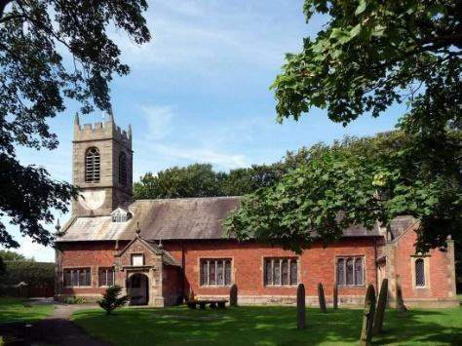

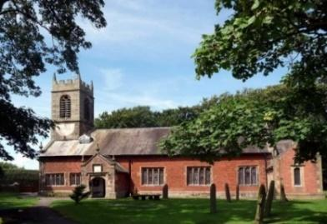

***Welcome to our church again this morning. Please stay for a chat and a cup of tea or coffee after the 10.30 service, a great way to meet people***

***Sunday 13th February 2022***

**DO NOT WORRY**

**“Seek first God’s Kingdom and his righteousness,**

**and these things will be given to you as well.”** *Matthew 6: v 34*

**PRAYER OF THE DAY: Eternal God, whose Son went among the**

**crowds and brought healing with his touch: help us to show his love,**

**in your Church as we gather together, and by our lives as they are**

**transformed into the image of Christ our Lord.**  **Amen.**

**Sunday School today during the service**

There are toys and colouring sheets

for younger children at the back of church.

**

**9.00am. Holy Communion (Book of Common Prayer) begins p237**

**10.30am. Morning Worship with Sunday School.**

**Readings: Philippians 3 v 12-16 Matthew 6: v 25-34.**

**Hymns: 450 – Morning has broken.**

**590 – Seek ye first (sung as a round)**

**Canticle 2 – O bless the God of Israel.**

**727 – What a friend we have in Jesus.**

**Supp. 6 – We rest on Thee**

**READINGS: Philippians 3 v 12-16.** Not that I have already obtained all this, or have already arrived at my goal, but I press on to take hold of that for which Christ Jesus took hold of me. Brothers and sisters, I do not consider myself yet to have taken hold of it. But one thing I do: forgetting what is behind and straining towards what is ahead,I press on towards the goal to win the prize for which God has called me heavenwards in Christ Jesus.

All of us, then, who are mature should take such a view of things. And if on some point you think differently, that too God will make clear to you. Only let us live up to what we have already attained.

**Matthew 6: v 25-34.**  ‘Therefore I tell you, do not worry about your life, what you will eat or drink; or about your body, what you will wear. Is not life more than food, and the body more than clothes? Look at the birds of the air; they do not sow or reap or store away in barns, and yet your heavenly Father feeds them. Are you not much more valuable than they? Can any one of you by worrying add a single hour to your life?

‘And why do you worry about clothes? See how the flowers of the field grow. They do not labour or spin. Yet I tell you that not even Solomon in all his splendour was dressed like one of these. If that is how God clothes the grass of the field, which is here today and tomorrow is thrown into the fire, will he not much more clothe you – you of little faith? So do not worry, saying, “What shall we eat?” or “What shall we drink?” or “What shall we wear?” For the pagans run after all these things, and your heavenly Father knows that you need them. But seek first his kingdom and his righteousness, and all these things will be given to you as well.  Therefore do not worry about tomorrow, for tomorrow will worry about itself. Each day has enough trouble of its own.

**Prayer:** We pray for Charlotte Hickey and Arthur Wilson who shortly to be baptised March, and for all those preparing for Confirmation. We pray for those who are sick, especially Erica Ivy, Tom Parkinson, Rose Brown, Ann Bradshaw, Steve Coughlan and James Turbefield. We give thanks for the lives of Stuart McMinn and Peter Parker and pray for their family and friends as they mourn.

**The Ladies Group** meet in the Village Hall this Tuesday – February 15th at 7.30pm

For a talk entitled Greenland – Icecap and Icebergs. (Speaker: Gordon Fletcher)

**A LOVE LETTER FROM GOD – HOUSEGROUPS**

**In our fortnightly bible study groups 7.30pm we are looking at the 1st letter of John. The great theme of this inspiring letter is God’s love. In the next 2 sessions Tuesday Feb 15th and Monday Feb 21st 7.30pm at the Rectory we will be looking at 1 John 2 v15-3v1. Please join us**

**“YOU ARE THE BODY OF CHRIST AND EACH ONE OF YOU IS A PART OF IT” (1 Corinthians 12 v27)**

**Thank you very much to those who identified the gifts they have been given by God. There is still time to fill in a sheet. Speak to Ann or Churchwardens.**



