Parish Dates February 2021 onwards
Wednesday 17th February ASH WEDNESDAY
6.00pm Holy Communion in Church
Sunday 21st February 09.00am Holy Communion in Church
10.30am Morning Worship via Zoom
Tuesday 23rd February 7.30pm Zoom Bible Study
Thursday 25th February 7.30pm Short time of Prayer via Zoom
Sunday 28th February 09.00am Holy Communion in Church
10.30am Morning Worship via Zoom
Tuesday 2nd March 7.30pm Zoom Bible Study
Thursday 4th March 7.30pm Short time of Prayer via Zoom
Sunday 7th March 09.00am Holy Communion in Church
10.30am CONFIRMATION SERVICE in Church with Bishop Jill Duff
Friday 12th March 7.30pm Zoom Quiz and Social
Sunday 14th March MOTHERING SUNDAY
09.00am Holy Communion in Church
10.30am Holy Communion in Church -First Communion for Confirmation candidates
A HUGE THANK YOU
TO COLIN AND CAROLE
FOR A BRILLIANT
VALENTINE’S QUIZ ON FRIDAY

We will aim to have recordings of all virtual services on the website hooleparishchurch.com by Sunday lunch time.

The Zoom link for our Zoom services for those who wish to join will be on the front page of the website.
Our Facebook page: St Michael and All Angels Church, Hoole, our website is www.hooleparishchurch.com
Rector – Revd Ann Templeman anntempleman@live.co.uk 01772 448515
The Rectory, 69 Liverpool Old Road Much Hoole PR4 4RB
Please take this sheet home with you
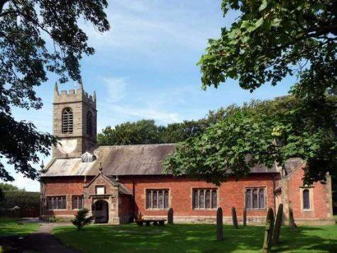
St. Michael and All Angels – Hoole

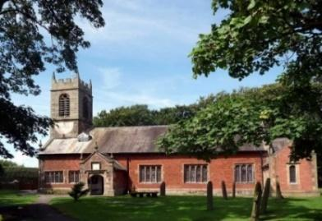

A special welcome to our church again this morning.
Please observe social distancing, but stay close to Christ.

Sunday 14th February 2021 1 before Lent

GOD’S LOVE OVERCOMES OUR SIN

But if anyone obeys his word, God’s love is truly made
complete in them. 1 John 2: v 5.

PRAYER OF THE DAY: Holy God, you know the disorder of our sinful lives: set straight our crooked hearts, and bend our wills to love your goodness and your glory in Jesus Christ our Lord. Amen.

No ‘break out group’ opportunity for young people today during the sermon
today as it’s the Light Party this afternoon.

9.00am. Holy Communion

10.30am. Morning Worship (Zoom Service)

Reading: 1 John 2: v 1-10.

Hymns : 428 – Love Divine.
738 – When I survey the wondrous cross.
447 – May the mind of Christ my Saviour.

BIBLE READING: 1 John 2: v 1-10. My dear children, I write
this to you so that you will not sin. But if anybody does sin, we have an advocate with the Father—Jesus Christ, the Righteous One. He is the atoning sacrifice for our sins, and not only for ours but also for the sins of the whole world.
We know that we have come to know him if we keep his commands.
Whoever says, “I know him,” but does not do what he commands is a liar, and the truth is not in that person. But if anyone obeys his word, God’s love is truly made complete in them. This is how we know we are in him: Whoever claims to live in him must live as Jesus did.
Dear friends, I am not writing you a new command but an old one, which you have had since the beginning. This old command is the message you have heard. Yet I am writing you a new command; its truth is seen in him and in you, because the darkness is passing and the true light is already shining.
Anyone who claims to be in the light but hates a brother or sister^{[b]} is still in the darkness. Anyone who loves their brother and sister^{[c]} lives in the light, and there is nothing in them to make them stumble.

Prayer. We pray for our Confirmation Group, preparing for Confirmation on March 7th. We pray too for those who are sick, especially Michael Pulvermacher, Joan Gleave, Eva Coxhead, Baby Erica Ivy, Beryl Carr, Beryl Cotton and The Parkinson family.

LENT AND BIBLE STUDIES

Bishops’ Lent book
For all Christians Lent is a time to take stock and spend more time with God. Our Bishops are providing a special booklet of daily Bible readings and prayer entitled Read, Mark Learn which will take us through the whole of Mark’s Gospel. These are completely free and are at the back of the church for you to help yourself.
Just sign your name to say you have taken one.
Lent begins for us with a live service of Holy Communion in Church at
6.00pm on Ash Wednesday Feb 17th
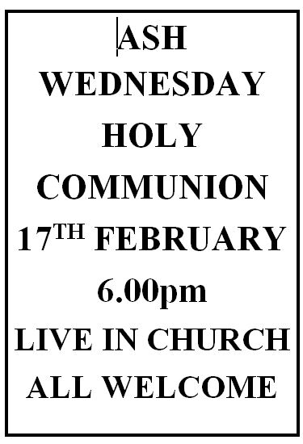
^{Bible studies by Zoom}
We will then use the Tuesday reading each week as the basis for our Zoom Bible study which will be weekly on Tuesdays throughout Lent at 7. 30pm starting on February 23rd Zoom link on website).
Prayer in Lent
There will also be a short time of prayer each week on Zoom on Thursdays at 7.30pm starting Feb 24th

