PARISH DATES
Tuesday 27th Feb. 10.15am Morning Prayer in the Lodge.
Wednesday 28th Feb. 9.30am-11.30am St Michael’s Little Angels.

Sunday 3rd March 9.00am Holy Communion
10.30am Parish Communion.
3.45pm GRANDPARENTS’ CHURCH in Village Hall
4.00pm Holy Communion (Old Mill Court)
Monday 4th March. 7.30pm Bible for Beginners in the Lodge.
Tuesday 5th March 10.15am Holy Communion in the Lodge.
Wednesday 6th March 9.30am-11.30am St Michael’s Little Angels.
Thursday 7th March 7.00pm PCC in the Lodge with Archdeacon Mark

Sunday 10th March 9.00am Holy Communion
10.30am MOTHERING SUNDAY SERVICE
with distribution of flowers at both services
Morning Worship with Sunday School.
Tuesday 12th March 10.15am Holy Communion in the Lodge.
Wednesday 13th March 9.30am-11.30am St Michael’s Little Angels.
Sunday 17th March 9.00am Holy Communion
10.30am Parish Communion with Sunday School.
Tuesday 19th March 10.15am Holy Communion in the Lodge.
Wednesday 20th March 9.30am-11.30am St Michael’s Little Angels.
FUTURE DATES FOR YOUR DIARY
Sunday 24th March PALM SUNDAY SERVICE with Donkey Procession
Starting at School at 10.10am.
Thurs. 28th March 7.00pm PASSOVER MEAL with Holy Communion in School
Friday 29th March 11.00am GOOD FRIDAY SERVICE
(An Hour at the Cross in Church – Children’s Hour at the Cross in the Lodge
Followed by Hunger Lunch in the Lodge).
Sunday 31st March. EASTER SUNDAY (with Children’s Easter Egg hunt)
JOURNEY to FREEDOM the Diocesan booklet for Lent is available in Church – Please collect one. Our suggested Bible readings during Lent are taken from the booklet. Suggested Bible Readings for this week:
Monday 26th Feb. Exodus 6: 28 – 7: 13. Tuesday 27th Feb. Exodus 7: 14-25.
Wednesday 28th Feb. Exodus 8: v 1-15. Thursday 29th Feb. Exodus 8: v 16-32.
Friday 1st March Exodus 9: v 1-12. Saturday 2nd March Exodus 9: v 13-35

www.hooleparishchurch.com Facebook : St Michael and All Angels Church, Hoole,
Rector Ann Templeman anntempleman@live.co.uk 01772 448515 or 07877659156
PLEASE TAKE THIS SHEET HOME WITH YOU.
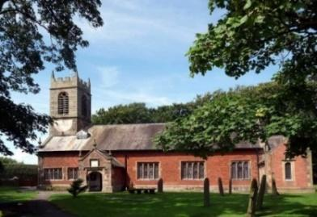
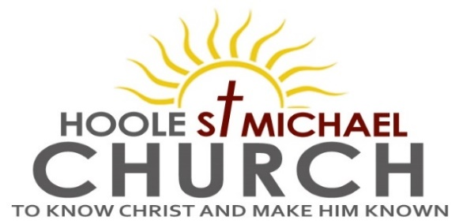

Welcome to our Church today.
Please stay for refreshments in the Lodge which follow the 10.30am service.

Sunday 25th February 2024

PUTTING GOD FIRST

The midwives feared God and did not do what the king of Egypt had told them to do; they let the boys live (Exodus 1: v 17)

PRAYER OF THE DAY Almighty and Everlasting God, you hate nothing that you have made and forgive the sins of all those who are penitent,: create and make in us contrite hearts that we, worthily lamenting our sins and acknowledging our wretchedness, may receive from you, the God of all mercy, perfect remission and forgiveness; through Jesus Christ your Son our Lord, who is alive and reigns with you, in the unity of the Holy Spirit, one God, now and for ever. Amen.

Sunday School today during the service.
There are toys and colouring sheets for young children at the
back of church.

9.00am. Holy Communion (Book of Common Prayer) begins p237

10.30am. Morning Worship with Sunday School.

Reading : Exodus 1: v 6-22.
Hymns: Suppl. 5 – Bless the Lord O my soul.
Screen – God’s love is big.
18 – All I once held dear.
Suppl. 4 – O to see the dawn (This, the power of the cross).
Suppl. 1 – In Christ alone.

5.00pm. Pizza & Praise in Church and Lodge.

Bible Reading: The Israelites oppressed. Exodus 1: v 6-22.
Now Joseph and all his brothers and all that generation died, but the Israelites were exceedingly fruitful; they multiplied greatly, increased in numbers and became so numerous that the land was filled with them
Then a new king, to whom Joseph meant nothing, came to power in Egypt. “Look,” he said to his people, “the Israelites have become far too numerous for us. Come, we must deal shrewdly with them or they will become even more numerous and, if war breaks out, will join our enemies, fight against us and leave the country.”
So they put slave masters over them to oppress them with forced labour, and they built Pithom and Rameses as store cities for Pharaoh. But the more they were oppressed, the more they multiplied and spread; so the Egyptians came to dread the Israelites and worked them ruthlessly. They made their lives bitter with harsh labour in brick and mortar and with all kinds of work in the fields; in all their harsh labour the Egyptians worked them ruthlessly.
The king of Egypt said to the Hebrew midwives, whose names were Shiphrah and Puah, “When you are helping the Hebrew women during childbirth on the delivery stool, if you see that the baby is a boy, kill him; but if it is a girl, let her live.” The midwives, however, feared God and did not do what the king of Egypt had told them to do; they let the boys live.
Then the king of Egypt summoned the midwives and asked them, “Why have you done this? Why have you let the boys live?” The midwives answered Pharaoh, “Hebrew women are not like Egyptian women; they are vigorous and give birth before the midwives arrive.”
So God was kind to the midwives and the people increased and became even more numerous. And because the midwives feared God, he gave them families of their own. Then Pharaoh gave this order to all his people: “Every Hebrew boy that is born you must throw into the Nile, but let every girl live.”

Prayer We continue to pray for all those affected by the conflicts in the Middle East and Ukraine. We pray for Caroline and Trevor who were married yesterday. We pray for the sick, especially His Majesty the King, the Princess of Wales, Beryl Blakeley, Jon Slinger, Wally Taylor, Edward Kenyon, Dan Conner, David Foley, George Ashcroft, and Elaine Read. We give thanks for the life of Majda Mortimer and pray for Andrea, Tom and all her family and friends,.

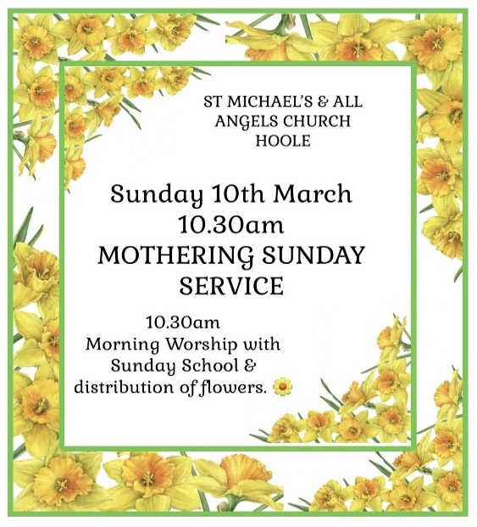

BIBLE FOR BEGINNERS
Monday March 4th 7.30pm in the Lodge
We will continue looking at Jesus’ teaching on Prayer with clips from the Chosen series.
Confirmation
Bishop Philip will be conducting our annual Confirmation Service on May 12th at 10.30am. Please let Rev Ann know if you are interested.
Prayer for healing: Sunday March 3rd
An opportunity for individual prayer for yourself or someone else after the 10.30am service
SOCIAL COMMITTEE – BEETLE DRIVE & QUIZ NIGHT
Will be held in the Lodge on Friday March 15th at 7.30pm
Cost £5.00 including light refreshments.
For further information and tickets contact Colin 01772 616978.

