**Parish Dates February 2022 onwards**

**Tuesday 1st March 10.15am Morning Prayer in church.**

**Wednesday 2nd March 9.15am School service in church**

**ASH WEDNESDAY 7.30pm Holy Communion.**

**Sunday 6th March 09.00am Holy Communion**

**10.30am Parish Communion with Sunday School**

**4.00pm Holy Communion (Old Mill Court)**

**7.30pm Housegroup at the Rectory**

**Tuesday 8th March 10.15am Holy Communion**

**7.30pm Housegroup at the Rectory**

**Thursday 10th March**  **4.30pm Chat and Chocolate**

**Friday 11th March 7.00-10.30pm – MAD MARCH MINGLE**

**Parish Quiz and Social at the Village Hall with meal and entertainment.**

**Get your tickets £10 adults £2 children today in church or from Colin**

**Sunday 13th March 09.00am Holy Communion**

**10.30am Morning Worship with Sunday School**

**12.00noon Baptism of Charlotte Hickey**

**Monday 14th March 2.45pm Songs of Praise in Ribble Court**

**7.30pm Housegroup at the Rectory (tbc)**

**Tuesday 15th March 10.00am Morning Worship.**

**7.30pm Joint Ladies Group & Men’s Fellowship**

**Sunday 20th March 09.00am Holy Communion**

**10.30am Parish Communion.**

**3.45pm Grandparents Church in the Village Hall**

**Monday 21st March 7.30pm Housegroup at the Rectory**

**Tuesday 22nd March 10.15am Prayer Time in church.**

**Thursday 24th March**  **4.30pm Chat and Chocolate**

**Suggested Bible readings this week.**

Monday 28th Feb. Mark 10: v 17-27. Tuesday 1st March Mark 10: v 28-31.

Wednesday 2nd March John 1: v 1-9. Thursday 3rd March John 1: v 10-18.

Friday 4th March John 1: v 19-28. Saturday 5th March John 1: v 29-34.

**Website :** **www.hooleparishchurch.com**

Facebook page: **St Michael and All Angels Church, Hoole**,

Rector – Revd Ann Templeman anntempleman@live.co.uk 01772 448515

The Rectory, 69 Liverpool Old Road Much Hoole PR4 4RB

*Please take this sheet home with you*

**St. Michael and All Angels – Hoole**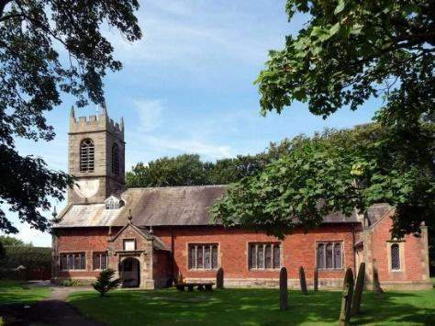

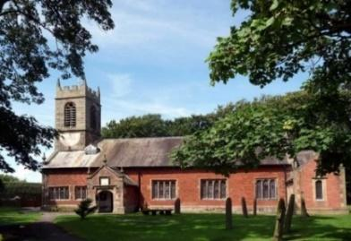

***Welcome to our church again this morning. Please stay for a chat and a cup of tea or coffee after the 10.30 service, a great way to meet people***

***Sunday 27th February 2022 (Next before Lent)***

**STORE UP TREASURE IN HEAVEN**

**“For where your treasure is, there your heart will be also”** *Matthew 6: v 21.*

**PRAYER OF THE DAY: Holy God, you know the disorder of our**

**sinful lives: set straight our crooked hearts, and bend our wills to love**

**your goodness and your glory in Jesus Christ our Lord.**  **Amen.**

**No Sunday School today during the service**

**Pancake Church at 3.45pm in the Village Hall**

There are toys and colouring sheets

for younger children at the back of church.

**

**9.00am. Holy Communion (Book of Common Prayer) begins p237**

**10.30am. Morning Worship.**

**Readings: Matthew 6: v 19-24.**

**Luke 12: v 16-21.**

**Hymns: 137 – Crown Him with many crowns (**omit v 2**).**

**18 – All I once held dear.**

**Canticle 1 – God we praise You.**

**689 – Thy hand, O God, has guided.**

**Suppl. 1: In Christ Alone.**

**3.45pm: Pancake Church in the Village Hall.**

**READINGS: Matthew 6: v 19-24.**  ‘Do not store up for yourselves treasures on earth, where moths and vermin destroy, and where thieves break in and steal. But store up for yourselves treasures in heaven, where moths and vermin do not destroy, and where thieves do not break in and steal. For where your treasure is, there your heart will be also.

‘The eye is the lamp of the body. If your eyes are healthy, your whole body will be full of light. But if your eyes are unhealthy, your whole body will be full of darkness. If then the light within you is darkness, how great is that darkness!

‘No one can serve two masters. Either you will hate the one and love the other, or you will be devoted to the one and despise the other. You cannot serve both God and Money.

**Luke 12: v 16-21.** Jesus told them this parable: ‘The ground of a certain rich man yielded an abundant harvest. He thought to himself, “What shall I do? I have no place to store my crops.”

‘Then he said, “This is what I’ll do. I will tear down my barns and build bigger ones, and there I will store my surplus grain. And I’ll say to myself, ‘You have plenty of grain laid up for many years. Take life easy; eat, drink and be merry.’”



‘But God said to him, “You fool! This very night your life will be demanded from you. Then who will get what you have prepared for yourself?” ‘This is how it will be with whoever stores up things for themselves but is not rich towards God.’

**Prayer:** We pray for a peace in Ukraine. We pray for Charlotte Hickey and Arthur Wilson who are to be baptised March. We pray for those who are sick, especially Erica Ivy, Tom Parkinson, Rose Brown, Ann Bradshaw, Steve Coughlan, Beryl Cottam, Barbara Wood and Roy Sanderson. We give thanks for the life of James Turbefield and pray for Sam Burns and the rest of the family and friends as they mourn.

**Donations of Cakes and Raffle Prizes for Mad March Mingle would be appreciated – please indicate on the sheet at the back of church.**

**“YOU ARE THE BODY OF CHRIST AND EACH ONE OF YOU IS A**

**PART OF IT” (1 Corinthians 12 v27) Thank you very much to those who identified the gifts they have been given by God. There is still time to fill in a sheet. Speak to Ann or Churchwardens.**

**LENT**

Lent is a time when Christians take stock and aim to spend more time with God. It begins **on Ash Wednesday 2nd February when there is a service of Holy Communion at 7.30pm.**There are no Bible studies this week in the hope that everyone will be able to make this solemn service a priority

**LENT BOOK – SIGNS OF LIFE**

Our bishops have produced a special booklet of daily Bible readings for Lent which take us through the whole of John’s Gospel; they are completely free – just help yourself to one at the back of the church.

We will then use one of the weekly readings for the next 5 weeks of Lent at our weekly Bible studies on Monday and Tuesday 7.30pm at the Rectory and Tues at 10.15am. Throughout Lent we will be studying a different passage each week for those of you who would like a weekly study.

