Parish Dates March 2021 onwards
Tuesday 2nd March 7.30pm Zoom Bible Study
Thursday 4th March 7.30pm Short time of Prayer via Zoom
Sunday 7th March 09.00am Holy Communion in Church
10.30am CONFIRMATION SERVICE in Church
with Bishop Jill Duff
Tuesday 9th March 7.30pm Zoom Bible Study
Thursday 11th March 7.30pm Short time of Prayer via Zoom
Friday 12th March 7.30pm Zoom Quiz and Social
Sunday 14th March MOTHERING SUNDAY
09.00am Holy Communion in Church
10.30am Holy Communion in Church
First Communion for Confirmation candidates

Monday 15th March 7.30pm PCCmeeting by Zoom
Tuesday 16th March 7.30pm Zoom Bible Study
Thursday 18th March 7.30pm Short time of Prayer via Zoom
Sunday 21st March 09.00am Holy Communion in Church
10.30am Family Communion in Church
Tuesday 23rd March 7.30pm Zoom Bible Study
We will aim to have recordings of all virtual services on the website hooleparishchurch.com by Sunday lunch time.

The Zoom link for our Zoom services for those who wish to join is on the front page of the website.
Our Facebook page: St Michael and All Angels Church, Hoole, our website is www.hooleparishchurch.com
Rector – Revd Ann Templeman anntempleman@live.co.uk 01772 448515
The Rectory, 69 Liverpool Old Road Much Hoole PR4 4RB
Please take this sheet home with you
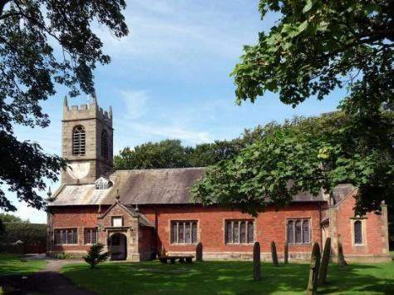
St. Michael and All Angels – Hoole

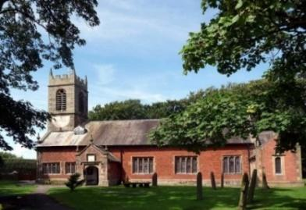

A special welcome to our services today both in church at 9.00am or on Zoom at 10.30am.
Please observe social distancing, but stay close to Christ.

Sunday 28th February 2021 Lent 2.

JESUS RESTORES A DEMON-POSESSED MAN.

“Go home to your own people and tell them how much the Lord has done for you, and how He has had mercy on you”. Mark 3: v 19.

PRAYER OF THE DAY: Almighty God, by the prayer and
discipline of Lent may we enter into the mystery of Christ’s
sufferings, and by following in his Way come to share in his glory;
through Jesus Christ our Lord. Amen.

There will be a ‘break out group’ opportunity for young people during the sermon
within the Zoom Service today.

9.00am. Holy Communion

10.30am. Morning Worship (Zoom Service)

Reading: Mark 5: v 1-20.

Hymns : 54 – (omit v 3 & 4) At the Name of Jesus.
45 – As the deer pants for the water.
137 – (omit v 2) Crown Him with many crowns.

BIBLE READING: Mark 5: v 1-20. They went across the lake to the region of the Gerasenes. When Jesus got out of the boat, a man with an evil spirit came from the tombs to meet him. This man lived in the tombs, and no one could bind him anymore, not even with a chain. For he had often been chained hand and foot, but he tore the chains apart and broke the irons on his feet. No one was strong enough to subdue him. Night and day among the tombs and in the hills he would cry out and cut himself with stones.
When he saw Jesus from a distance, he ran and fell on his knees in front of him. He shouted at the top of his voice, ‘What do you want with me, Jesus, Son of the Most High God? In God’s name don’t torture me!’ For Jesus had said to him, ‘Come out of this man, you evil spirit!’
Then Jesus asked him, ‘What is your name?’
‘My name is Legion,’ he replied, ‘for we are many.’ And he begged Jesus again and again not to send them out of the area.
A large herd of pigs was feeding on the nearby hillside. The demons begged Jesus, ‘Send us among the pigs; allow us to go into them.’ He gave them permission, and the evil spirits came out and went into the pigs. The herd, about two thousand in number, rushed down the steep bank into the lake and were drowned.
Those tending the pigs ran off and reported this in the town and countryside, and the people went out to see what had happened. When they came to Jesus, they saw the man who had been possessed by the legion of demons, sitting there, dressed and in his right mind; and they were afraid. Those who had seen it told the people what had happened to the demon-possessed man – and told about the pigs as well. Then the people began to plead with Jesus to leave their region.
As Jesus was getting into the boat, the man who had been demon-possessed begged to go with him. Jesus did not let him, but said, ‘Go home to your own people and tell them how much the Lord has done for you, and how he has had mercy on you.’ So the man went away and began to tell in the Decapolis^{[b]} how much Jesus had done for him. And all the people were amazed.

Prayer. We pray for those Group, preparing for Confirmation next Sunday, Riley Burns, Harrison Coomer, Morgan Cooper, Joe Higham, Isla Peterson Adam Smith, Grace Wignall, Shelley Cuff and Lisa Higham. We pray too for those who are sick, especially Michael Pulvermacher, Joan Gleave, Eva Coxhead, Baby Erica Ivy, Beryl Carr, Pat Mortimer and Tommy Lyon. We pray too for the Spencer family and all who mourn. We give thanks for the life of Michael Scott.
LENT AND BIBLE STUDIES Bishops’ Lent book
For all Christians Lent is a time to take stock and spend more time with God. Please help yourself to a free Lent book from the back of the church which will take you through the whole of Mark’s Gospel.
This week’s readings are:-
Mon. March 1st Mark 5: v 21-43. Tues. March 2nd Mark 6: v 1-6.
Wed. March 3rd Mark 6: v 7-13. Thurs. March 4th Mark 6: v 14-29.
Fri. March 5th Mark 6: v 30-44. Sat. March 6th Mark 6: v 45-56.

Bible studies by Zoom
We will then use the Tuesday reading each week as the basis for our Zoom Bible study which will be weekly on Tuesdays throughout Lent at 7. 30pm continuing on March 2nd (Zoom link on website).

Prayer in Lent There will also be a short time of prayer each week on Zoom on Thursdays at 7.30pm continuing on March 4th.

