Parish Dates From February 2023

Tuesday 7th Feb 10.15am Morning Prayer in the Lodge
Wednesday 8th Feb 7.15pm ALPHA in the Lodge
WHY AND HOW SHOULD WE TELL OTHERS?
Thursday 9th Feb. 4.30pm Bible and Biscuits in the Lodge.
Sunday 12th Feb 9.00am Holy Communion
10.30am Morning Worship with Sunday School
Tuesday 14th Feb. 10.15am Morning Prayer in the Lodge.
7.30pm Men’s Fellowship in the Village Hall.
Wednesday 15th Feb NO ALPHA THIS WEEK.
Saturday 18th Feb 7.30pm Karaoke and Quiz Night (see inside)
Sunday 19th Feb 9.00am Holy Communion
10.30am Holy Communion.
3.45pm. PANCAKE CHURCH IN VILLAGE HALL
Tuesday 21st Feb. 10.15am Morning Prayer in the Lodge.
7.30pm Ladies Group in the Village Hall.
Wednesday 22nd Feb. 7.30pm. ASH WEDNESDAY HOLY COMMUNION.
Thursday 23rd Feb 4.30pm Chat & Chocolate in the Lodge
Sunday 26th Feb 9.00am Holy Communion
10.30am Morning Worship with Sunday School
Tuesday 28th Feb. 10.15am Holy Communion in the Lodge.
Wednesday 1st March 7.15pm ALPHA in the Lodge
HOW CAN I RESIST EVIL?
Thursday 2nd March 4.30pm Bible and Biscuits in the Lodge.
Sunday 5th March 9.00am Holy Communion
10.30am Parish Communion with Sunday School
4.00pm Holy Communion (Old Mill Court)
Tuesday 7th March 10.15am Holy Communion in the Lodge.
Wednesday 8th March 7.15pm ALPHA in the Lodge
DOES GOD HEAL TODAY?
Thursday 9th March 4.30pm Chat & Chocolate in the Lodge

Suggested Bible Readings This Week.
Monday 6th Feb. Mark 6 v 53-end. Tuesday 7th Feb. Mark 7: v 1-13.
Wednesday 8th Feb. Mark 7: v 14-23. Thursday 9th Feb. Mark 7 v 24-30.
Friday 10th Feb. Mark 7: v 31-end. Saturday 11th Feb. Mark 8: v 1-10.
www.hooleparishchurch.com
Facebook page: St Michael and All Angels Church, Hoole,
Rector Ann Templeman anntempleman@live.co.uk 01772 448515 or 07877659156
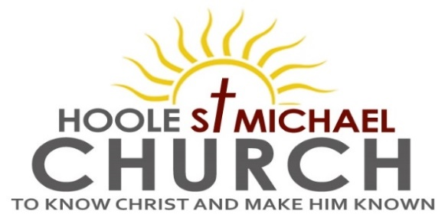
Welcome to our Church today.
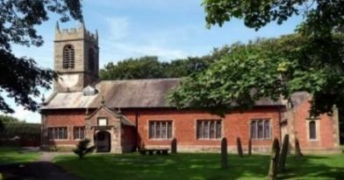
Please stay for refreshments in the Lodge after the service.
Sunday 5th February 2023

GOD’S SAVING ACT.

‘Praise be to the Lord, the God of Israel, for He has come and
redeemed his people.’ Luke 1: v 68.

PRAYER OF THE DAY Eternal God, whose Son went among the
crowds and brought healing with his touch: help us to show his love,
in your Church as we gather together, and by our lives as they are
transformed into the image of Christ our Lord. Amen.
Sunday School today during the service. There are toys and
colouring sheets for younger children at the back of church

9.00am. Holy Communion (Book of Common Prayer) begins p237

10.30am. Parish Communion with Sunday School
Reading: Luke 1: v 67-80.
Hymns: Screen – Light of the world, you stepped down into darkness.
901 – This little light of mine.
Canticle 2 – O bless the God of Israel.
658 – There is a redeemer.
461 – My Jesus my saviour.
H/C Hymns: Screen – Here is Love vast as the ocean. 620 – Such love.

4.00pm. Holy Communion (Old Mill Court).
Reading: Luke 1: v 67-80. His father Zechariah was filled with the
Holy Spirit and prophesied:
‘Praise be to the Lord, the God of Israel, because he has come to his people and redeemed them. He has raised up a horn of salvation for us
in the house of his servant David (as he said through his holy prophets of long ago), salvation from our enemies and from the hand of all who hate us –
to show mercy to our ancestors and to remember his holy covenant, the oath he swore to our father Abraham: to rescue us from the hand of our enemies,
and to enable us to serve him without fear in holiness and righteousness before him all our days.
And you, my child, will be called a prophet of the Most High; for you will go on before the Lord to prepare the way for him, to give his people the knowledge of salvation through the forgiveness of their sins, because of the tender mercy of our God, by which the rising sun will come to us from heaven to shine on those living in darkness and in the shadow of death,
to guide our feet into the path of peace.’
And the child grew and became strong in spirit; and he lived in the wilderness until he appeared publicly to Israel.

Prayer: We pray for Dexter Holding and Harry Tomlinson- Farrel who have both been recently baptised and for their families at this special time in family life and for all those who will prepare for Confirmation on May 21st. We pray for the sick especially Erika Ivy, Sam Burns, Mona Lewis, Christine Barker, Maureen Williams, Jim Ashcroft, Josephine Hodge and Antonietta Broadhurst. We give thanks for the lives of Annie Robinson and John Carr & pray for their families & friends.
SAVE THE DATE
CORONATION CHARITY DINNER FRIDAY 28TH APRIL at the VENUE, MUCH HOOLE VILLAGE HALL 7.00PM
CORONATION WEEKEND MAY 6TH/7TH
Sunday May 7th 10.30am
CIVIC SERVICE in St Michael’s Church
followed by
COMMUNITY CELEBRATIONS ON ST MICHAEL'S SCHOOL FIELD WITH BBQ, and FOOTBALL MATCH
Karaoke and Quiz Night in the Lodge Saturday February 18th at 7.30pm
The evening opens with a short Music Quiz, going on to Karaoke. The price including drinks and nibbles is £5.00 with children free. Tickets on sale today

Leprosy Mission – Used Stamps If you have any used stamps please bring them to church or give them to Sheila Taylor during the next month as the scheme use to raise money for charity is being discontinued.
ALPHA SESSIONS JANUARY –7.15- 8.45PM IN THE LODGE
With each session repeated at 11.00am on the following Tuesday.
Wed 8th Feb WHY AND HOW SHOULD WE TELL OTHERS?
Wednesday 15th February NO ALPHA THIS WEEK
Beginning of Lent:
Wednesday 22nd February 7.30pm ASH WEDNESDAY Holy Communion
5. Wednesday 1st March HOW CAN I RESIST EVIL?
6. Wednesday 8th March DOES GOD HEAL TODAY?
7. Wednesday 15th March HOW CAN I MAKE THE MOST OF THE REST OF MY LIFE? - WITH JACOB’S JOIN MEAL
8. Wednesday 22nd March PREPARING FOR EASTER 1
9. Wednesday 29th March PREPARING FOR EASTER 2
10. SUNDAY 2ND APRIL PALM SUNDAY HOLY WEEK BEGINS
10.30AM Palm Sunday service with donkey procession
11. THURSDAY 6TH APRIL 7.00PM Maundy Thursday PASSOVER MEAL
CONFIRMATION SUN 21ST MAY
STOP PRESS! Bishop Philip the new Bishop of Blackburn has kindly agreed to conduct our Confirmation service this year.
Please let Rev Ann know if you are interested in joining the adult or young people’s preparation group

