**Parish Dates February 2022 onwards**

**Monday 7th February 7.30pm House Group at the Rectory**

**Tuesday 8th February 10.15am Morning prayer with Holy Communion**

**2.45pm School Service in church**

**7.30pm Men’s Fellowship in Village Hall**

**Thursday 10th February** from 11.30am Locals’ Lunch in Village Hall.

**4.30pm Chat and Chocolate**

**Sunday 13th February 09.00am Holy Communion**

**10.30am Morning Worship with Sunday School**

**Tuesday 15th February 10.15am Prayer time in church.**

**7.30pm House Group at the Rectory**

**Wednesday 16th February 11.30am funeral of Stuart McMinn**

**Sunday 20th February 09.00am Holy Communion**

**10.30am Parish Communion with Sunday School**

**Monday 21st February 7.30pm House Group at the Rectory**

**Tuesday 22nd February 10.15am Prayer time in church.**

**Thursday 24th February** from 11.30am Locals’ Lunch in Village Hall.

**4.30pm Chat and Chocolate**

**Sunday 27th February 09.00am Holy Communion**

**10.30am Morning Worship**

**3.45pm Pancake Church in the Village Hall.**

**Tuesday 1st March 10.15am Prayer time in church.**

**Wednesday 2nd March ASH WEDNESDAY 7.30pm Holy Communion.**

**Sunday 6th March 09.00am Holy Communion**

**10.30am Parish Communion with Sunday School**

**4.00pm Holy Communion (Old Mill Court)**

**Monday 7th March 7.30pm House Group at the Rectory**

**KEY DATE FOR YOUR DIARY**

**Friday 11th March 7.00-10.30pm – Parish Quiz and Social at**

**the Village Hall with meal and entertainment.**

**Get your tickets today from Colin or churchwardens**

**Website :** **www.hooleparishchurch.com**

Facebook page: **St Michael and All Angels Church, Hoole**,

Rector – Revd Ann Templeman anntempleman@live.co.uk 01772 448515The Rectory, 69 Liverpool Old Road Much Hoole PR4 4RB

*Please take this sheet home with you*

**St. Michael and All Angels – Hoole**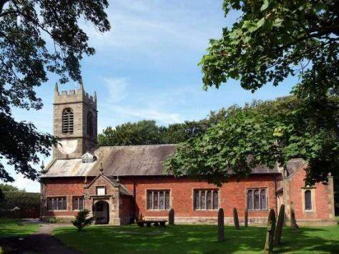

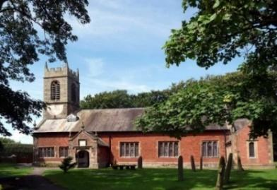 ***Sunday 6th February 2022***



***Platinum Jubilee of Accession of Queen Elizabeth 11***

**THE BEATITUDES – THE SERMON ON THE MOUNT**

**“Blessed are those who hunger and thirst for righteousness, for they will be filled.”** *Matthew 5: v 6*

**PRAYER OF THE DAY:** Almighty God, the fountain of all goodness, bless our Sovereign Lady, Queen Elizabeth, and all who are in authority under her; that they may order all things in wisdom and equity, righteousness and peace, to the honour and glory of your name and the good of your Church and people; through Jesus Christ your Son our Lord, who is alive and reigns with you, in the unity of the Holy Spirit, one God, now and for ever. Amen.

**Sunday School today during the service**

There are toys and colouring sheets

for younger children at the back of church.

**

**9.00am. Holy Communion (Book of Common Prayer) begins p237**

**10.30am. Parish Communion with Sunday School.**

**Readings: Romans 12: v 17-21.**

**Matthew 5: v 1-10.**

**Hymns: 489 – O God beyond all praising.**

**Screen – You are shaped for serving God.**

**437 – Make me a channel of your peace.**

**Supp. 3 – Before the throne of God above.**

**448 – Meekness and Majesty.**

**HC Screen: Blessed be your Name,77Blessed are the pure in heart.**

**4.00pm: Holy Communion (Old Mill Court)**

**READINGS: Romans 12: v 17-21.**

Do not repay anyone evil for evil. Be careful to do what is right in the eyes of everyone. If it is possible, as far as it depends on you, live at peace with everyone. Do not take revenge, my dear friends, but leave room for God’s wrath, for it is written: “It is mine to avenge; I will repay,” says the Lord. On the contrary: “If your enemy is hungry, feed him;     if he is thirsty, give him something to drink. In doing this, you will heap burning coals on his head.” Do not be overcome by evil, but overcome evil with good.

**Matthew 5: v 1-10.**

Now when Jesus saw the crowds, he went up on a mountainside and sat down. His disciples came to him, and he began to teach them. He said:

‘Blessed are the poor in spirit,     for theirs is the kingdom of heaven.  
Blessed are those who mourn, for they will be comforted.  
 Blessed are the meek, for they will inherit the earth.  
Blessed are those who hunger and thirst for righteousness,

    for they will be filled.  
Blessed are the merciful, for they will be shown mercy.  
 Blessed are the pure in heart, for they will see God.  
Blessed are the peacemakers, for they will be called children of God.  
 Blessed are those who are persecuted because of righteousness,  
     for theirs is the kingdom of heaven.

**Prayer:** We pray today for Harry, George and Henrietta Bracewell who were baptised last Sunday, and for Charlotte Hickey and Arthur Wilson to be baptised in March and for all their families at this special time. We pray for those who are sick, especially Erica Ivy, Patricia Mortimer, Rose Wood, Tom Parkinson, Karen Kenyon, Rose Brown, Steve Coughlan and James Turbefield. We give thanks for the lives of Stuart McMinn and Peter Parker and pray for their family and friends as they mourn.

**Confirmation**

**2 Confirmation groups have begun-one for adults, one for**

**young people aged 11-18. Please let Rev Ann know if you are interested in**

**joining these groups.**

**Suggested Bible readings this week.**

Monday 7th Feb. Mark 6: v 53-end. Tuesday 8th Feb. Mark 7: v 1-13.

Wednesday 9th Feb. Mark 7: v 14-23. Thursday 10th Feb. Mark 7: v 24-30.

Friday 11th Feb. Mark 7: v 31-end. Saturday 12th Feb. Mark 8: v 1-10.

**A LOVE LETTER FROM GOD – HOUSEGROUPS**

**In our Bible Study/Housegroups we will be looking at the**

**1st letter of John (page 1225 in the church Bibles) between now and Lent. The great theme of this inspiring letter is God’s love. In the next session, Monday 7th February, we will be looking at 1 John 2: v 2-14.**

**Churches together Penwortham  Foodbank**

Please don’t forget to keep donating to the Foodbank..

**“YOU ARE THE BODY OF CHRIST AND EACH ONE OF YOU IS A PART OF IT” (1 Corinthians 12 v27)**

**Thank you very much to those who identified the gifts they have been given by God. Today if you regard St Michael’s as your church there is still time to fill in a sheet. Speak to Ann or Churchwardens.**



