Parish Dates From January 2023

Tuesday 17th Jan. 10.15am Holy Communion in the Lodge.
1.00pm Funeral of Jeffrey Oates
7.30pm Ladies Group AGM & Social Village Hall
Wednesday 18th Jan. 7.15pm ALPHA 2 begins in the Lodge.
HOW DOES GOD GUIDE US?
Thursday 19th Jan. 4.30pm Chat and Chocolate in the Lodge

Sunday 22nd Jan. 9.00am Holy Communion
10.30am Morning Worship with Sunday School and Baptism of Dexter Holding.
3.45pm PARTY CHURCH (in St Michael’s School)
Monday 23rd Jan. 7.30pm PCC Meeting in the Lodge.
Tuesday 24th Jan. 10.15am Holy Communion in the Lodge.
Wednesday 25th Jan. 11.00am Funeral of Mark James Wilson.
7.15pm ALPHA continues in the Lodge.
WHO IS THE HOLY SPIRIT?
Thursday 26th Jan. 4.30pm Bible and Biscuits in the Lodge.
Sunday 29th Jan. 9.00am Holy Communion
10.30am Parish Communion with Sunday School and
Baptism of Harry Tomlinson-Farrell.
Tuesday 31st Jan. 10.15am Holy Communion in the Lodge.
Wednesday 1st Fe 7.15pm ALPHA in the Lodge
WHAT DOES THE HOLY SPIRIT DO?
Thursday 2nd Feb 4.30pm Chat & Chocolate in the Lodge
Sunday 5th Feb 9.00am Holy Communion
10.30am Holy Communion with Sunday School
Tuesday 7th Feb 10.15am Morning Prayer in the Lodge
Wednesday 8th Feb 7.15pm ALPHA in the Lodge
WHY AND HOW SHOULD WE TELL OTHERS?
Saturday 18th Feb 7.30pm Karaoke and Quiz Night (see inside)
Suggested Bible Readings This Week.
Monday 16th Jan. Mark 2 v 18-22. Tuesday 17th Jan. Mark 2: v 23-end.
Wed. 18th Jan. Mark 3: v 1-6. Thursday 19th Jan. Mark 3: v 7-12.
Friday 20th Jan. Mark 3: v 13-19. Saturday 21st Jan. Mark 3: v 20-21.
www.hooleparishchurch.com
Facebook page: St Michael and All Angels Church, Hoole,
Rector Ann Templeman anntempleman@live.co.uk 01772 448515 or 07877659156

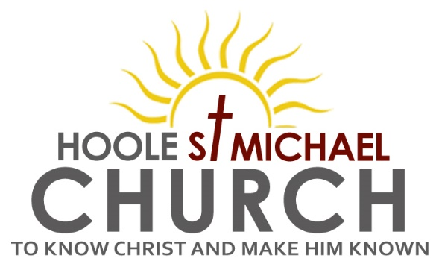
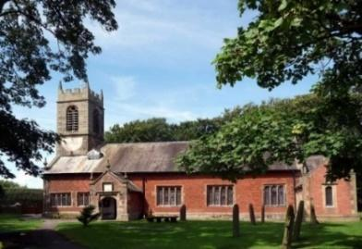
Welcome to our Church today. Please stay for refreshments in the Lodge after the service, and return to the church for the short play at 12.00noon.
Sunday 15th January 2023

JESUS THE LAMB OF GOD.

‘Behold the Lamb of God who takes away the sin of the world’. John 1: v29.

PRAYER OF THE DAY: “Almighty God, in Christ you make all things new:
transform the poverty of our nature by the riches of your grace, and in the
renewal of our lives make known your heavenly glory; through Jesus Christ
your Son our Lord, who is alive and reigns with you, in the unity of the Holy
Spirit, one God, now and for ever. ” Amen.
Sunday School today during the service. There are toys and
colouring sheets for younger children at the back of church

9.00am. Holy Communion (Book of Common Prayer) begins p237

10.30am. Parish Communion with Sunday School.
Hymns: 463 – My song is love unknown.
Screen – You are shaped for serving God.
658 – There is a Redeemer.
364 – Jesus, the name high over all. (Alt. 332 – I the Lord)
H/C Hymns: Screen – Yet not I but through Christ in me.
374 – Just as I am, without one plea.

12.00noon: Drama – There came Three Soldiers. (St Michael’s Players)

Reading: John 1: v 29-42. The next day John saw Jesus coming towards him and said, ‘Look, the Lamb of God, who takes away the sin of the world!
This is the one I meant when I said, “A man who comes after me has surpassed me because he was before me.” I myself did not know him, but the reason I came baptising with water was that he might be revealed to Israel.’
Then John gave this testimony: ‘I saw the Spirit come down from heaven as a dove and remain on him. And I myself did not know him, but the one who sent me to baptise with water told me, “The man on whom you see the Spirit come down and remain is the one who will baptise with the Holy Spirit.” I have seen and I testify that this is God’s Chosen One.’
The next day John was there again with two of his disciples. When he saw Jesus passing by, he said, ‘Look, the Lamb of God!’ When the two disciples heard him say this, they followed Jesus. Turning round, Jesus saw them following and asked, ‘What do you want?’
They said, ‘Rabbi’ (which means ‘Teacher’), ‘where are you staying?’
‘Come,’ he replied, ‘and you will see.’ So they went and saw where he was staying, and they spent that day with him. It was about four in the afternoon.
Andrew, Simon Peter’s brother, was one of the two who heard what John had said and who had followed Jesus. The first thing Andrew did was to find his brother Simon and tell him, ‘We have found the Messiah’ (that is, the Christ). And he brought him to Jesus.
Jesus looked at him and said, ‘You are Simon son of John. You will be called Cephas’ (which, when translated, is Peter).

Prayer: We continue to pray that 2023 may be a year filled with love, joy and peace. We pray for the sick especially Erika Ivy, Sam Burns, Mona Lewis, Christine Barker, Antonietta Broadhurst, Isaac Rostron, Andy Shaw, Josephine Hodge, Bob Jones, Beryl and Bill Carr. We give thanks for the lives of Jeffrey Oates and Mark Wilson & & pray for their families & friends.

Karaoke and Quiz Night in the Lodge Saturday February 18th at 7.30pm
The evening opens with a short Music Quiz, going on to Karaoke. The price including drinks and nibbles is £5.00 with children free. Please keep the date.

ALPHA SESSIONS JANUARY – MARCH 2023
ALL SESSIONS 7.15- 8.45PM IN THE LODGE
1. Wednesday 18th January HOW DOES GOD GUIDE US?
2. Wednesday 26th January WHO IS THE HOLY SPIRIT?
3.Wednesday 1st February WHAT DOES THE HOLY SPIRIT DO?
4. Wednesday 8th February WHY AND HOW SHOULD WE TELL OTHERS?
Wednesday 15th February NO ALPHA THIS WEEK
Beginning of Lent:
Wednesday 22nd February 7.30pm ASH WEDNESDAY Holy Communion
5. Wednesday 1st March HOW CAN I RESIST EVIL?
6. Wednesday 8th March DOES GOD HEAL TODAY?
7. Wednesday 15th March HOW CAN I MAKE THE MOST OF THE REST OF MY LIFE? - WITH JACOB’S JOIN MEAL
8. Wednesday 22nd March PREPARING FOR EASTER 1
9. Wednesday 29th March PREPARING FOR EASTER 2
10. SUNDAY 2ND APRIL PALM SUNDAY HOLY WEEK BEGINS
10.30AM Palm Sunday service with donkey procession from St Michael’s school to church
11. THURSDAY 5TH APRIL 7.00PM Maundy Thursday
PASSOVER MEAL

