Parish Dates January 2022 onwards
Monday January 17th 7.30pm PCC at the Village Hall
Tuesday 18th January 10.15am Holy Communion in church.
7.30pm House Group at the Rectory
7.30pm Ladies Group in the Village Hall
POSTPONED!!! Friday 21st January 7.00pm -10.30pm New Year Parish Social: Music from 60s to 90s in the Village Hall.

Sunday 23rd January 09.00am Holy Communion
10.30am Morning Worship
3.45pm NOISY CHURCH in Church
Monday 24th January 7.30pm House Group at the Rectory
Tuesday 25th January 10.15am Prayer time in church.
Thursday 27th January from 11.30am Locals’ Lunch in Village Hall.
4.30pm Chat and Chocolate

Sunday 30th January 09.00am Holy Communion
10.30am Parish Communion with Sunday School
Tuesday 1st February 10.15am Prayer time in church.
2.45pm School Service in church

Sunday 6th February 09.00am Holy Communion
10.30am Parish Communion with Sunday School
Confirmation
2 Confirmation groups will be starting in the New Year to prepare for Confirmation in the summer:
1. For adults – there are already a number of people who have expressed an interest in this group. There will be 8-10 x1hr sessions discussing the basics of Christian commitment. Everyone is welcome whatever your age or Christian background.
2. For young people age 11-18 – we already have 7 interested
Please let Rev Ann know if you would like to join either group

Website : www.hooleparishchurch.com
Facebook page: St Michael and All Angels Church, Hoole,
Rector – Revd Ann Templeman anntempleman@live.co.uk 01772 448515The Rectory, 69 Liverpool Old Road Much Hoole PR4 4RB
Please take this sheet home with you
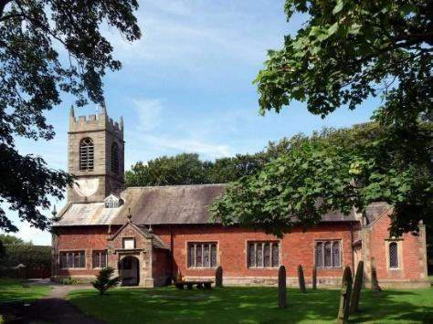
St. Michael and All Angels – Hoole

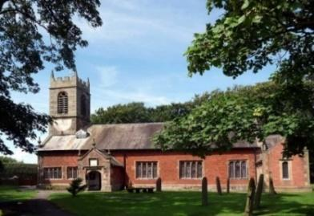

Welcome to our church again this morning. Please stay for a chat and a cup of tea or coffee after the 10.30 service, a great way to meet people

Sunday 16th January 2022 Epiphany 2

THE CHURCH – THE BODY OF CHRIST

‘You are the body of Christ, and each one is a part of it’
1 Corinthians 12: v 27.

PRAYER OF THE DAY: Almighty God, in Christ you make all things
new: transform the poverty of our nature by the riches of your grace,
and in the renewal of our lives make known your heavenly glory;
through Jesus Christ your Son our Lord, who is alive and reigns with
you, in the unity of the Holy Spirit, one God, now and for ever. Amen.

Sunday School today during the service
There are toys and colouring sheets
for younger children at the back of church.

9.00am. Holy Communion (Book of Common Prayer) begins p237

10.30am. Parish Communion with Sunday School
Readings: 1 Corinthians 12: v 4-13.
1 Corinthians 12: v 27-31.

Hymns: 54 – At the name of Jesus (tune 2)
915 / Screen – Who put the colours in the rainbow.
72 Bind us together Screen.
636 – The Church’s one foundation.

H/C Hymns: Screen – We are one in the Spirit.
620 – Such love.
BIBLE READINGS: 1 Corinthians 12: v 4-13 There are different kinds of gifts, but the same Spirit distributes them. There are different kinds of service, but the same Lord. There are different kinds of working, but in all of them and in everyone it is the same God at work.
Now to each one the manifestation of the Spirit is given for the common good. To one there is given through the Spirit a message of wisdom, to another a message of knowledge by means of the same Spirit, to another faith by the same Spirit, to another gifts of healing by that one Spirit, to another miraculous powers, to another prophecy, to another distinguishing between spirits, to another speaking in different kinds of tongues, and to still another the interpretation of tongues. All these are the work of one and the same Spirit, and he distributes them to each one, just as he determines.
Just as a body, though one, has many parts, but all its many parts form one body, so it is with Christ. For we were all baptised by one Spirit so as to form one body – whether Jews or Gentiles, slave or free – and we were all given the one Spirit to drink.
1 Corinthians 12: v 27-31. Now you are the body of Christ, and each one of you is a part of it. And God has placed in the church first of all apostles, second prophets, third teachers, then miracles, then gifts of healing, of helping, of guidance, and of different kinds of tongues. Are all apostles? Are all prophets? Are all teachers? Do all work miracles? Do all have gifts of healing? Do all speak in tongues? Do all interpret? Now eagerly desire the greater gifts.

Prayer: We pray for those who are sick, especially Baby Erica Ivy, Patricia Mortimer, Rose Wood, Tom Parkinson, Karen Kenyon, Rose Brown, Peter Parker, Steve Coughlan and James Turbefield. We give thanks for the lives of Eva Coxhead, Michael Taylor & Mavis McCormick & pray for their family & friends.
New Year’s Resolution?
Please consider coming along to our fortnightly Bible Studies and/or the weekly prayer time on Tuesday mornings?
Prayer of commitment
I am no longer my own, but yours,
send me where you will, rank me with whom you will;
let me be employed for you, or laid aside for you;
exalted for you, or brought low for you;
let me be full, let me be empty;
Freely and wholeheartedly I yield my life and all I possess to your pleasure and disposal. Amen.

Suggested Bible readings this week.
Monday 17th Jan. Mark 2: v 18-22. Tuesday 18th Jan. Mark 2: v 23-end.
Wednesday 19th Jan. Mark 3: v 1-6. Thursday 20th Jan. Mark 3: v 7-12.
Friday 21st Jan. Mark 3: v 13-19. Saturday 22nd Jan. Mark 3: v 20-21.

A LOVE LETTER FROM GOD – HOUSEGROUPS
In our Bible Study/Housegroups we will be looking at the
1st letter of John (page 1225 in the church Bibles) between now and Lent. The great theme of this inspiring letter is God’s love. In the first session, Tuesday 18th and Monday 24th January, we will be looking at 1 John 1.
TUESDAY 10.15am IN CHURCH
This will be a short service of either Morning Prayer or Holy Communion – a lovely time midweek to meet and pray together over God’s Word.
